# Renewing Ansible Tower certs:

## Find out if you have access to update the certs:

Go [here](https://directoryworks.hpecorp.net/protected/groups/view/normal/?dn=cn%3Dautomation-hybrid-cloud%2Cou%3DGroups%2Co%3Dhp.com) and check if you are a owner and member of “automation-hybrid-cloud” group. If not please contact the owners to obtain access.

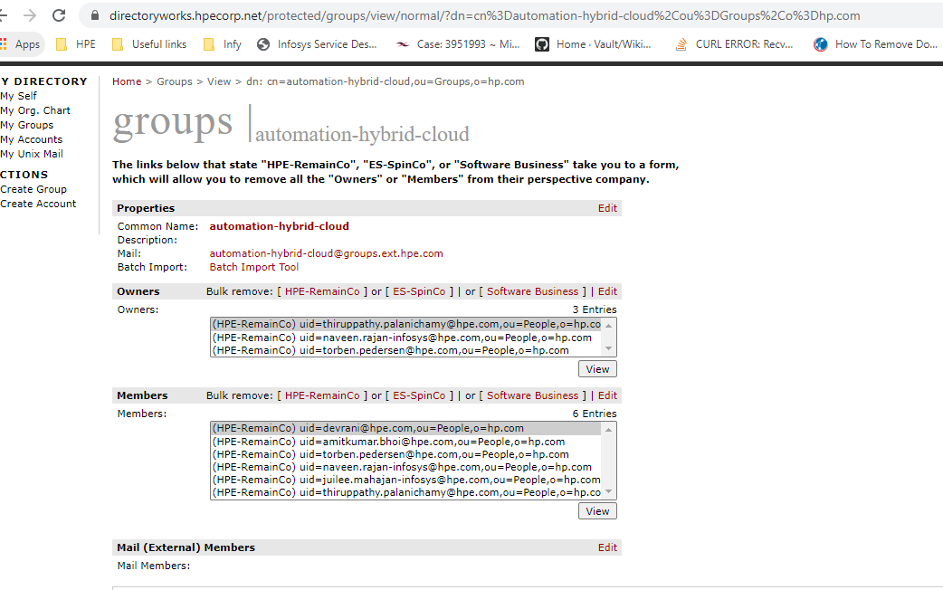

## Generate Private key and CSR by following below documents

Generating Private key and CSR -



CSR Inputs to provide, please leave Organization Unit field empty during CSR creation –



Note: Use the FQDN from the existing certificate.

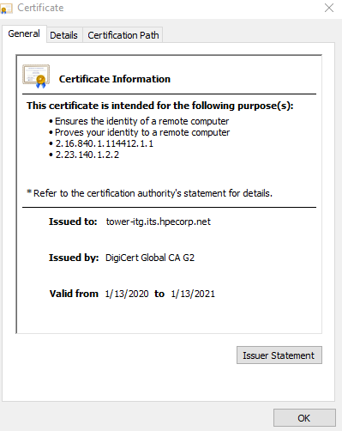

## Creating certificate

* 1. Go to - <https://g1t6039.austin.hpecorp.net/hp/client/sslPublicStart.php>

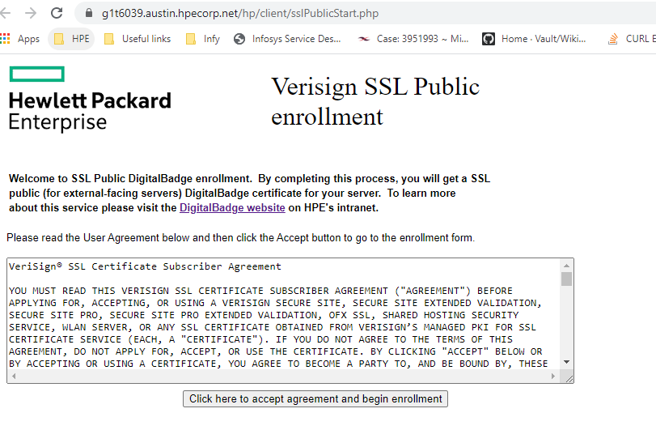

* 1. Proceed accepting for next two prompts, as we have an active cert.

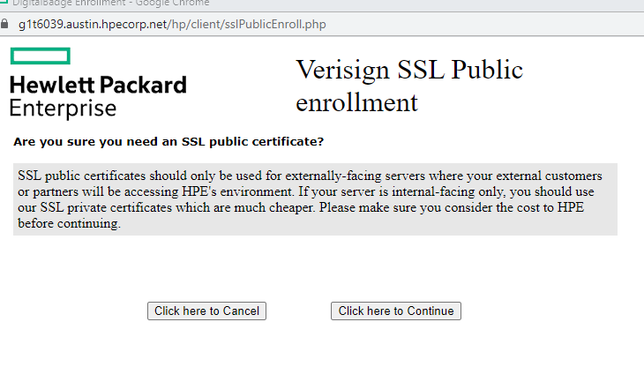

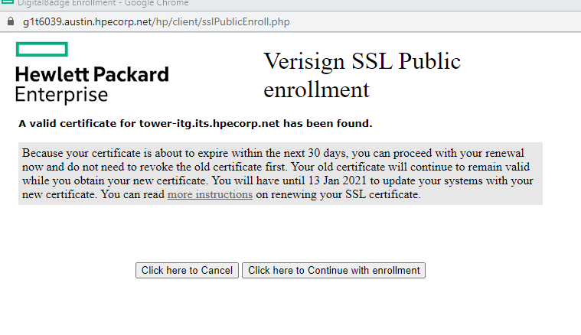

* 1. In the below form Provide the tower details as follows,

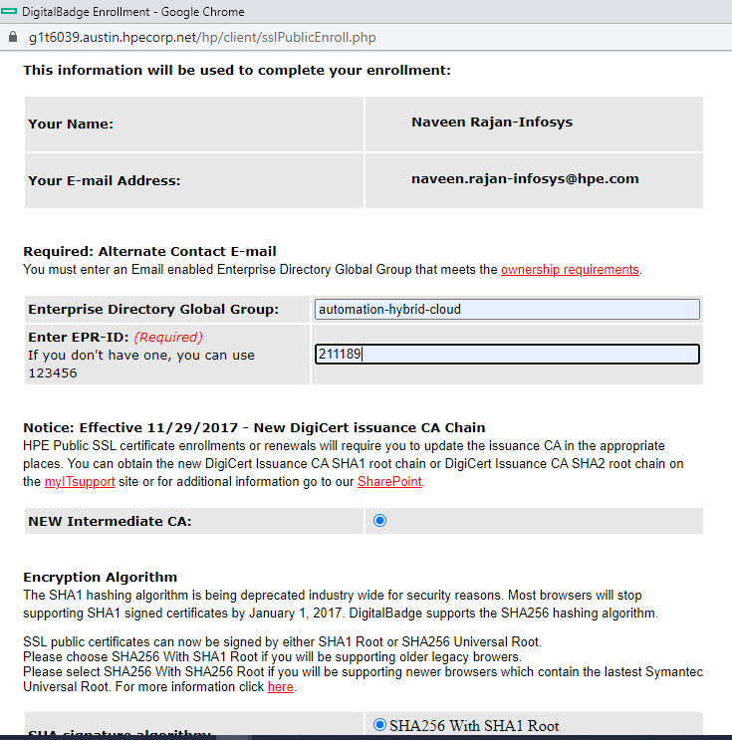

* 1. Copy the CSR we generated earlier in step 2 and paste it in the below text box

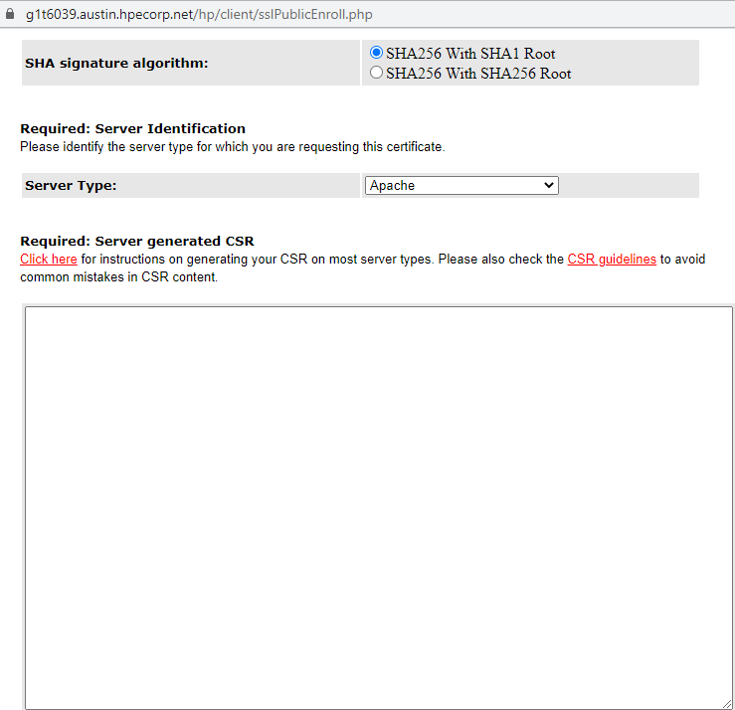

* 1. Open the existing cert and go to SANS under details tab, copy all the URLs alone without “DNS Name=”

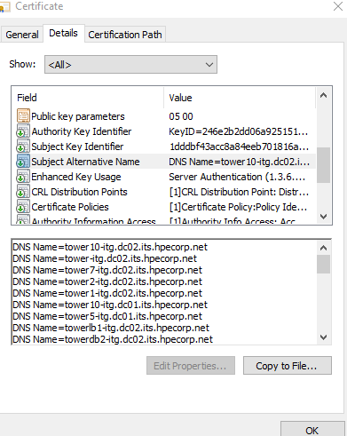

* 1. Enter the SANS obtained above in the following box and click continue,

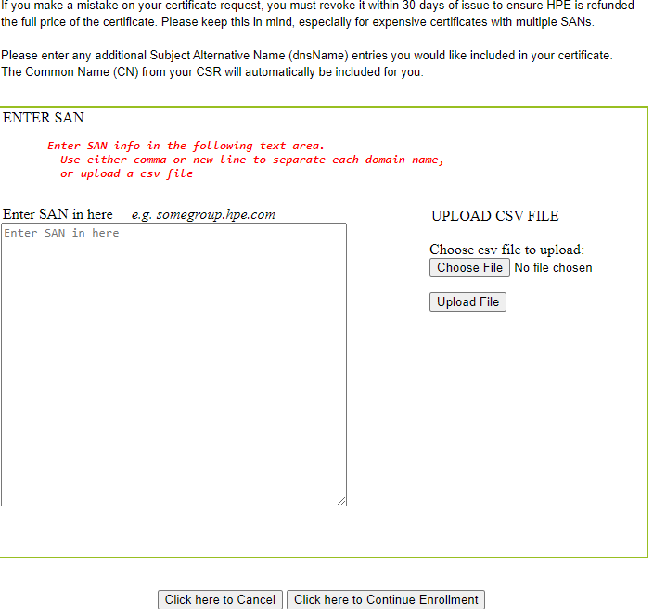

* 1. Review the details entered and proceed with enrollment and click continue enrollment

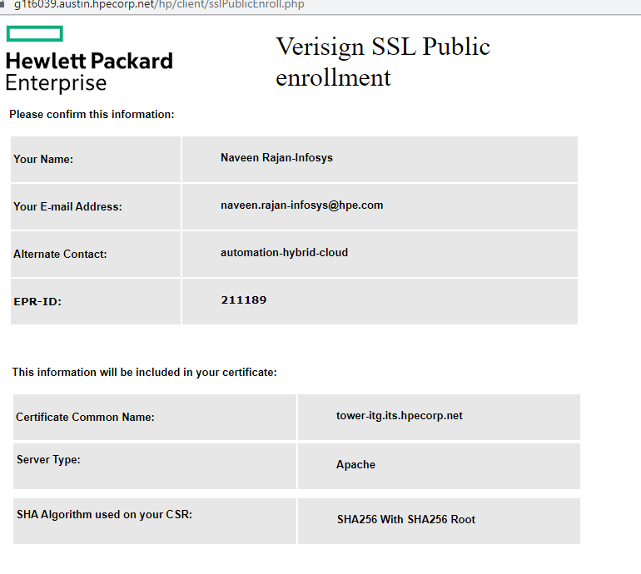

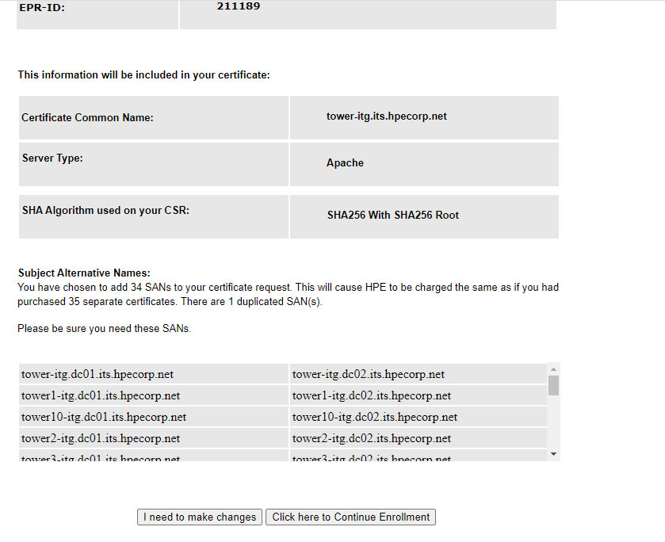

## Apply certs on Tower’s server side

Login to all ansible servers of that respective environment in both colos and update the newly obtained certs

Steps:

1. /etc/tower/tower.cert – edit this and add chain of generated cert(.crt) followed by appending the key(.key) in the same file
2. /etc/tower/tower.key – just add the private key(.key) alone here
3. Systemctl restart nginx – restart nginx service
4. View the Tower cert in browser to confirm the update of validity.

