## Steps to white list vulnerabilities:

Get the existing policy file from <https://anchore.dc01.its.hpecorp.net/v1/ui/#!/Policies/list_policies>

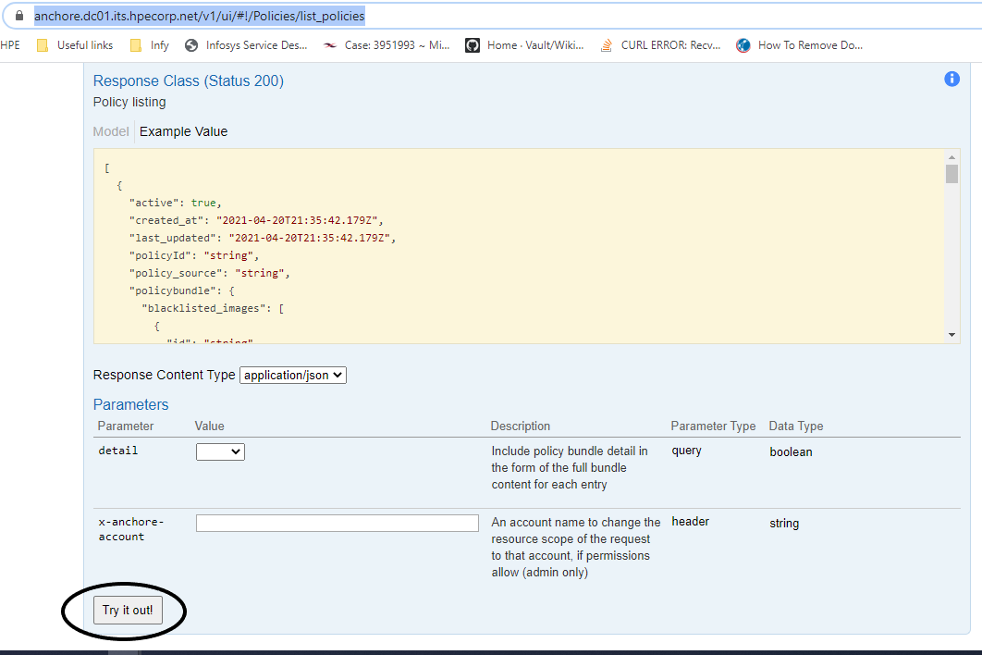

Choose **true** in the details drop down and Click **Try it out.**

Copy the results to an editor and remove the outer square braces and policybundlemetadata block.

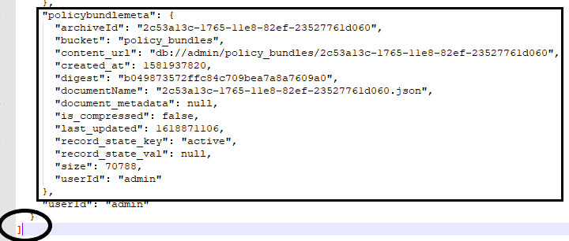

Add the vulnerability to whitelist with new block as seen below,

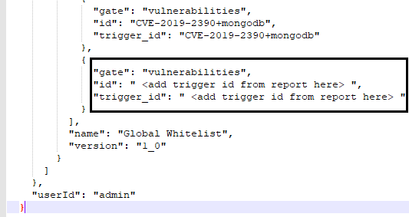

Add the edited content from editor to bundle param here -> <https://anchore.dc01.its.hpecorp.net/v1/ui/#!/Policies/update_policy>

Enter policy ID from the editor, as policyID in the param

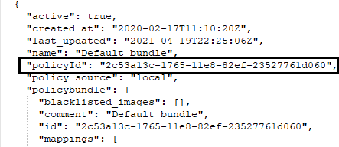

Choose make policy active yes and click try it out to update the policy.

You can check the updated policy from <https://anchore.dc01.its.hpecorp.net/v1/ui/#!/Policies/list_policies> , if it has the updated vulnerabilities.