### High CPU Utilization:

What can we do to identify the high CPU utilizing process over a course of time?

1. If the server has **New Relic Monitoring**, we can check the Process utilizing the CPU using it.

New Relic steps to CPU check usage of a host:

1. Open New relic - <https://one.newrelic.com/> and enter the search params as seen in below image I.e., entity type as host and hostname as the server you are trying to find the process for high CPU utilization

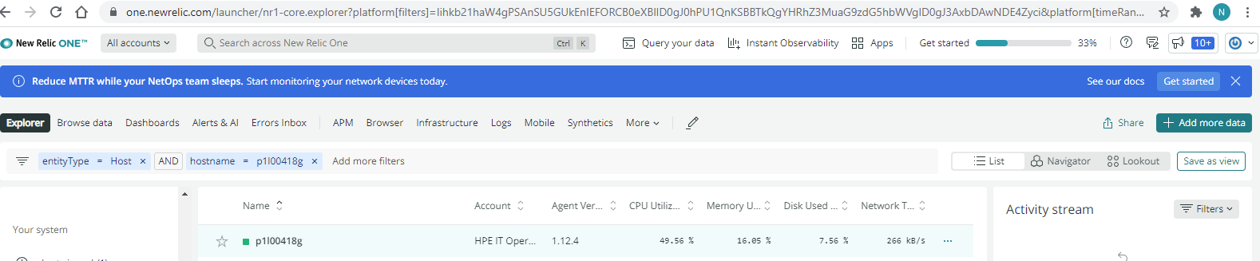

1. Tweak the time period on top right corner as needed and scroll down to the bottom to find the Process running chart.

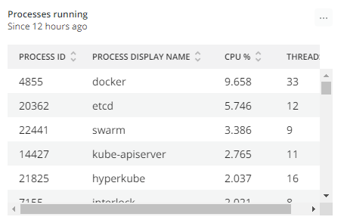

1. Record the processes found earlier in the Incident ticket.

How to find the CPU Utilization of server over a time period?

We can use Nagios for the same, please ask with in team for Nagios creds if needed.

1. Login to Nagios and move to reports tab <https://nagiosxidc01.dc01.its.hpecorp.net/nagiosxi/reports/>
2. Enter the filters as needed and provide hostname for which you are checking the Utilization as seen below and click run.

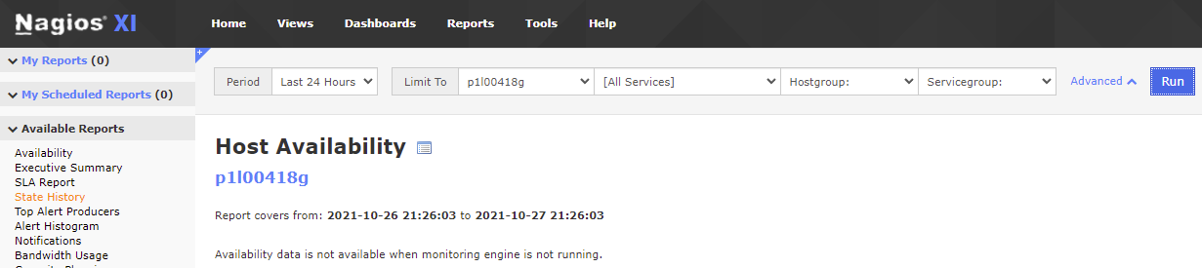

1. In the next page click on performance graphs and scroll down to CPU,

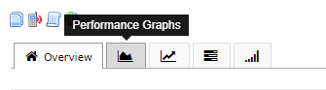

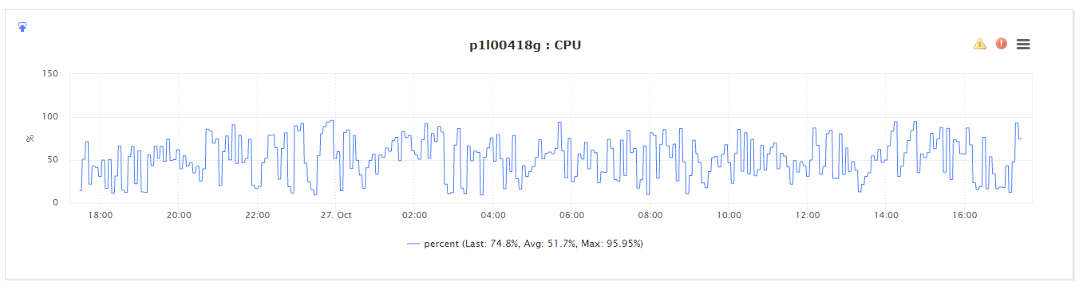

1. You can hover to see how frequently the server is having CPU spikes and how long it stays and record the pattern to Service Now alert.

### Checking Live server process usage,

Linux has wide range of tools to view the CPU/Memory Utilization, below are few examples.

#### Using PS:

**ps -eo pid,ppid,%mem,%cpu,args --sort=-%cpu | head**

This will provide data of the Process ID , it’s memory, CPU usage and the complete process command, also sorted in the most CPU utilizing order. This is data is very useful for servers have CPU/Memory utilization as we can grab the process details and drill through further to take necessary action.

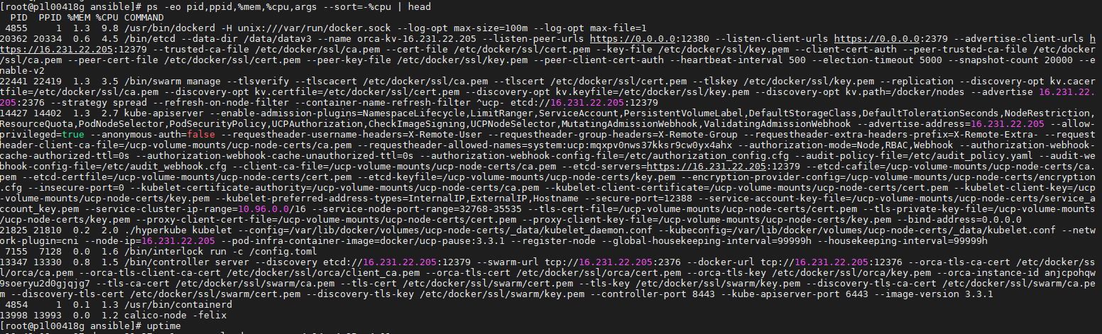

Using top:

Running top, as we all know, will display the processes and their resource use in the most using process order.

Please note the lode average on top, this is how much the load was for past 1, 5, and 15 minutes. Also note the process which is constantly consuming most of the CPU.

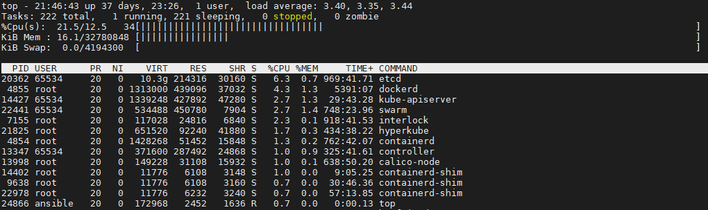

Tip- tap ‘t’ twice on keyboard to get a bar showing utilization of CPU.

Using nmon:

NMON is another utility which gives more user friendly and more data. The command provides a self-explanatory response to proceed, all we have to enter ‘nmon’.

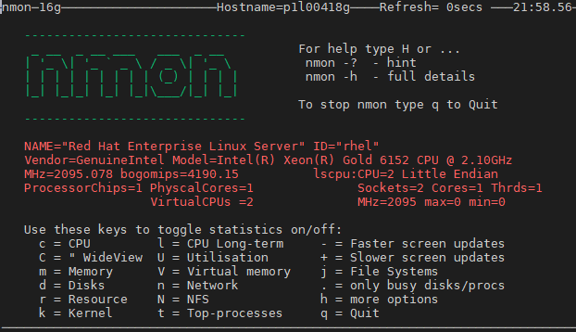

I got below to review CPU Utilization, hit ‘C’, ‘t’ and ’u’ in series.

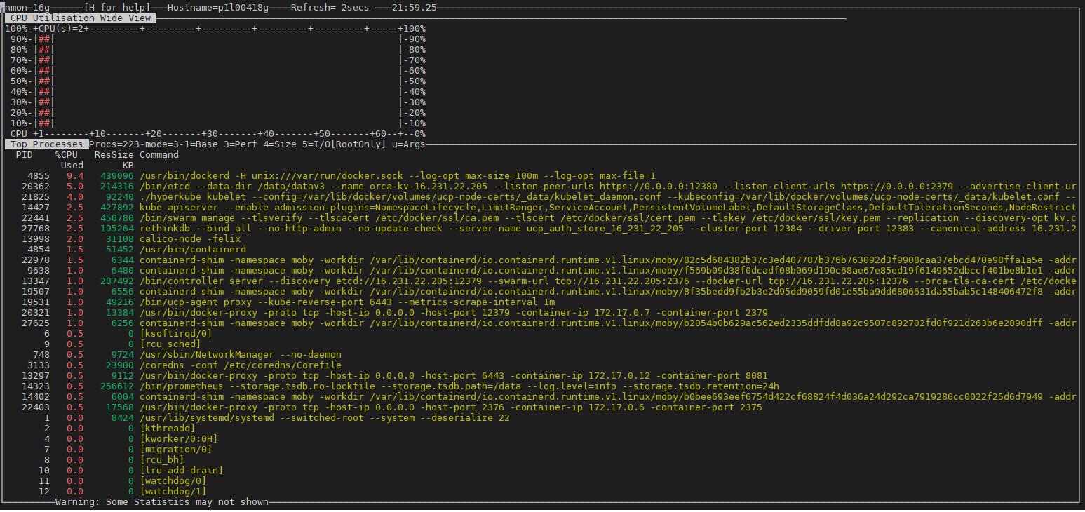

Command to check processes using Swap:

find /proc -maxdepth 2 -path "/proc/[0-9]*/status" -readable -exec awk -v FS=":" '{process[$1]=$2;sub(/^[ \t]+/,"",process[$1]);} END {if(process["VmSwap"] && process["VmSwap"] != "0 kB") printf "%10s %-30s %20s\n",process["Pid"],process["Name"],process["VmSwap"]}' '{}' \; | awk '{print $(NF-1),$0}' | sort -hr | head | cut -d " " -f2-

