**Name: Regino Balogo Jr.  
  
Section: BSCS 3A-AI**

**Date/Deadline: September 12, 2024**

**Step 1. Fork the repository.**

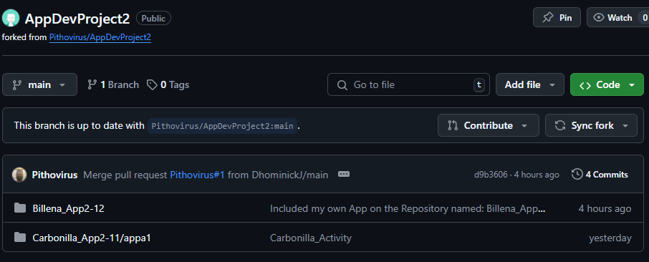

**Step 2. Clone it to your local computer.**

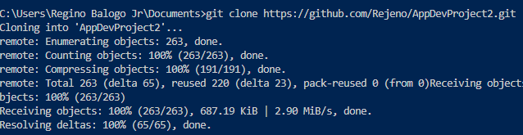

**Step 3. After making your app, stage the created app to Git.**

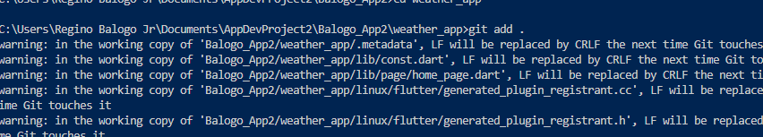

**Step 4. Commit the changes.**



**Step 5. Push it to your repository.**

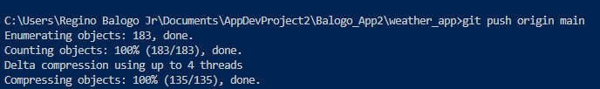

**Step 6. Pull request.**

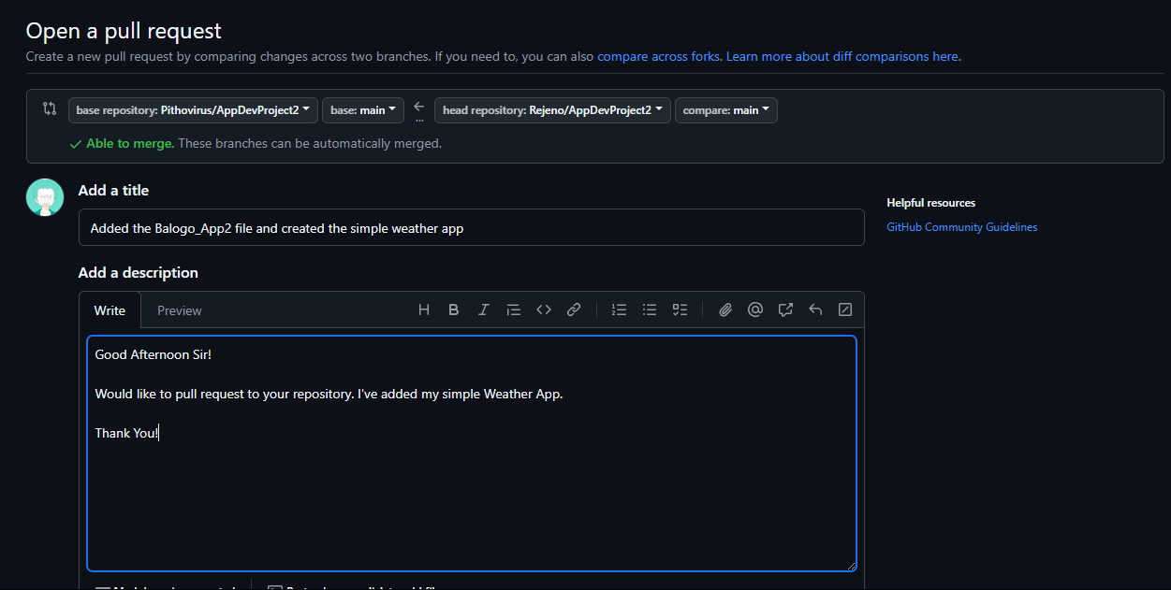

**Weather App**

