**Name: Dhominick John S. Billena  
  
Section: BSCS 3A**

**Date/Deadline: September 12, 2024**

**Step 0: Making my own copy of the repository**

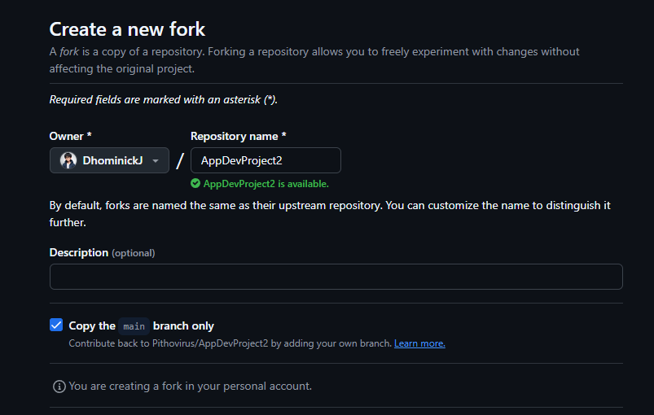

**Step 1: Cloning the Repository and Making a Folder**

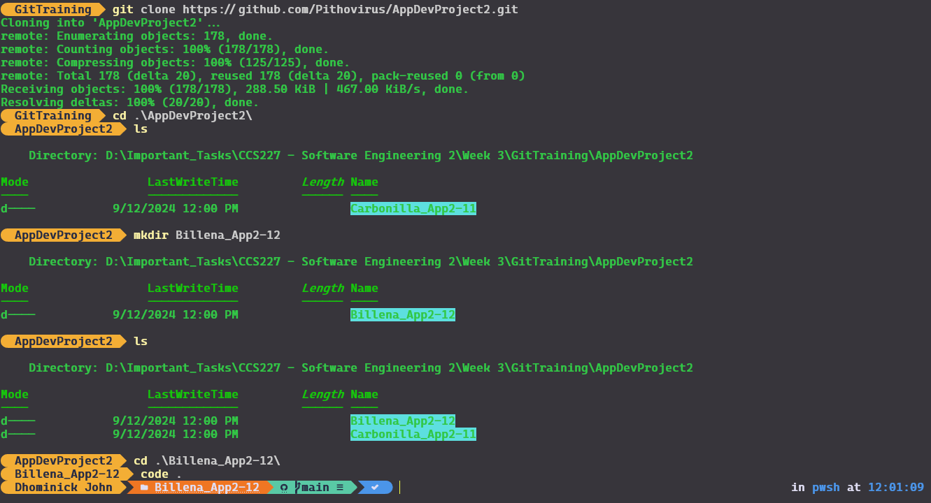

**Commands used:**

**git clone** [**https://github.com/Pithovirus/AppDevProject2.git**](https://github.com/Pithovirus/AppDevProject2.git)

**git status**

**mkdir Billena_App2-12**

**Step 2: Added the files for staging and comitted with a message**

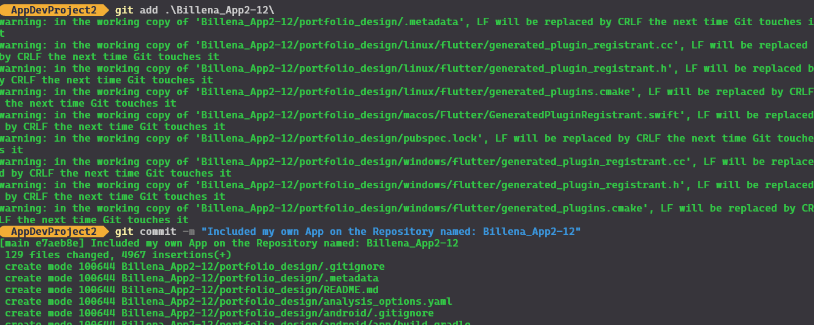

**Commands Used:**

**git add .\Billena_App2-12**

**git commit -m “Commit Message”**

**Step 3: Pushing the changes to the repository**

**Due to the mistake done by not making my own repository in the first place, I will be changing the remote address of the repo via the repository settings:**

**Step 3.1: Changing the remote repository address**

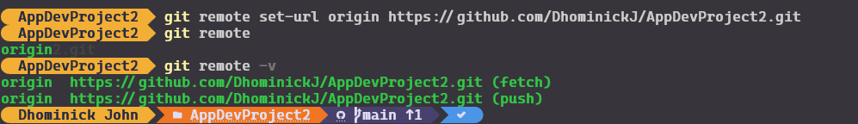

**Commands used:**

**git remote set-url (branch) (new repo)**

**git remote -v**

**Step 4: Pushing the changes to the forked repository**

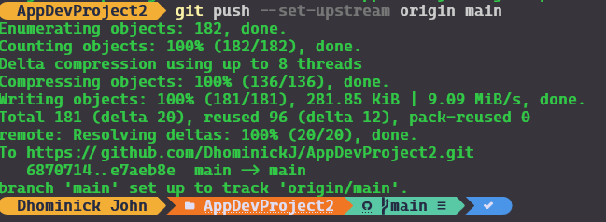

**Commands used:**

**git push –set-upstream origin main**

**Step 5: Pushing the Changes to the Main Repository Address via Github Pull Request**

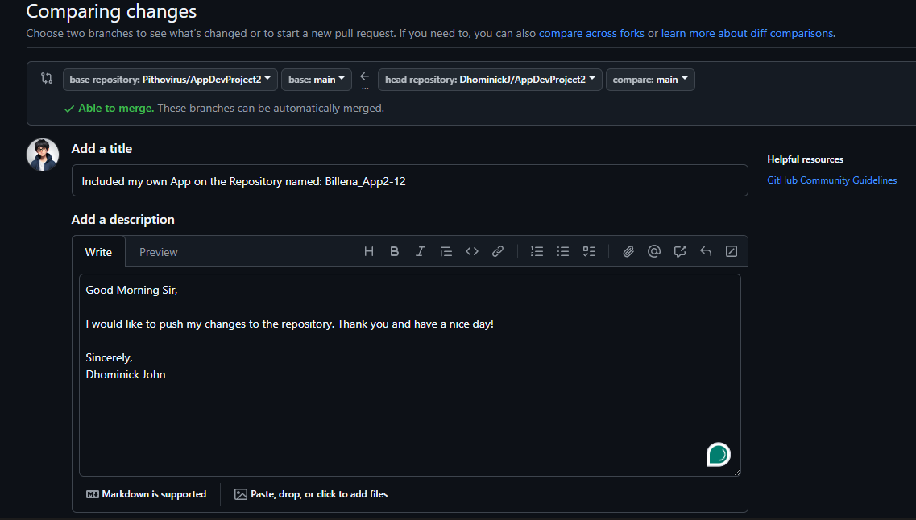

**Thank you and have a nice day!**