Step 1: Forked the repository <https://github.com/Pithovirus/AppDevProject2.git> to my own github



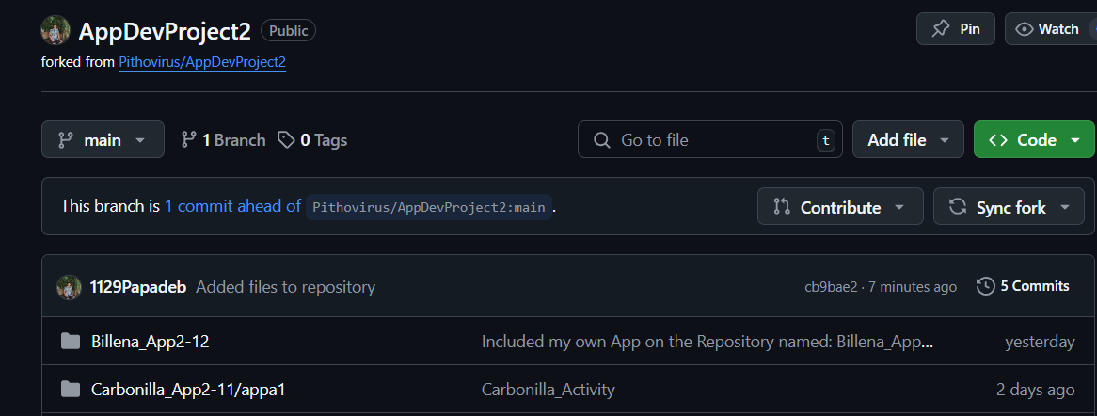Step 2: Clone the forked repository

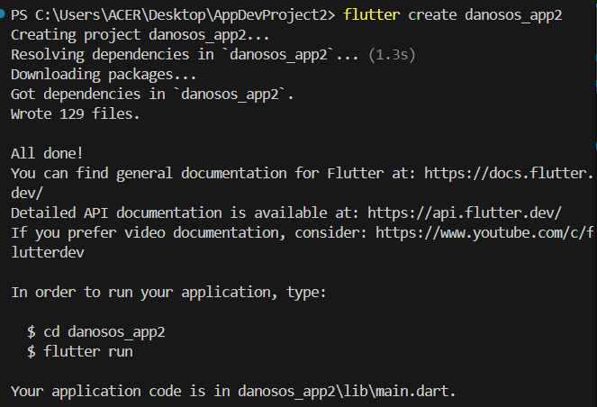Step 3: Made a folder named: danosos_app2 using flutter create in vsc terminal

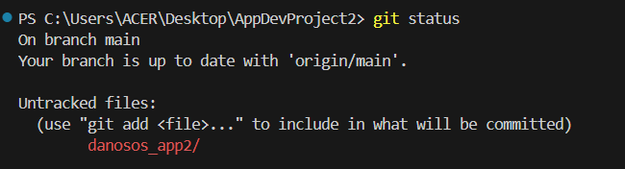Step 4: Checked the status of the repository using git status

Step 5: Added files using git add

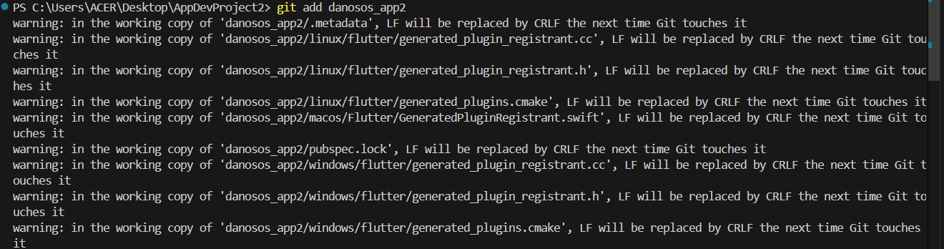

Step 6: Committed files to the repository

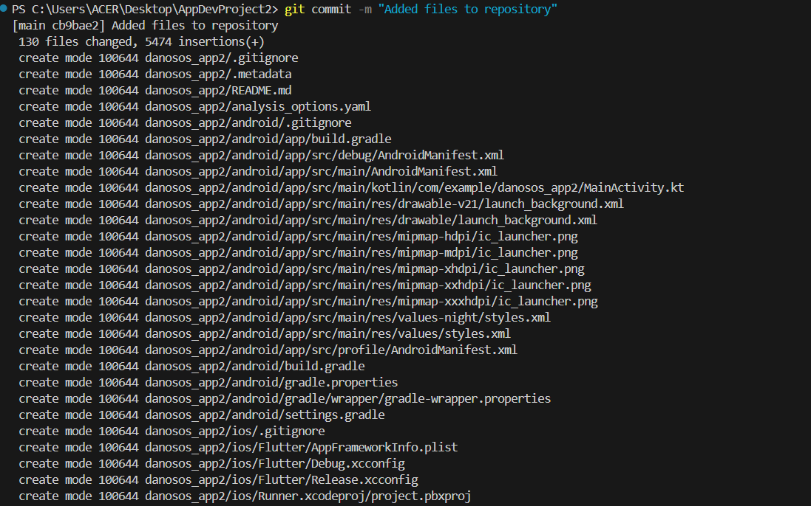

Step 7: Pushed added folder and files to the repository

