Rhazel Jay V. Gumacal BSCS 3A

CC206

Screenshots of the Git Commands

**Git Status**

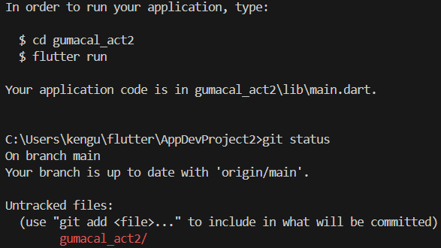

**Git Add**

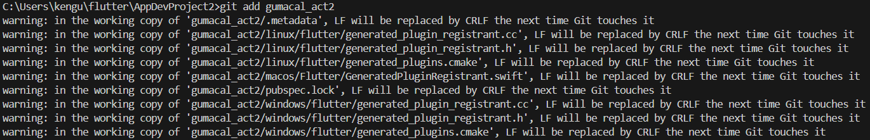

**Git Commit**

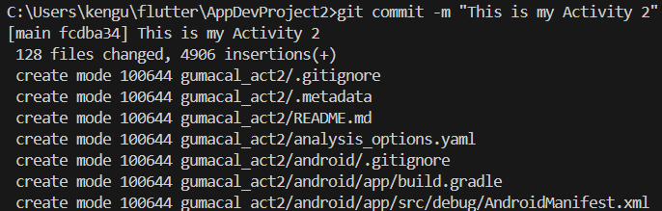

**Git Push**

