Ca₂Fe₂O₅ (mp-aaabmiue)
锚定本地 CIF “mp-dbsgu.cif”（文件名 ID mp-dbsgu 系统性错位）。经结构匹配得到真实 Materials Project ID：mp-aaabmiue。

Summary（Materials Project 页面卡片字段）
Formula | Ca2Fe2O5
Material ID (true) | mp-aaabmiue
Energy Above Hull | 0.1928 eV/atom
Space Group | P-1 (#2, Triclinic)
Band Gap | 1.0489 eV (indirect)
Predicted Formation Energy | -2.2634 eV/atom
Magnetic Ordering | FM
Total Magnetization | 20.0 μB/cell, 10.0 μB/f.u.
Experimentally Observed | No (theoretical)
Is Metal | False
Is Stable | False

Crystal structure
Crystal system | Triclinic
Space group symbol / number | P-1 / 2
Point group | -1
a, b, c (Å) | 6.0312, 6.5071, 6.5306
α, β, γ (°) | 109.213, 96.868, 103.216
Volume (Å³) | 230.262
Sites | 18
Density (g/cm³) | 3.9208
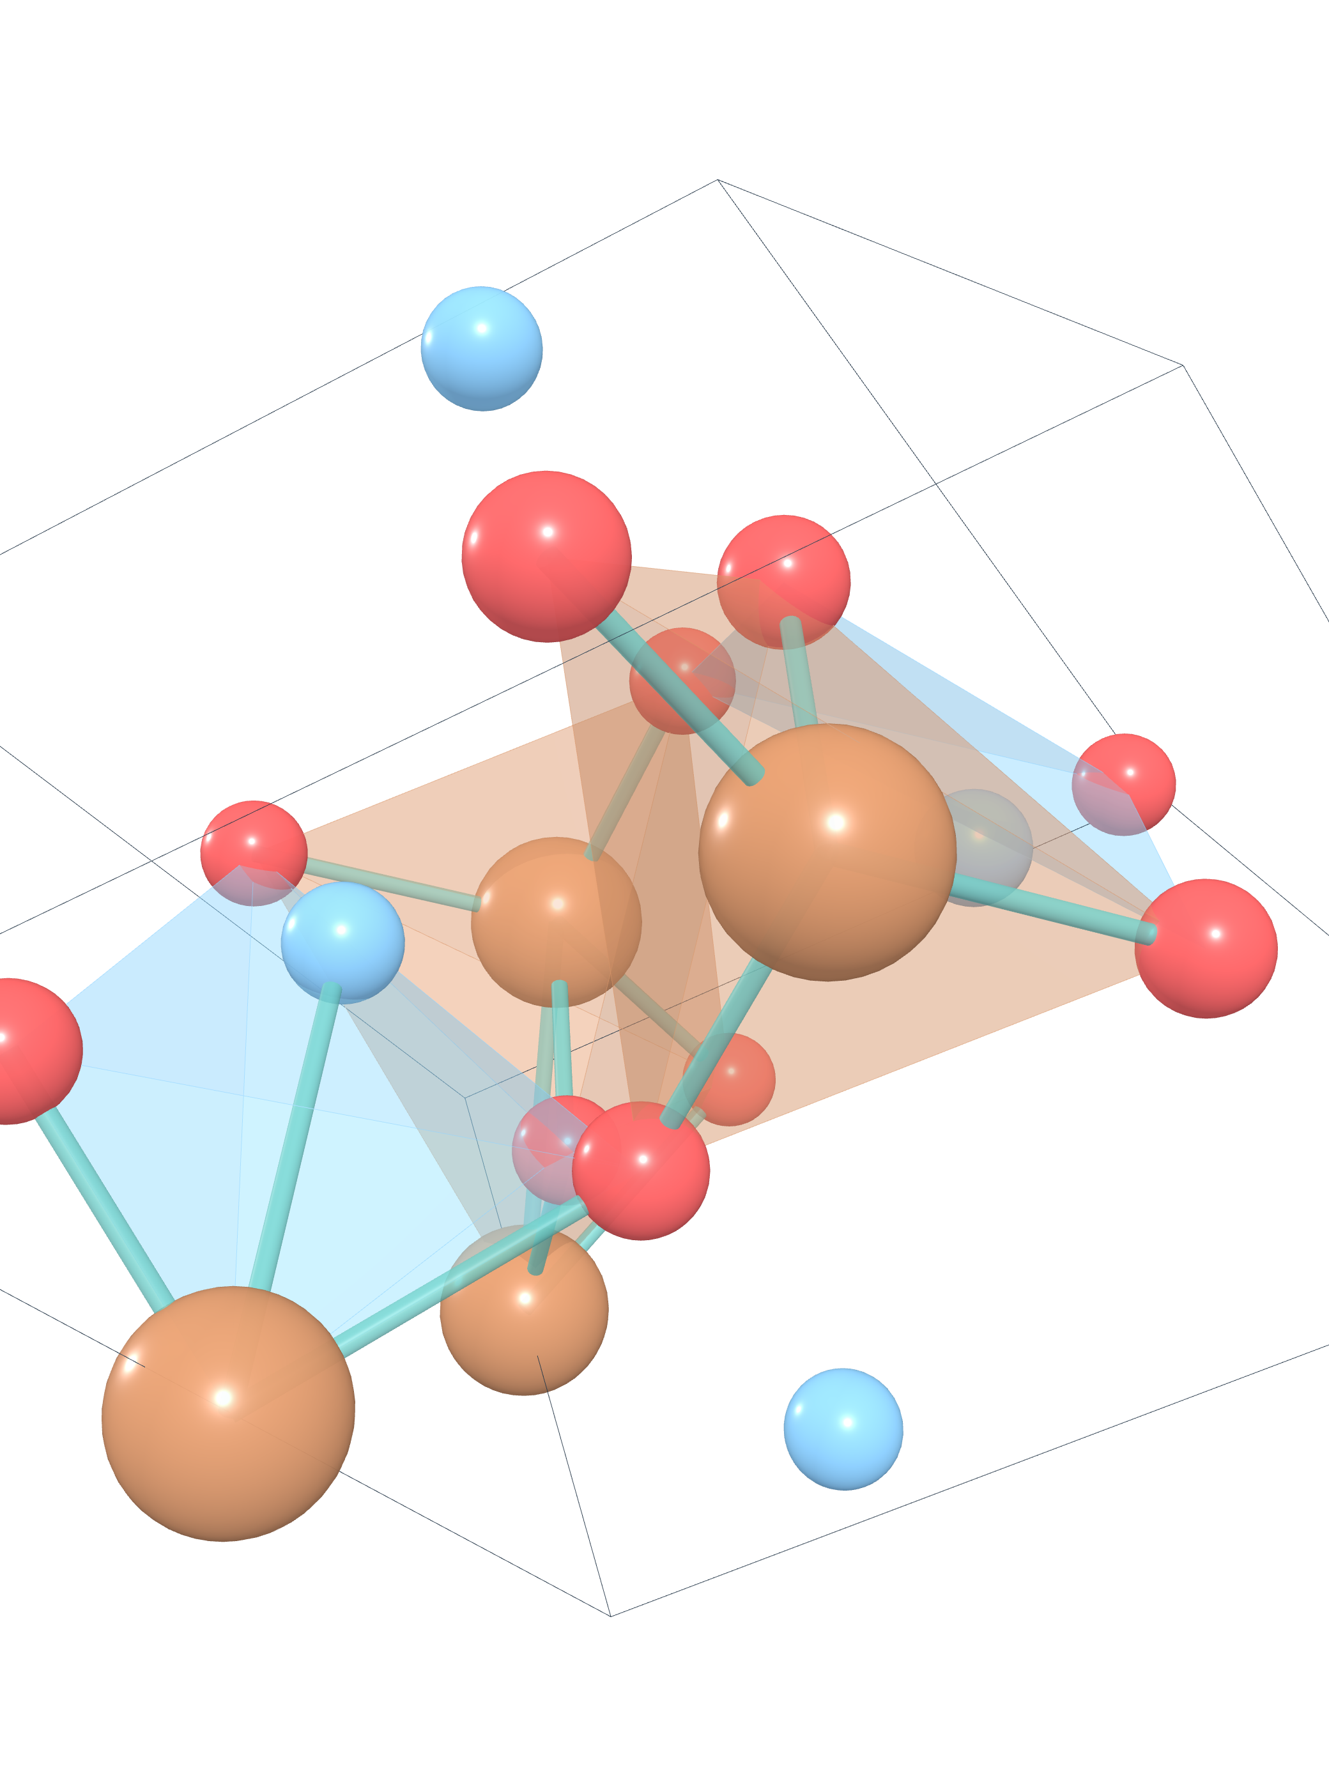
图 1. Ca₂Fe₂O₅ 晶体结构（crystal_3d_viewer_package 渲染）

Electronic structure
Band gap | 1.0489 eV
CBM | 4.1185
VBM | 3.0696
E-Fermi | 3.24
Is gap direct | False
Is metal | False
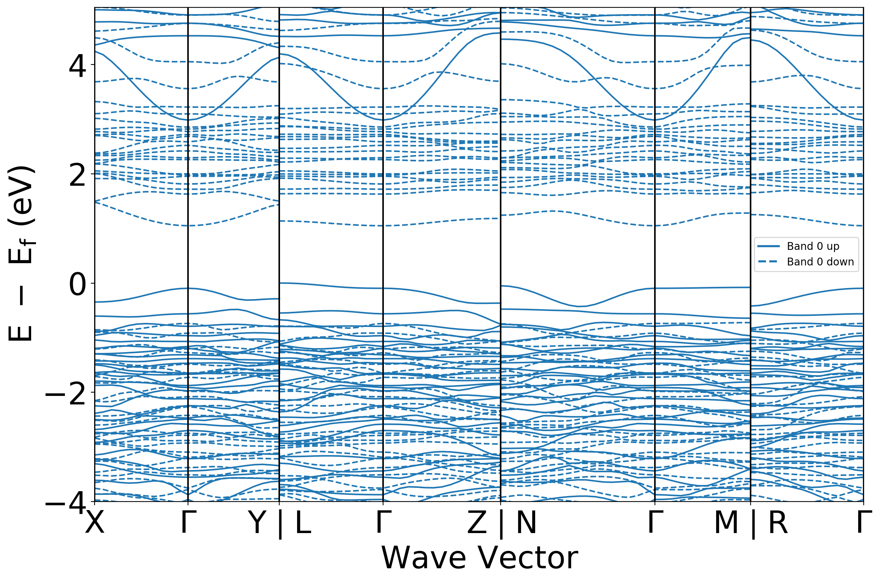
图 2. Ca₂Fe₂O₅ 能带结构（band structure）
（该材料在 Materials Project 上无 DOS 对象。）

Magnetism
Ordering | FM
Total magnetization | 20.0 μB
Num magnetic sites | 12
Types of magnetic species | ['Fe', 'O']

Description（auto-generated, robocrystallographer）结构描述
English
Ca₂Fe₂O₅ crystallizes in the triclinic P̅1 space group. There are two inequivalent Ca sites. In the first Ca site, Ca is bonded to six O atoms to form distorted CaO₆ pentagonal pyramids that share corners with three FeO₆ octahedra, edges with two FeO₆ octahedra, and an edgeedge with one CaO₆ pentagonal pyramid. The corner-sharing octahedral tilt angles range from 20-76°. There are a spread of Ca-O bond distances ranging from 2.30-2.73 Å. In the second Ca site, Ca is bonded in a 6-coordinate geometry to six O atoms. There are a spread of Ca-O bond distances ranging from 2.30-2.62 Å. There are three inequivalent Fe sites. In the first Fe site, Fe is bonded in a 6-coordinate geometry to six O atoms. There are a spread of Fe-O bond distances ranging from 1.95-2.39 Å. In the second Fe site, Fe is bonded to six O atoms to form FeO₆ octahedra that share corners with two equivalent FeO₆ octahedra, corners with two equivalent CaO₆ pentagonal pyramids, and edges with two equivalent CaO₆ pentagonal pyramids. The corner-sharing octahedral tilt angles are 29°. There are a spread of Fe-O bond distances ranging from 1.95-2.26 Å. In the third Fe site, Fe is bonded to six O atoms to form distorted FeO₆ octahedra that share corners with two equivalent FeO₆ octahedra, corners with four equivalent CaO₆ pentagonal pyramids, and edges with two equivalent CaO₆ pentagonal pyramids. The corner-sharing octahedral tilt angles are 29°. There are a spread of Fe-O bond distances ranging from 1.93-2.28 Å. There are five inequivalent O sites. In the first O site, O is bonded to three Ca and two Fe atoms to form a mixture of distorted corner and edge-sharing OCa₃Fe₂ trigonal bipyramids. In the second O site, O is bonded in a 4-coordinate geometry to two Ca and two Fe atoms. In the third O site, O is bonded to three Ca and two Fe atoms to form a mixture of distorted corner and edge-sharing OCa₃Fe₂ trigonal bipyramids. In the fourth O site, O is bonded in a 5-coordinate geometry to two Ca and three Fe atoms. In the fifth O site, O is bonded in a 5-coordinate geometry to two Ca and three Fe atoms.
中文
Ca₂Fe₂O₅结晶于三斜P̅1空间群。存在两个不等价的Ca位点。在第一个Ca位点，Ca与六个O原子成键，形成畸变的CaO₆五角锥，该五角锥与三个FeO₆八面体共角、与两个FeO₆八面体共边、并与一个CaO₆五角锥共边。共角八面体的倾斜角范围为20-76°。Ca-O键长分布范围为2.30-2.73 Å。在第二个Ca位点，Ca与六个O原子形成六配位构型。Ca-O键长分布范围为2.30-2.62 Å。存在三个不等价的Fe位点。在第一个Fe位点，Fe与六个O原子形成六配位构型。Fe-O键长分布范围为1.95-2.39 Å。在第二个Fe位点，Fe与六个O原子成键，形成FeO₆八面体，该八面体与两个等价的FeO₆八面体共角、与两个等价的CaO₆五角锥共角、并与两个等价的CaO₆五角锥共边。共角八面体的倾斜角为29°。Fe-O键长分布范围为1.95-2.26 Å。在第三个Fe位点，Fe与六个O原子成键，形成畸变的FeO₆八面体，该八面体与两个等价的FeO₆八面体共角、与四个等价的CaO₆五角锥共角、并与两个等价的CaO₆五角锥共边。共角八面体的倾斜角为29°。Fe-O键长分布范围为1.93-2.28 Å。存在五个不等价的O位点。在第一个O位点，O与三个Ca和两个Fe原子成键，形成一种畸变的、共角与共边混合的OCa₃Fe₂三角双锥。在第二个O位点，O与两个Ca和两个Fe原子形成四配位构型。在第三个O位点，O与三个Ca和两个Fe原子成键，形成一种畸变的、共角与共边混合的OCa₃Fe₂三角双锥。在第四个O位点，O与两个Ca和三个Fe原子形成五配位构型。在第五个O位点，O与两个Ca和三个Fe原子形成五配位构型。

