CoS₂ (mp-aaabwjmf)
锚定本地 CIF “mp-bqxye.cif”（文件名 ID mp-bqxye 系统性错位）。经结构匹配得到真实 Materials Project ID：mp-aaabwjmf。

Summary（Materials Project 页面卡片字段）
Formula | CoS2
Material ID (true) | mp-aaabwjmf
Energy Above Hull | 0.0019 eV/atom
Space Group | Pbca (#61, Orthorhombic)
Band Gap | 0.0 eV (metal)
Predicted Formation Energy | -0.4529 eV/atom
Magnetic Ordering | FM
Total Magnetization | 4.0122 μB/cell, 1.003 μB/f.u.
Experimentally Observed | No (theoretical)
Is Metal | True
Is Stable | False

Crystal structure
Crystal system | Orthorhombic
Space group symbol / number | Pbca / 61
Point group | mmm
a, b, c (Å) | 5.4444, 5.5685, 5.5395
α, β, γ (°) | 90.0, 89.987, 90.0
Volume (Å³) | 167.94
Sites | 12
Density (g/cm³) | 4.8672
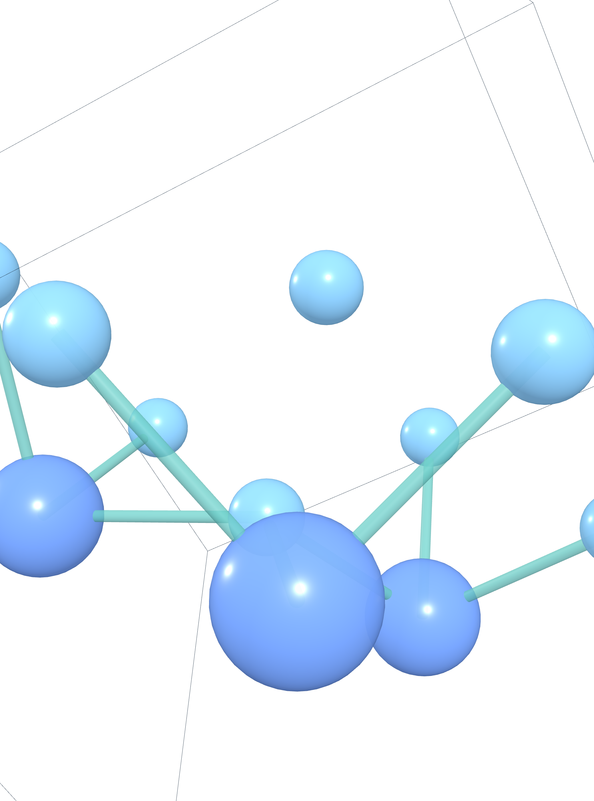
图 1. CoS₂ 晶体结构（crystal_3d_viewer_package 渲染）

Electronic structure
Band gap | 0.0 eV
CBM | —
VBM | —
E-Fermi | 7.9598
Is gap direct | False
Is metal | True
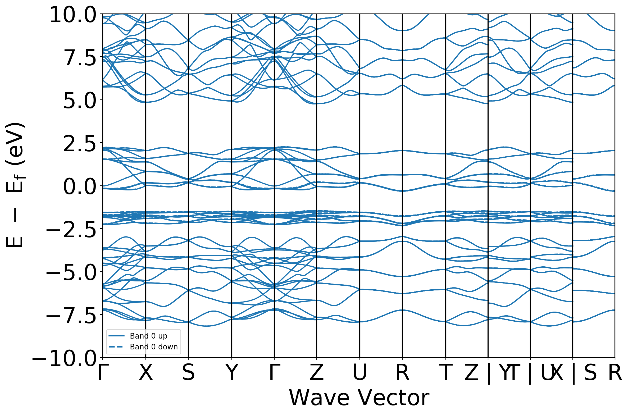
图 2. CoS₂ 能带结构（band structure）
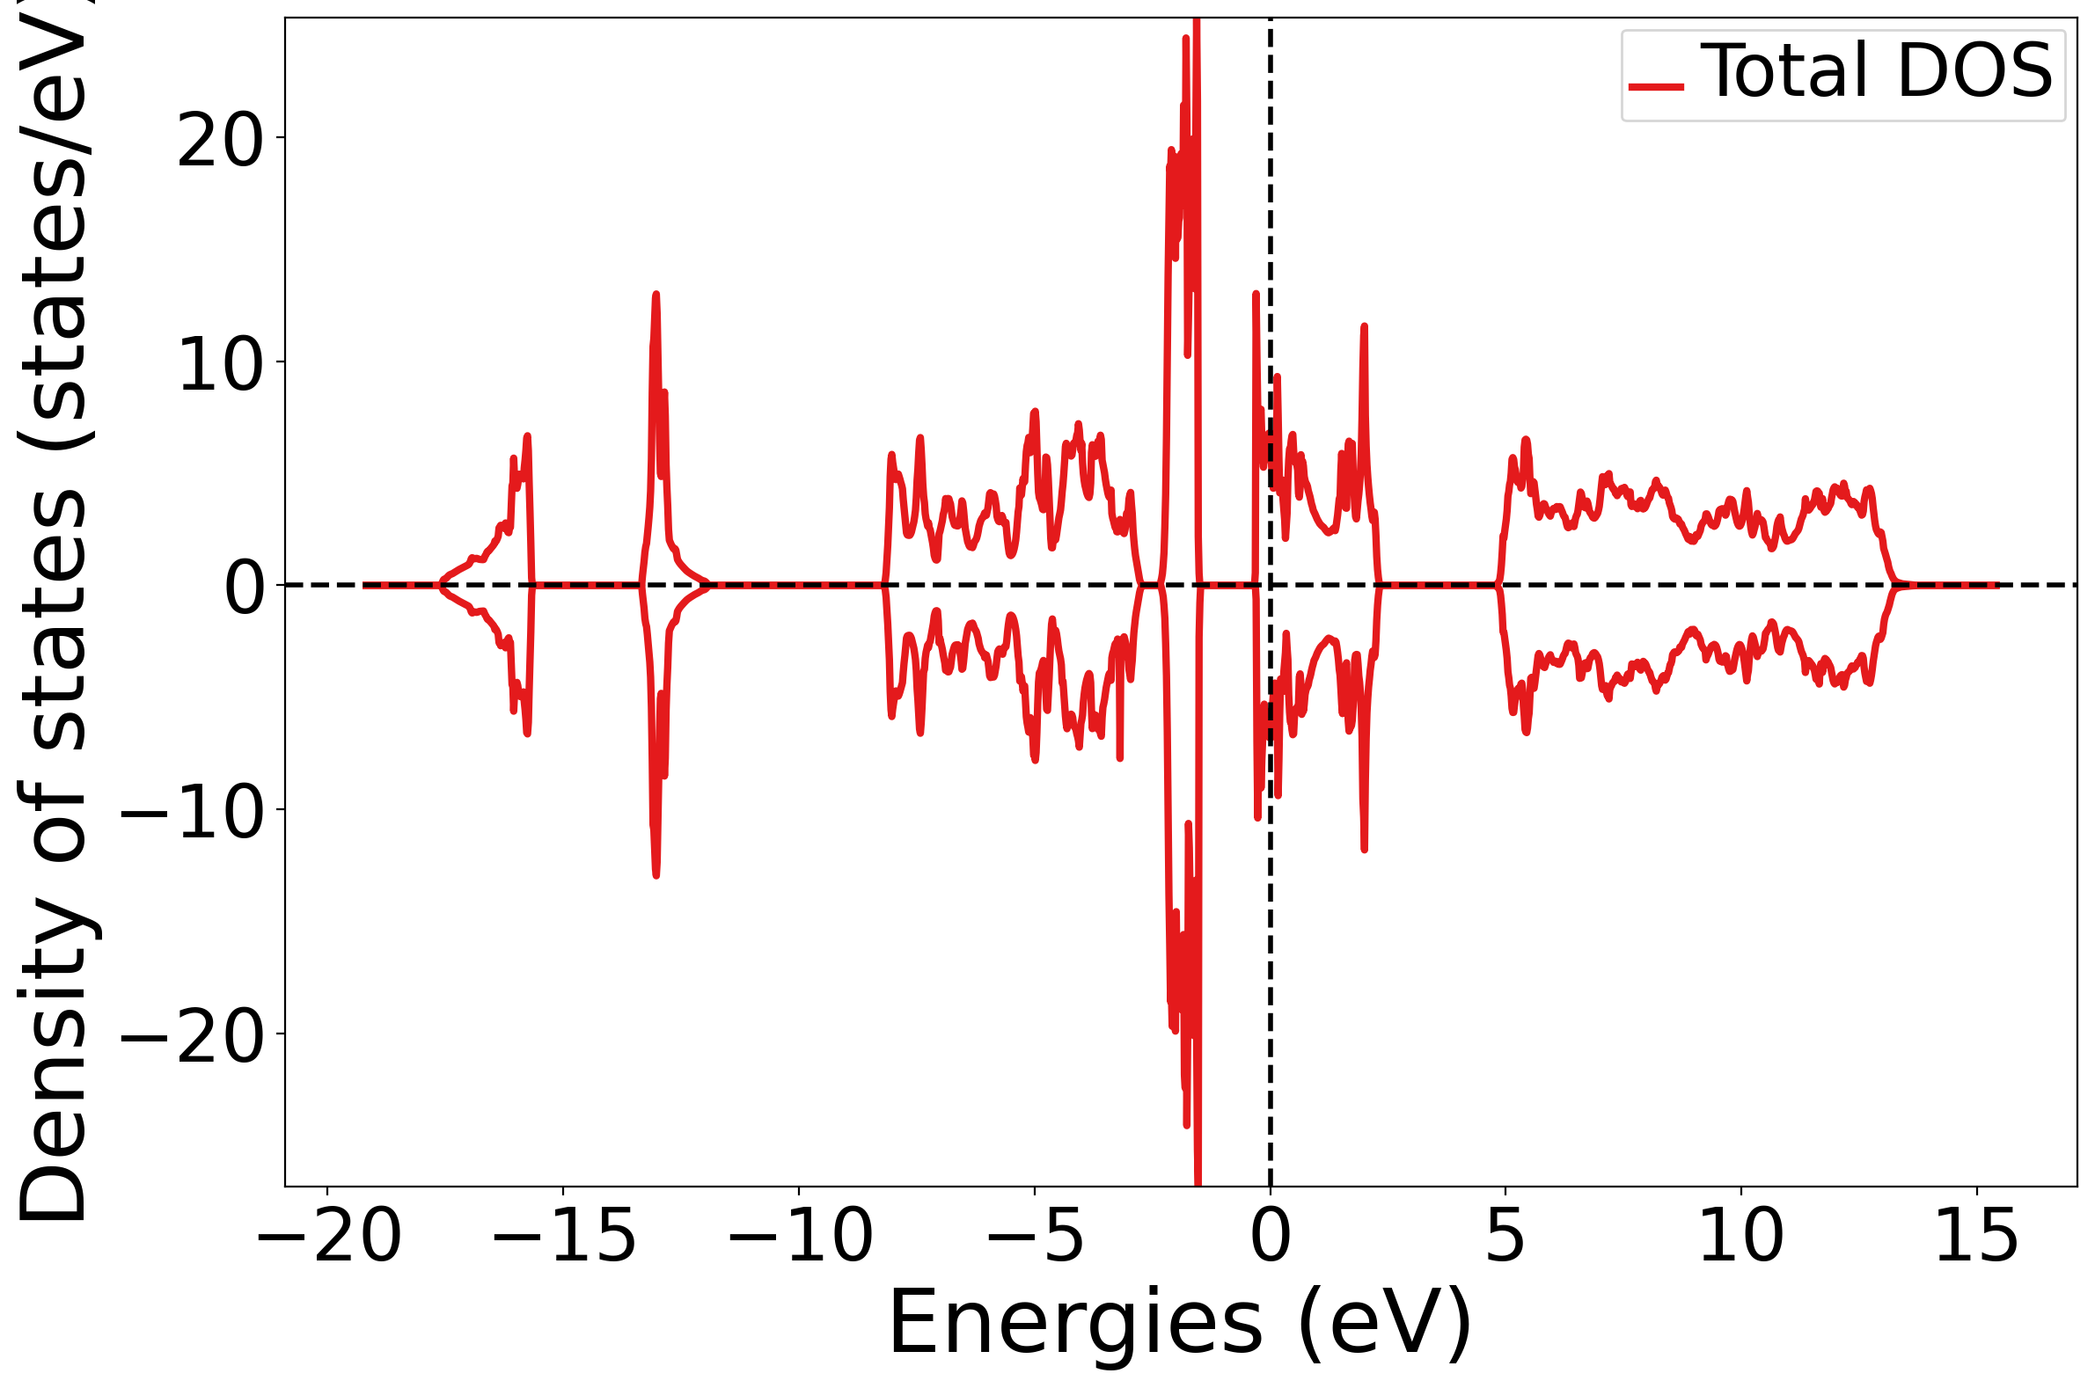
图 3. CoS₂ 态密度（DOS）

Magnetism
Ordering | FM
Total magnetization | 4.0122 μB
Num magnetic sites | 4
Types of magnetic species | ['Co']

Description（auto-generated, robocrystallographer）结构描述
English
CoS₂ is Pyrite-like structured and crystallizes in the orthorhombic Pbca space group. Co is bonded to six equivalent S atoms to form CoS₆ octahedra that share corners with twelve equivalent CoS₆ octahedra and corners with six equivalent SCo₃S tetrahedra. The corner-sharing octahedral tilt angles are 65°. There are a spread of Co-S bond distances ranging from 2.28-2.33 Å. S is bonded to three equivalent Co and one S atom to form distorted SCo₃S tetrahedra that share corners with three equivalent CoS₆ octahedra and corners with fifteen equivalent SCo₃S tetrahedra. The corner-sharing octahedral tilt angles range from 76-78°. The S-S bond length is 2.14 Å.
中文
CoS₂为黄铁矿型结构，结晶于正交Pbca空间群。Co与六个等价的S原子成键，形成CoS₆八面体，该八面体与十二个等价的CoS₆八面体共角，并与六个等价的SCo₃S四面体共角。共角八面体的倾斜角为65°。Co-S键长分布在2.28-2.33 Å范围内。S与三个等价的Co原子和一个S原子成键，形成畸变的SCo₃S四面体，该四面体与三个等价的CoS₆八面体共角，并与十五个等价的SCo₃S四面体共角。共角八面体的倾斜角为76-78°。S-S键长为2.14 Å。

