Mn₂FeO₄ (mp-aaaacfmm)
锚定本地 CIF “mp-bhfcx.cif”（文件名 ID mp-bhfcx 系统性错位）。经结构匹配得到真实 Materials Project ID：mp-aaaacfmm。

Summary（Materials Project 页面卡片字段）
Formula | Mn2FeO4
Material ID (true) | mp-aaaacfmm
Energy Above Hull | 0.0587 eV/atom
Space Group | Imma (#74, Orthorhombic)
Band Gap | 0.0 eV (metal)
Predicted Formation Energy | -1.8846 eV/atom
Magnetic Ordering | FM
Total Magnetization | 28.0 μB/cell, 14.0 μB/f.u.
Experimentally Observed | No (theoretical)
Is Metal | True
Is Stable | False

Crystal structure
Crystal system | Orthorhombic
Space group symbol / number | Imma / 74
Point group | mmm
a, b, c (Å) | 6.0875, 6.0875, 6.1668
α, β, γ (°) | 59.568, 59.568, 61.803
Volume (Å³) | 162.572
Sites | 14
Density (g/cm³) | 4.6928
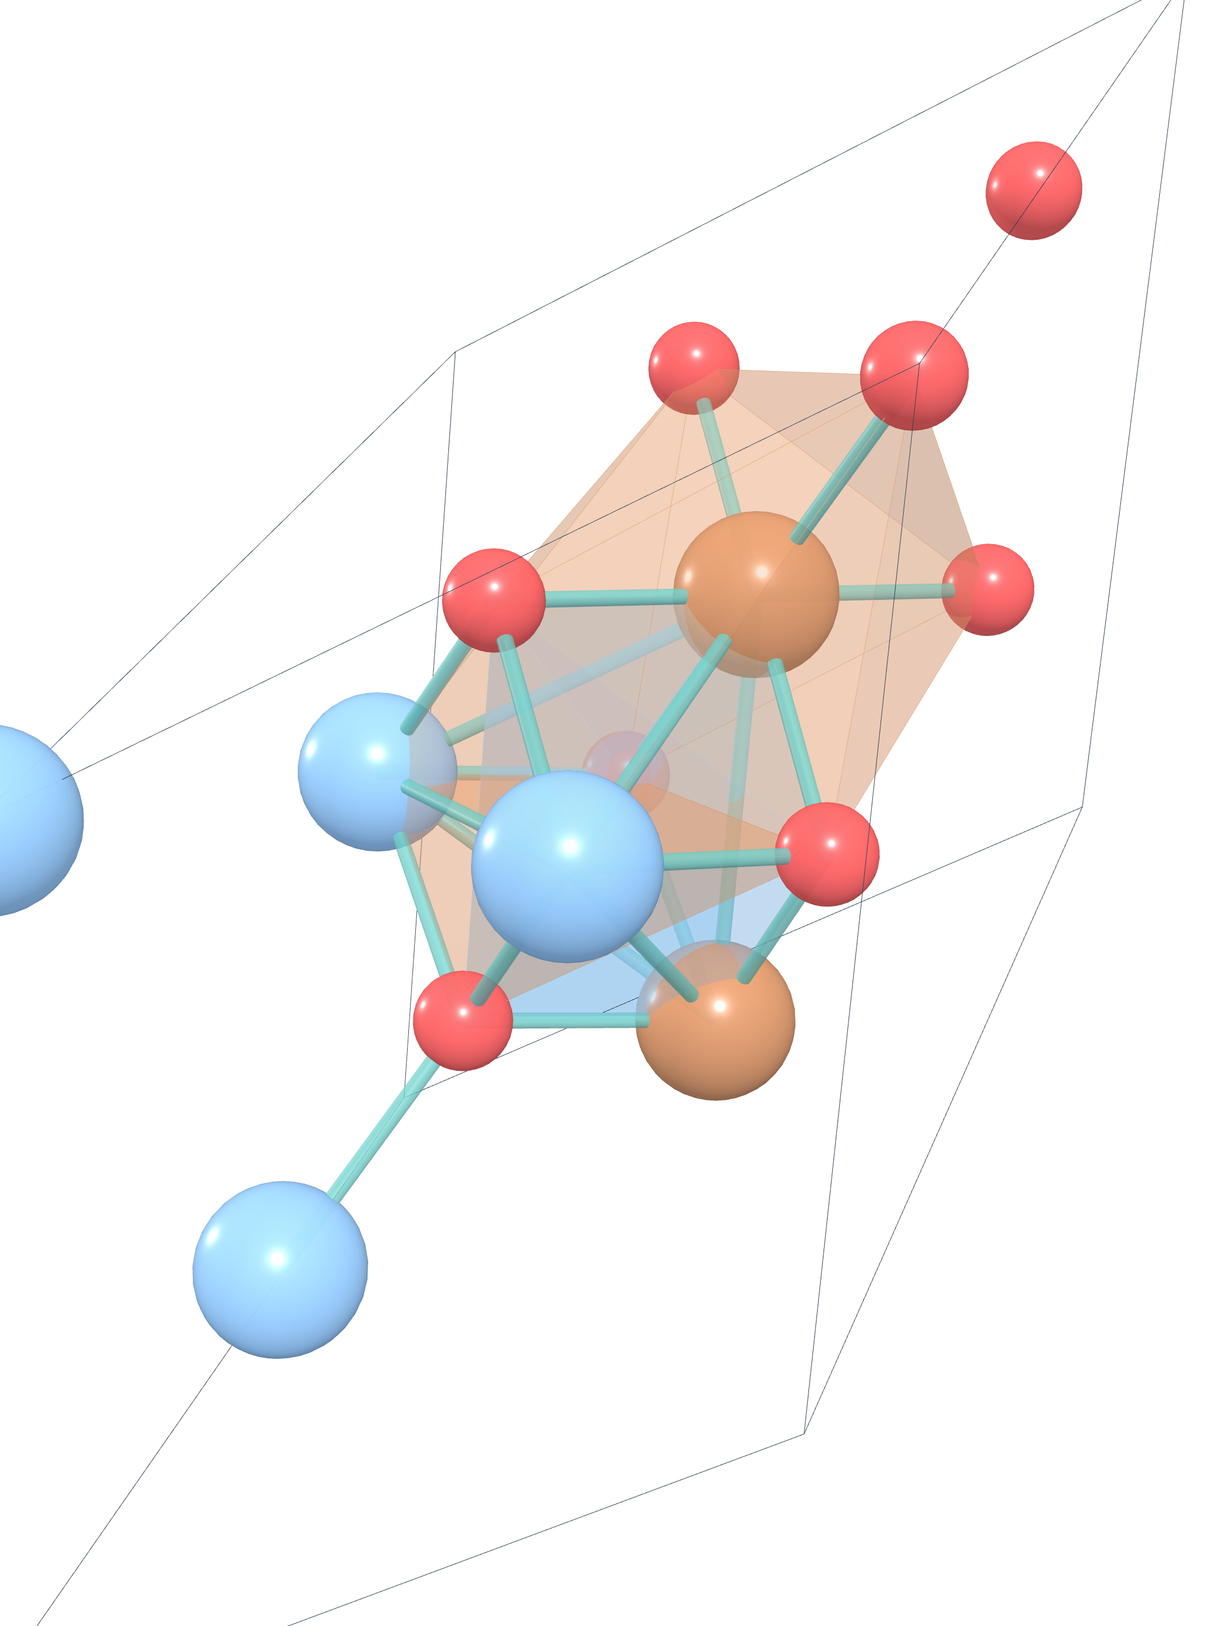
图 1. Mn₂FeO₄ 晶体结构（crystal_3d_viewer_package 渲染）

Electronic structure
Band gap | 0.0 eV
CBM | —
VBM | —
E-Fermi | 3.5777
Is gap direct | False
Is metal | True
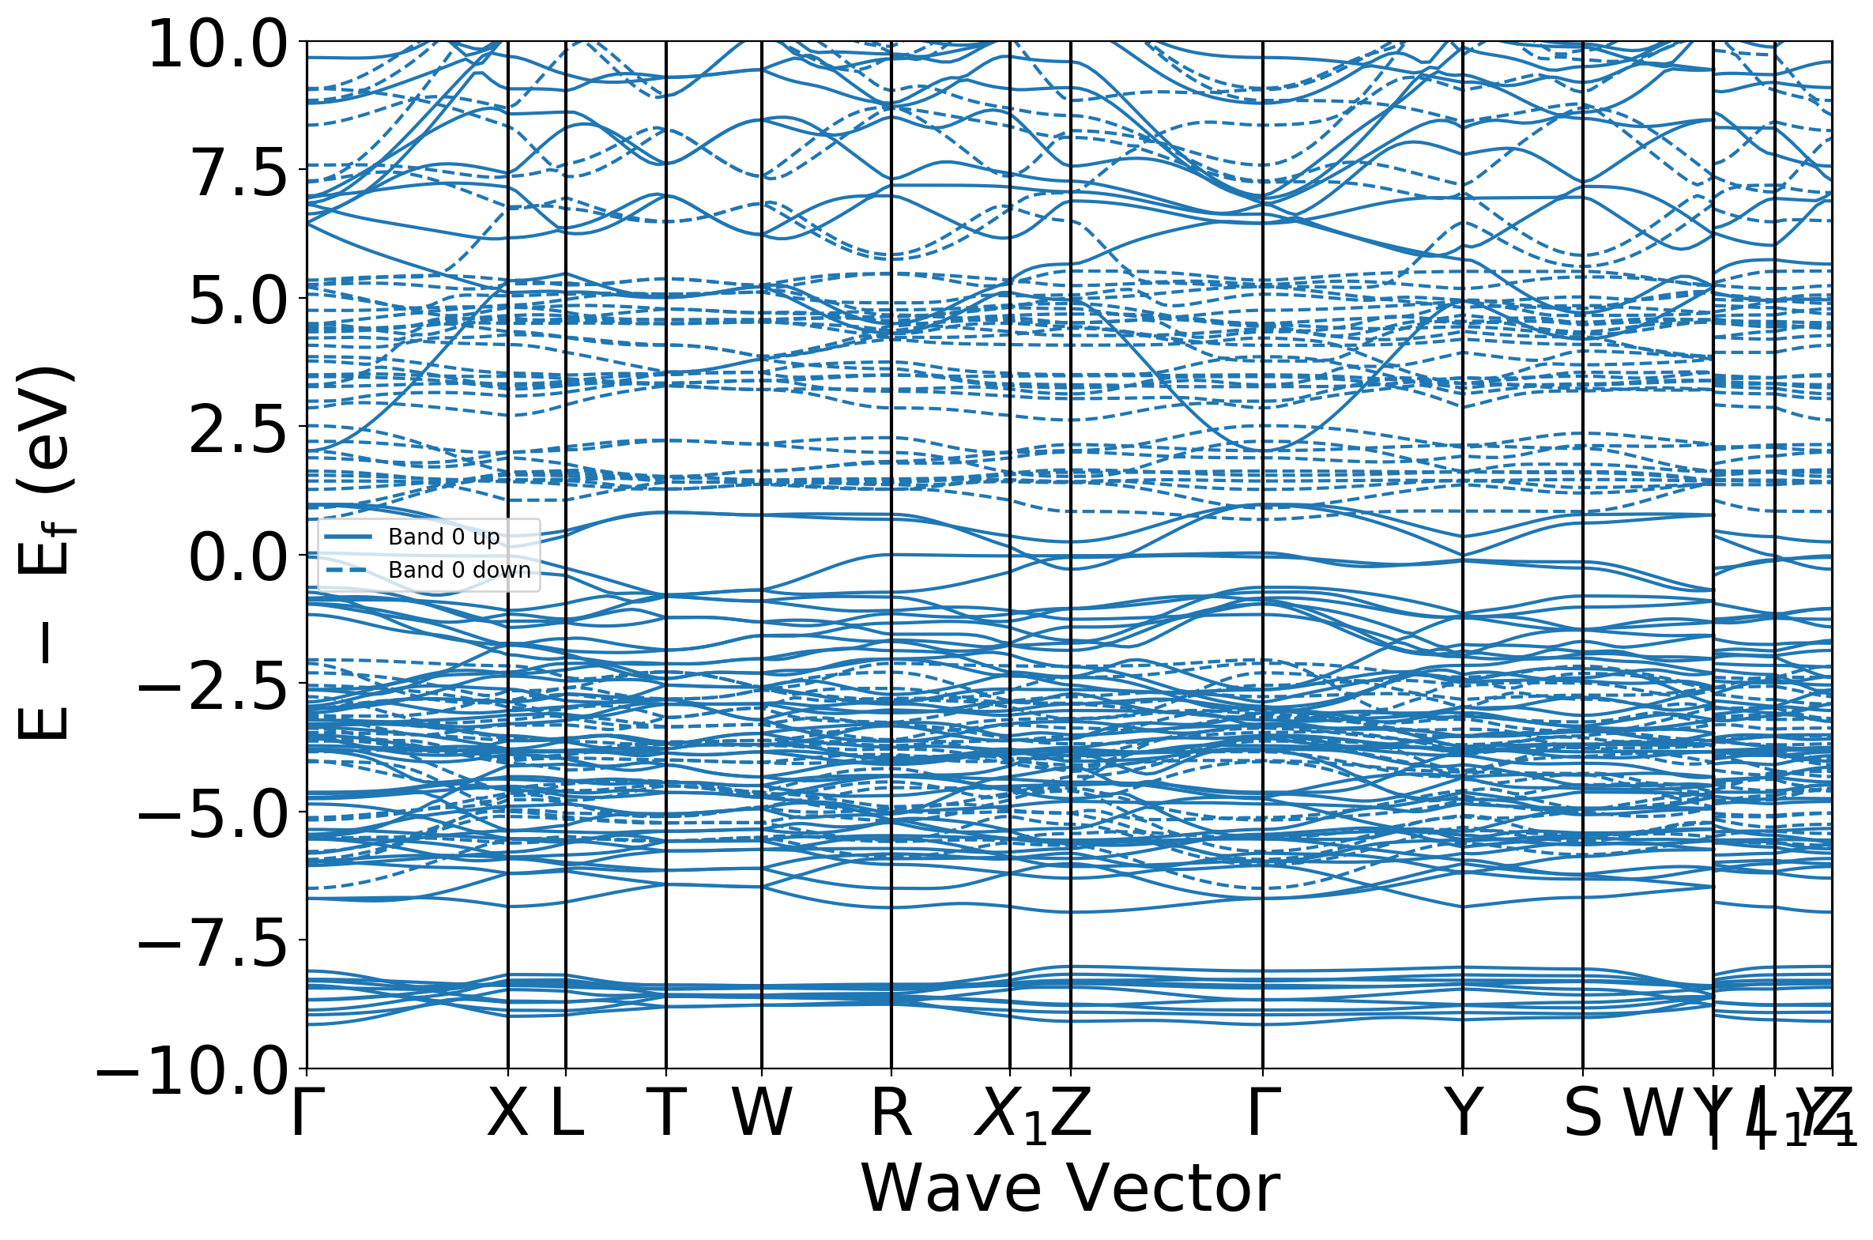
图 2. Mn₂FeO₄ 能带结构（band structure）
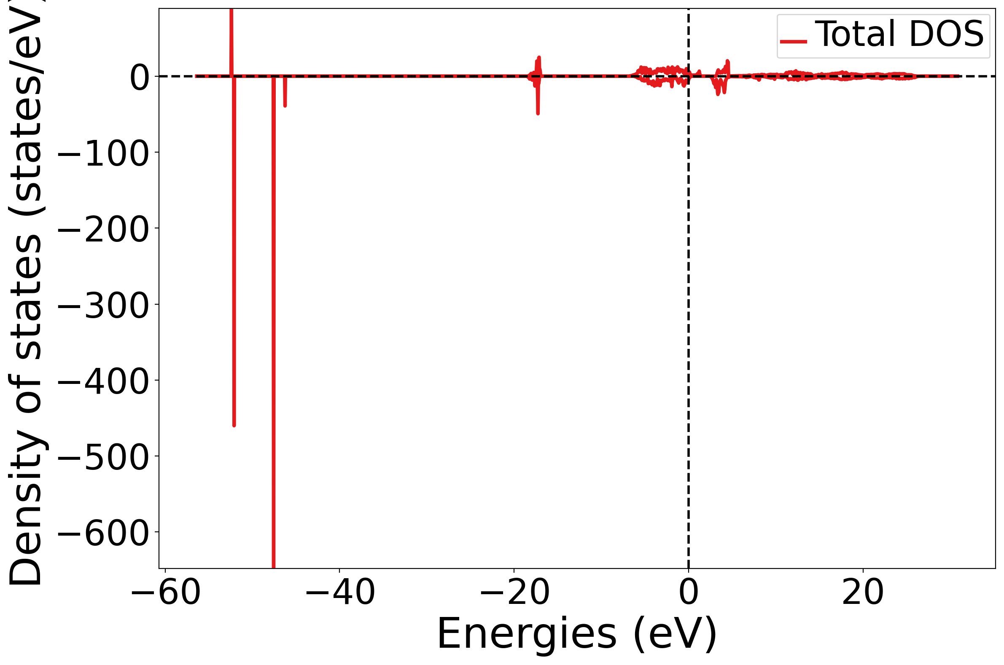
图 3. Mn₂FeO₄ 态密度（DOS）

Magnetism
Ordering | FM
Total magnetization | 28.0 μB
Num magnetic sites | 6
Types of magnetic species | ['Mn', 'Fe']

Description（auto-generated, robocrystallographer）结构描述
English
FeMn₂O₄ is Spinel-like structured and crystallizes in the orthorhombic Imma space group. There are two inequivalent Mn sites. In the first Mn site, Mn is bonded to four O atoms to form MnO₄ tetrahedra that share corners with six equivalent MnO₆ octahedra and corners with six equivalent FeO₆ octahedra. The corner-sharing octahedral tilt angles range from 57-61°. There are two shorter (2.04 Å) and two longer (2.07 Å) Mn-O bond lengths. In the second Mn site, Mn is bonded to six O atoms to form MnO₆ octahedra that share corners with six equivalent MnO₄ tetrahedra, edges with two equivalent MnO₆ octahedra, and edges with four equivalent FeO₆ octahedra. There are two shorter (1.97 Å) and four longer (2.12 Å) Mn-O bond lengths. Fe is bonded to six O atoms to form FeO₆ octahedra that share corners with six equivalent MnO₄ tetrahedra, edges with two equivalent FeO₆ octahedra, and edges with four equivalent MnO₆ octahedra. There are two shorter (2.00 Å) and four longer (2.09 Å) Fe-O bond lengths. There are two inequivalent O sites. In the first O site, O is bonded to three Mn and one Fe atom to form a mixture of distorted corner and edge-sharing OMn₃Fe trigonal pyramids. In the second O site, O is bonded to two Mn and two equivalent Fe atoms to form a mixture of distorted corner and edge-sharing OMn₂Fe₂ trigonal pyramids.
中文
FeMn₂O₄为尖晶石型结构，结晶于正交晶系Imma空间群。存在两个不等价的Mn位点。在第一个Mn位点中，Mn与四个O原子成键形成MnO₄四面体，该四面体与六个等价的MnO₆八面体共角，并与六个等价的FeO₆八面体共角。共角八面体的倾斜角范围为57-61°。存在两个较短(2.04 Å)和两个较长(2.07 Å)的Mn-O键长。在第二个Mn位点中，Mn与六个O原子成键形成MnO₆八面体，该八面体与六个等价的MnO₄四面体共角，与两个等价的MnO₆八面体共边，并与四个等价的FeO₆八面体共边。存在两个较短(1.97 Å)和四个较长(2.12 Å)的Mn-O键长。Fe与六个O原子成键形成FeO₆八面体，该八面体与六个等价的MnO₄四面体共角，与两个等价的FeO₆八面体共边，并与四个等价的MnO₆八面体共边。存在两个较短(2.00 Å)和四个较长(2.09 Å)的Fe-O键长。存在两个不等价的O位点。在第一个O位点中，O与三个Mn和一个Fe原子成键，形成畸变的共角和共边混合的OMn₃Fe三角锥。在第二个O位点中，O与两个Mn和两个等价的Fe原子成键，形成畸变的共角和共边混合的OMn₂Fe₂三角锥。

