Lab 10 Flexbox

In lab11.html, set flex property to layout as below

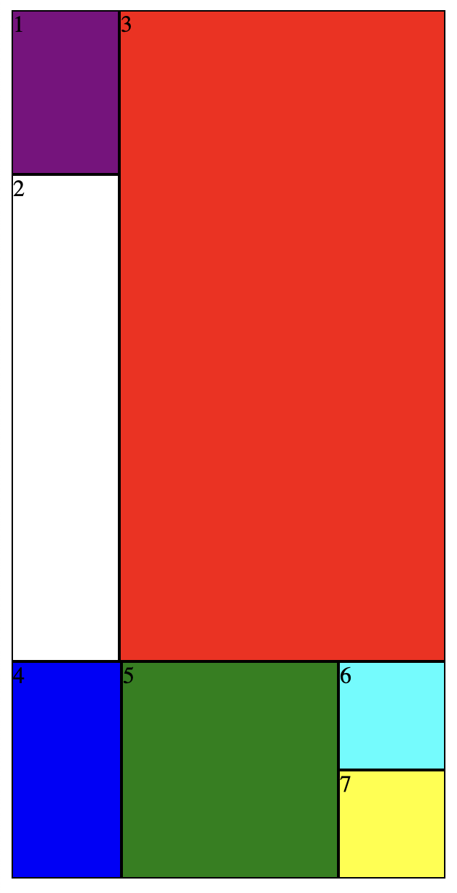
2
1
1
3
1
1
3

3
1

Lab11.html
