Lab 10 Flexbox

In lab10.html, set flex property to layout as below

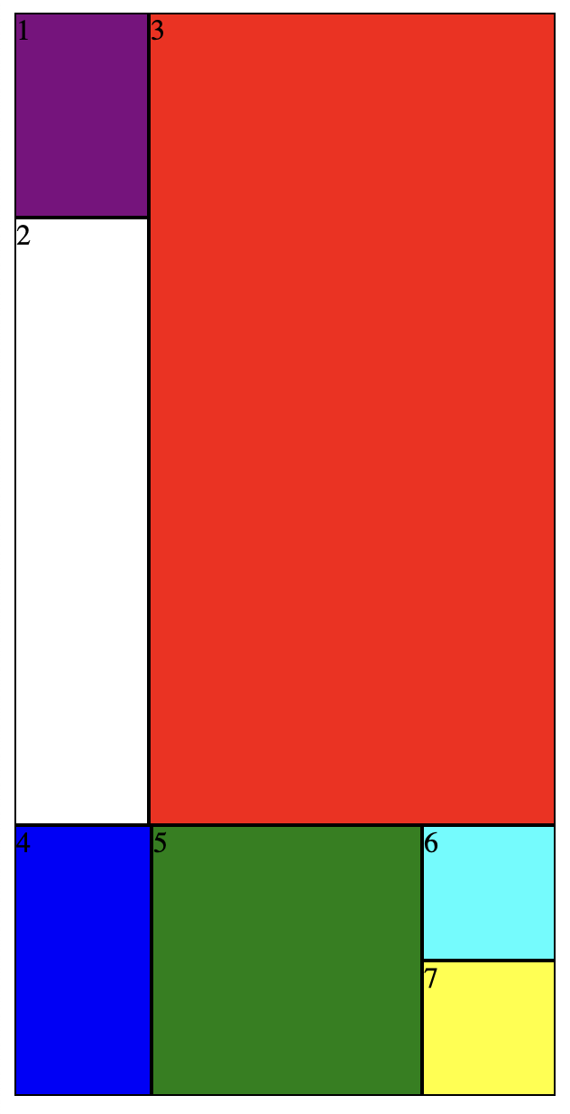
2
1
1
3
1
1
3

3
1

Lab10.html
