Takreem Malik
SE-B
AI chat

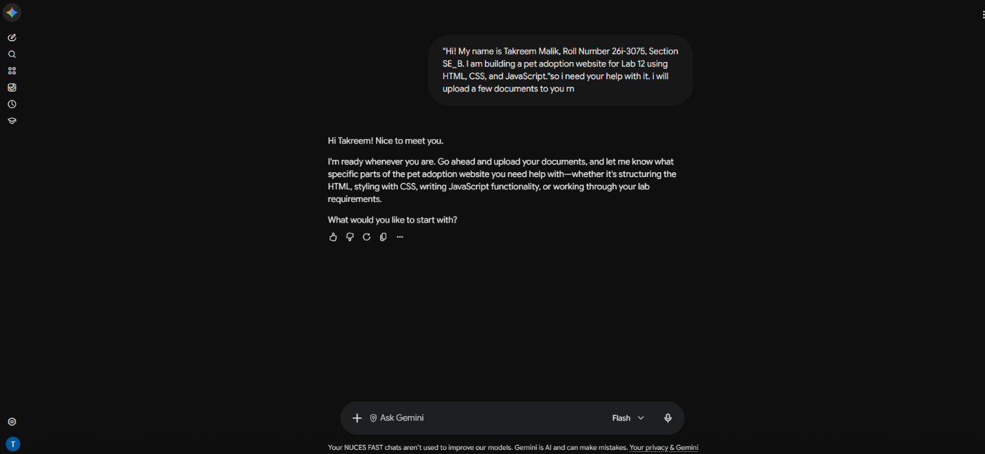
Prompt;
"Hi! My name is Takreem Malik, Roll Number 26i-3075, Section SE_B. I am building a pet adoption website for Lab 12 using HTML, CSS, and JavaScript."so i need your help with it. i will upload a few documents to you rn

Result;
It told me to upload all the documents and then ask for whatever help was needed.

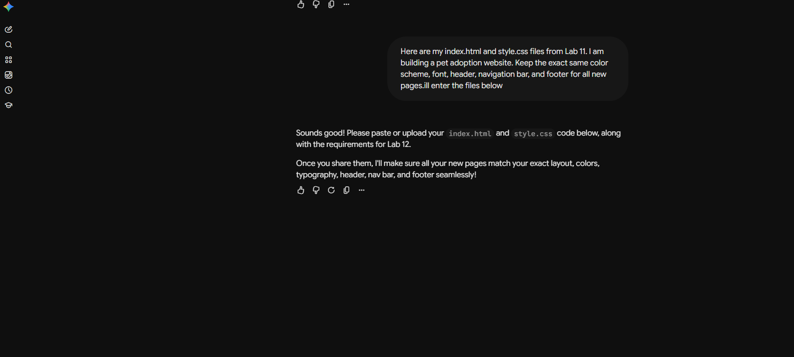

Prompt;
Here are my index.html and style.css files from Lab 11. I am building a pet adoption website. Keep the exact same color scheme, font, header, navigation bar, and footer for all new pages.ill enter the files below

Result;
Here I gave it my 2 files and it created 2 more pages for me and gave e their html codes which interlinked all pages so they work on the website and the two pages involdved the contact info page and the petsgrid page

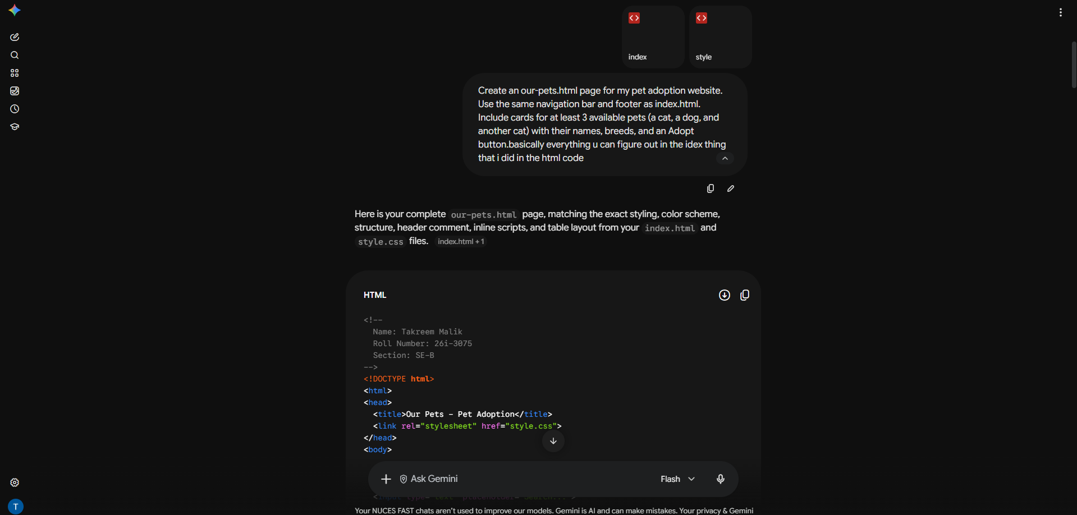

Prompt;

Create an our-pets.html page for my pet adoption website. Use the same navigation bar and footer as index.html. Include cards for at least 3 available pets (a cat, a dog, and another cat) with their names, breeds, and an Adopt button.basically everything u can figure out in the idex thing that i did in the html code

Result;
Here I finally gave it my files so it can create the other two pages for me

