CSE7101 – CAPSTONE PROJECT

REPORT

Analysis and identification of malicious mobile applications

Batch Number : COM_18

Roll Number | Student Name
20221COM0165 | BHOOMIKA S HORAPETI
20221COM0144 | ROSHAN RAJU K K
20221COM0171 | AMOGH ARUN MALAGE

Under the Supervision of,
Mr. Sunil Kumar Sahoo
Assistant Professor
School of Computer Science and Engineering
Presidency University

Name of the Program: COMPUTER ENGINEERING
Name of the HoD: Dr. PALLAVI R
Name of the Program Project Coordinator: Ms. BENITHA CHRISTINAL J
Name of the School Project Coordinators: Dr. SAMPATH A K , Dr.GEETHA A
Abstract

The explosive development of mobile applications has revolutionaized the digital
communication and presented new avenues of security vulnerabilities to malicious
applications. Such malicious applications can pose to be regular applications, hence
grabbing personal information, interfering with how the user uses their device, and various other privacy-related concerns. The project is aimed at performing the systematic ranking and detection of malicious mobile apps through processing and analysing both the static and dynamic characteristics, including permission, API calls, network activity, and code patterns. Machine learning models are used to improve accuracy in detection and classification of performance, using a hybrid model of CNN-LSTM. The research evaluation of the current detection approaches and please indicate the limitations of these methods along with the suggested hybrid detection system that will integrate components of both the static and dynamic analysis with machine learning to provide real-time security. This structure is benchmarked against such datasets MH100K . The result strengthens the infrastructure of mobile security mechanism, and the framework gives resistance to changing threats in mobile security besides portraying clear conclusions to researchers and practitioners.

Literature Review
To be perfectly honest, within the past decade, even the determination of what mobile apps are fraudulent has become solely a point of research priority partly due to the rising Android malware outbreak, and partly the inability of outdated signature-based antivirus programs to actually do anything useful anymore.
This early already researchers considered such methods of static analysis as DREBIN (Arp et al., 2014) and DroidAPIMiner (Aafer et al., 2013). These earthquakes demonstrated that with sufficient attention to permissions, manifest functions, and API looks, it was possible to train machine learning models which can, in reality, classify apps on the actual device- very cool to scale malware identification.
However, the downside was not only that where using a static method is a very fast and uses few resources but also that it turned out quite fragile upon coming to obfuscation, repackaging of code, or API changes. This urged towards high-tech stuff.
Leap to MaMaDroid (Mariconti et al., 2017), based on behavioral modelling. It abstracts API calls into Markov chains, whereby it can discover suspicious sequences without relying on particular APIs- huge achievements towards strength.
DroidMiner (Yang et al., 2014) encodes the intentions of predator motion as graphical computation, whereas DroidAnalytics (Zheng et al., 2013) forms itself a dissimilarity that generated signature and connected malware groupsqueens intimes of crest and decline of malware.
Once people noticed that the statical aspects were not sufficient, they resorted to dynamic analysis. The effectiveness of taking a closer look at system calls during the execution of the app was demonstrated in the work of Dimjasevic et al. (2015), and running on real devices and training a deep learning to learn the actual run-time behavior were emphasized in the work of DL-Droid (Alzaylaee et al., 2019), which is considerably more realistic than even an emulator.
Combination frameworks where both static and dynamic clues are mixed appeared potentially useful, but provide a trade off between scalability and anti-obfuscation properties. During this time, the ML industry outgrew classics and random forests, transitioning to models with some sense of capturing feature interactions, such as Factorization Machines (Li et al., 2018), and deep learning models, such as CNNs, RNNs, and currently graph neural networks. These enable researchers to be able to express control-flow and dependencies in a richer way.
The real-life systems such as AndroAnalyzer (Arslan et al., 2021) and got pipelines which are discussed by Elayan et al. (2021) demonstrated that the deep models can be actually functional in practice. Nevertheless, explainability and transparency are merely issues under consideration.
The other important direction is adversarial resistance: KuafuDet (Chen et al., 2017) demonstrated that adversarial training intentionally in evasion and poisoning leads adversaries to deceive adversary-aware or adversarial-aware new methods of training. Muzaffar et al. (2022) and Senanayake et al. (2021) emphasize the importance of the robustness/interpretability in the performance of real deployments in surveys.
One of the biggest obstacles is still Obfuscation. It was demonstrated that even elaborate packing, reflection and encryption strategies can undermine static detectors, which makes the field go to the abstraction or dynamic direction (Elsersy et al., 2022).
It is discussed that red flags have been raised in anger with regard to the bias in data sets and the impossibility of time sensitive evaluation system in bench mark studies (2025). Historical systems such as DREBIN or AMD can also become unable to predict a new set of samples, which overstates metrics of the success of models used in academia.
Overall, all these 15 papers give a consistent direction: starting with lightweight quasi-statistical techniques, then flashy sequence- and graph-based, controlled dynamic, and real-world analysis, traditional ML, and deep-learning and adversarial-robust models. However, scalability to deploy app-stores, resistance to intelligent opponents and standard testing remain missing thus the community is seeking Novel hybrid, explainable, adversarial aware detection and defensive systems that will successfully achieve the challenge of abreast the evolving android malware spectre whilst remaining accurate and efficient.

Architecture Diagram

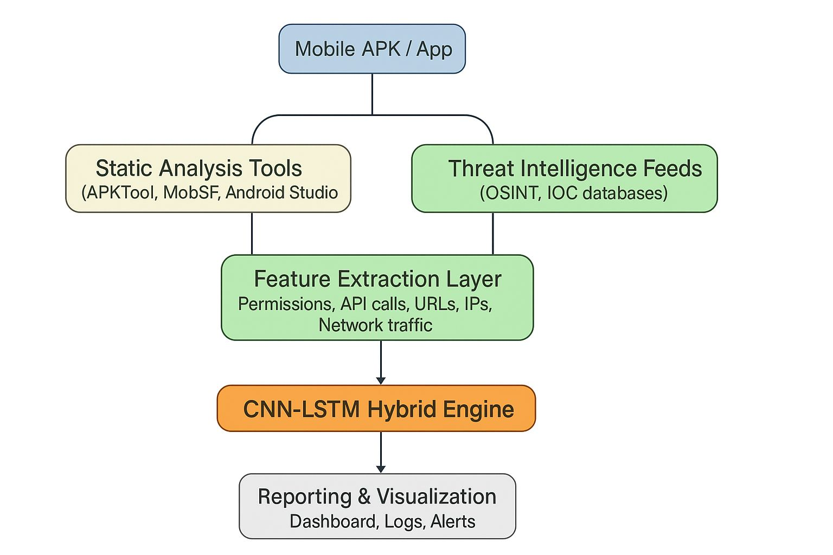

The figure provides a multi-layered architecture of mobile application security analysis, which is developed to identify malware and vulnerabilities in Android applications (APKs).
- Input: Mobile APK / App
The procedure starts with the object of analysis a mobile application package file. This would be the uncooked input that will be tested by the whole system.
- Parallel Data Collection:
The system simultaneously receives the information on two different sources to create a comprehensive profile of the application.
- Statistical Analysis Tools:
The application is analyzed and disassembled without being run. Such tools as APKTool, MobSF (Mobile Security Framework) and Android Studio are used to reverse-engineer the app, inspect its code, scan the AndroidManifest.xml file to see permissions it requires, and extract the core of the Android app. This gives an inside roadmap of what can be done in the app.
- The Threat Intelligence Feeds:
Concurrently, the system is accessing external databases to find out some background information. It works with OSINT (Open-Source Intelligence) and IOCs (Indicators of Compromise) databases, verifying any use of known malicious content on the app, like hard coded IP addresses, URLS, or cryptographic hashes that have been earlier attributed to any malware campaign. This would give it an external and real-world framework of established dangers.
- Feature Extraction Layer:
This layer interprets the raw data that has come out of the precedent stage into some machine-learnable format combined with structure. It logically temples out salient characteristics, which are quantitative data points that describe the possible behaviour of the app. These include:
- Permissions asked (e.g. contacts, SMS, camera access).
- The currency of API calls that are internally done in the code (ex. a function that sends texts or accesses files).
- Inbuilt URLs and network communication IP addresses.
- Applied logic network traffic patterns.

- CNN-LSTM Hybrid Engine:
It is the most essential part of the system in terms of its analysis, and a more advanced deep learning model determines the real threat. The selection of a model of hybrid is important:
CNN (Convolutional Neural Network) is effective at localizing patterns. It is able to detect particular, odd matches of API calls or code snippets that in most cases show indicators of malware.
LSTM (Long Short-Term Memory) is created to be able to comprehend sequences and context. It is in a position to trace the order of operations or the sequence of network requests in identifying more complex behaviors that emerge over time.
With the differentiation of these two models, the engine will identify not only those threats that are simple and well known, but also those attacks that are complex and novel that make use of a particular sequence of actions.

- Reporting & Visualization:
The last phase interprets complex analysis of the engine to present the results in a form comprehensible to humans. This enables a security analyst to have a quick appreciation of the risk profile of the app:

- Dashboard:
Overview of the examination showing the depth analysis and important threats in a summary form.
- Process logs:
Provides entries to see a more comprehensive analysis, in a finer detail.
- Alerts:
Plays instant notification in case the app is considered as malicious or it has a severe weakness.

System Design
The suggested system can be viewed as a manner of automatically detecting Android malware with the help of a combination of LSTM and CNN deep learning. This is divided into three main sections, which include data preprocessing, feature extraction, and then the malware classification itself. The processing phases are as follows: first, in the course of preprocessing we extract all the raw dataset features, i.e. permissions, API calls, intents, you name it, clean them out and transform them into numbers that can be processed by the network. This is where CNN then narrows down to local patterns within these sequences of features, which simply means identifying the way some permissions and API usage coincide with one another. The LSTM layer then intervenes to identify longer term connections between those features representing the timing or logical connections that tend to indicate something is off or malicious. Last, there are fully connected dense layers that do a binary classification and provide you with a yes/no prediction of whether an app is safe or bad. That is in addition to training, evaluation, and reporting modules, hence you have measures such as accuracy, precision, recall, F1-score, and confusion matrices.

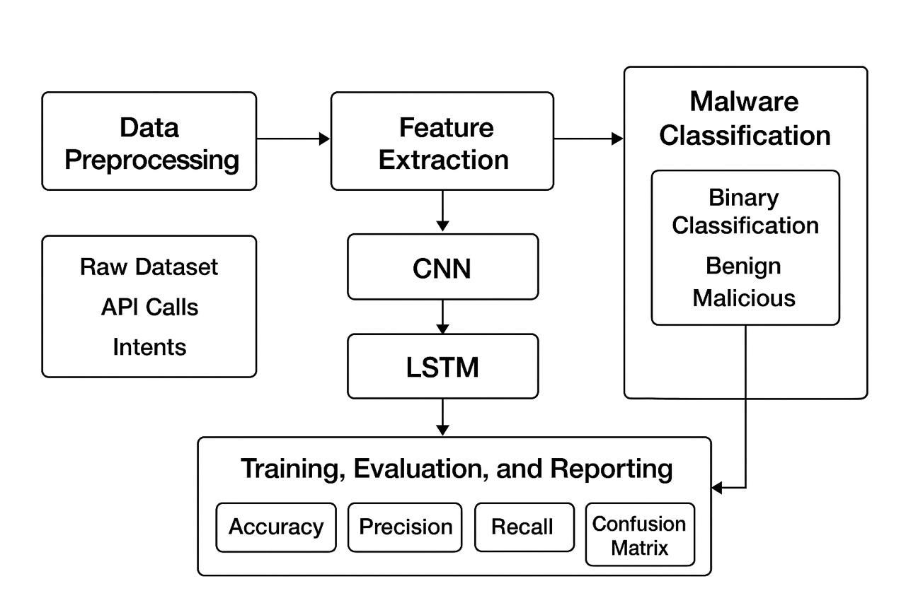

Algorithm Details
The main engine of the proposed system is a hybrid deep learning model of Convolutional Neural Networks(CNN) and Long Short-Term Memory (LSTM) network. In essence, this combination allows us to utilize the capabilities of the two architectures to achieve good, valid malware detection which is what everyone desires in their project.
- CNN Layer: The CNN component of the model is the one-dimensional convolutional layers to identify local patterns on the high-dimensional feature vectors we draw out of Android app data such as permissions, API calls and intents. On these series of features, by sliding filters, the CNN identifies the correlations and patterns that appear suspicious. Then we reduce the size of the feature maps by applying MaxPooling layers with the discarding of least significant local information. This saves a lot of calculation and it ensures that the key signals are retained in the subsequent processing.
- LSTM Layer: The CNN spits out a sequence in a sequence, so normally, whatever the CNN spits out is immediately fed to an LSTM layer. LSTMs are particularly effective at learning patterns that occur over time, i.e. they are literally the neural network time-travelling inquisitive eyes. In the case of malware detection, this implies that they are capable of identifying those devious sequences of permissions or API calls that when arranged in the proper order, are a signal to the fact that something shady is going on. It helps to make sure that the model does not only look at features, but also has to remember the sequence in which they appear.

- Dense Layers and Dropout: Once the sequence stuff has been configured then the model runs it through a series of dense layers of fully connected networks, which convert those learned features to the final answer. To prevent overfitting of the model to mere memorization (i.e. to prevent overfitting), we dropout randomly selected neurons when training. It is such as a test of cheat prevention, which makes the network study what is really important in order to address invisible information.
- Activation Function and Loss: The final layer discards a sigmoid activation function to obtain a probability score malicious or benign. Our training has a binary cross entropy loss and integrates Adam optimizer to shake the weights. The entire kit-n-caboodle allows us to train more effectively and be kept stable, despite the feature set being huge and thick.
- Evaluation : Now, when we actually ran the model on a dataset that no one had trained it on it was very strict. We checked accuracy, precision, recall, F1-score and even plotted a confusion matrix all of which provide us with a fair understanding of the models performance in classifying things.

All in all, this hybrid CNN-LSTM object is cool, in that it can deal with all those high-dimensional binary features, and can simultaneously see the local stuff, as well as the sequential stuff. Combining those capabilities, the system performs a good task of catching Android malware, reduces the number of false positives and provides a better detection rate, which is a win-win.
Module description
The malware detection system that we propose will be divided into a series of modules, which will concern themselves with various processing pipeline steps. This modular design allows keeping things simple, scalable and maintainable.

- Data Preprocessing Module:
Here we preprocess the raw data in order to run deep learning. We purge the data by eliminating the missing, erratic, or corrupt data to ensure that the data is of high quality. String encoded features such as permissions and intents are converted in to a number which neural nets can interpret. We make the features normal and scaled, also, to standardize the data, and this makes the model more stable to train, and the model performs better.

- Feature Extraction Module:
In this case we extract the useful features of raw Android app data. Each app is processed 166 permissions, 24417 API calls, and 250 intents. We optionally perform dimensionality reduction and deal with sparse representations in order to increase efficiency and reduce the size of the model. This maintains only the most informative aspects at the expense of reduction.

- LSTM‑CNN Model Module:
It consists of this core module that creates a hybrid model of deep-learning combining CNN and LSTM layers. The CNN layers identify local trends and correlations in the feature vectors whereas the LSTM layers identify time-sequential dependencies and trends in behavior. We conclude with the dropout and dense layers of binary classification; dropout prevents the possibility of overfitting and allows a better approach to novel information.

- Validation Module:
This section brings the training loop on. We divide the data into training and validation data sets and execute an optimized loop using early stopping so as not to overfit. Both the loss and the accuracy are tracked when training and when validating the model to ensure that the model converges and remains stable.

- Evaluation Module:
Once we have trained a model we test it on unknown data. To measure the performance of classification, we calculate important measures such as accuracy, precision, recall, and F1 -score. We also create a confusion matrix to visualize and track and plot training/valid loss and accuracy curves to learn how the model is trained in terms of epochs.

About the Dataset
The MH100K data, then, is what I have been digging so far, and it is an enormous amount of Android applications, but 101975 APK samples. Each individual entry has comprehensive metadata that is essentially a treasure trove to study.
- SHA256 Hash and Filename: APKs are distinctly identified by a identifier, and thus it also can be used to track individual apps.
- Name and API level: You can see the name of the app and the android version to which it is compatible, among other things.
- Permissions: Android permissions will be displayed and there are 166 binary features that indicate which app is requesting what permissions.
- API Calls: Guess what- there are 24417 features which give a list of all the API calls made by the app.
- Intents: The features contained in the dataset are 250 which represent the intents which are defined in each app, which are helpful in observing the communication between apps.
- VirusTotal Analysis: They have their detection numbers and malware type labels, providing a swift overview of the number of engines which detected each app and what the type of malware was.
Training goes by the name CLASS column. A score of 0 is used to indicate benign applications, and a 1 to indicate malicious ones. The information is sparse, high dimensional and binary hence it best suits the use of deep learning models which can be trained to identify complicated patterns in permissions and API usage to identify malware activity.

