

PROGRAM NAME : DIT
MODULE CODE : ITSL004_L02
MODULE NAME : PROGRAMMING FUNDAMENTALS
NATIONAL LIBRARY SYSTEM
BOOK KEEP MANAGEMENT SYSTEM

FULL NAME : JESSLYN BOEDIONO GOENAWAN
STUDENT ID : 10245280
DATE : 13 February 2023

TABLE OF CONTENTS
- Project Introduction 3
- UML Design Class Diagrams 3
- Explanation of Programs 3
3.1 Book class 3
3.1.1 UML class diagram 3
3.1.1 Book Class Code 3
3.2 User Account class 4
3.2.1 UML class diagram 5
3.2.2 User Account class code 6
3.3 Rental class 6
3.3.1 UML class diagram 6
3.3.2 Rental class code 7
3.4 Admin Account class 7
3.4.1 UML class diagram 7
3.4.2 Admin Account class code 8
3.5 Management System class 8
3.5.1 UML class diagram 9
3.5.2 Management System class code 9
3.5.3 Output 10
4. Reflection on this assignment 11
4.1 Lesson learnt 11
4.2 Unresolved/unachievable requirements 11
5. Appendices 12
5.1 Program 1 12
6. References 13

Project Introduction

Aethyr IT has been given a task for the developer to make a project called “Bookkeep Rental Management” using Java Application for the National Library in Singapore. This application will then satisfy the book keepers in quick accessibility and rental management of books in the library.

UML Design Class Diagrams

Main
Book
- BID : int
- bName : String
- bDesc : String
- bGenre : String
- rPrice : double

userAcc
- UID : int
- uFN : String
- uLN : String
- cDate : String
- ArrayList<String> GenrePref

bookRental
- RID : int
- rDate : String
- rUserAcc : rUserAcc object
- ArrayList<Book> rentalList

adminAcc
- aID : int
- aN : String
- aUsn : String
- aPw : String

managementSystem
- ArrayList<adminAcc> adminAccList;
- ArrayList<bookRental> rentalList;
- ArrayList<userAcc> uAccounts;
- ArrayList<Book> bookList;

Book
+ getBID()
+ setBID (int BID)
+ getbName()
+ setbName (string bName)
+ getbDesc ()
+ setbDesc (String bDesc)
+ getbGenre()
+ setbGenre (String bGenre)
+ getbrentalPr()
+ setbrentalPr (double brentalPr)

userAcc
+ getUID ()
+ setUID(int UID)
+ getuFN ()
+ setuFN (String uFN)
+ getuLN ()
+ setuLN (String LN)
+ getcDate()
+ setcDate (String cDate)
+ addbGenre (String bGenre)
+ removebGenre(String bGenre)

bookRental
+ getRID ()
+ setRID (int RID)
+ getrDate ()
+ setrDate (String rDate)
+ getrUserAcc()
+ setrUserAcc (userAcc rUserAcc)
+ addBook1 (Book Book1)
+ removeBook1 (Book Book1)
+ totalRprice()

adminAcc
+ getaID ()
+ setaID (int aID)
+ getaN ()
+ setaN (String aN)
+ getaUsn ()
+ setaUsn (String aUsn)
+ getaPw ()
+ setaPw (String aPw)

Explanation of Programs

For the Java book rental program, to specify each function of the code, it will be divided into five classes which are book class, user account class, rental class, admin account class, management system class.

  - BOOK CLASS
    - UML class diagram
Book
- BID : int
- bName : String
- bDesc : String
- bGenre : String
- rPrice : double

+ getBID()
+ setBID (int BID)
+ getbName()
+ setbName (string bName)
+ getbDesc ()
+ setbDesc (String bDesc)
+ getbGenre()
+ setbGenre (String bGenre)
+ getbrentalPr()
+ setbrentalPr (double brentalPr)

    - Book class Code
First of all, some important functions will need to do an import, as example for Scanner function so it will be “import java.util.Scanner;” at the very beginning of the program.
Book class will be the class where book ID, name, description, genre, and rental price fields are identified. Afterwards, those fields will need their constructor (arguments) before setter and getter, each fields use void setter and data types getter.
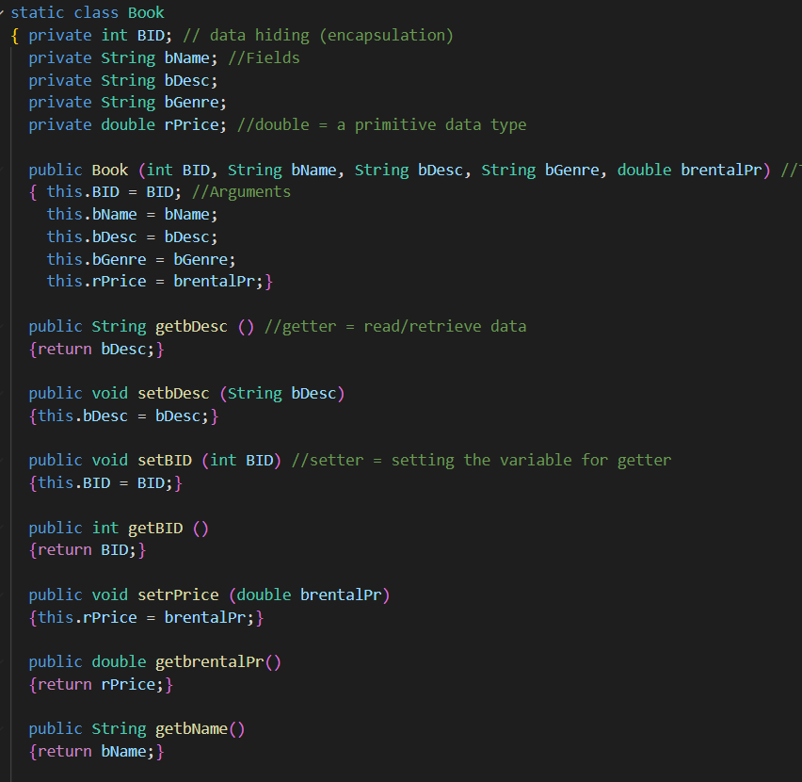

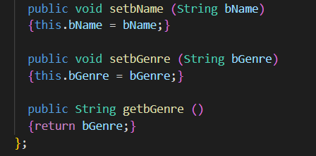

  - User Account Class

    - UML class diagram

userAcc
- UID : int
- uFN : String
- uLN : String
- cDate : String
- ArrayList<String> GenrePref

+ getUID ()
+ setUID(int UID)
+ getuFN ()
+ setuFN (String uFN)
+ getuLN ()
+ setuLN (String LN)
+ getcDate()
+ setcDate (String cDate)
+ addbGenre (String bGenre)
+ removebGenre(String bGenre)

    - User Account class Code
The same as the book class, user account class also identify and make constructors code for required fields. However, genre preference will use ArrayList, as in will take the data from the previous class. There are extra methods which are addGenre and removeGenre that will be used to add/remove genre from the ArrayList.
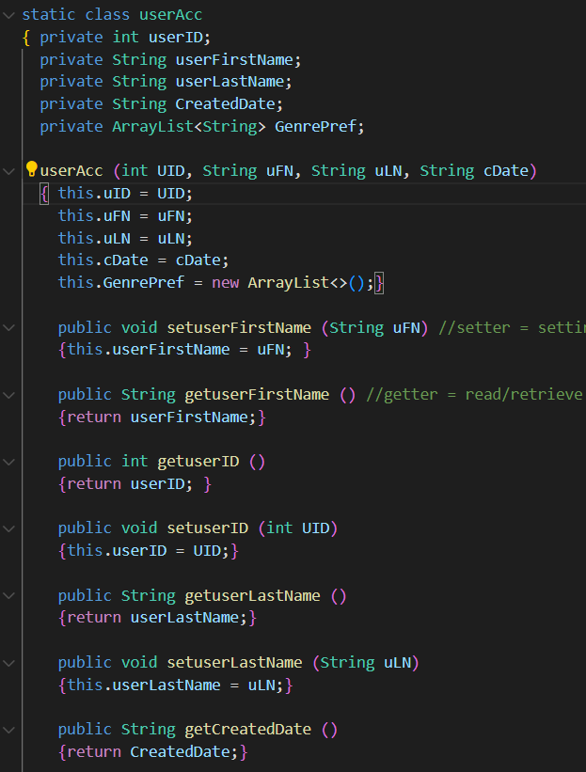

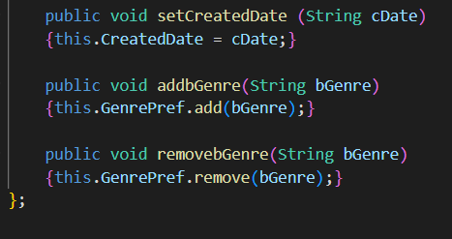

  - Rental Class
    - UML class diagram
bookRental
- RID : int
- rDate : String
- rUserAcc : rUserAcc object
- ArrayList<Book> rentalList

+ getRID ()
+ setRID (int RID)
+ getrDate ()
+ setrDate (String rDate)
+ getrUserAcc()
+ setrUserAcc (userAcc rUserAcc)
+ addBook1 (Book Book1)
+ removeBook1 (Book Book1)
+ totalRprice()

    - Rental class Code
Rental class will have constructors (arguments) for rental ID, date, user account object. The userAccount will be taken an object from User Account class, then for the book list where all added book located, will use ArrayList (connected with Book object). Add/Remove methods will be put inside of a Main class, together with rental price calculation method.
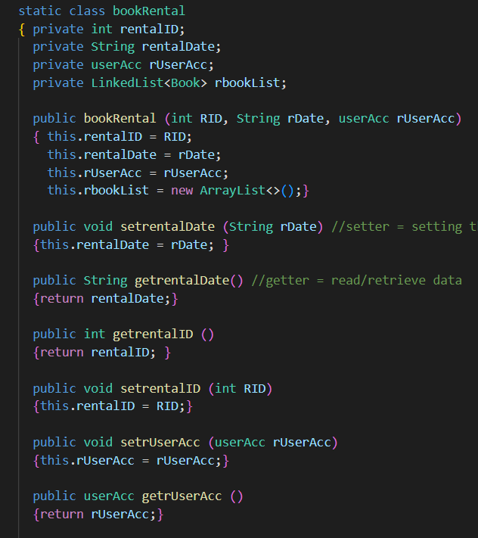

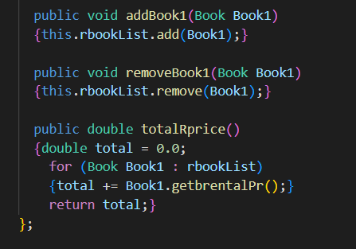

  - Admin Account Class
    - UML class diagram
adminAcc
- aID : int
- aN : String
- aUsn : String
- aPw : String

+ getaID ()
+ setaID (int aID)
+ getaN ()
+ setaN (String aN)
+ getaUsn ()
+ setaUsn (String aUsn)
+ getaPw ()
+ setaPw (String aPw)

    - Admin Account class Code
For the admin account class, simply it is almost the same as book class; however, admin features will be ID, name, username, password. This is use for the admin to log in and access all features only by entering some data.
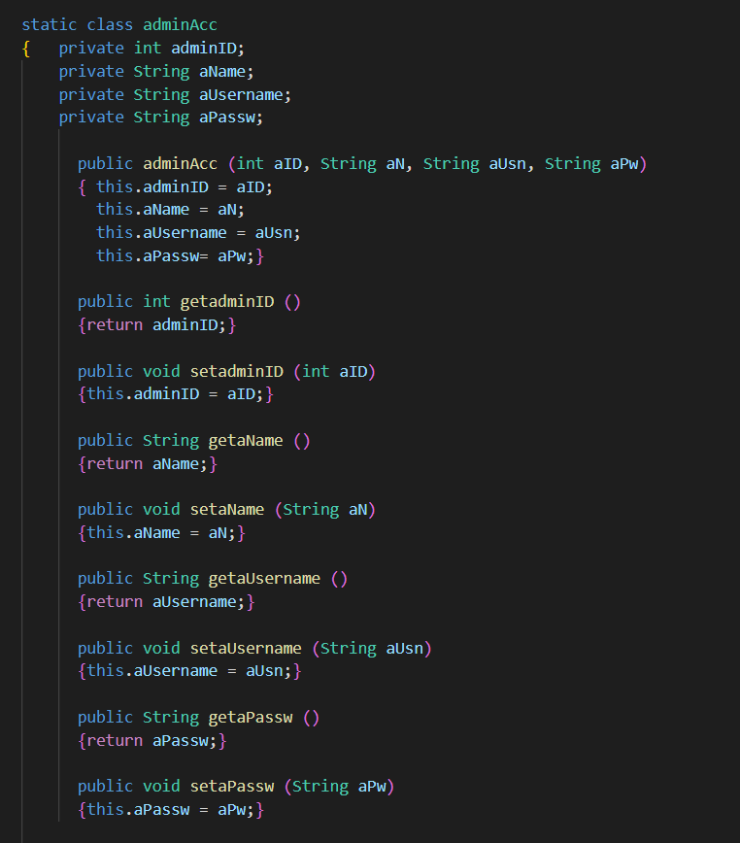

  - Management System Class
    - UML Diagram Class
managementSystems
- ArrayList<adminAcc> adminAccList;
- ArrayList<bookRental> rentalList;
- ArrayList<userAcc> uAccounts;
- ArrayList<Book> bookList;

    - Management System class Code
This class will contain all the systematic codes from the arraylist of the object to the ending.
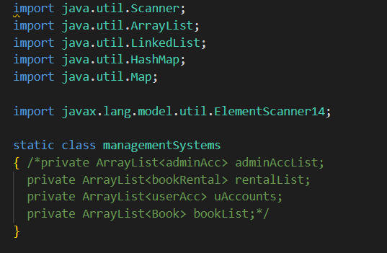

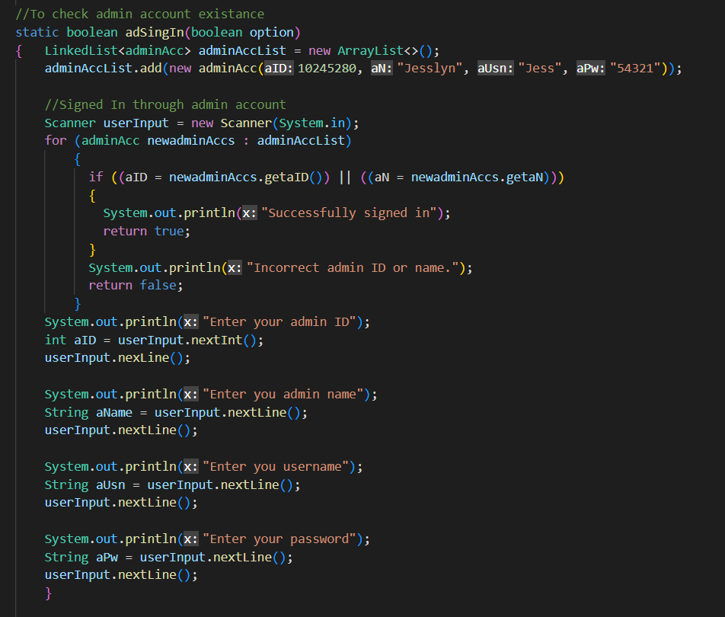

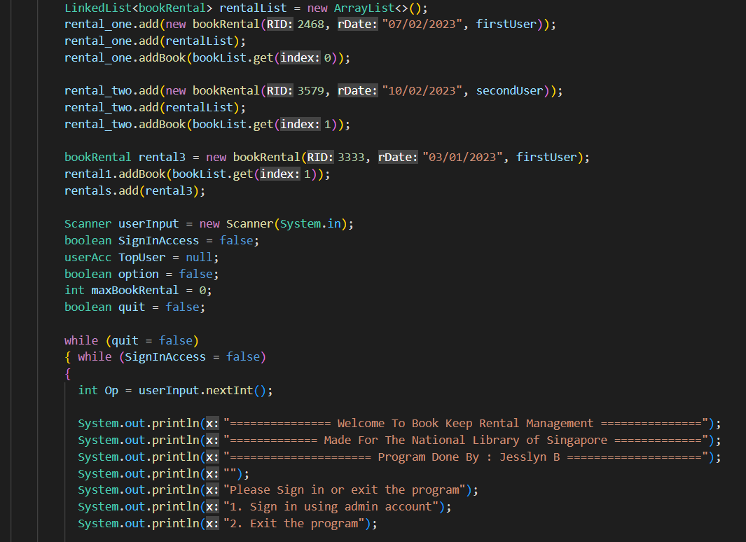
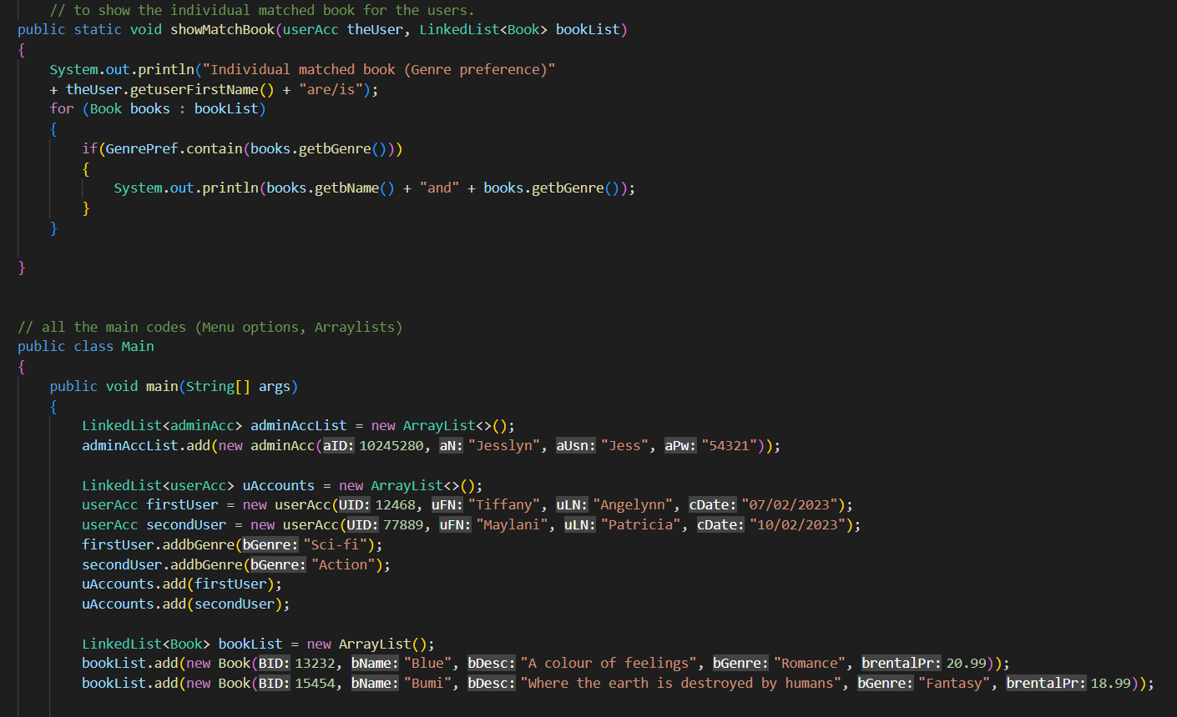
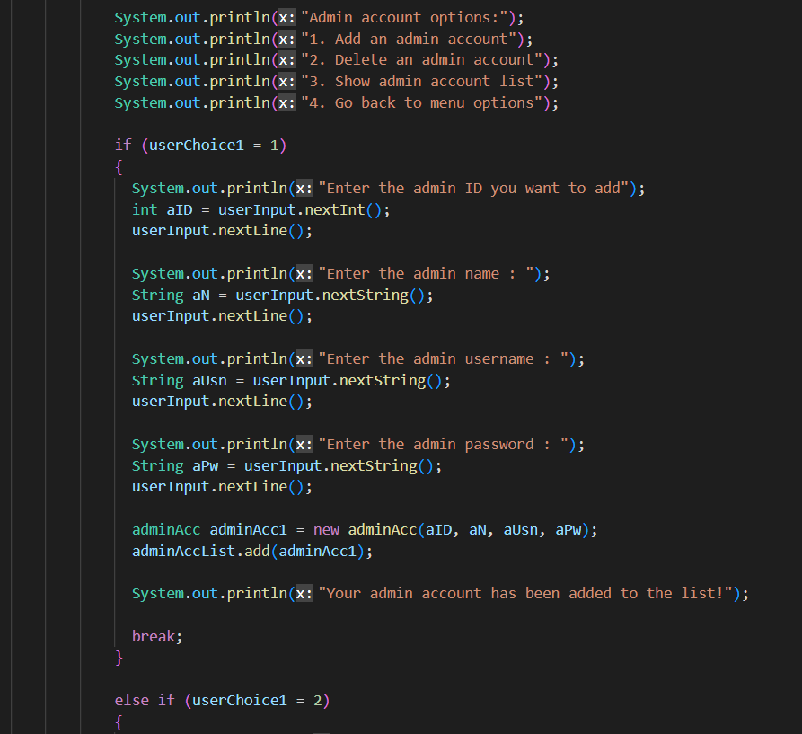
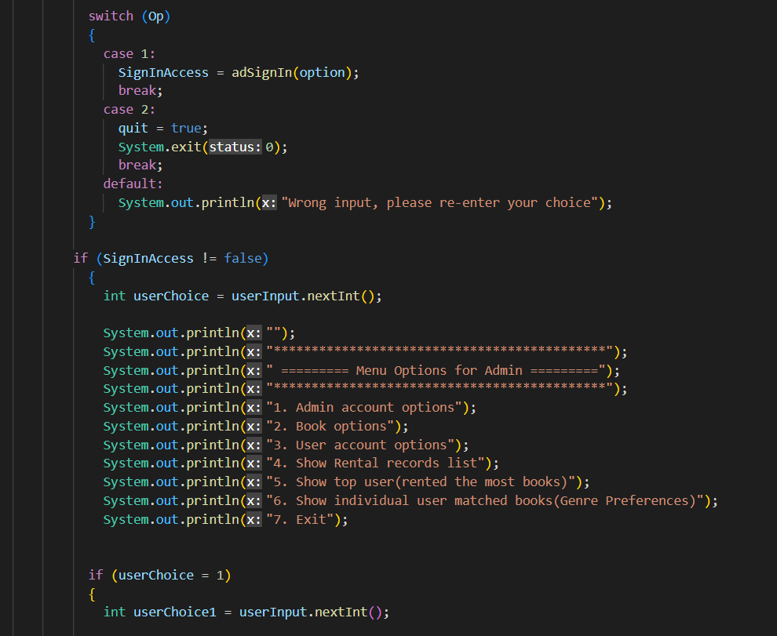
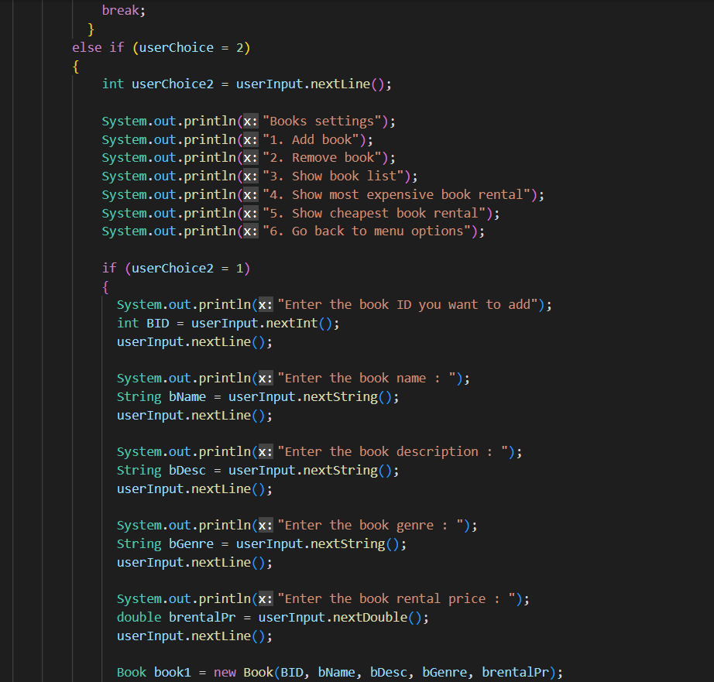
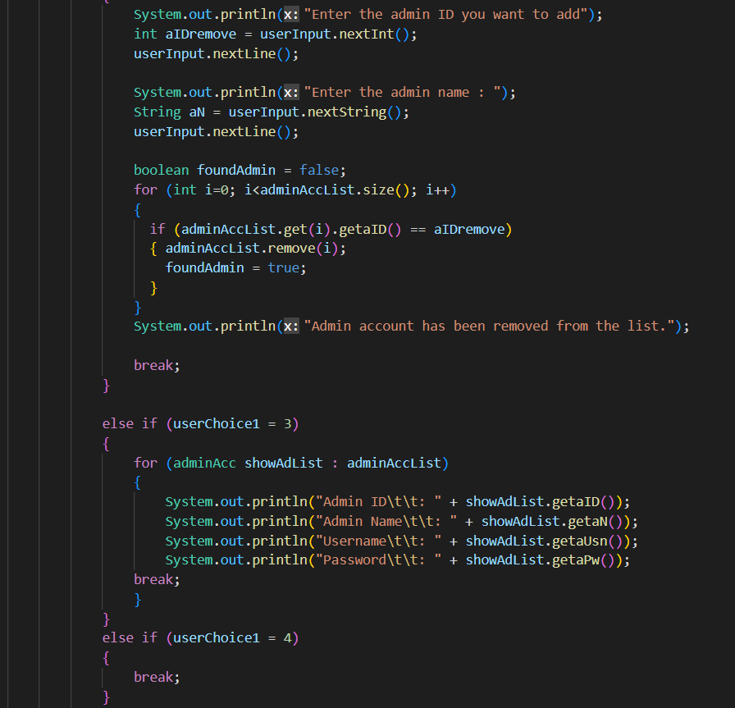
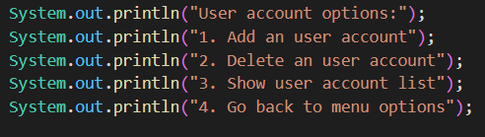
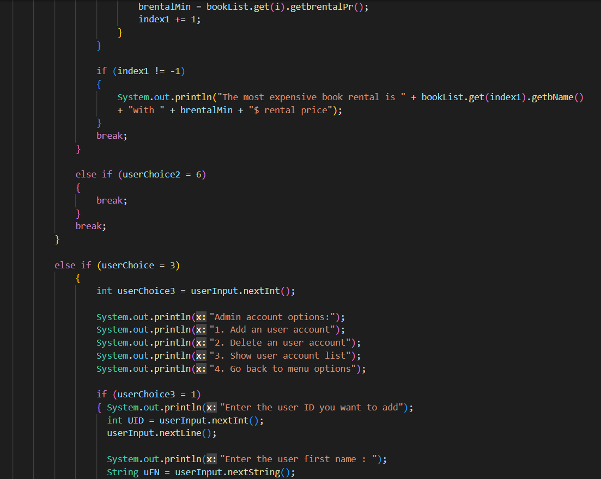
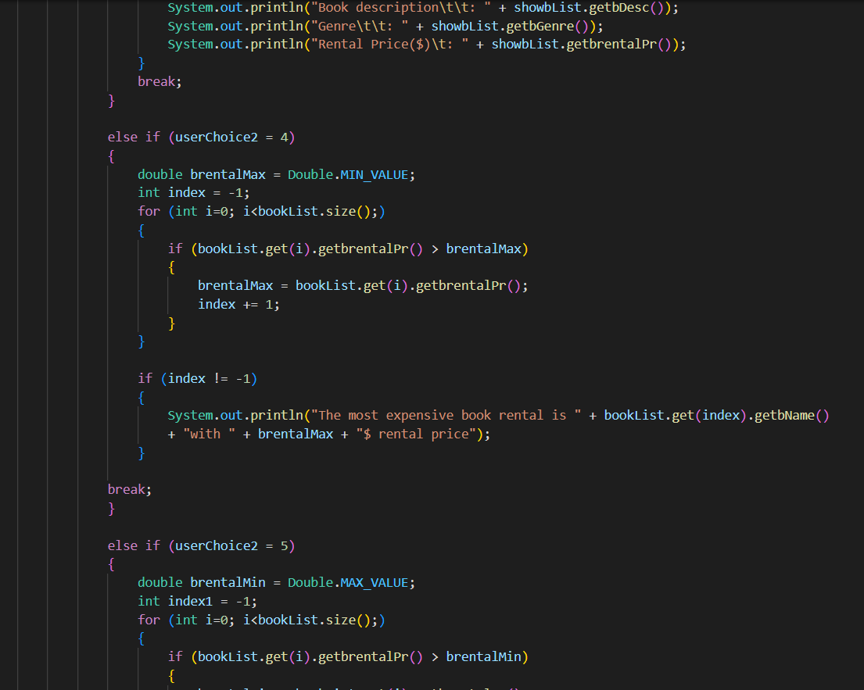
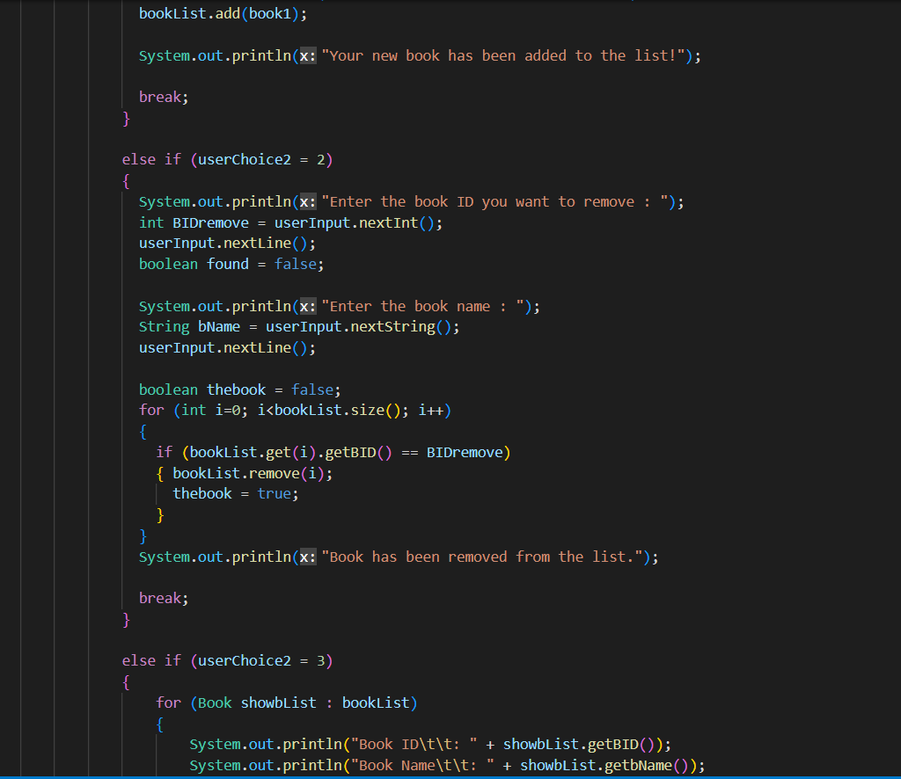
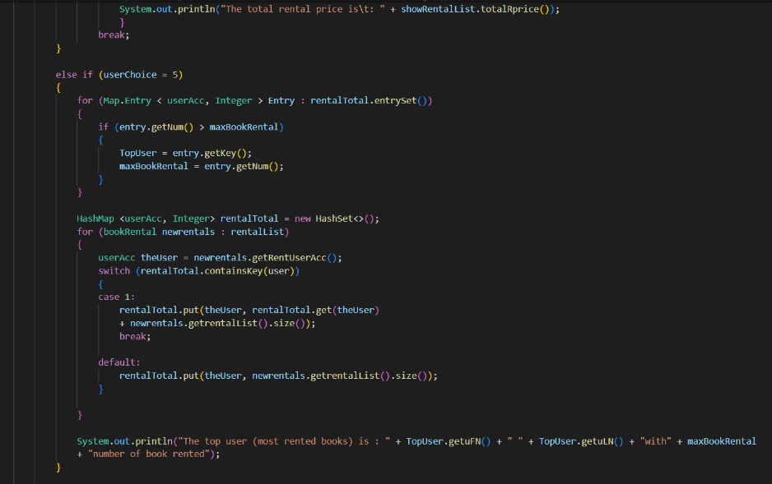
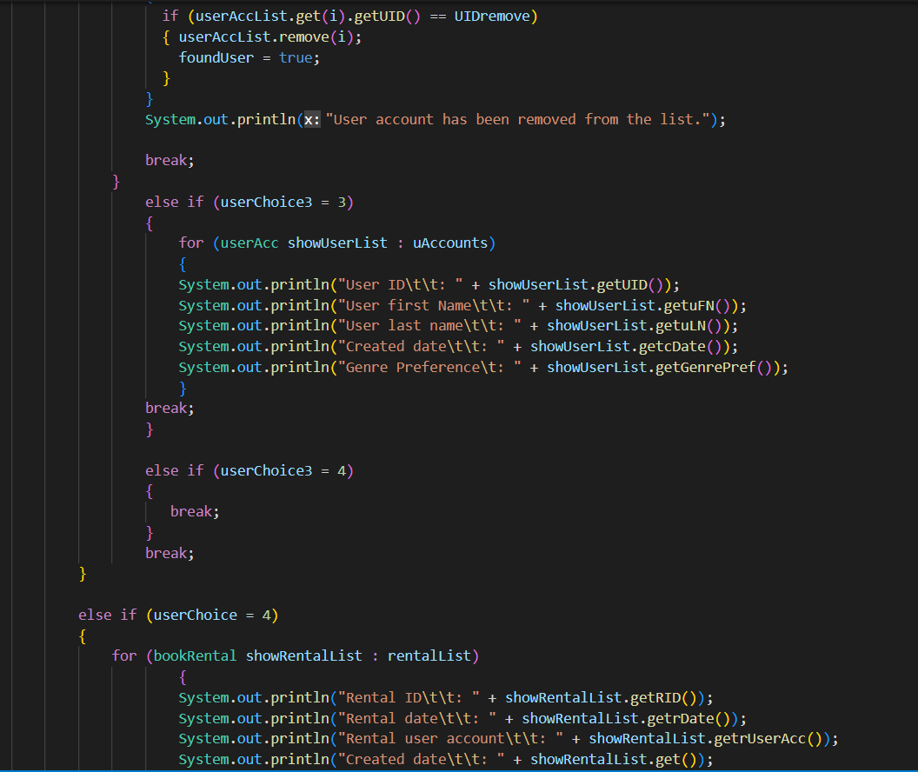
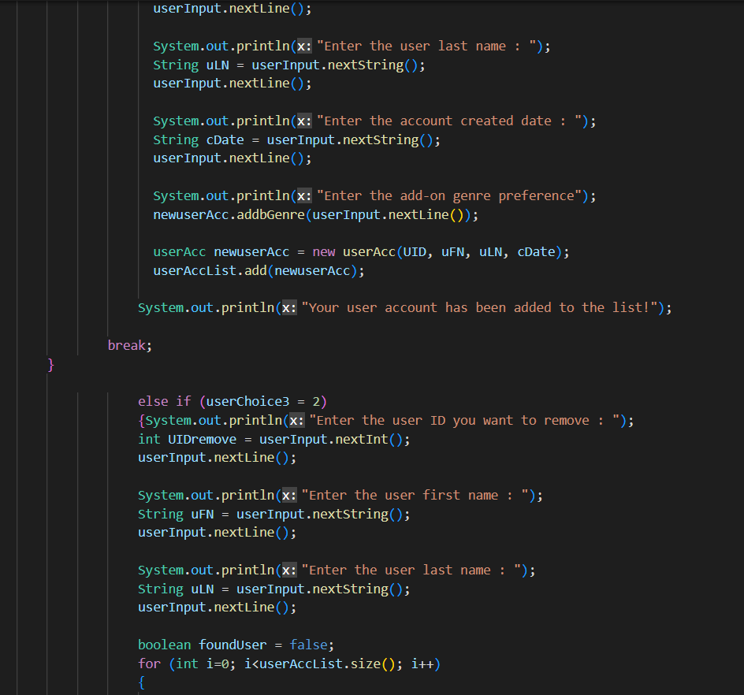
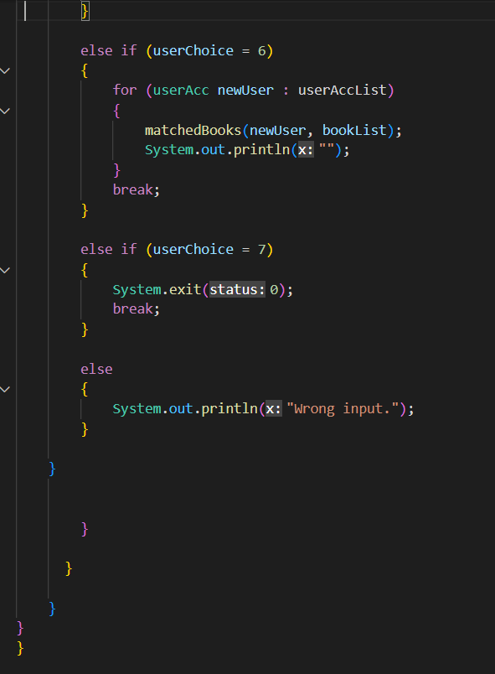

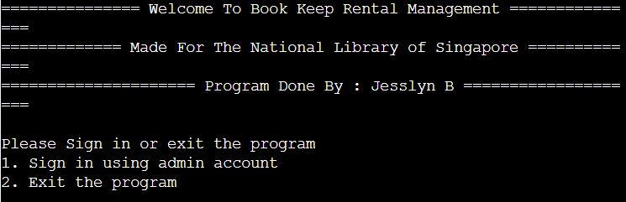
    - Output

The first display will be like above, the program users will be asked to choose to log in using admin account of exit the program.
This is the next display if we choose number 1. The user then sign in with the registered admin account.
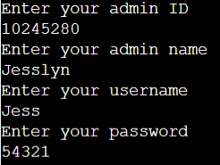

If the user input the wrong admin account then it will terminates the program.
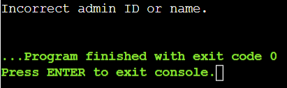

If correct, this leads to the menu options
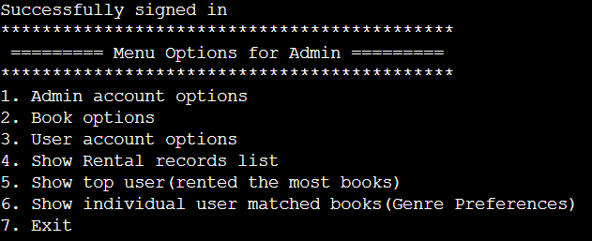

Now user can choose which menu they would like to see.
For number 1, 2, and 3, the program will give us another options
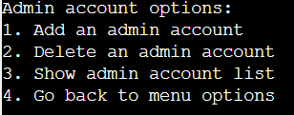

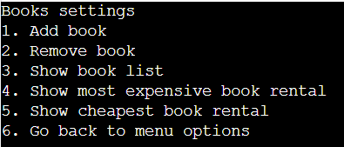

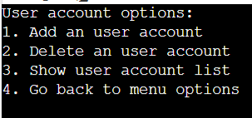

4.Reflection
  - Lesson Learnt
From this java project, I have studied various of java code model which can be implemented in real-life situation. Java is the most effective way of code programming because of its code detailed on each mechanism. Although it is tough at first, that java script is quite complicated to deal with, soon enough I learn to remember some java codes unconsciously.
  - Unachievable requirements
Unfortunately, I have not got enough time to rescanning back my code, it has some kind of error with my ArrayList, but it still works just fine.

5.Appendicies
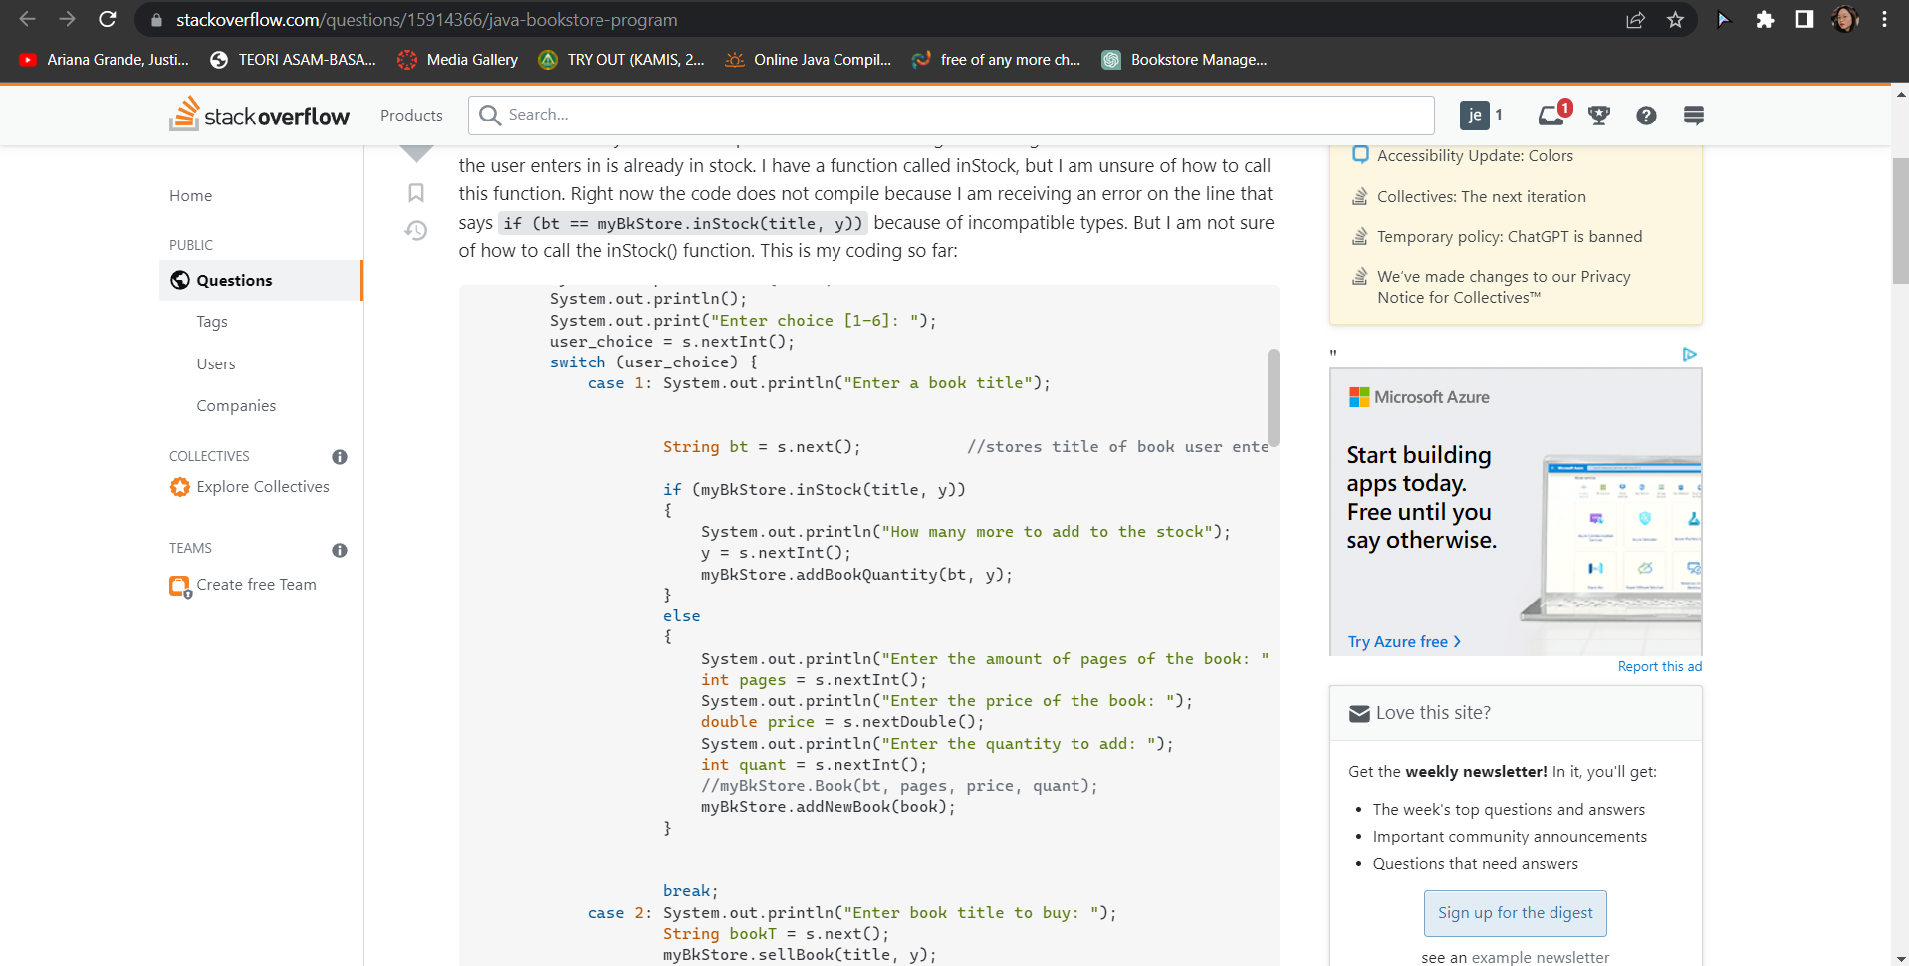

(Stack Overflow, 2023)

6.Reference
Stack Overflow, 2023. Stack Overflow. [Online]
Available at: https://stackoverflow.com/questions/15914366/java-bookstore-program
[Accessed Saturday February 2023].

