Database Architecture

Role | Responsibilities
Admin | User management, system configuration
Production Manager | Production planning and scheduling
Machine Operator | Operates machines and updates production
Quality Inspector | Defect inspection and quality control
Maintenance Engineer | Machine maintenance and downtime management

Database Tables

Users
UserId PK
FullName
Email
PasswordHash
RoleId FK
CreatedAt
Status

Roles
RoleId PK
RoleName

ProductionPlans
PlanId PK
ProductName
TargetQuantity
StartDate
EndDate
Status
CreatedBy FK

ProductionOrders
OrderId PK
PlanId FK
MachineId FK
Quantity
ProducedQuantity
Status

Machines
MachineId PK
MachineName
MachineCode
Location
Status
LastMaintenanceDate

MachineReadings
ReadingId PK
MachineId FK
Temperature
Vibration
PowerConsumption
Timestamp

Defects
DefectId PK
OrderId FK
MachineId FK
DefectType
Severity
Description
ReportedBy FK
CreatedAt

MaintenanceLogs
LogId PK
MachineId FK
EngineerId FK
IssueDescription
Resolution
MaintenanceDate

ProductionAnalytics
AnalyticsId PK
MachineId FK
Efficiency
Downtime
DefectRate
CalculatedDate

UseCase Diagram

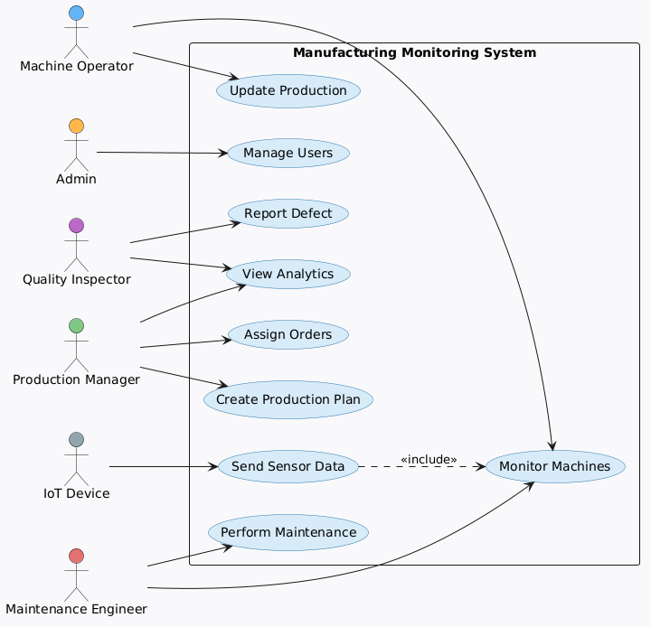

ER Diagram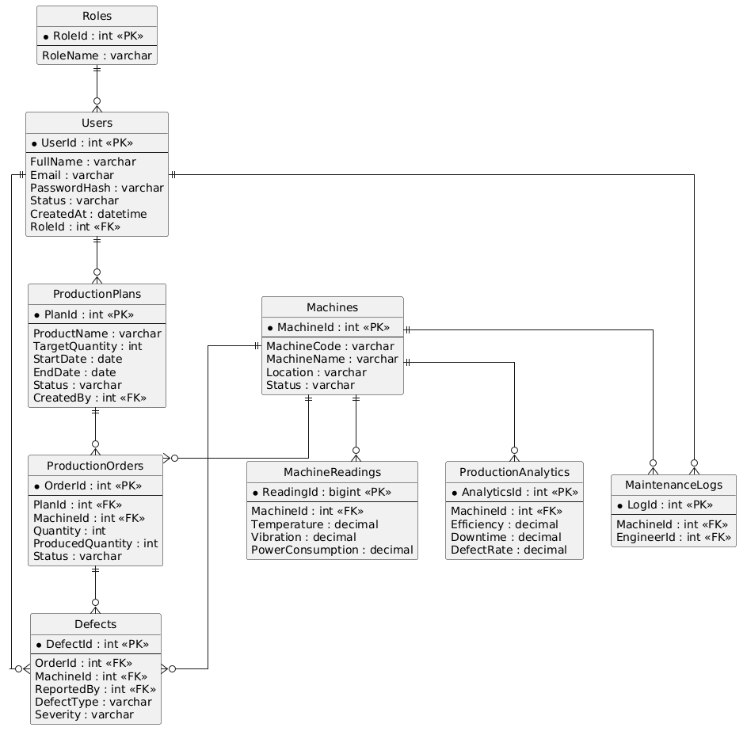

Class Diagram:
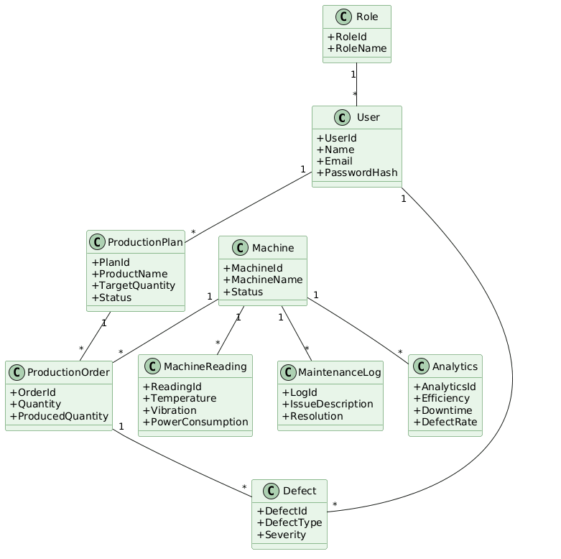

Sequence Diagram(Defect)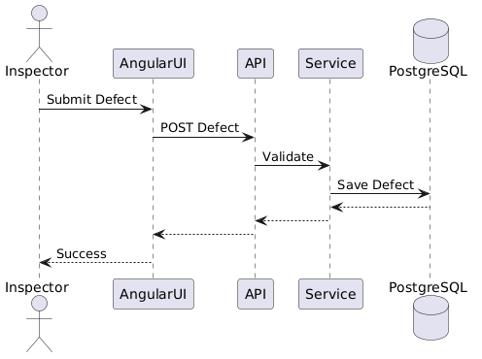
Manufactorint Monitoring
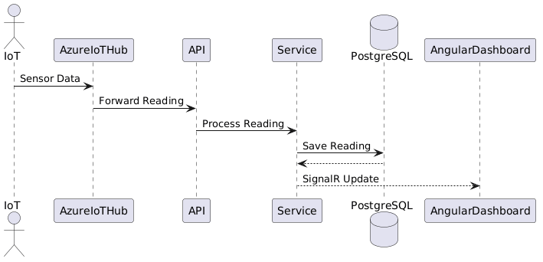

Production
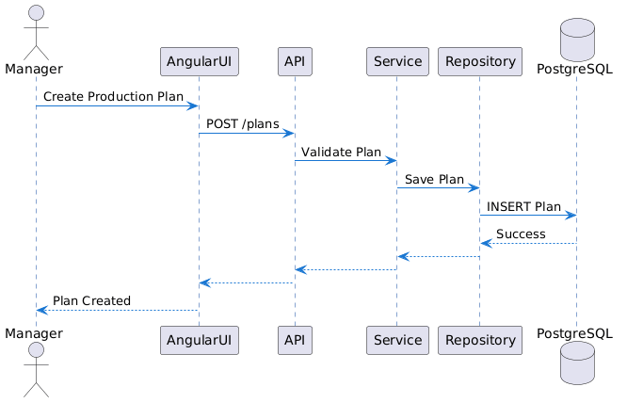

Activity Diagram

