AFSM Diagram and Description

1. AFSM State Diagram

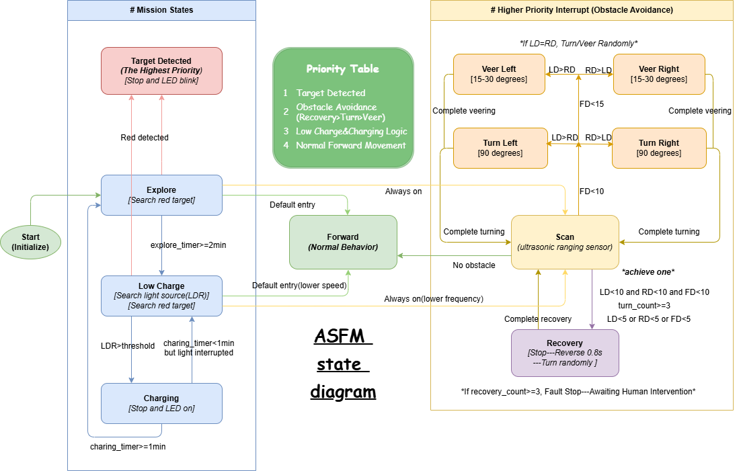

2. State Descriptions
State | Description
Start | All hardware is initialized (servos, ultrasonic sensor, color sensor, LDR, LED), the scan servo is centred, and all timers are reset. Unconditionally transitions to Explore once initialisation is complete.
Explore | Normal exploration mode. The robot walks forward (Forword sub-state, full speed) while continuously scanning for obstacles (Scan sub-state, always on). The TCS3200 color sensor checks for the red target all the time. A 2-minute explore timer starts on entry. Exit: red_detected → Target Detected; explore_timer >= 2 min → Low Charge.
Low Charge | Simulated low-battery mode entered after 2 minutes of exploration without finding the red target. The robot continues exploring at reduced speed (Forward, lower speed) with Scan still active(decrease frequency slightly). LDR monitoring for high-intensity light is now enabled. Red target detection remains active. Exit: LDR > threshold → Charging; red_detected → Target Detected.
Charging | Simulated charging state. The robot stops all movement and remains stationary. Monitors LDR continuously. Obstacle avoidance is NOT active in this state, and the LED steady on. Exit: charging_timer >= 1 min & light still present → Explore; light interrupted before 1 min → Low Charge.
Target Detected | The end state with the highest priority. Triggered when the TCS3200 color sensor detects a red patch. The robot stops all movement immediately, and the on-board LED blinks continuous. No outgoing transitions.

State | Description
Scan | Uses the HC-SR04 ultrasonic sensor on a scanning servo to measure distances in three directions: FD (front, 90°), LD (left, 30°), and RD (right, 150°). Always active during Explore and Low Charge. Feeds distance data to the obstacle avoidance decision logic. FD >= 15 cm & LD/RD clear → Forward; obstacle detected → Turn or Veer; all directions blocked → Recovery.
Forward | Default walking gait using four leg servos. Lowest priority behaviour. Full speed in Explore, reduced speed in Low Charge. Activated as a parallel sub-state by Explore and Low Charge. Exit: obstacle → Turn/Veer ; stuck → Recovery.
Turn Left | 90-degree left turn manoeuvre. Triggered when an obstacle is detected ahead and the left side has more clearance (LD > RD). After completing the turn, the scan re-checks the forward path. Exit: path clear → Forward/Scan; still blocked → Veer Left/Right; turn_count >= 3 → Recovery.
Turn Right | 90-degree right turn manoeuvre. Triggered when an obstacle is detected ahead and the right side has more clearance (RD > LD). After completing the turn, the scan re-checks the forward path. Exit: path clear → Forward/Scan; still blocked → Veer Left/Right; turn_count >= 3 → Recovery.
Veer Left | 15–30 degree slight left turn. Triggered when the right side has less clearance after a Turn Left, or when a minor adjustment is needed (RD > LD with obstacle ahead). This is a smoother, smaller correction than a full turn. Exit: veering complete → Scan/Forward; still blocked → Turn; turn_count >= 3 → Recovery.
Veer Right | 15–30 degree slight right turn. Triggered when the left side has less clearance after a Turn Right, or when a minor adjustment is needed (LD > RD with obstacle ahead). This is a smoother, smaller correction than a full turn. Exit: veering complete → Scan/Forward; still blocked → Turn; turn_count >= 3 → Recovery.
Recovery | Safety state triggered when the robot is stuck: three consecutive failed avoidance attempts (turn_count >= 3), or all three ultrasonic directions are blocked (LD < 10 & RD < 10 & FD < 10), or any direction is dangerously close (LD < 5 or RD < 5 or FD < 5). The robot reverses for approximately 1 second, then performs a random turn. Exit: recovery complete & path clear → Scan/Forward; recovery_count >= 3 → Fault Stop (awaiting human intervention).

3. Transition Table

3.1 Mission State Transitions
Source | Target | Condition | Description
Start | Explore | init_complete | Hardware initialised, servos centred, timers reset.
Explore | Low Charge | explore_timer >= 2 min | 2-minute exploration timer expired without red target.
Explore | Target Detected | red_detected | TCS3200 detects red patch. Immediate stop + LED blink.
Low Charge | Charging | LDR > threshold | High-intensity light detected — robot stops to simulate charging.
Low Charge | Target Detected | red_detected | TCS3200 detects red patch in low-battery mode.
Charging | Explore | charging_timer >= 1 min & light_present | Full 1-minute charge under continuous light.
Charging | Low Charge | light_interrupted (timer < 1 min) | Light removed before charge complete.

3.2 Obstacle Avoidance Transitions
Source | Target | Condition | Description
Explore | Forward | default entry (parallel) | Explore activates Forward at full speed.
Explore | Scan | always on (parallel) | Explore activates Scan for continuous ultrasonic detection.
Low Charge | Forward | default entry, lower speed (parallel) | Low Charge activates Forward at reduced speed.
Low Charge | Scan | always on, lower frequency (parallel) | Low Charge activates Scan.
Scan | Turn Left | FD < 15 cm & LD > RD | Obstacle ahead, left side has more clearance.
Scan | Turn Right | FD < 15 cm & RD > LD | Obstacle ahead, right side has more clearance.
Scan | Veer Left | obstacle & RD > LD (minor adjustment) | Slight left correction needed.
Scan | Veer Right | obstacle & LD > RD (minor adjustment) | Slight right correction needed.
Scan | Recovery | LD<10 & RD<10 & FD<10, or LD<5 or RD<5 or FD<5, or turn_count>=3 | All directions blocked, dangerously close, or repeated failures.
Turn Left | Scan | complete turning | Turn finished, re-scan environment.
Turn Left | Recovery | turn_count >= 3 | Three consecutive failed left turns.
Turn Left | Veer Right | RD > LD | After turn, right side needs minor correction.
Turn Right | Scan | complete turning | Turn finished, re-scan environment.
Turn Right | Recovery | turn_count >= 3 | Three consecutive failed right turns.
Turn Right | Veer Left | LD > RD | After turn, left side needs minor correction.
Veer Left | Scan | complete veering | Veering finished, re-scan environment.
Veer Left | Recovery | turn_count >= 3 | Repeated veer failures.
Veer Right | Scan | complete veering | Veering finished, re-scan environment.
Veer Right | Recovery | turn_count >= 3 | Repeated veer failures.
Recovery | Scan | recovery complete & path clear | Backup + random turn completed, path now clear.
Recovery | Fault Stop | recovery_count >= 3 | Robot is completely stuck — awaiting human intervention.
*Any obstacle state | Forward | path clear | When path is confirmed clear, return to default forward movement.

Note: If LD = RD, the robot turns or veers randomly. All obstacle avoidance states share the turn_count counter, which resets to 0 when the robot returns to Forward. Recovery has its own recovery_count.

4. Priority & Timers

4.1 Priority Table
Priority | Behaviour | States | Note
1 (Highest) | Target Detection | Target Detected | Red detected → immediate stop, preempts everything.
2 | Obstacle Avoidance | Scan, Turn Left, Turn Right, Veer Left, Veer Right, Recovery | Active in Explore and Low Charge only (NOT in Charging). Internal priority: Recovery > Turn > Veer.
3 | Charging Logic | Charging, Low Charge | LDR-based light detection and simulated charging.
4 (Lowest) | Normal Movement | Forward | Default walking gait, most easily interrupted.

4.2 Timers
Timer | Duration | Trigger | Action
Explore Timer | 2 minutes | Entry to Explore | Timer expires → transition to Low Charge.
Charging Timer | 1 minute | Entry to Charging | Timer expires & light present → return to Explore; light interrupted before 1 min → return to Low Charge.
LED Blink Timer | 500 ms toggle | Entry to Target Detected | Non-blocking LED toggle using ticks_ms().
Turn Count | count >= 3 | Each failed avoidance attempt | Triggers Recovery state. Resets on return to Forward.
Recovery Count | count >= 3 | Each Recovery entry | Triggers Fault Stop (awaiting human intervention).

5. Pseudocode
The pseudocode below describes the four main mission states, following the style shown in the assignment brief.

5.1 Explore State
if State == "Explore"
while explore_timer != 2 min AND target != found
# Parallel: Forward (full speed) + Scan (always on)
if object_detection == False
go forward (full speed)
else
avoid_obstacle() # Turn / Veer / Recovery
if target == found
change state to "Target Detected"
else
reset explore timer to 0
change state to "Low Charge"

5.2 Low Charge State
if State == "Low Charge"
while target != found
# Parallel: Forward (reduced speed) + Scan (always on) + LDR check
if LDR > threshold
change state to "Charging"
if object_detection == False
go forward (reduced speed)
else
avoid_obstacle() # Turn / Veer / Recovery
if target == found
change state to "Target Detected"

5.3 Charging State
if State == "Charging"
# Robot is stationary, no obstacle avoidance
while charging_timer != 1 min
if light interrupted
change state to "Low Charge"
# charging_timer == 1 min AND light still present
reset explore timer to 0
change state to "Explore"

5.4 Target Detected State
if State == "Target Detected"
stop all movement
while True
blink LED every 500 ms # non-blocking
# Terminal state — no further transitions

