FINA4340A · STRUCTURED PRODUCTS: FUNDAMENTALS AND ANALYSIS
HOMEWORK · YIELD CURVE PCA
The Curve
in Three Moves

Principal-component analysis of the US Treasury curve — and the week in March 2023 when the banking system, and the Fed path, repriced.
PREPARED BY | Marcus Chan
DATA | US Treasury · CBOE · S&P Dow Jones Indices
SAMPLE / EVENT | 4 Oct 1993 – 8 Mar 2023 / 9–17 Mar 2023

October 2026
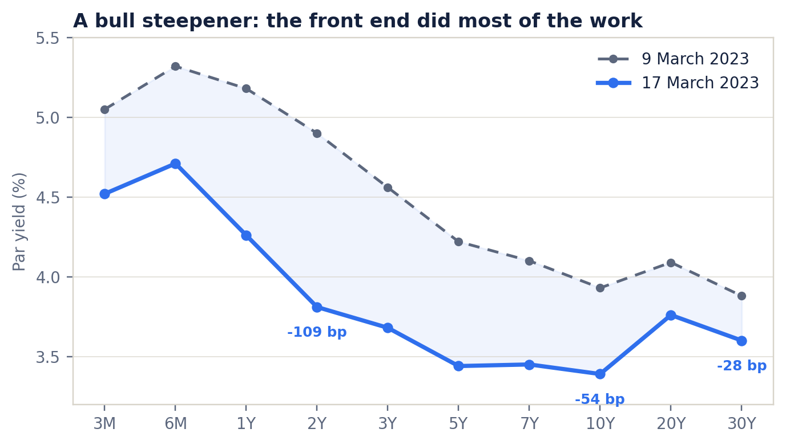
The 9 March and 17 March 2023 Treasury curves. The front end fell much more than the long end: a bull steepener.
Source: US Department of the Treasury, daily par yield curve rates.

CONTENTS
A short tour of the argument
01 Executive summary The answer in one page
02 1. Data and method Tenors, sample, first differences, covariance PCA
03 2. The three factors What level, slope and curvature look like
04 3. The March 2023 move Yields, factor scores and the 3-factor fit
05 4. What was driving it? Flight to quality, the Fed path and global bank stress
06 5. The interactive toy The 3-factor playground and how to use it
07 6. Caveats and conclusion What PCA can and cannot tell us
08 7. Optional: 3-year SPX PPN Call-spread structure, pricing and term sheet
09 Appendix Full loadings, data notes and references

HOW TO USE THIS REPORT
Read the executive summary for the result. Sections 1–3 contain the method and the quantitative decomposition. Section 4 explains the news flow. Section 5 describes the interactive companion, and Section 7 is the optional PPN extension. The appendix has the full loading table and sources.

THE SHORT ANSWER

Executive summary

The US Treasury curve did not make a parallel shift in March 2023. It made a large bull move, but the front end fell much more than the long end, so the curve steepened sharply. That shape is exactly what a three-factor PCA is designed to separate: a big level shock, a positive slope shock, and a smaller curvature twist.
2Y YIELD | 10Y YIELD | 2S10S | VIX
−109 bp  4.90% → 3.81% | −54 bp  3.93% → 3.39% | +55 bp  −97 → −42 bp | +12.8%  22.6 → 25.5, peak 26.5

The three factors explain 96.0% of the variance of daily yield changes in the 1993–2023 sample: PC1 (level) 67.9%, PC2 (slope) 23.4%, and PC3 (curvature) 4.7%. For the 9→17 March move, the factor scores are −208 bp on PC1, +66.5 bp on PC2 and +39.4 bp on PC3. In daily-standard-deviation units, that is approximately −14σ, +7.6σ and +10σ — a very large, cumulative six-session move.
PC1 does most of the work: it contributes about −75 bp at the 10Y and explains 87% of the raw squared yield changes. But PC2 and PC3 are what make the move a steepener rather than a parallel rally. PC2 adds about +28 bp to 2s10s, and PC3 adds about +21 bp. The 10Y fit is almost exact (−54.4 bp versus −54.0 bp actual), while the 2Y is the hardest point: the model predicts −99.5 bp against −109.0 bp actual, a 9.5 bp residual.
BOTTOM LINE
The week was a classic flight-to-quality and Fed-repricing event: a large negative level shock plus a positive slope shock, with a smaller twist. Three factors capture the broad shape, but not every front-end idiosyncrasy. The 2Y residual is a useful reminder that PCA is a summary, not a structural model.

The main drivers were the failure of Silicon Valley Bank and the emergency official response, a sharp repricing of the expected Fed path, and the global bank-stress episode around Credit Suisse. February CPI, released on 14 March, was roughly in line and did not reverse the move. Equities were volatile but ended the week almost flat; this was primarily a rates and bank-risk event, not a broad equity sell-off.
The companion interactive toy turns the same three factors into a hands-on curve. Three sliders change PC1, PC2 and PC3; a “Solo” button isolates each factor; a preset replays the SVB week; and a day-by-day timeline shows the actual path. It is a static site, so it can be published directly on GitHub Pages.

HOW THE CURVE WAS DECOMPOSED

1 Data and method

1.1 Data and sample
I use the US Treasury’s daily par yield curve rates for ten constant maturities: 3M, 6M, 1Y, 2Y, 3Y, 5Y, 7Y, 10Y, 20Y and 30Y. Yields are in percent, so a change from 4.90 to 3.81 is recorded as −109 bp. The full file covers 1990–2023. The PCA is estimated on daily first differences through 8 March 2023, the day before the event window, so the event is not used to fit the factors.
The complete-case sample starts on 4 October 1993, when the 20Y tenor becomes available, and contains 6,364 daily changes. The 30Y was discontinued between 2002 and 2006; those observations are omitted rather than filled. The event window uses 7 closing dates, from 9 March to 17 March 2023 (six overnight changes). The 30Y is included because the long end’s muted response is part of the story.

1.2 Estimation
Let yₜ(τ) be the yield at maturity τ on day t, and Δyₜ = yₜ − yₜ₋₁. I estimate the sample covariance matrix of Δy and take its first three eigenvectors. Because all tenors are in the same units, I do not standardise the changes; standardising would give the short end more weight and change the economic interpretation. The loadings are normalised to unit length, so the factor score is in yield units and the product loading × score is in percentage points.
THE MODEL
Δy(τ) ≈ s₁ · PC1(τ) + s₂ · PC2(τ) + s₃ · PC3(τ). The level on the screen is y(τ) = y₀(τ) + Σ sⱼ · PCⱼ(τ), where y₀ is the 9 March 2023 curve.

I choose signs so that PC1 is a level shift (all loadings positive), PC2 is a steepener (long-end loading positive, short-end negative), and PC3 is a twist with a negative 5Y loading. These are labels for interpretation, not restrictions from the data. The event decomposition projects the 9→17 March change vector onto the pre-event loadings: sⱼ = PCⱼ′ · Δy. Because the three PCs are orthogonal, the contributions add up; the residual is what the three factors miss.

1.3 What the factors explain
Factor | Variance explained | Cumulative | Std. dev. of score
PC1 | 67.9% | 67.9% | 14.9 bp
PC2 | 23.4% | 91.2% | 8.8 bp
PC3 | 4.7% | 96.0% | 3.9 bp
PC4–PC10 | 4.0% | 100.0% | —
Table 1. PCA variance shares, daily changes, 4 Oct 1993 – 8 Mar 2023.
The first three factors explain 96.0% of the sample variance. The standard deviation is for the daily factor score, not for a yield.
The 96.0% figure is high, but it is not a guarantee that three factors will fit a particular episode. The March 2023 move was extreme and concentrated at the front end, which is exactly where a three-factor approximation is most likely to leave a residual.
LEVEL, SLOPE AND A TWIST

2 The three factors

Figure 1 plots the loadings. The blue line is the level factor: every tenor has a positive loading, with the largest values around 5–7Y. A positive PC1 score raises the whole curve; a negative score lowers it. This is the “parallel” factor, although it is not perfectly flat: the long end moves a little less than the belly.
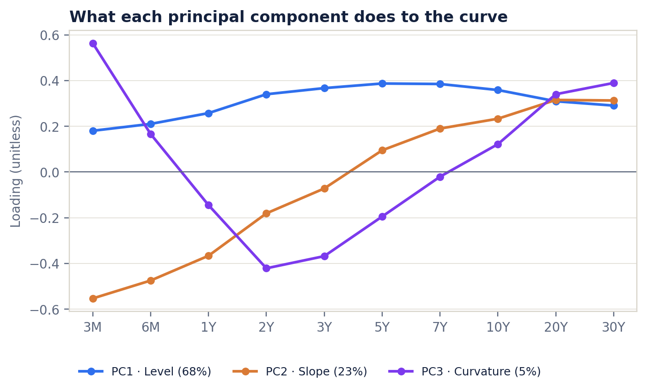
Figure 1. The first three principal-component loadings. PC1 is level, PC2 is slope and PC3 is a wings-versus-belly twist.
Estimated from daily changes in ten US Treasury par yields, 4 Oct 1993 – 8 Mar 2023.
Level. PC1 is the largest factor at 67.9% of variance. A one-standard-deviation PC1 score is 14.9 bp; multiplied by the 10Y loading of 0.359, that is about 5.4 bp at the 10Y. The factor is not a pure parallel shift because the 5Y loading (0.387) is higher than the 30Y loading (0.291), so a level shock also changes the curve’s shape a little.
Slope. PC2 explains 23.4%. Its loadings run from −0.553 at 3M to +0.313 at 30Y, crossing zero near 5Y. A positive score is a steepener: the long end rises relative to the short end (or the short end falls more). A one-standard-deviation score is 8.8 bp and moves 2s10s by about 3.6 bp. This is the factor that captures growth, term-premium and Fed-path news.
Curvature. PC3 explains 4.7% and is the most interesting shape. The loadings are +0.564 at 3M, −0.421 at 2Y, −0.195 at 5Y, +0.122 at 10Y and +0.389 at 30Y. A positive score therefore pushes the very front end and the long end up, while the 2–5Y sector falls. It is a twist, not a textbook 2s5s10s butterfly. I label it “curvature” because it changes the shape of the curve at a smaller scale; the label is descriptive.
The fact that PC1 is 68%, rather than the 80–90% often quoted for US yields, is not a mistake. The sample includes the 2020–23 period, when front-end volatility was extraordinary, and the curve has ten tenors including the 20Y and 30Y. A shorter sample or a 2Y–10Y-only curve would produce a larger first factor. The economic interpretation is unchanged.
A BULL STEEPENER, NOT A PARALLEL RALLY

3 The March 2023 move

3.1 What happened to the curve
On 9 March 2023 the 2Y par yield was 4.90% and the 10Y was 3.93%. By 17 March the 2Y was 3.81% and the 10Y was 3.39%. The 2Y fell 109 bp, the 10Y 54 bp and the 30Y only 28 bp. The 2s10s spread moved from −97 bp to −42 bp, a 55 bp steepening. The 3M–10Y spread was almost unchanged (−112 bp to −113 bp), because the very front end and the 10Y fell by similar amounts. The 5Y butterfly (2×5Y − 2Y − 10Y) moved from −39 bp to −32 bp, a modest 7 bp cheapening of the belly.
Figure 2. The Treasury curve on 9 and 17 March 2023. The front end led the rally and the long end stayed relatively anchored.
Source: US Department of the Treasury. Par yields, percent.

3.2 The factor decomposition
Table 2 reports the full decomposition. The 3-factor fit explains 95.4% of the cross-sectional variation around the mean, and it is close at the 10Y and 30Y. It misses the 2Y by 9.5 bp and the 3Y by 7.7 bp. The pattern is not random: the front end moved in a way that the first three factors — estimated on a long sample — do not fully capture. The 2Y residual is the largest single error.
Tenor | 9 Mar | 17 Mar | Δ bp | PC1 | PC2 | PC3 | Fit | Resid.
3M | 5.05 | 4.52 | -53.0 | -37.6 | -36.8 | +22.2 | -52.2 | -0.8
6M | 5.32 | 4.71 | -61.0 | -43.8 | -31.6 | +6.5 | -68.9 | +7.9
1Y | 5.18 | 4.26 | -92.0 | -53.7 | -24.4 | -5.7 | -83.7 | -8.3
2Y | 4.90 | 3.81 | -109.0 | -70.9 | -12.0 | -16.6 | -99.5 | -9.5
3Y | 4.56 | 3.68 | -88.0 | -76.4 | -4.8 | -14.5 | -95.7 | +7.7
5Y | 4.22 | 3.44 | -78.0 | -80.6 | +6.3 | -7.7 | -82.0 | +4.0
7Y | 4.10 | 3.45 | -65.0 | -80.2 | +12.6 | -0.8 | -68.4 | +3.4
10Y | 3.93 | 3.39 | -54.0 | -74.7 | +15.5 | +4.8 | -54.4 | +0.4
20Y | 4.09 | 3.76 | -33.0 | -64.5 | +21.0 | +13.4 | -30.1 | -2.9
30Y | 3.88 | 3.60 | -28.0 | -60.5 | +20.8 | +15.3 | -24.4 | -3.6
Table 2. Yields and the 3-factor decomposition, 9 → 17 March 2023 (bp).
PC1/PC2/PC3 columns are loading × score. Fit is their sum; residual is actual minus fit. Rows may not add exactly because of rounding.
The factor scores are large because they are cumulative over six sessions. PC1 is −208 bp, or −14.0 daily standard deviations. PC2 is +66.5 bp (+7.6σ), and PC3 is +39.4 bp (+10.0σ). The score magnitudes should not be read as one-day shocks: a −14σ move over a week is unusual but not impossible when the level factor is measured on daily changes.
Factor | Score | Size | Share of squared Δy | 10Y contrib. | 2s10s contrib. | 5Y fly contrib.
PC1 | -208.4 | -14.0σ | 87.3% | -74.7 | -3.8 | -15.7
PC2 | +66.5 | +7.6σ | 8.9% | +15.5 | +27.5 | +9.2
PC3 | +39.4 | +10.0σ | 3.1% | +4.8 | +21.4 | -3.6
Residual | — | — | 0.7% | +0.4 | +9.9 | +17.1
Actual | — | — | 100.0% | -54.0 | +55.0 | +7.0
Table 3. Factor scores and their contributions to the 10Y yield, 2s10s and the 5Y butterfly (bp).
Share is each factor’s squared contribution divided by the squared actual change vector. Residual is the part not explained by the three factors.
There are two different “shares” in this report, and they answer different questions. The 67.9% in Table 1 is the share of sample variance explained by PC1 over 1993–2023. The 87.3% in Table 3 is the share of the squared yield changes in this particular event. The event is even more level-dominated than the average day: PC1 accounts for 87%, PC2 9% and PC3 3% of the raw squared changes, with 0.7% left in the residual.
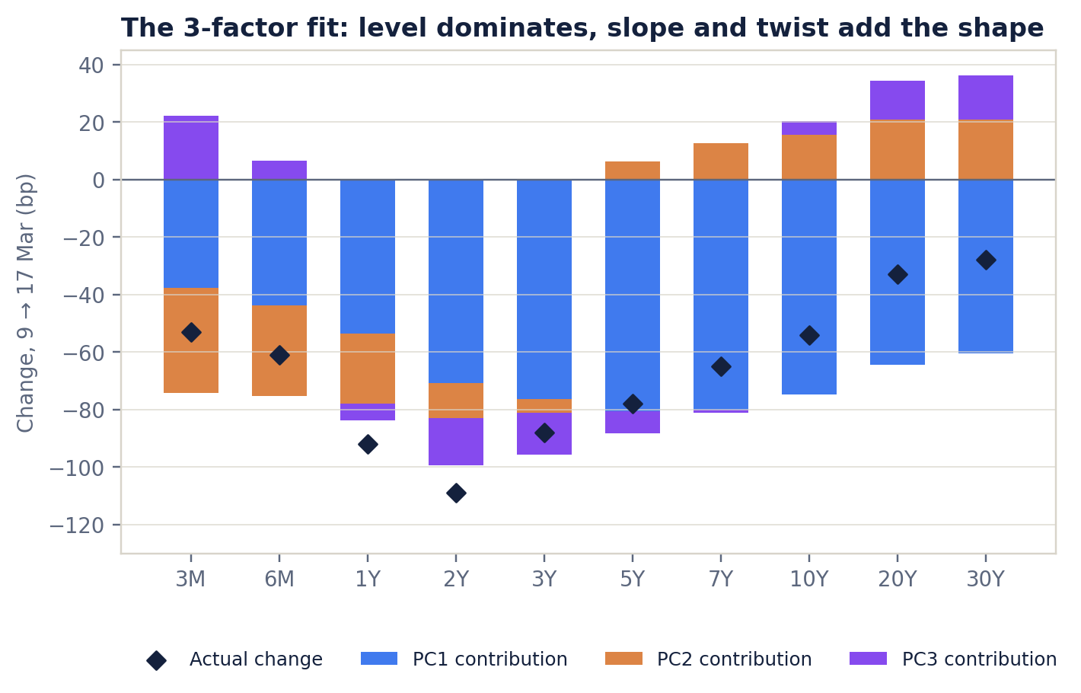
Figure 3. The 3-factor decomposition by tenor. Blue is level, orange is slope and purple is curvature; the diamond is the actual change.
A positive bar raises the yield; a negative bar lowers it. The 2Y residual is the largest miss.
The slope decomposition is the most useful part. PC1 actually flattens 2s10s by 3.8 bp, because its belly loading is higher than its 10Y loading: a level rally pulls the 5Y down more than the 10Y. PC2 then adds 27.5 bp and PC3 adds 21.4 bp. The residual adds 9.9 bp. So the steepening is not a pure “slope factor” story: the twist also did a lot of work at the front end. This is why the 2Y residual is large.
The 5Y butterfly decomposition is less clean. PC1 reduces the fly by 15.7 bp (the belly rallies more than the wings), PC2 adds 9.2 bp and PC3 subtracts 3.6 bp, leaving a 17.1 bp residual. The 3-factor model therefore captures the direction of the move but not the precise curvature. A 4th or 5th factor would reduce the residual only modestly; the front-end move is genuinely idiosyncratic relative to the long sample.
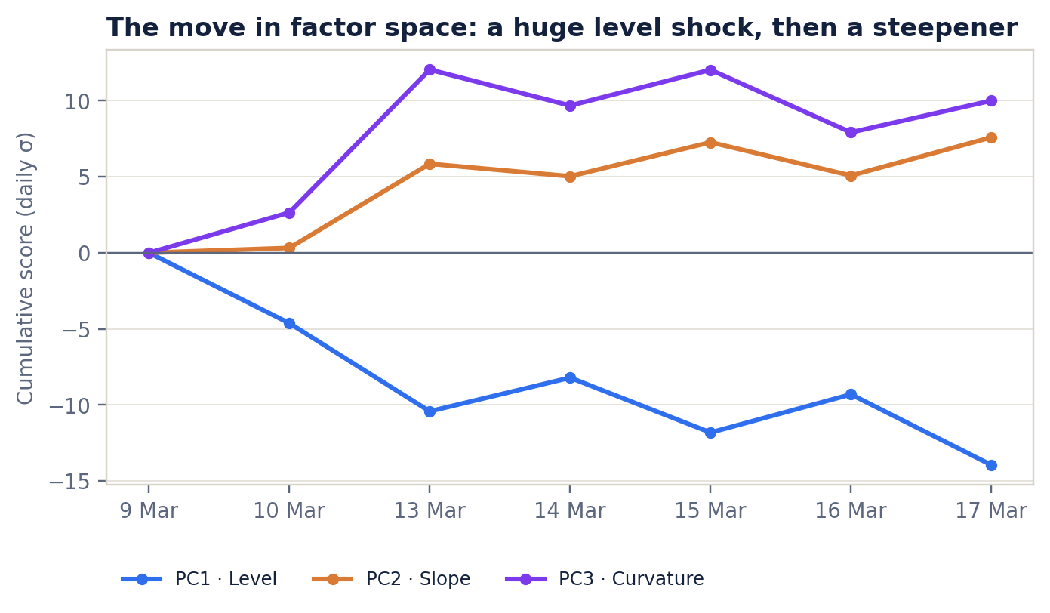
Figure 4. Cumulative factor scores during the event window, in daily standard deviations.
The level factor falls almost monotonically; the slope factor jumps on 13 March and stays positive; the curvature factor spikes at the same time.

A BANK SHOCK, A FED REPRICING AND A GLOBAL FLIGHT TO QUALITY

4 What was driving it?

The PCA tells us the shape of the move. It does not tell us the news that caused it. The event window contains several overlapping shocks, and the timing of the daily moves helps identify them.
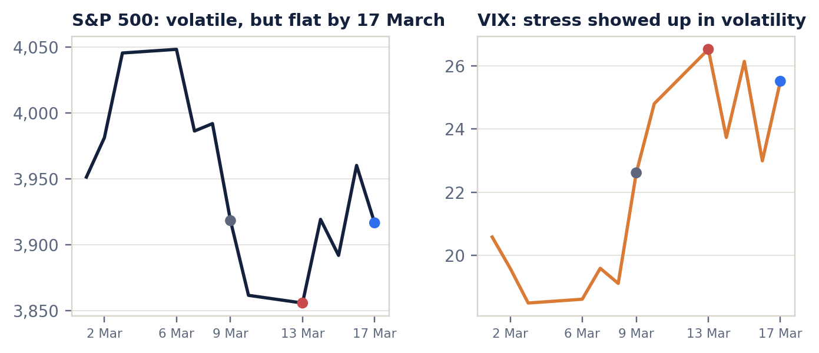
Figure 5. The S&P 500 and the VIX around the event. Equities were volatile but ended the week almost flat; volatility stayed elevated.
Source: S&P Dow Jones Indices via FRED; CBOE VIX historical data.

4.1 Flight to quality: SVB and the official backstop
Silicon Valley Bank was closed by California regulators on 10 March 2023, and the FDIC was appointed receiver. On 12 March, the Treasury, the Federal Reserve and the FDIC announced that all depositors of SVB and Signature Bank would be made whole, and the Fed created the Bank Term Funding Program (BTFP) to provide liquidity against high-quality collateral. These actions reduced the risk of a systemic deposit run, but they did not remove the shock to bank funding and credit supply.
The immediate market response was a large safety bid for Treasuries. Yields fell across the curve, which is the negative PC1 contribution. The front end fell more because it is most sensitive to the expected policy path and to the banking system’s demand for liquidity. That is the positive PC2 contribution. The long end fell less because inflation and fiscal risk did not disappear; the 30Y fell only 28 bp. This is the classic signature of a flight-to-quality rally that is concentrated at the front end.

4.2 The Fed path repriced
Before the SVB failure, the market was still debating how high the Fed would go and how long it would hold. During the week, the 2Y yield — the closest liquid proxy for the expected policy path — fell 109 bp. That is much larger than the 54 bp fall at the 10Y. Investors moved from “higher for longer” toward “the hiking cycle is near its end, and cuts may come later in 2023.” The exact terminal-rate numbers are not needed to make the point: the relative move in the 2Y is the evidence.
This is why the slope factor is positive even though the level factor is negative. A standard bear flattener (higher policy rates, long end anchored) has a negative PC2. A bull steepener (lower policy rates, long end anchored) has a positive PC2. March 2023 was the second kind.

4.3 Global bank stress and the ECB
The stress became global on 15 March, when Credit Suisse’s shares fell sharply and the Swiss National Bank offered a liquidity backstop. The ECB raised rates by 50 bp on 16 March, but the bank-stress channel dominated the market reaction. The combination of a European bank scare and a central bank that was still hiking added to the demand for safe assets, while keeping the long end relatively anchored.
The 14 March US CPI release was roughly in line (February CPI rose 0.4% m/m and 6.0% y/y). Yields actually rebounded a little that day as the first panic faded. That is useful: the data was not the main driver. The event was a financial-stability shock, not a pure inflation shock.

4.4 A short timeline
- 9 Mar. SVB’s capital raise fails; bank stocks weaken. 2Y 4.90%, 10Y 3.93%, VIX 22.6.
- 10 Mar. SVB is closed; FDIC appointed receiver. 2Y 4.60%, 10Y 3.70%.
- 12 Mar. Treasury/Fed/FDIC protect depositors; BTFP announced.
- 13 Mar. First trading day after the backstop. 2Y 4.03%, 10Y 3.55%, VIX peaks at 26.5.
- 14 Mar. February CPI roughly in line; yields rebound a little. 2Y 4.20%, 10Y 3.64%.
- 15 Mar. Credit Suisse crisis; SNB liquidity backstop. 2Y 3.93%, 10Y 3.51%.
- 16 Mar. ECB hikes 50 bp; bank stress dominates. 2Y 4.14%, 10Y 3.56%.
- 17 Mar. Week ends in a bull steepener. 2Y 3.81%, 10Y 3.39%, 30Y 3.60%.
CAUSALITY CAVEAT
PCA is a statistical decomposition, not a structural model. The labels “level”, “slope” and “curvature” are interpretations of the eigenvectors. The event is consistent with a large negative level shock, a positive slope shock and a twist, but the method cannot prove that SVB “caused” a particular factor score. The news flow and the timing of the daily moves are the evidence for the narrative.

A THREE-DIAL CURVE, WITH THE MARCH WEEK BUILT IN

5 The interactive toy

The Word report is the static analysis. The companion site is the toy: a single-page, dependency-free web app that lets the reader move the three factors and see the curve, the change by tenor, and a plain-English readout. It uses the same loadings, base curve and event data as this report.
The model on screen is y(τ) = y₀(τ) + Σ sⱼ · PCⱼ(τ), where y₀ is the 9 March 2023 curve. The sliders are in units of the daily standard deviation of each factor, so a −14σ PC1 move is the same size as the level shock in the event. The toy does not re-estimate the PCA in the browser; it uses the precomputed loadings, which keeps it fast and reproducible.

5.1 What the reader can do
- Move PC1, PC2 and PC3. The curve animates, the 10Y/2s10s/5Y-fly metrics update, and the “who feels it” panel shows whether a duration position, a steepener or a bullet-versus-barbell position wins.
- Press “SVB week” to set the sliders to the actual event scores. The fitted curve is drawn solid and the actual 17 March curve is dotted, so the residual is visible.
- Press “Solo” on any factor to see that factor alone. This is the fastest way to learn the difference between a level shift, a steepener and a twist.
- Replay the week day by day. The timeline is synchronized with the chart, and the 2Y/10Y/2s10s readout shows how the market moved from 9 to 17 March.
- Reset to the 9 March base curve, or try the bull-steepener, bear-flattener and belly-twist presets.

5.2 Design and deployment
The site is static HTML, CSS and vanilla JavaScript. The data is embedded in a generated JavaScript file; there is no server, no database and no external chart library. That makes it easy to publish on GitHub Pages: put the folder in a repository, enable Pages on the main branch, and the site is live at the repository URL. The analysis scripts that produce the data and the Word report are included in the same folder.
FILES IN THE SUBMISSION
index.html — the toy. assets/style.css and assets/app.js — the interface and interactions. data/curve_data.js — the loadings, curves and event data. analysis/pca_yield_curve.py — the PCA and data build. analysis/ppn_pricing.py — the optional PPN pricing. report/Yield_Curve_PCA_Report.docx — this document.

WHAT THE THREE FACTORS CAN AND CANNOT DO

6 Caveats and conclusion

Three factors are a good summary of the curve, but they are not a full model of the world. The main caveats are:
- The PCA is estimated on par yields, not zero-coupon yields. Par yields are the right data for the homework and for the curve shape, but a trader pricing bonds would bootstrap a zero curve. The factor interpretation is unaffected; the level of the fit could change slightly.
- The loadings are estimated over a long sample and held fixed for the event. That is the right way to avoid look-ahead bias, but it means the model may not reflect the market’s factor structure during a regime change. A rolling-window PCA would give different scores.
- The 2Y residual is 9.5 bp, and the 5Y-fly residual is 17.1 bp. The model captures the direction of the move, not every relative-value nuance. A 4th or 5th factor would reduce the residual only modestly, because the front-end move is genuinely unusual relative to the long sample.
- PCA is descriptive, not causal. The factor labels are economic interpretations. The event narrative is supported by the timing of the news and the daily yield moves, not by an identified structural shock.
None of these caveats changes the main answer. The March 2023 move was a large bull steepener: a dominant negative level shock, a positive slope shock, and a smaller twist. The level factor explains most of the variance, but the slope and curvature factors explain why the curve did not simply shift down in parallel. The official backstop, the Fed-path repricing and the global bank-stress episode are the most plausible drivers.

A CALL SPREAD WITH A 130% CAP

7 Optional: a 3-year SPX principal-protected note

This section is an indicative extension, not an offer. The structure is a three-year, 100% principal-protected note linked to the S&P 500 Index. The upside comes from a European 100–130% call spread. The note pays 100% of principal at maturity plus 100% participation in the index return between 100% and 130%; the maximum redemption is 130%. There is no downside participation, but the investor takes issuer credit risk.

7.1 Why a call spread?
A vanilla three-year at-the-money call would cost about 17.2% of notional at 22% volatility, which is more than the 10.5% option budget available after buying the zero-coupon bond floor. A call spread is cheaper because the investor gives up the upside above the cap. The 100–130% spread costs 9.56%, which fits the budget and still offers 100% participation. A wider 80–120% spread costs 17.9% and would only support about 59% participation; a 100–125% spread costs 8.41% and would support about 125% participation, but with a lower cap. The 100–130% structure is the balanced choice.

7.2 Pricing assumptions
Input | Value | Note
Spot (S₀) | 3,916.64 | S&P 500 close, 17 Mar 2023
Term (T) | 3.0 years | 17 Mar 2023 → 17 Mar 2026
Risk-free rate (r) | 3.70% | 3Y Treasury par yield 3.68%, rounded up
Dividend yield (q) | 1.50% | Assumption
Volatility (σ) | 22.0% | Long-dated vol; VIX 25.5 is short-dated
Principal protection | 100% | Zero-coupon bond floor
Table 4. Indicative pricing assumptions for the 3-year SPX note.
Black–Scholes call spread, continuous dividend yield, European exercise. Illustrative only.

7.3 Pricing
The zero-coupon bond floor is 100 · e^(−0.037×3) = 89.49. The 100% call costs 17.24% of notional; the 130% call costs 7.69%; the call spread is 9.56%. The fair value is 89.49 + 9.56 = 99.05. At an issue price of 100, the residual 0.95% covers fees and issuer margin. The maximum redemption is 130%, and the minimum at maturity is 100% (before issuer credit risk).
Component | Value | Method
Zero-coupon bond floor | 89.49% | 100 · e^(−rT)
100% call | 17.24% | Black–Scholes
130% call | 7.69% | Black–Scholes
100–130% call spread | 9.56% | 100% call − 130% call
Fair value | 99.05% | Floor + call spread
Fees / margin | 0.95% | Issue price 100 − fair value
Table 5. Indicative value of the 3-year SPX principal-protected note.
The note is shown at 100% of notional. The 0.95% residual is not a recommendation; it is the difference between fair value and issue price.
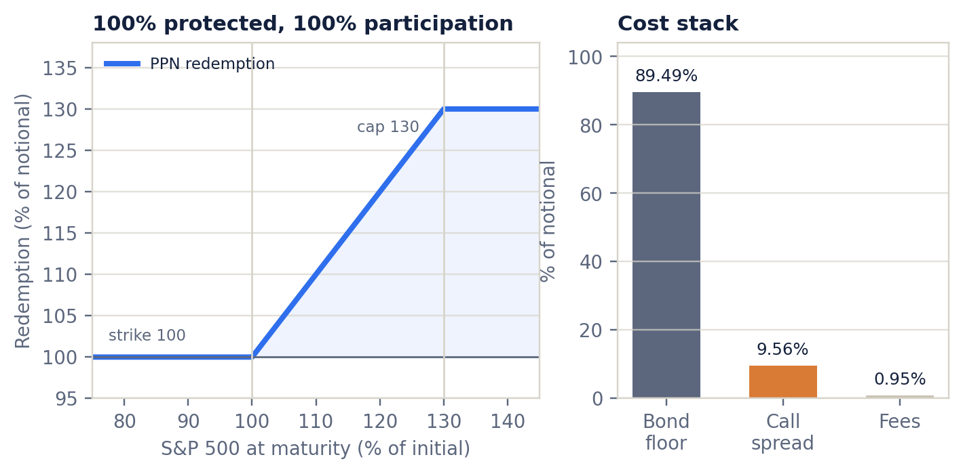
Figure 6. Payoff at maturity and the cost stack. The note is floored at 100% and capped at 130%; the call spread is the upside engine.
Indicative Black–Scholes valuation, 17 Mar 2023. Not an offer; issuer credit risk is not priced here.

7.4 What strikes could be offered
Structure | Cost | Participation* | Comment
80–120% call spread | 17.90% | 59.0% | wider strike range
100–125% call spread | 8.41% | 125.0% | higher participation, lower cap
100–130% call spread | 9.56% | 110.0% | base case: 100% participation, 130% cap
100–130% up-and-out call | 0.90% | n.m. | ~47% knock-out probability; principal still protected
Table 6. Strike alternatives at 22% volatility.
*Affordable participation before fees: option budget 10.51% divided by structure cost. The chosen 100–130% call spread supports 110% before fees; the term sheet uses 100% participation and a 0.95% fee. “n.m.” = not meaningful for the up-and-out because of the barrier.
The up-and-out alternative is instructive. A 100% strike, 130% barrier up-and-out call costs only 0.90% of notional at 22% volatility, because it knocks out in about 47% of simulated paths. A headline participation number would be misleading: in the knockout states the note returns only principal. The call spread is simpler to explain and has no path-dependent barrier risk, which is why it is the recommended structure for a retail-style PPN.

7.5 Indicative term sheet
Term | Indicative term
Issuer | SPV / issuer (not specified)
Issue date | 17 March 2023
Maturity | 17 March 2026
Underlying | S&P 500 Index (SPX)
Notional | USD 1,000,000
Issue price | 100%
Principal protection | 100% at maturity, subject to issuer credit risk
Participation | 100%
Cap | 130% of initial level
Strikes | 100% / 130% call spread, European
Initial level | 3,916.64
Settlement | Cash; max(100%, 100% + 100% × max(0, min(S_T/S₀, 1.30) − 1.00))
Fees | 0.95% included in issue price
Listing / secondary | None / indicative, issuer may provide
Credit risk | Issuer / guarantor
Table 7. Indicative term sheet. For discussion only; not an offer or a commitment to trade.
The payoff is principal-protected at maturity but is subject to the issuer’s credit risk. Secondary market prices may be below issue price.

7.6 Risks
- Issuer credit risk: the principal protection is only as good as the issuer. A default can result in a loss of principal.
- Capped upside: the investor gives up index returns above 130%. In a strong bull market, the note will underperform a direct index investment.
- No dividends: the note does not receive SPX dividends. The dividend yield assumption is embedded in the pricing.
- Secondary market risk: the note may be illiquid, and early sale may be at a discount to fair value.
- Model risk: the indicative value depends on the volatility, rate and dividend assumptions. A change in volatility changes the cost of the call spread and therefore the feasible participation.

TABLES, DATA NOTES AND REFERENCES

Appendix

A.1 Full PCA loadings
Tenor | PC1 | PC2 | PC3
3M | 0.180 | -0.553 | 0.564
6M | 0.210 | -0.475 | 0.166
1Y | 0.258 | -0.366 | -0.145
2Y | 0.340 | -0.181 | -0.421
3Y | 0.367 | -0.072 | -0.368
5Y | 0.387 | 0.095 | -0.195
7Y | 0.385 | 0.190 | -0.020
10Y | 0.359 | 0.233 | 0.122
20Y | 0.309 | 0.315 | 0.340
30Y | 0.291 | 0.313 | 0.389
Table A1. Full loading matrix. Columns are orthonormal; the square of each column sums to one.
Estimated from daily changes, 4 Oct 1993 – 8 Mar 2023.

A.2 Data notes
Treasury par yields are constant-maturity, coupon-bearing par yields, not zero-coupon yields. The 20Y tenor begins in October 1993. The 30Y was discontinued between 2002 and 2006; complete-case estimation therefore omits those dates. The event data are the 4 p.m. Treasury par yield curve rates. The VIX is the CBOE close; the S&P 500 is the daily close from S&P Dow Jones Indices via FRED. All calculations are in Python (pandas, NumPy); the website uses only vanilla JavaScript.
The PCA is estimated on daily first differences. The covariance matrix is not standardised. Signs are chosen for readability: PC1 all-positive (level), PC2 long-end positive (steepener), PC3 5Y negative (twist). The event scores are projections of the cumulative 9→17 March change onto the pre-event loadings. The fit is the sum of the three contributions; the residual is actual minus fit.

A.3 References
[1] US Department of the Treasury. Daily Treasury Par Yield Curve Rates. https://home.treasury.gov/resource-center/data-chart-center/interest-rates/TextView?type=daily_treasury_yield_curve
[2] Board of Governors of the Federal Reserve System. “Joint Statement by Treasury, Federal Reserve, and FDIC,” 12 March 2023. https://www.federalreserve.gov/newsevents/pressreleases/monetary20230312b.htm
[3] FDIC. “FDIC Creates a Deposit Insurance National Bank of Santa Clara to Protect Insured Depositors of Silicon Valley Bank,” 10 March 2023. https://www.fdic.gov/news/press-releases/2023/pr23016.html
[4] CNBC. “Treasury yields dip as investors consider outlook for bank stocks, monetary policy,” 17 March 2023. https://www.cnbc.com/2023/03/17/us-treasury-yields-investors-consider-outlook-for-bank-stocks.html
[5] BIS. “Christine Lagarde: ECB press conference — introductory statement,” 16 March 2023. https://www.bis.org/review/r230316h.htm
[6] US Bureau of Labor Statistics. “Consumer Price Index — February 2023,” 14 March 2023. https://www.bls.gov/news.release/archives/cpi_03142023.htm
[7] CBOE. VIX historical data. https://www.cboe.com/tradable_products/vix/vix_historical_data/
[8] Federal Reserve Bank of St. Louis (FRED). S&P 500 (SP500). https://fred.stlouisfed.org/series/SP500
[9] Litterman, R. and Scheinkman, J. (1991). “Common Factors Affecting Bond Returns.” Journal of Fixed Income, 1(1), 54–61.

A.4 Files
Path | Contents
index.html | Interactive three-factor curve toy
assets/style.css, assets/app.js | Styling and interactions
data/curve_data.js | Loadings, base/event curves and event data
data/curve_data.json | Same data in JSON
analysis/pca_yield_curve.py | PCA, decomposition and report figures
analysis/ppn_pricing.py | Optional PPN pricing and payoff chart
report/figures/ | Report figures (PNG, 220 dpi)
report/tables/ | Event decomposition, loadings and PPN tables (CSV)
Table A2. Submission files.
The site is static; publish the folder root on GitHub Pages and open index.html.

