Standard Operating Procedure Document
- SOP Card
SCHRODERS_ID | SGSY009
RDS_ID | 44
Client | Algebra
Category | Performance Summary
Business | Institutional
Mandate Code | QA22681 (QA22681000, QA22681100, QA22681200)
Fund Code | N/A
Type | Bespoke
Frequency | Monthly
Due Date | BD7

- Procedure
Obtain the performance files for the related mandate codes, summarize those in an email, and send them to the Client Executive.
Step | Action | Notes | Screenshot
1 | Let’s start by obtaining the performance files that we’ll need.  Go to the usual performance folder for QA mandate codes, which is https://s365.sharepoint.com/sites/acc-control-perf/PerformanceReport2025/Forms  And then, navigate to the folder corresponding to the reporting month and locate the following files:  - PerfReport_YYYYMMDD_MTH_1_QA22681000.xlsx  - PerfReport_YYYYMMDD_MTH_1_QA22681100.xlsx  - PerfReport_YYYYMMDD_MTH_1_QA22681200.xlsx  Where YYYYMMDD represents the last day of the reporting month, like in “20250331” | In the example, we are looking for Mar 2025 files, so we need to download these three files:  - PerfReport_20250331_MTH_1_QA22681000.xlsx  - PerfReport_20250331_MTH_1_QA22681100.xlsx  - PerfReport_20250331_MTH_1_QA22681200.xlsx | 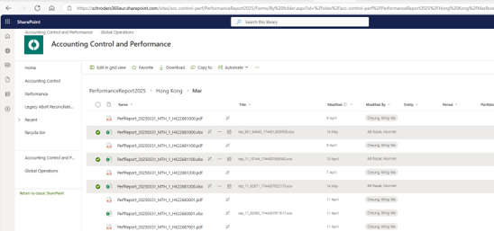
2 | Download all three performance files into the output folder for this client, and for the corresponding month.  This would be in the Algebra folder: https://s365eur.sharepoint.com/sites/reporting-operations/algebra  Once the three files are in there, please rename those in the following way:  - PerfReport_YYYYMMDD_MTH_1_QA22681000.xlsx rename to “Algebra Combined Performance Month YYYY.xlsx”, where Month YYYY represents the reporting month as in “March 2025”  - PerfReport_YYYYMMDD_MTH_1_QA22681100.xlsx rename to “Algebra Fixed Income Performance Month 2025.xlsx”, where Month YYYY represents the reporting month as in “March 2025”  - PerfReport_YYYYMMDD_MTH_1_QA22681200.xlsx rename to “Algebra Global Equity Performance Month 2025.xlsx”, where Month YYYY represents the reporting month as in “March 2025” | So, once we have copied and renamed all three files, these are the ones we have:  - Algebra Combined Performance March 2025.xlsx  - Algebra Fixed Income Performance March 2025.xlsx  - Algebra Global Equity Performance March 2025.xlsx
3 | Then, given what we must prepare is a set of data that is later shared through the body of an email, what is suggested is that you open the email available in the RDS Folder, with name “Source Performance Reports.msg”  Once you have that email opened, you can copy the table that appears there into a blank (new) MsWord document, which is for a previous month.  That way, you’ll be able to work on that Word document, and once you have finished all steps for current reporting month, you will be able to copy the table from the Word doc into the email. |  | This is how the sample email looks like:  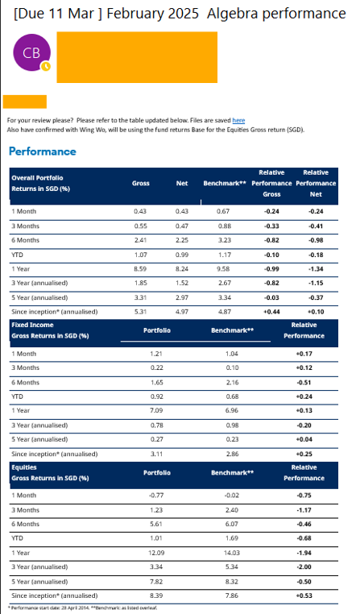
4 | So, copy those three tables into a new MsWord document, one after the other.  Once you have done this, you can start updating the table/s in the MsWord document with the data forresponding to the current reporting month. |  | 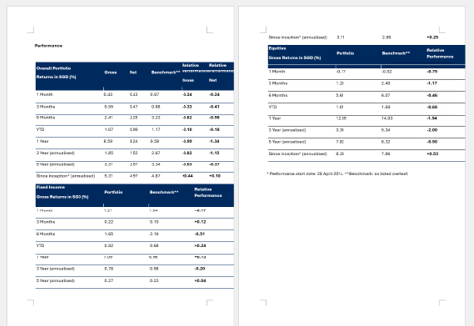
5 | Now, to start updating the data, open the Excel file “Algebra Fixed Income Performance Month YYYY.xlsx” that you have ready in the output folder, for the current reporting month.  Go to the “Performance Summary” Sheet. | In the case of the example, the source file we are going to use is “Algebra Fixed Income Performance March 2025.xlsx” | This is how that performance sheet is looking. Note that the yellow highlights have been done to show which specific data we are interested in.
6 | So now we must start updating the first of the tables we have in the MsWord document, which is the one with title “Overall Portfolio Returns in SGD (%)”  Then, we must set into columns:  - Gross: data from Column B “Portfolio Gross” from the Excel  - Net: data from column D “Portfolio Net” from the Excel  - “Benchmark”: data from Column F from the Excel  - “Relative Performance Gross”: calculate the difference from the value in column Gross minus the value in column Benchmark  - “Relative Performance Net”: calculate the difference from the value in column Net minus the value in column Benchmark  Ensure you are rounding all figures to 2 decimals and for the last two columns (“Relative Performance Gross” and “Relative Performance Net”), please set always the sign, either if it’s positive or negative. | In the example, please see the value from Excel and afterwards, the table with the data properly set, as following operations described in this step 6. | This is the table to update, where all previous data has been wiped:  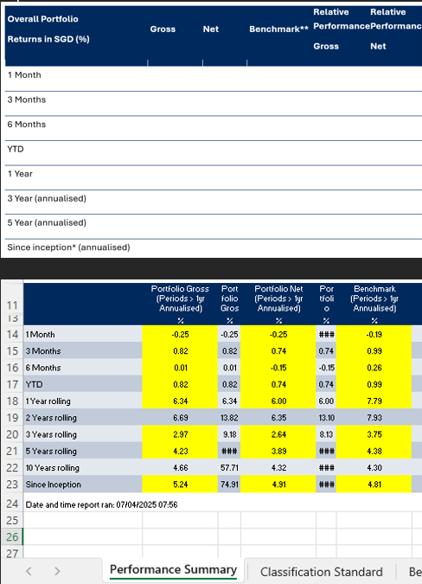  Values updated into the MsWord table:  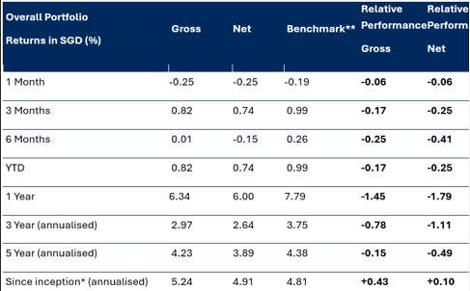
7 | Next, we must repeat the same steps 5 and 6, but for the next table in the MsWord doc, which is “Fixed Income Gross Returns in SGD (%)”, and to get the source values to copy, we must use this time the performance file “Algebra Fixed Income Performance Month YYYY.xlsx”, being Month YYYY the reporting month, as in “March 2025” | Screenshot of the table that we are about to update, with data from the previous month.  In this example, we are going to use the file “Algebra Fixed Income Performance March 2025.xlsx” to update the table, in next step. | 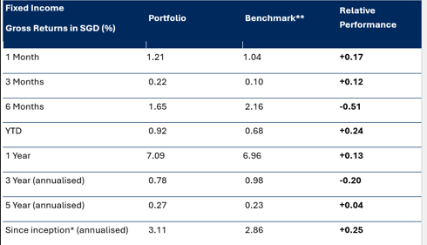
8 | For this “Fixed Income Gross Returns in SGD (%)” table, we will be updating in this way:  - Portfolio: data from Column B “Portfolio Gross” in the “Performance Summary” sheet.  - Benchmark: data from Column F “Benchmark” in the “Performance Summary” sheet.  - Relative Performance: calculate the difference from the value in column Portfolio minus the value in column Benchmark.  Ensure you are rounding all figures to 2 decimals and for the last column (“Relative Performance”), please set always the sign, either if it’s positive or negative. |  | So we clear the table in the MsWord, and this is the data from Excel that we are going to use:  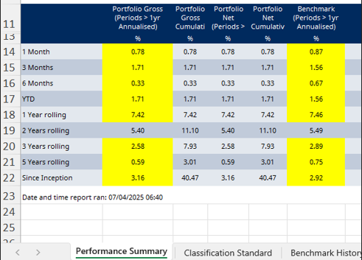  After updating the table in MsWord, that one looks like this:  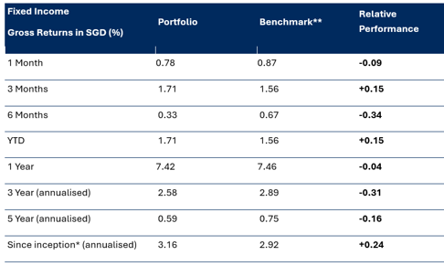
9 | And once again, we need to repeat the same steps as in Step 7 and Step 8, but for the last table that we have in MsWord, which is “Equities Gross Returns in SGD (%)”.  In this case, the source of data will be the third performance Excel file, the one with name “Algebra Global Equity Performance Month YYYY.xlsx”, where Month YYYY represents the reporting month, like in “March 2025”. | Screenshot of the table that we are about to update, with data for the previous month.  In this example, we are going to use the file “Algebra Global Equity Performance March 2025.xlsx” to update the table, in next step. | 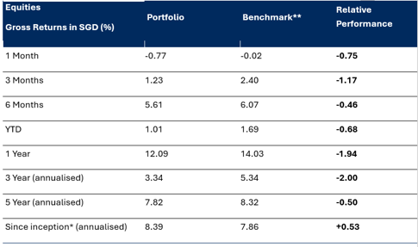
10 | For this “Equities Gross Returns in SGD (%)” table, we will be updating in this way:  - Portfolio: under the “Total Equity” row, use “Fund Return Base” in the “Classification Standard” sheet  - Benchmark: under the “Total Equity” row, use “BM return base” in the “Classification Standard” sheet.  - Relative Performance: calculate the difference from the value in column Portfolio minus the value in column Benchmark.  Ensure you are rounding all figures to 2 decimals and for the last column (“Relative Performance”), please set always the sign, either if it’s negative or positive. |  | So we clear the table in the MsWord, and this is the data from Excel that we are going to use – from the “Classification Standard” sheet:  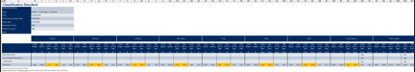  After updating the table in MsWord, that one looks like this:  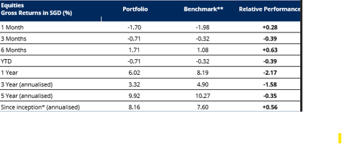
11 | There is another last piece of data that needs to be copied at the bottom of those tree tables.  To get that, go back to the email that was mentioned in Step 3.  Once there, go to the bottom of the three tables, and locate the text that will look like the one in the screenshot.  Copy that piece also from the email and paste it into the MsWord document, at the bottom of the tables. |  | 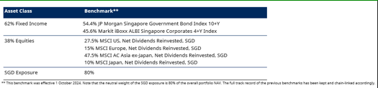
12 | Now you have in the MsWord all the content that you must later paste into the email.  While still in MsWord, please ensure each table contains the same text in the footer as in the email (if any).  Once all verified, you can go to the email again and click in “Reply All”. It will look like the one in the screenshot.
13 | Please prepare the email like the ones in the screenshot, with the details provided in the next column | Subject: March 2025 Algebra Performance  To: me@home.com  Cc: you@home.com  Body:  Dear all,  Please find the performance for the Algebra portfolio as at end Mar 2025 below.  We will provide detailed performance attribution and commentary in the monthly investment report when it is available. Please let us know if you need any further information. | 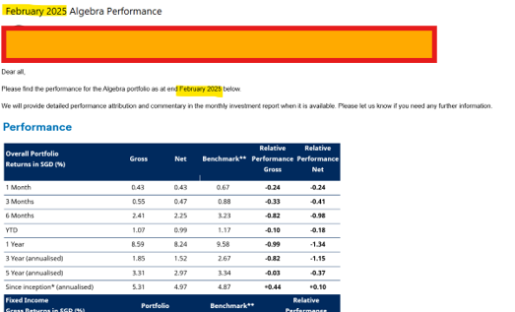
14 | Send the email

- Revision History
- Additional Comments

