3/3 11463112 劉泰愿 Mini/Micro LED Design and Challenges for Advanced Displays
葉志庭教授
筆記:
What is Mini LEDs and Micro LEDs?

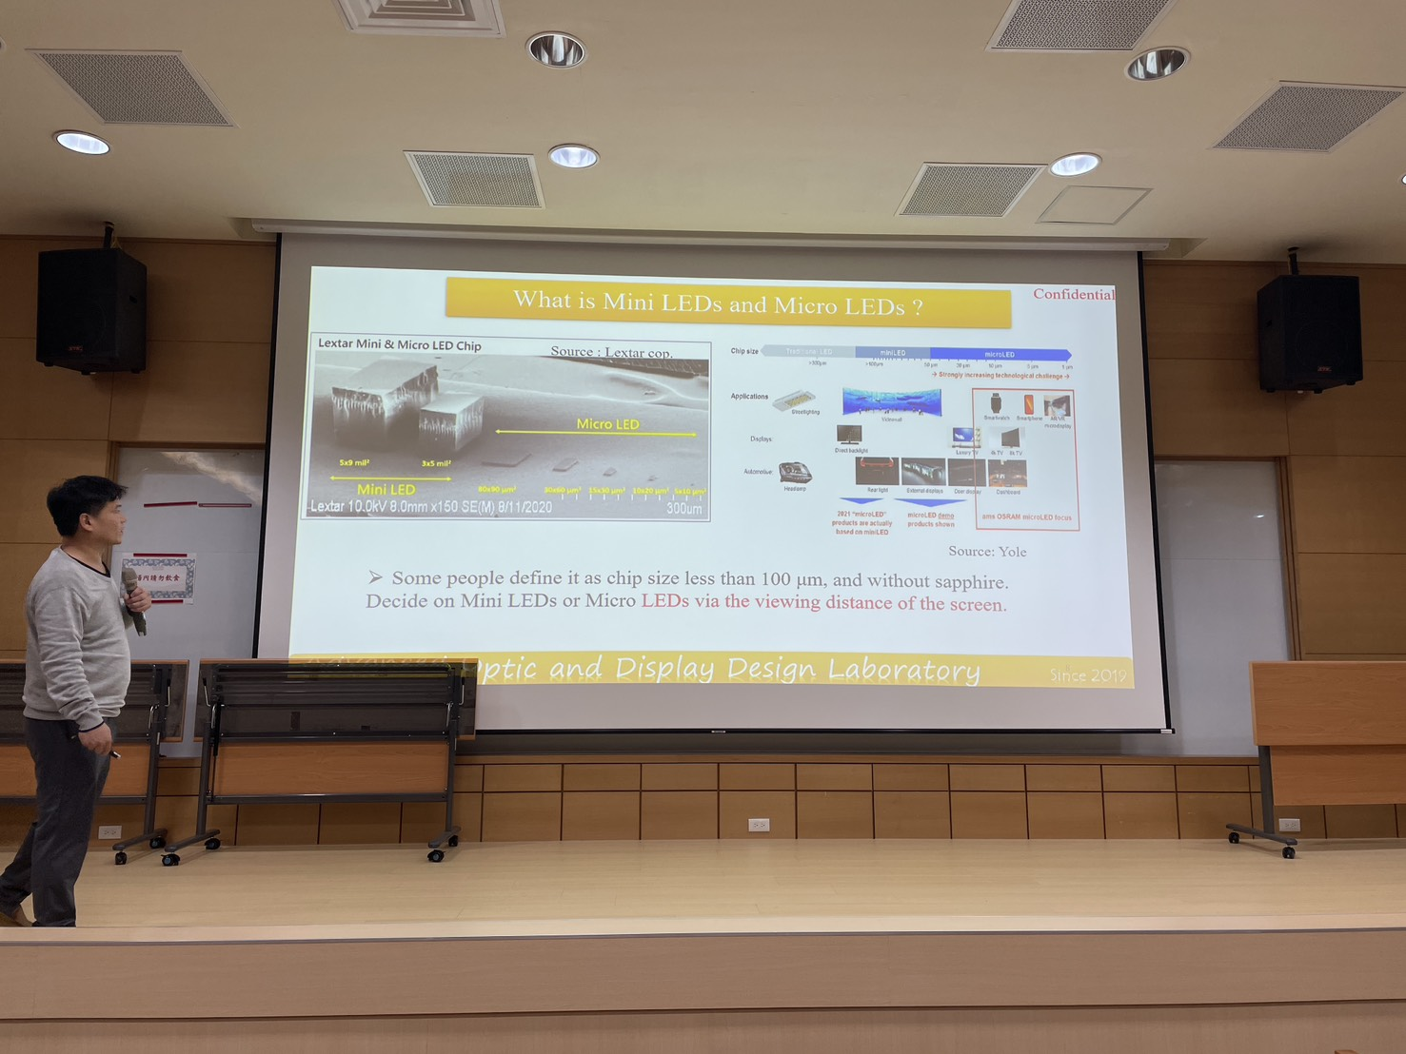

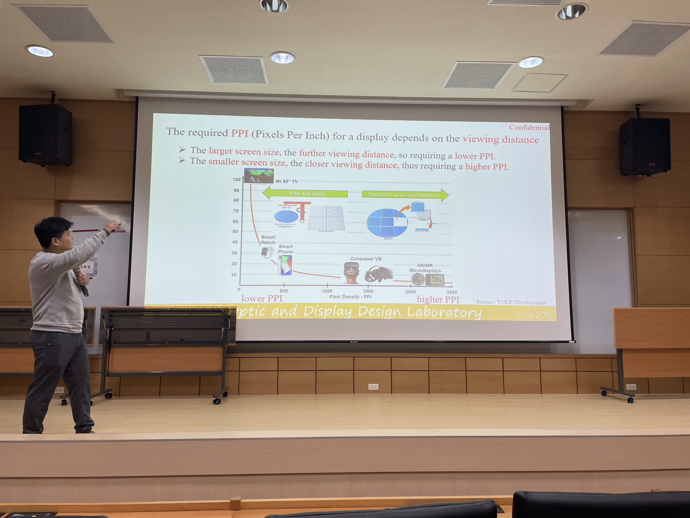
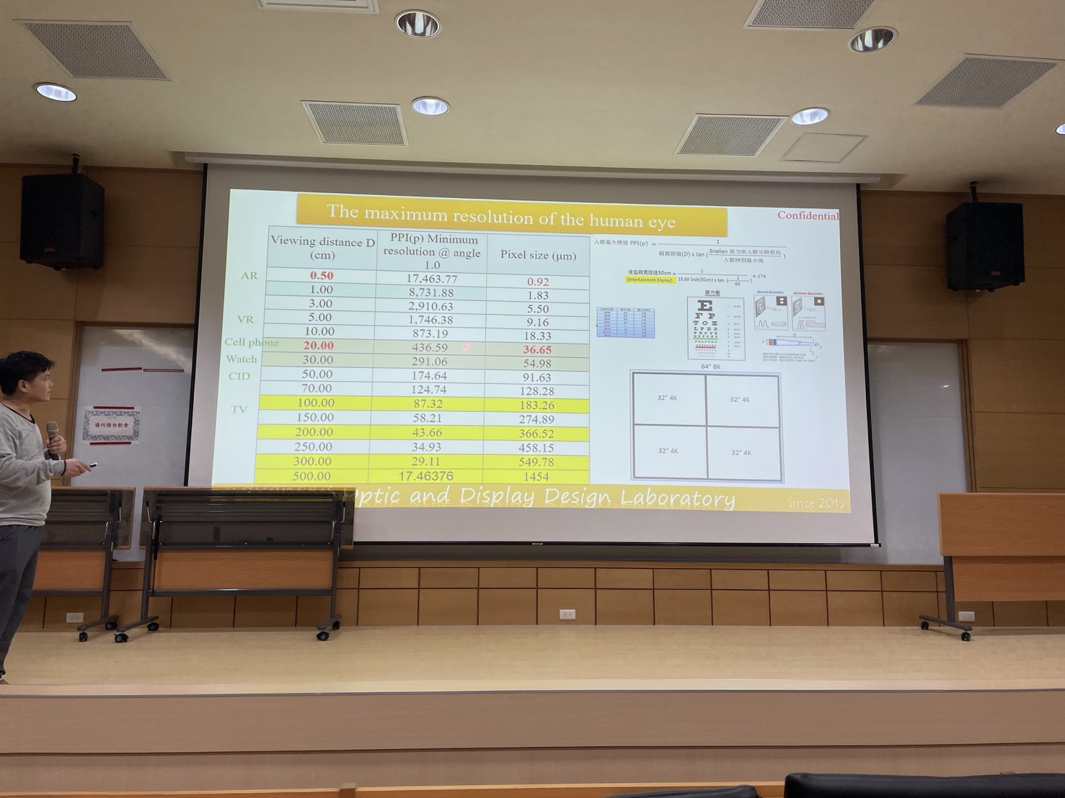
The maximum resolution of the human eye
LED v.s OLED v.s Micro LED

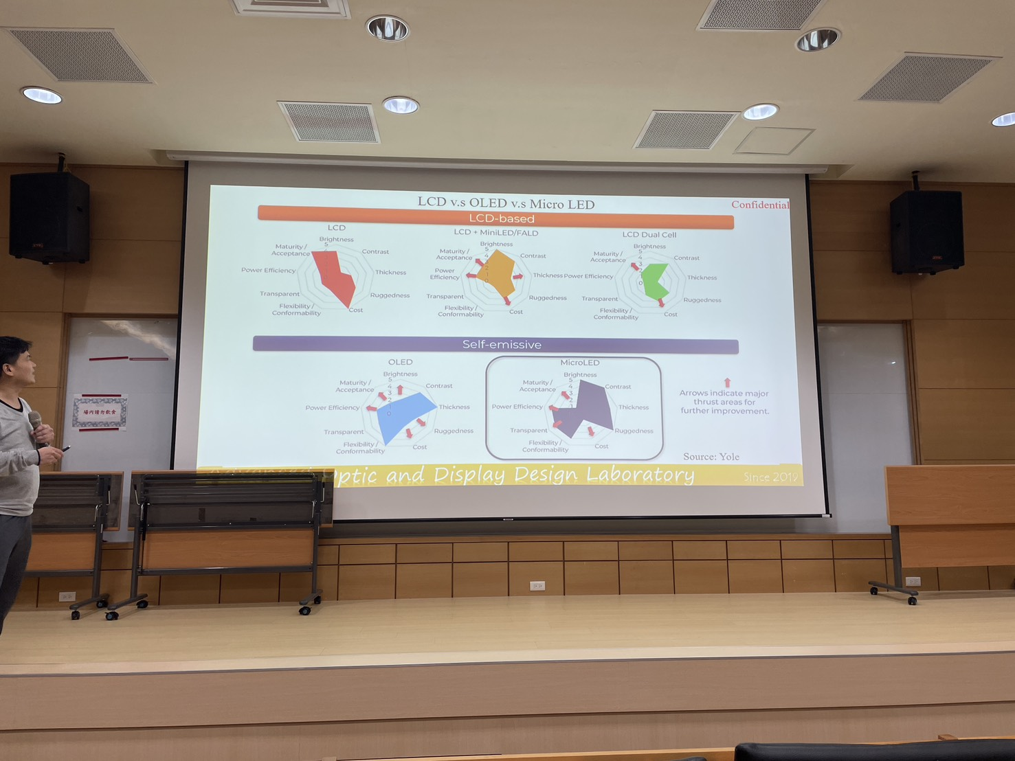

Process of Micor LED display
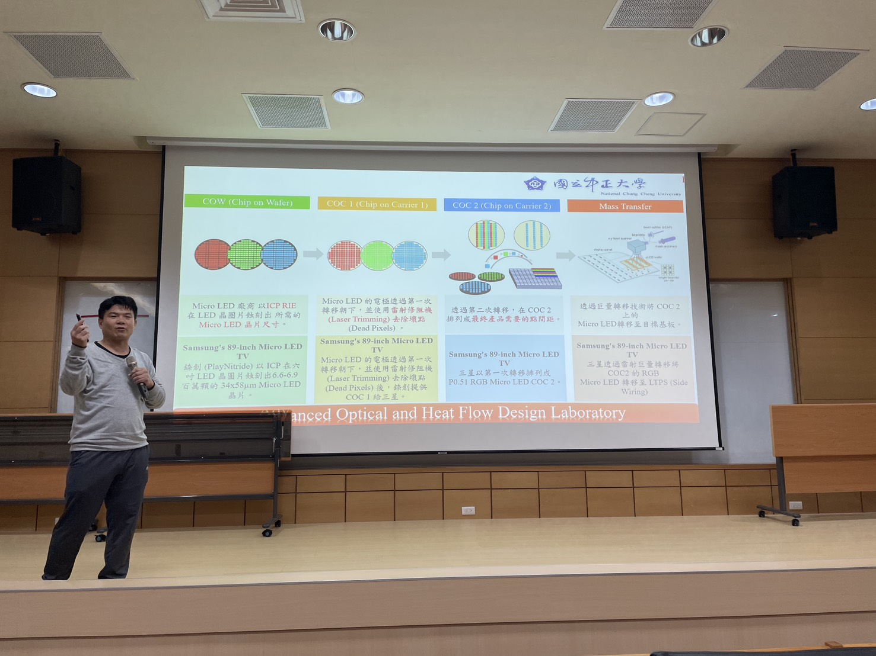
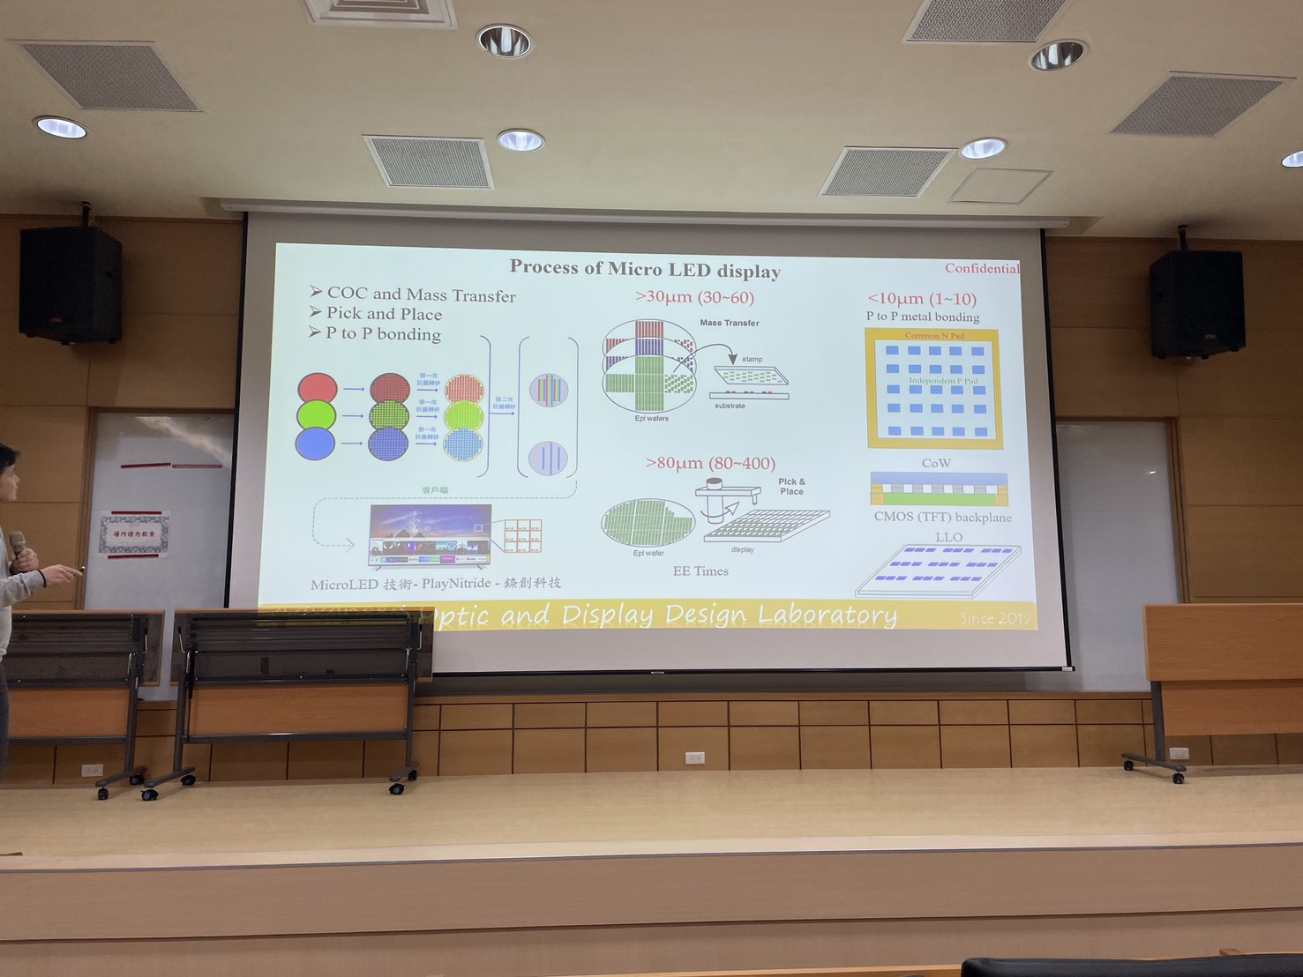

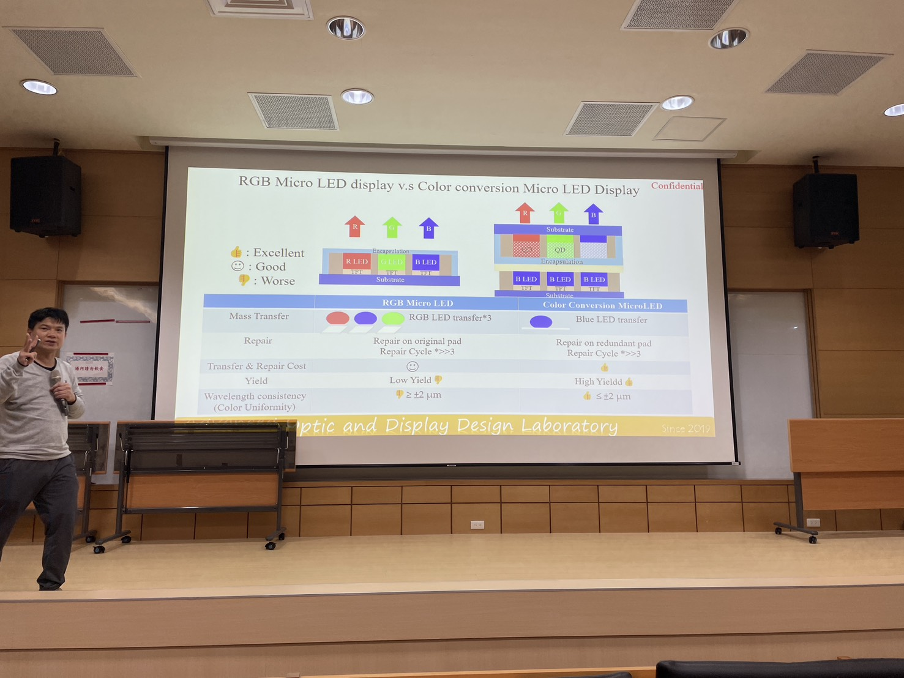
RGB Micro LED display v.s Color conversion Micro LED Display
Structure of Liquid-Crystal Module(LCM)
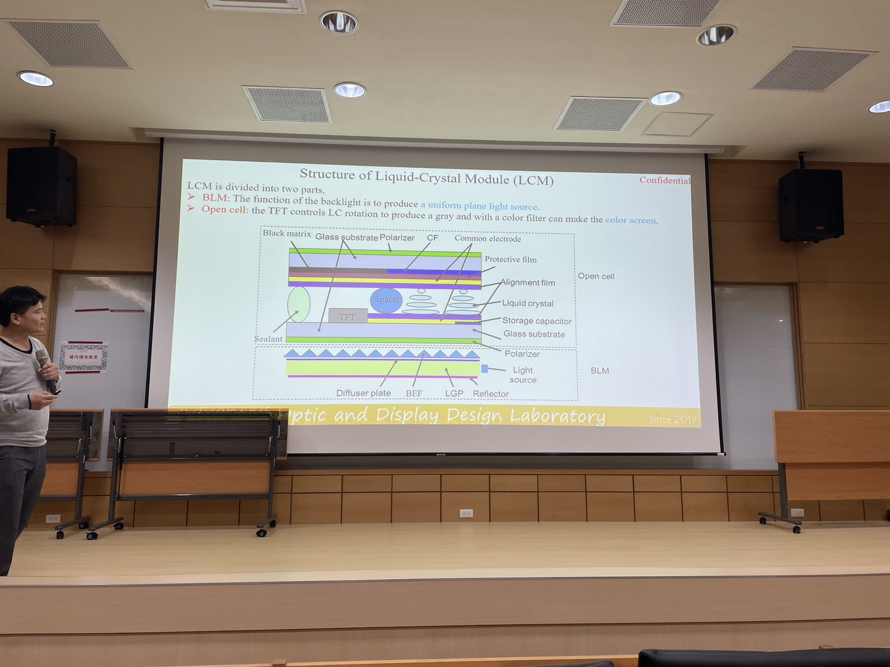
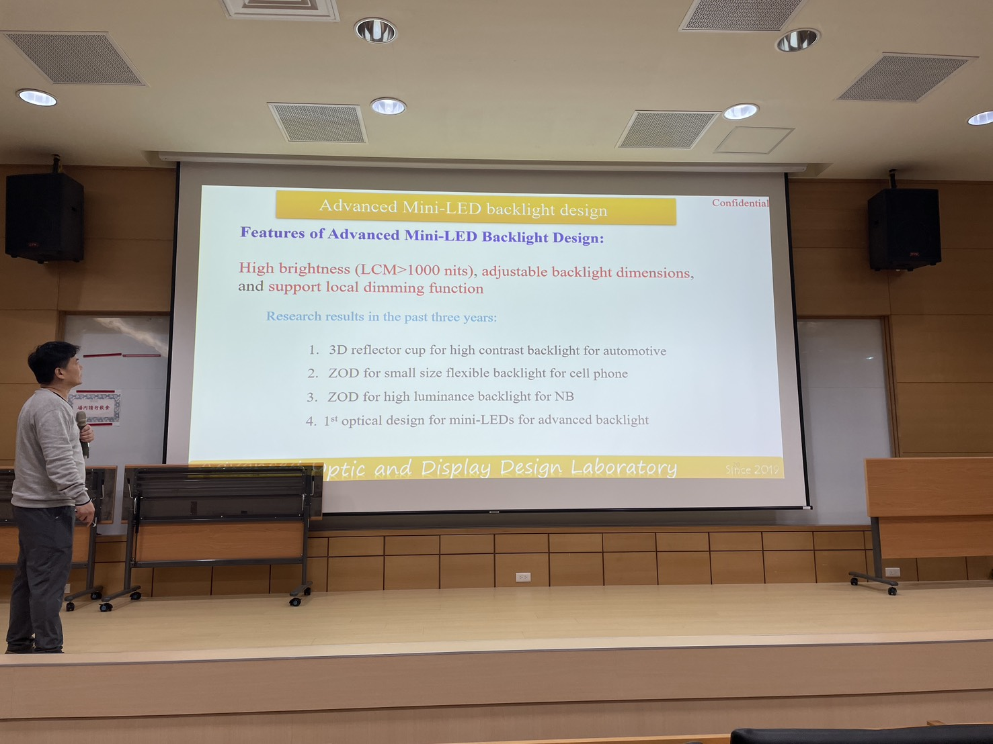
Advanced Mini-LED backlight design
1.3D reflector cup for high contrast backlight
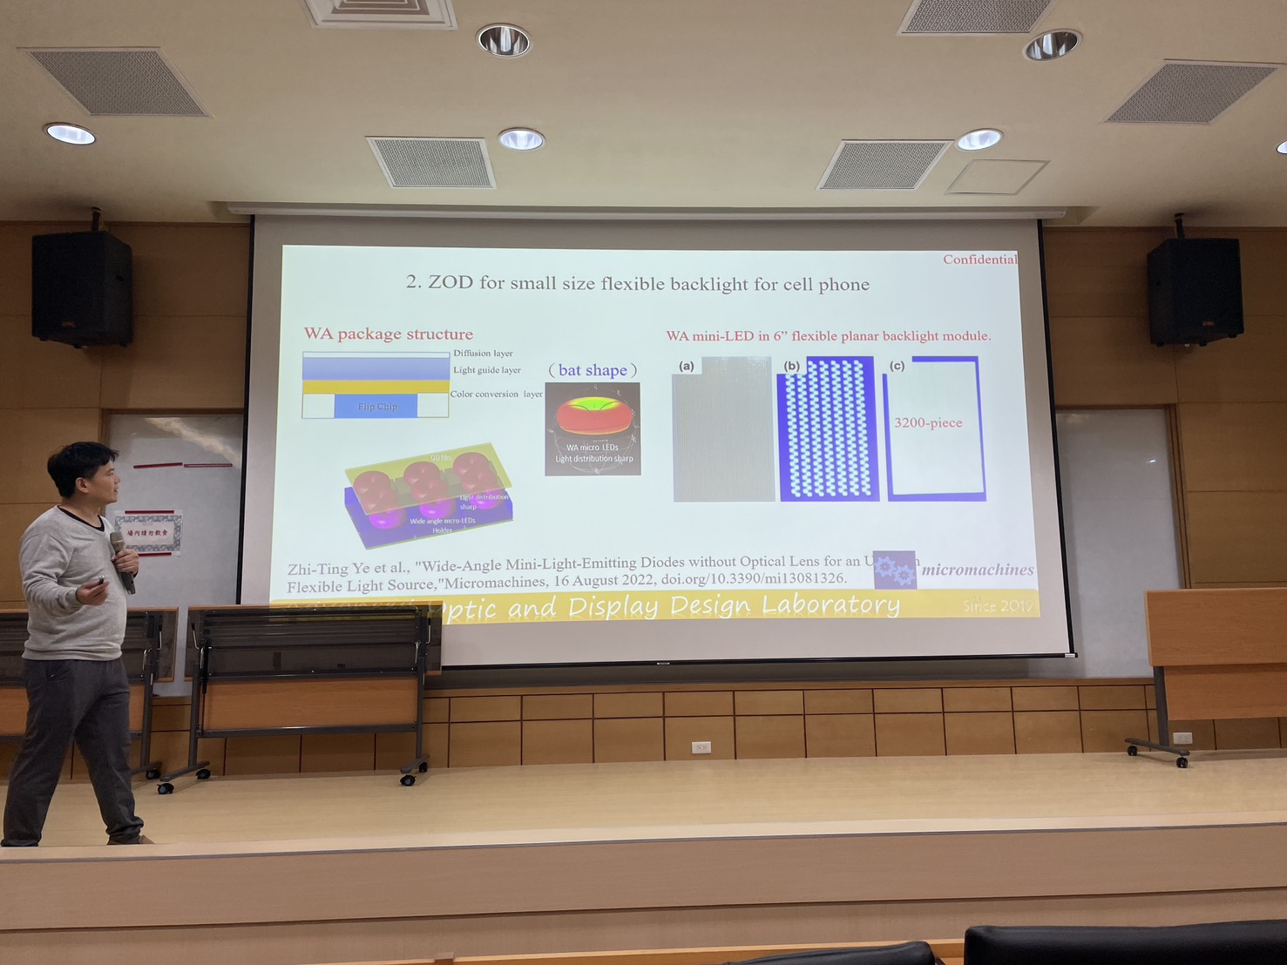
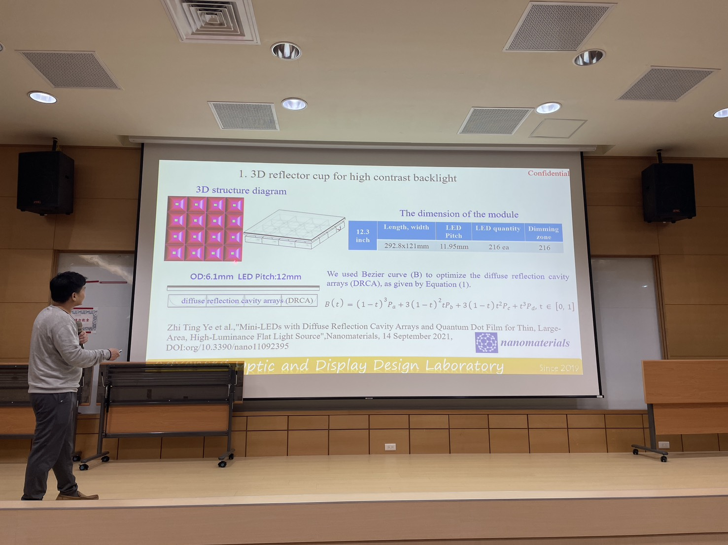
2.ZOD for small size flexible backlight for cell phone
A case for epitaxy structure of Mini/Micro LEDs
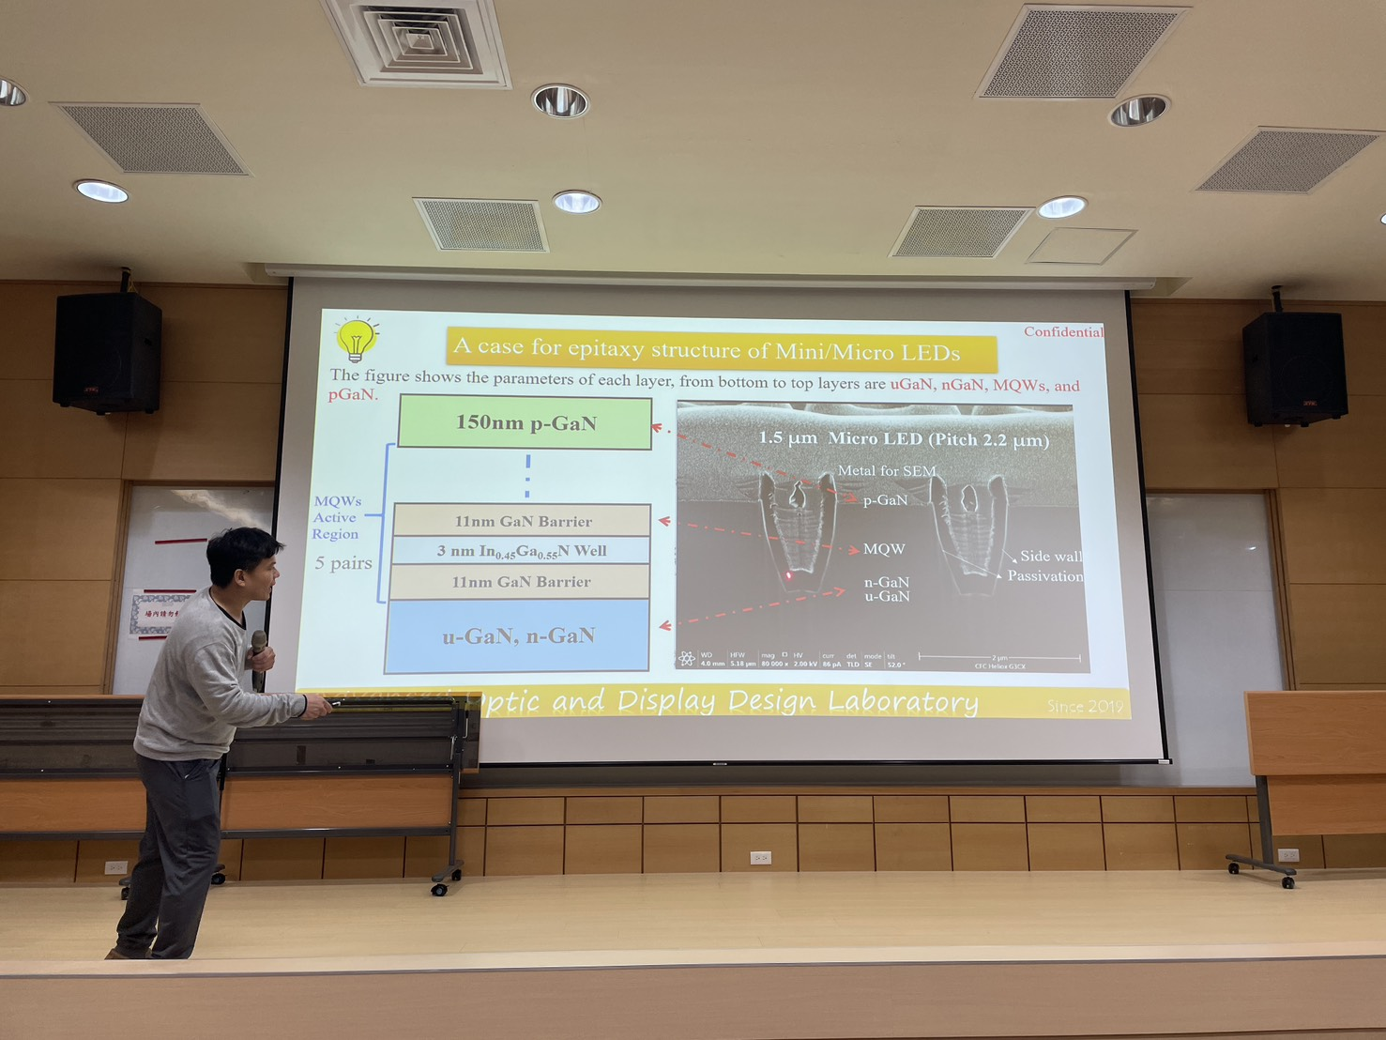
Highly Reflective Thin-Film (HRTF) Optimization for Full-Angle Micro-LEDs
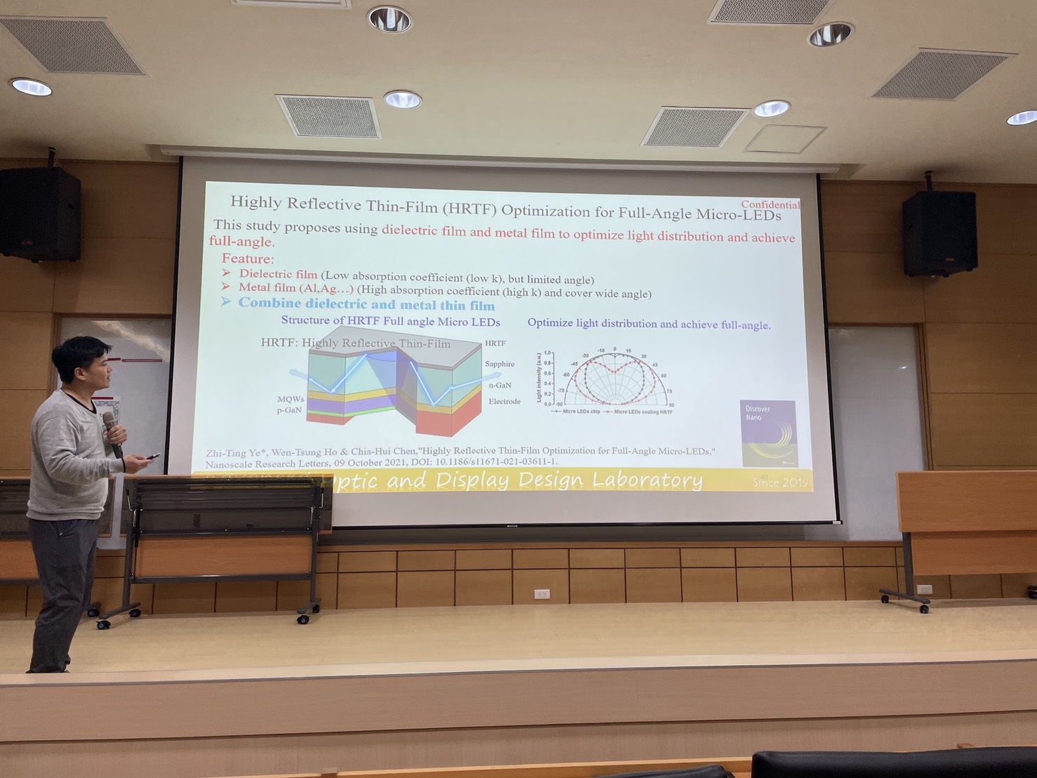
Color purity enhance film for Mini/Micro LED display
