1150080107_Lê Thị Hoài My_11CNPM2

LAB 8

HỘP TRẮNG VÀ SELENIUM WEBDRIVER
B ÀI 1 THIẾT LẬP SELENIUM WEBDRIVER VỚI ECLIPSE VÀ MAVEN
Mục tiêu: Cài đặt và cấu hình Selenium WebDriver, viết test case kiểm thử tiêu đề trang web
Yêu cầu: JDK 11+, Eclipse hoặc IntelliJ, Maven, trình duyệt Chrome

II. BÀI TẬP THỰC HÀNH
Bài tập 1.1 KIỂM THỬ TIÊU ĐỀ TRANG WEB (1.0 điểm)
Tạo project Maven mới tên 'Bai1_Selenium'. Viết test case kiểm thử tiêu đề trang
https://www.saucedemo.com:

Bước 1: Cấu hình pom.xml

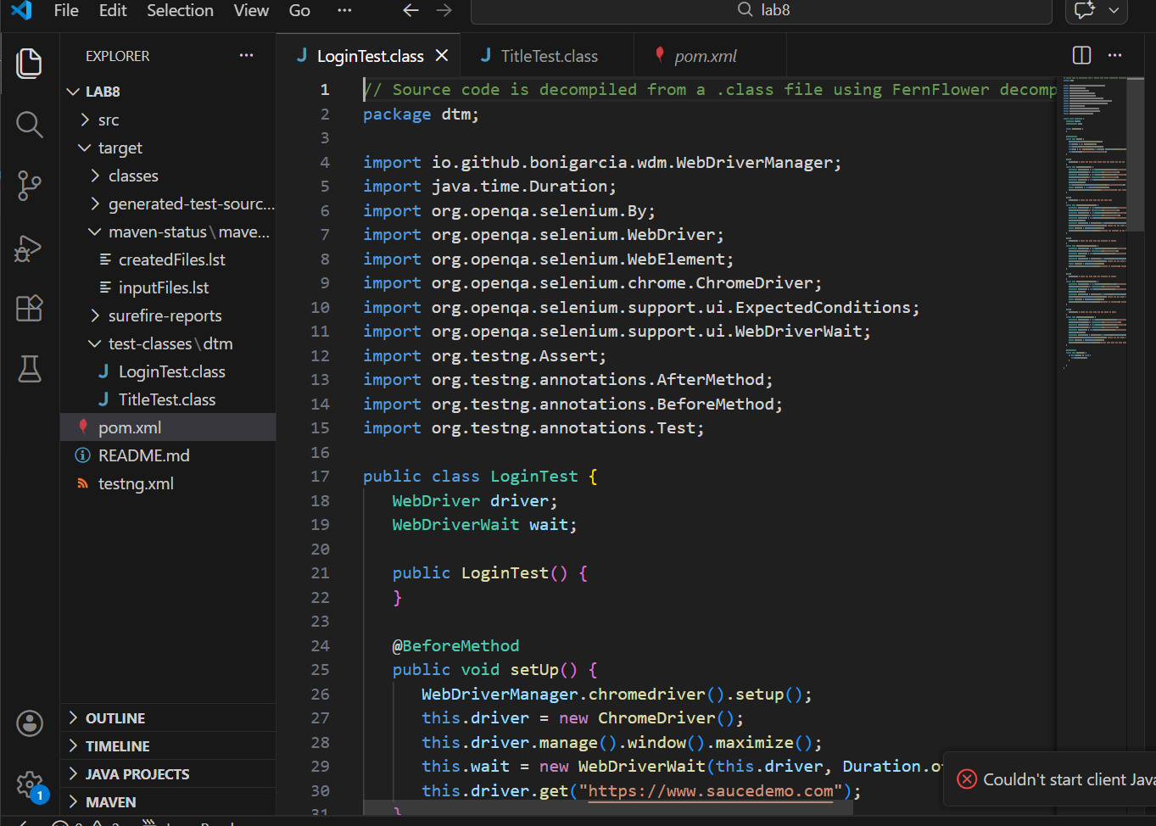

<?xml version="1.0" encoding="UTF-8"?>
<project xmlns="http://maven.apache.org/POM/4.0.0"
xmlns:xsi="http://www.w3.org/2001/XMLSchema-instance"
xsi:schemaLocation="http://maven.apache.org/POM/4.0.0 http://maven.apache.org/xsd/maven-4.0.0.xsd">
<modelVersion>4.0.0</modelVersion>

<groupId>dtm</groupId>
<artifactId>Bai1_Selenium</artifactId>
<version>1.0-SNAPSHOT</version>

<properties>
<maven.compiler.source>11</maven.compiler.source>
<maven.compiler.target>11</maven.compiler.target>
<project.build.sourceEncoding>UTF-8</project.build.sourceEncoding>
</properties>

<dependencies>
<!-- Selenium WebDriver -->
<dependency>
<groupId>org.seleniumhq.selenium</groupId>
<artifactId>selenium-java</artifactId>
<version>4.15.0</version>
</dependency>

<!-- WebDriverManager: tự động quản lý ChromeDriver -->
<dependency>
<groupId>io.github.bonigarcia</groupId>
<artifactId>webdrivermanager</artifactId>
<version>5.6.3</version>
</dependency>

<!-- TestNG -->
<dependency>
<groupId>org.testng</groupId>
<artifactId>testng</artifactId>
<version>7.8.0</version>
<scope>test</scope>
</dependency>
</dependencies>

<build>
<plugins>
<plugin>
<groupId>org.apache.maven.plugins</groupId>
<artifactId>maven-surefire-plugin</artifactId>
<version>3.0.0-M5</version>
</plugin>
</plugins>
</build>
</project>

Bước 2: Tạo file testng.xml
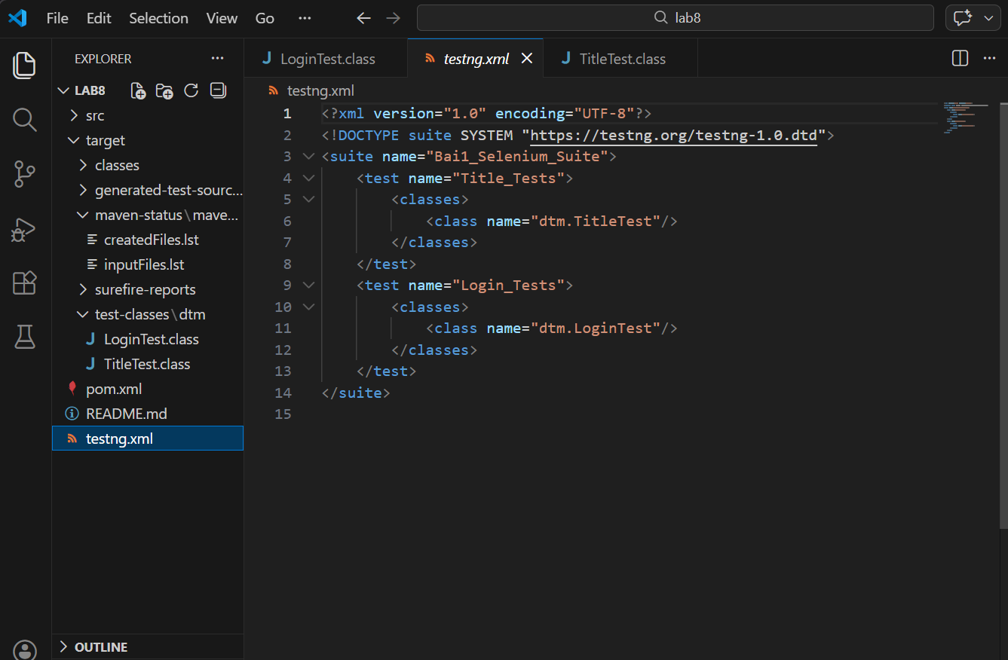

Bước 3: Viết code test TitleTest.java

// Source code is decompiled from a .class file using FernFlower decompiler (from Intellij IDEA).
package dtm;

import io.github.bonigarcia.wdm.WebDriverManager;
import org.openqa.selenium.By;
import org.openqa.selenium.WebDriver;
import org.openqa.selenium.WebElement;
import org.openqa.selenium.chrome.ChromeDriver;
import org.testng.Assert;
import org.testng.annotations.AfterMethod;
import org.testng.annotations.BeforeMethod;
import org.testng.annotations.Test;

public class TitleTest {
WebDriver driver;

public TitleTest() {
}

@BeforeMethod
public void setUp() {
WebDriverManager.chromedriver().setup();
this.driver = new ChromeDriver();
this.driver.manage().window().maximize();
this.driver.get("https://www.saucedemo.com");
}

@Test(
description = "Kiem thu tieu de trang chu"
)
public void testTitle() {
String expectedTitle = "Swag Labs";
String actualTitle = this.driver.getTitle();
Assert.assertEquals(actualTitle, expectedTitle, "Tieu de trang khong dung!");
}

@Test(
description = "Kiem thu URL trang chu"
)
public void testURL() {
String actualUrl = this.driver.getCurrentUrl();
Assert.assertTrue(actualUrl.contains("saucedemo"), "URL khong hop le!");
}

@Test(
description = "Kiem thu nguon trang (page source)"
)
public void testPageSource() {
String pageSource = this.driver.getPageSource();
Assert.assertTrue(pageSource.contains("Swag Labs"), "Page source khong chua 'Swag Labs'!");
Assert.assertTrue(pageSource.contains("login"), "Page source khong chua 'login'!");
Assert.assertTrue(pageSource.contains("password"), "Page source khong chua 'password'!");
Assert.assertFalse(pageSource.isEmpty(), "Page source khong duoc rong!");
}

@Test(
description = "Kiem thu form dang nhap co hien thi hay khong"
)
public void testLoginFormDisplay() {
WebElement usernameField = this.driver.findElement(By.id("user-name"));
Assert.assertTrue(usernameField.isDisplayed(), "Username field khong hien thi!");
WebElement passwordField = this.driver.findElement(By.id("password"));
Assert.assertTrue(passwordField.isDisplayed(), "Password field khong hien thi!");
WebElement loginButton = this.driver.findElement(By.id("login-button"));
Assert.assertTrue(loginButton.isDisplayed(), "Login button khong hien thi!");
WebElement logo = this.driver.findElement(By.className("login_logo"));
Assert.assertTrue(logo.isDisplayed(), "Logo khong hien thi!");
}

@AfterMethod
public void tearDown() {
if (this.driver != null) {
this.driver.quit();
}

}
}

KẾT QUẢ
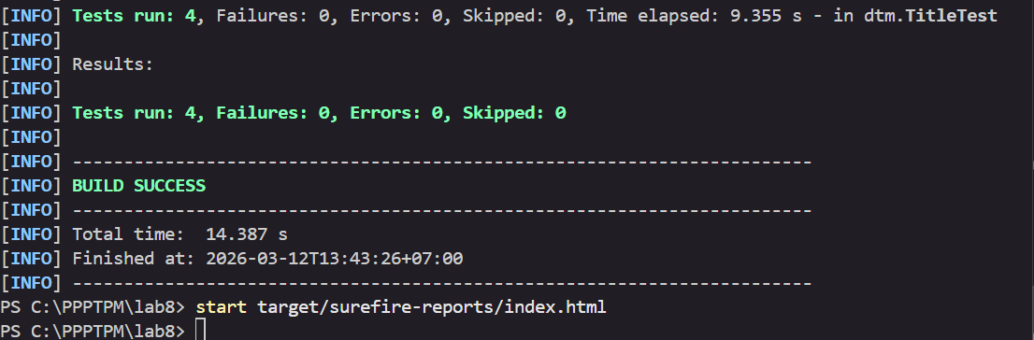

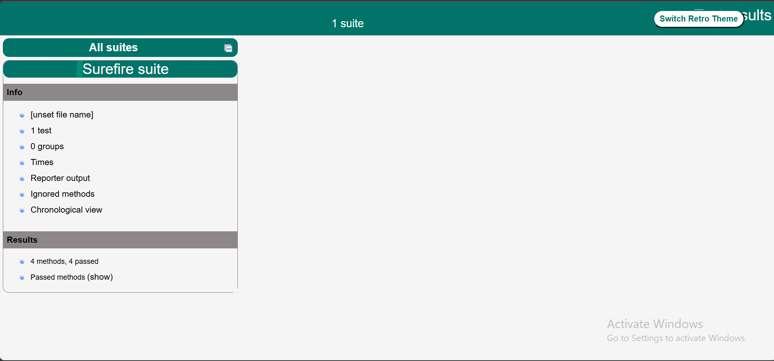

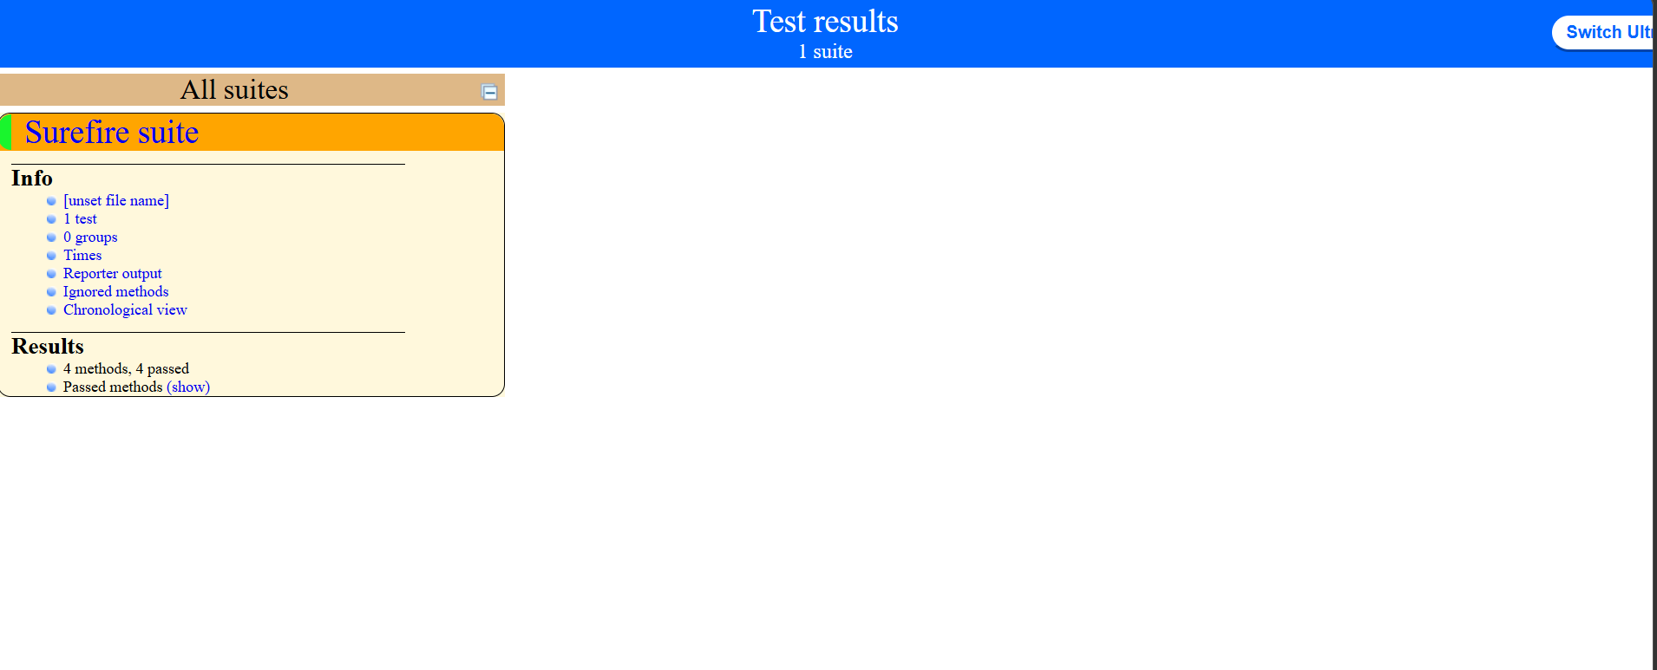

Bài tập
1.2
KIỂM THỬ FORM ĐĂNG NHẬP (1.0 điểm)

Tạo file logintest.class

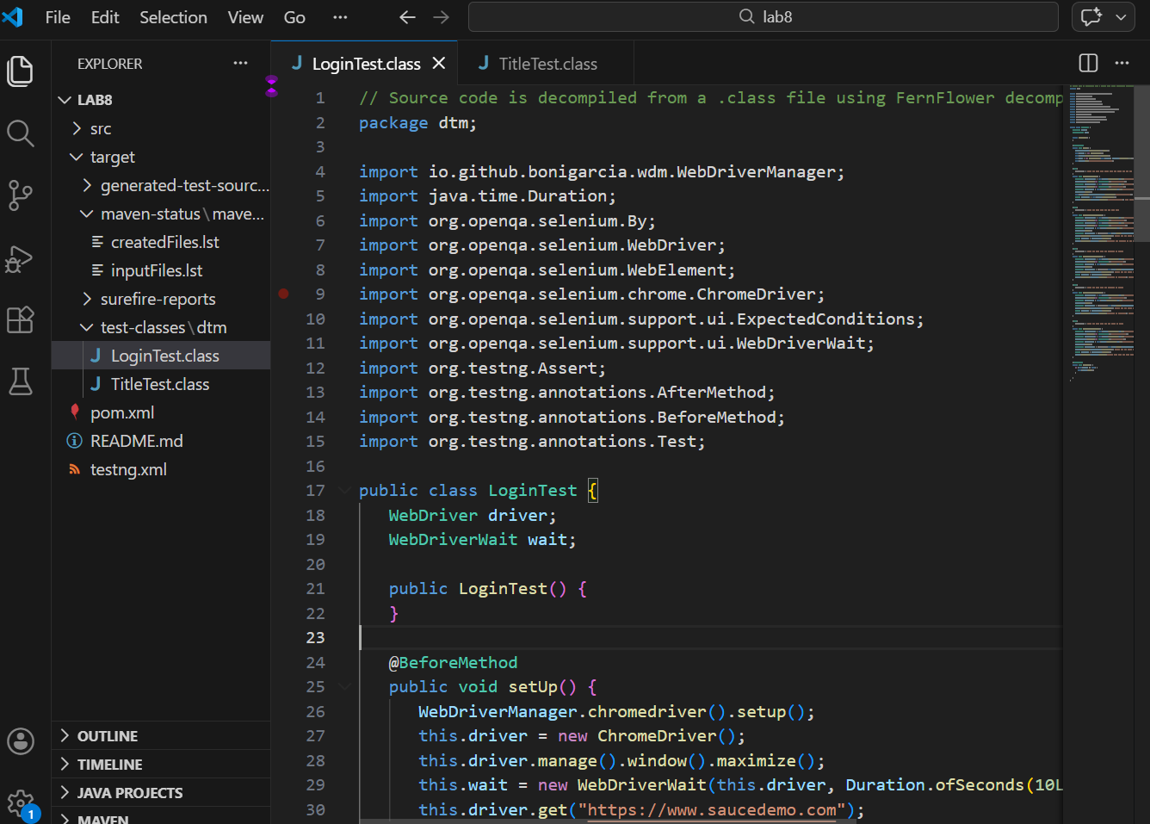
// Source code is decompiled from a .class file using FernFlower decompiler (from Intellij IDEA).
package dtm;

import io.github.bonigarcia.wdm.WebDriverManager;
import java.time.Duration;
import org.openqa.selenium.By;
import org.openqa.selenium.WebDriver;
import org.openqa.selenium.WebElement;
import org.openqa.selenium.chrome.ChromeDriver;
import org.openqa.selenium.support.ui.ExpectedConditions;
import org.openqa.selenium.support.ui.WebDriverWait;
import org.testng.Assert;
import org.testng.annotations.AfterMethod;
import org.testng.annotations.BeforeMethod;
import org.testng.annotations.Test;

public class LoginTest {
WebDriver driver;
WebDriverWait wait;

public LoginTest() {
}

@BeforeMethod
public void setUp() {
WebDriverManager.chromedriver().setup();
this.driver = new ChromeDriver();
this.driver.manage().window().maximize();
this.wait = new WebDriverWait(this.driver, Duration.ofSeconds(10L));
this.driver.get("https://www.saucedemo.com");
}

@Test(
description = "Kiem thu dang nhap thanh cong voi thong tin hop le"
)
public void testLoginSuccess() {
WebElement usernameField = this.driver.findElement(By.id("user-name"));
usernameField.sendKeys(new CharSequence[]{"standard_user"});
WebElement passwordField = this.driver.findElement(By.id("password"));
passwordField.sendKeys(new CharSequence[]{"secret_sauce"});
WebElement loginButton = this.driver.findElement(By.id("login-button"));
loginButton.click();
this.wait.until(ExpectedConditions.urlContains("/inventory.html"));
String currentUrl = this.driver.getCurrentUrl();
Assert.assertTrue(currentUrl.contains("/inventory.html"), "URL khong chuyen sang trang inventory sau khi dang nhap thanh cong!");
}

@Test(
description = "Kiem thu dang nhap voi mat khau sai"
)
public void testLoginWrongPassword() {
WebElement usernameField = this.driver.findElement(By.id("user-name"));
usernameField.sendKeys(new CharSequence[]{"standard_user"});
WebElement passwordField = this.driver.findElement(By.id("password"));
passwordField.sendKeys(new CharSequence[]{"wrong_password"});
WebElement loginButton = this.driver.findElement(By.id("login-button"));
loginButton.click();
WebElement errorMessage = (WebElement)this.wait.until(ExpectedConditions.visibilityOfElementLocated(By.cssSelector("[data-test='error']")));
Assert.assertTrue(errorMessage.isDisplayed(), "Thong bao loi khong hien thi khi nhap sai mat khau!");
String errorText = errorMessage.getText();
Assert.assertTrue(errorText.contains("Username and password do not match"), "Noi dung thong bao loi khong dung!");
}

@Test(
description = "Kiem thu dang nhap voi username de trong"
)
public void testLoginEmptyUsername() {
WebElement passwordField = this.driver.findElement(By.id("password"));
passwordField.sendKeys(new CharSequence[]{"secret_sauce"});
WebElement loginButton = this.driver.findElement(By.id("login-button"));
loginButton.click();
WebElement errorMessage = (WebElement)this.wait.until(ExpectedConditions.visibilityOfElementLocated(By.cssSelector("[data-test='error']")));
Assert.assertTrue(errorMessage.isDisplayed(), "Thong bao loi khong hien thi khi bo trong username!");
String errorText = errorMessage.getText();
Assert.assertTrue(errorText.contains("Username is required"), "Thong bao loi khong dung! Mong doi: 'Username is required'");
}

@Test(
description = "Kiem thu dang nhap voi password de trong"
)
public void testLoginEmptyPassword() {
WebElement usernameField = this.driver.findElement(By.id("user-name"));
usernameField.sendKeys(new CharSequence[]{"standard_user"});
WebElement loginButton = this.driver.findElement(By.id("login-button"));
loginButton.click();
WebElement errorMessage = (WebElement)this.wait.until(ExpectedConditions.visibilityOfElementLocated(By.cssSelector("[data-test='error']")));
Assert.assertTrue(errorMessage.isDisplayed(), "Thong bao loi khong hien thi khi bo trong password!");
String errorText = errorMessage.getText();
Assert.assertTrue(errorText.contains("Password is required"), "Thong bao loi khong dung! Mong doi: 'Password is required'");
}

@Test(
description = "Kiem thu dang nhap voi tai khoan bi khoa"
)
public void testLoginLockedUser() {
WebElement usernameField = this.driver.findElement(By.id("user-name"));
usernameField.sendKeys(new CharSequence[]{"locked_out_user"});
WebElement passwordField = this.driver.findElement(By.id("password"));
passwordField.sendKeys(new CharSequence[]{"secret_sauce"});
WebElement loginButton = this.driver.findElement(By.id("login-button"));
loginButton.click();
WebElement errorMessage = (WebElement)this.wait.until(ExpectedConditions.visibilityOfElementLocated(By.cssSelector("[data-test='error']")));
Assert.assertTrue(errorMessage.isDisplayed(), "Thong bao loi khong hien thi khi dung tai khoan bi khoa!");
String errorText = errorMessage.getText();
Assert.assertTrue(errorText.contains("Sorry, this user has been locked out"), "Thong bao loi khong dung! Mong doi: 'Sorry, this user has been locked out'");
}

@AfterMethod
public void tearDown() {
if (this.driver != null) {
this.driver.quit();
}

}
}

KÊTS QUẢ
