1150080107_Lê Thị Hoài My

LAB 7:WINFORM KẾT NỐI CƠ SỞ DỮ LIỆU NÂNG CAO

B. Nội dung
Thực hành 1: Hiển thị dữ liệu trên control DataGridView

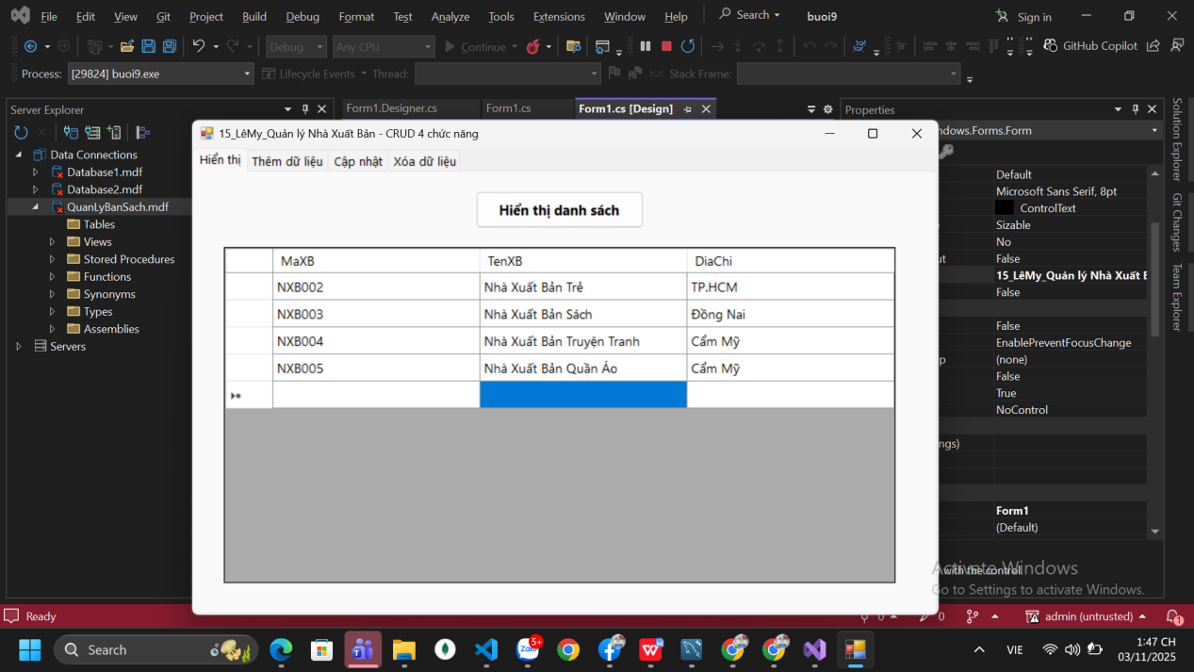

Thực hành 2: Thêm dữ liệu cho bảng Nhà xuất bản
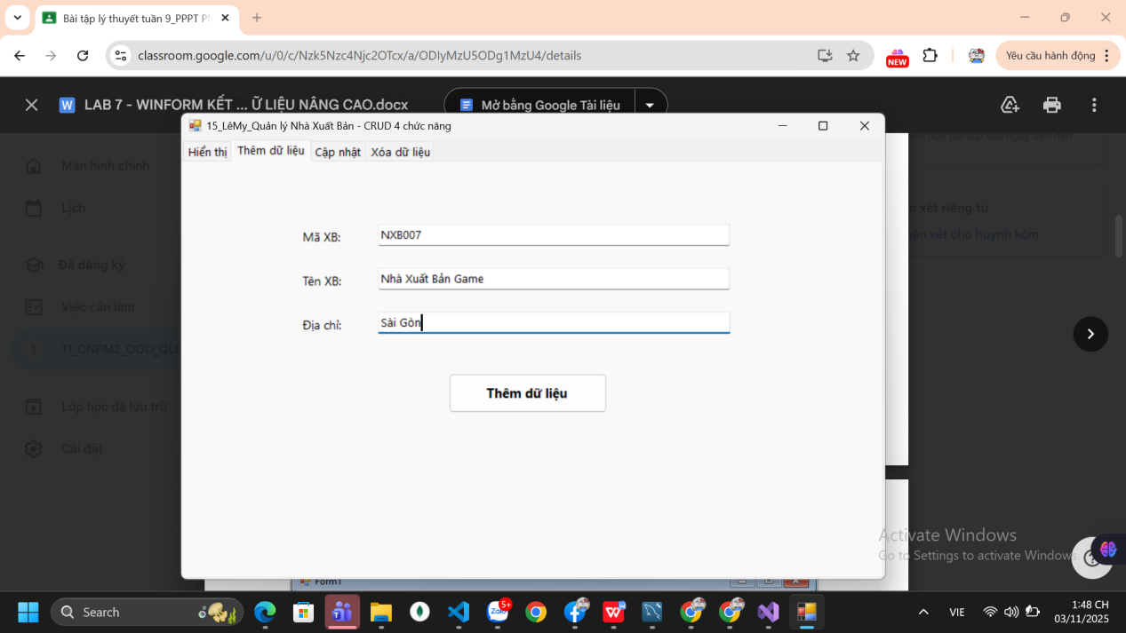
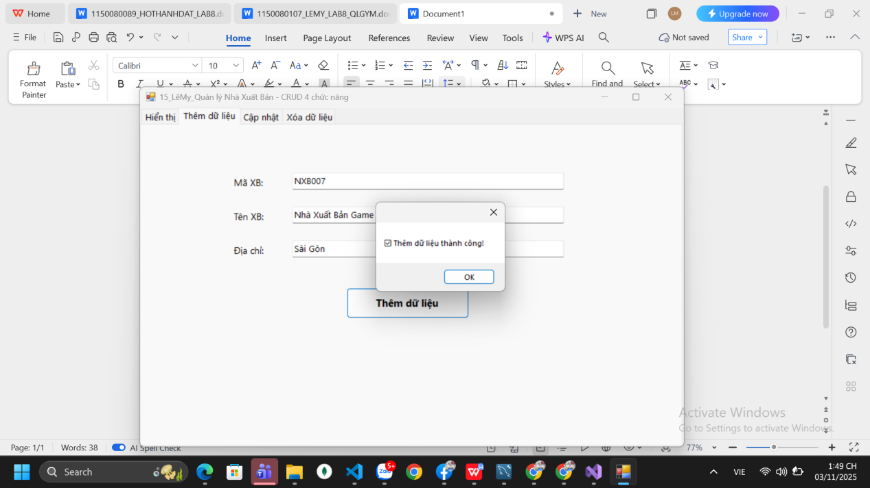

Thực hành 3: Cập nhật dữ liệu cho bảng Nhà xuất bản

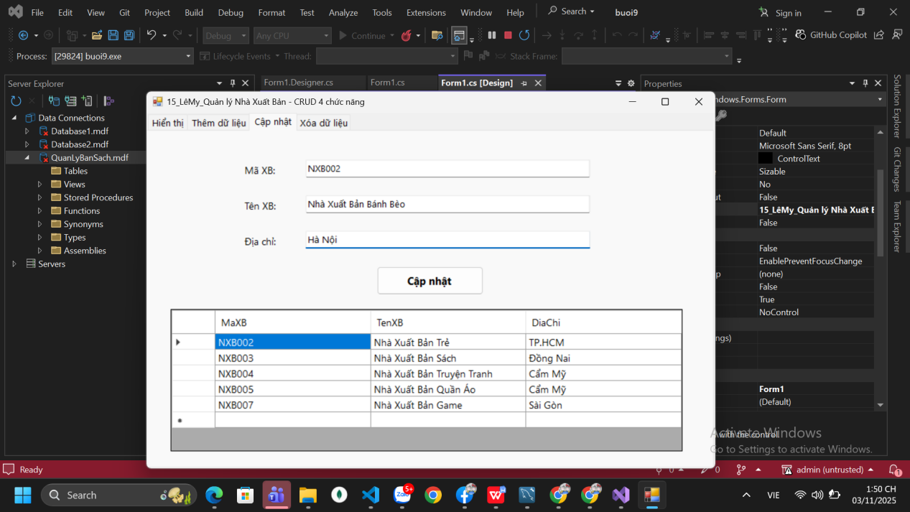

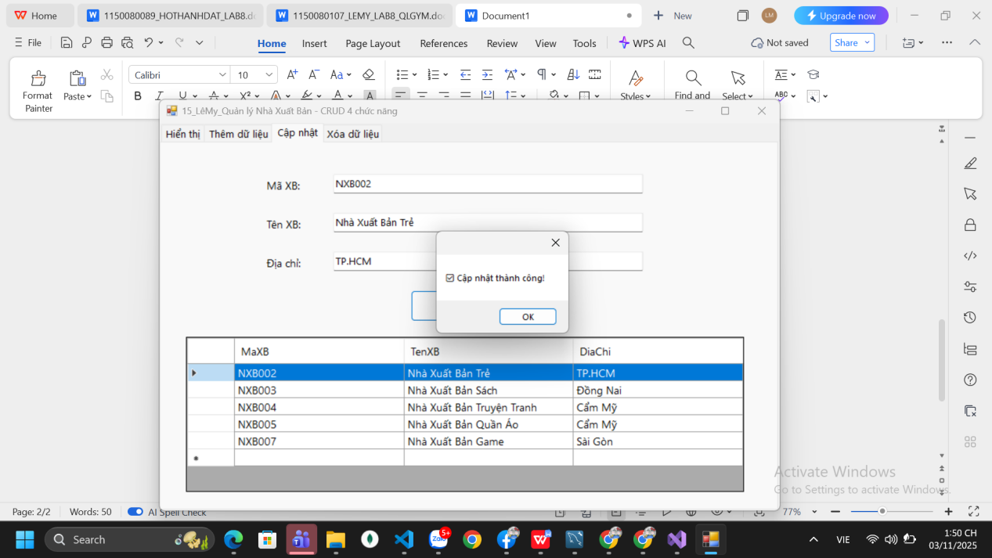

Thực hành 4: Xóa dữ liệu cho bảng Nhà xuất bản

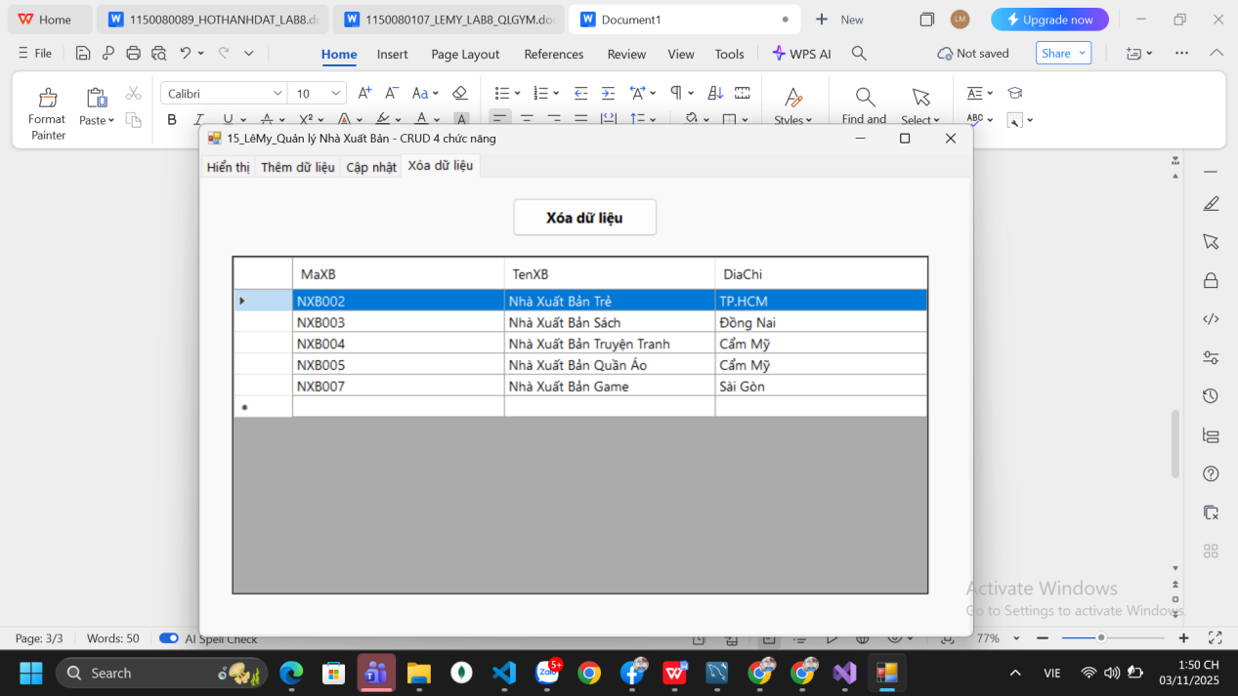

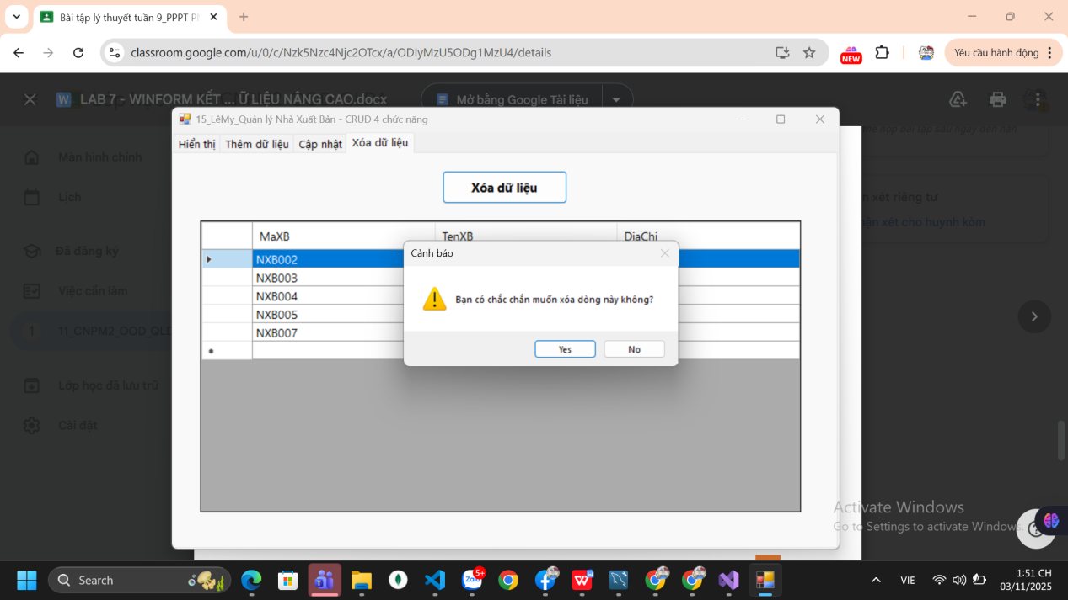

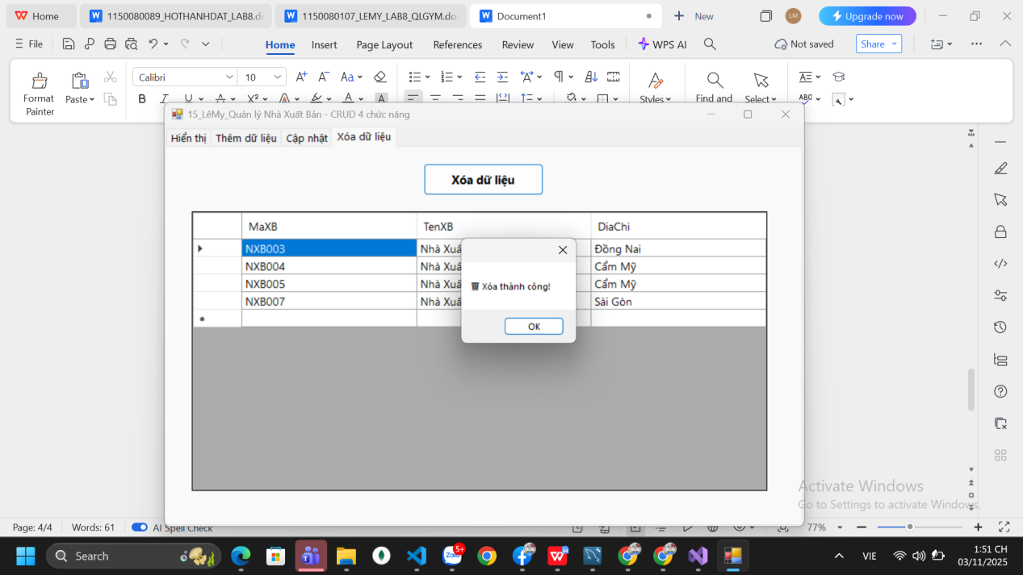

namespace buoi9
{
partial class Form1
{
/// <summary>
/// Required designer variable.
/// </summary>
private System.ComponentModel.IContainer components = null;

/// <summary>
/// Clean up any resources being used.
/// </summary>
/// <param name="disposing">true if managed resources should be disposed; otherwise, false.</param>
protected override void Dispose(bool disposing)
{
if (disposing && (components != null))
{
components.Dispose();
}
base.Dispose(disposing);
}

#region Windows Form Designer generated code

private void InitializeComponent()
{
this.tabMain = new System.Windows.Forms.TabControl();
this.tabHienThi = new System.Windows.Forms.TabPage();
this.btnHienThi = new System.Windows.Forms.Button();
this.dgvDanhSach = new System.Windows.Forms.DataGridView();
this.tabThem = new System.Windows.Forms.TabPage();
this.btnThemDL = new System.Windows.Forms.Button();
this.txtDiaChi = new System.Windows.Forms.TextBox();
this.txtTenXB = new System.Windows.Forms.TextBox();
this.txtMaXB = new System.Windows.Forms.TextBox();
this.label3 = new System.Windows.Forms.Label();
this.label2 = new System.Windows.Forms.Label();
this.label1 = new System.Windows.Forms.Label();
this.tabSua = new System.Windows.Forms.TabPage();
this.btnSuaDL = new System.Windows.Forms.Button();
this.txtDiaChi_Sua = new System.Windows.Forms.TextBox();
this.txtTenXB_Sua = new System.Windows.Forms.TextBox();
this.txtMaXB_Sua = new System.Windows.Forms.TextBox();
this.label6 = new System.Windows.Forms.Label();
this.label5 = new System.Windows.Forms.Label();
this.label4 = new System.Windows.Forms.Label();
this.dgvSua = new System.Windows.Forms.DataGridView();
this.tabXoa = new System.Windows.Forms.TabPage();
this.btnXoaDL = new System.Windows.Forms.Button();
this.dgvXoa = new System.Windows.Forms.DataGridView();
this.tabMain.SuspendLayout();
this.tabHienThi.SuspendLayout();
((System.ComponentModel.ISupportInitialize)(this.dgvDanhSach)).BeginInit();
this.tabThem.SuspendLayout();
this.tabSua.SuspendLayout();
((System.ComponentModel.ISupportInitialize)(this.dgvSua)).BeginInit();
this.tabXoa.SuspendLayout();
((System.ComponentModel.ISupportInitialize)(this.dgvXoa)).BeginInit();
this.SuspendLayout();
//
// tabMain
//
this.tabMain.Controls.Add(this.tabHienThi);
this.tabMain.Controls.Add(this.tabThem);
this.tabMain.Controls.Add(this.tabSua);
this.tabMain.Controls.Add(this.tabXoa);
this.tabMain.Dock = System.Windows.Forms.DockStyle.Fill;
this.tabMain.Font = new System.Drawing.Font("Segoe UI", 10F);
this.tabMain.Location = new System.Drawing.Point(0, 0);
this.tabMain.Name = "tabMain";
this.tabMain.SelectedIndex = 0;
this.tabMain.Size = new System.Drawing.Size(800, 500);
this.tabMain.TabIndex = 0;
//
// tabHienThi
//
this.tabHienThi.Controls.Add(this.btnHienThi);
this.tabHienThi.Controls.Add(this.dgvDanhSach);
this.tabHienThi.Location = new System.Drawing.Point(4, 37);
this.tabHienThi.Name = "tabHienThi";
this.tabHienThi.Padding = new System.Windows.Forms.Padding(3);
this.tabHienThi.Size = new System.Drawing.Size(792, 459);
this.tabHienThi.TabIndex = 0;
this.tabHienThi.Text = "Hiển thị";
this.tabHienThi.UseVisualStyleBackColor = true;
//
// btnHienThi
//
this.btnHienThi.Font = new System.Drawing.Font("Segoe UI", 11F, System.Drawing.FontStyle.Bold);
this.btnHienThi.Location = new System.Drawing.Point(300, 20);
this.btnHienThi.Name = "btnHienThi";
this.btnHienThi.Size = new System.Drawing.Size(180, 40);
this.btnHienThi.TabIndex = 1;
this.btnHienThi.Text = "Hiển thị danh sách";
this.btnHienThi.UseVisualStyleBackColor = true;
this.btnHienThi.Click += new System.EventHandler(this.btnHienThi_Click);
//
// dgvDanhSach
//
this.dgvDanhSach.AutoSizeColumnsMode = System.Windows.Forms.DataGridViewAutoSizeColumnsMode.Fill;
this.dgvDanhSach.ColumnHeadersHeightSizeMode = System.Windows.Forms.DataGridViewColumnHeadersHeightSizeMode.AutoSize;
this.dgvDanhSach.Location = new System.Drawing.Point(30, 80);
this.dgvDanhSach.Name = "dgvDanhSach";
this.dgvDanhSach.RowHeadersWidth = 51;
this.dgvDanhSach.RowTemplate.Height = 29;
this.dgvDanhSach.Size = new System.Drawing.Size(720, 360);
this.dgvDanhSach.TabIndex = 0;
//
// tabThem
//
this.tabThem.Controls.Add(this.btnThemDL);
this.tabThem.Controls.Add(this.txtDiaChi);
this.tabThem.Controls.Add(this.txtTenXB);
this.tabThem.Controls.Add(this.txtMaXB);
this.tabThem.Controls.Add(this.label3);
this.tabThem.Controls.Add(this.label2);
this.tabThem.Controls.Add(this.label1);
this.tabThem.Location = new System.Drawing.Point(4, 37);
this.tabThem.Name = "tabThem";
this.tabThem.Padding = new System.Windows.Forms.Padding(3);
this.tabThem.Size = new System.Drawing.Size(792, 459);
this.tabThem.TabIndex = 1;
this.tabThem.Text = "Thêm dữ liệu";
this.tabThem.UseVisualStyleBackColor = true;
//
// btnThemDL
//
this.btnThemDL.Font = new System.Drawing.Font("Segoe UI", 11F, System.Drawing.FontStyle.Bold);
this.btnThemDL.Location = new System.Drawing.Point(300, 240);
this.btnThemDL.Name = "btnThemDL";
this.btnThemDL.Size = new System.Drawing.Size(180, 45);
this.btnThemDL.TabIndex = 6;
this.btnThemDL.Text = "Thêm dữ liệu";
this.btnThemDL.UseVisualStyleBackColor = true;
this.btnThemDL.Click += new System.EventHandler(this.btnThemDL_Click);
//
// txtDiaChi
//
this.txtDiaChi.Location = new System.Drawing.Point(220, 170);
this.txtDiaChi.Name = "txtDiaChi";
this.txtDiaChi.Size = new System.Drawing.Size(400, 34);
this.txtDiaChi.TabIndex = 5;
//
// txtTenXB
//
this.txtTenXB.Location = new System.Drawing.Point(220, 120);
this.txtTenXB.Name = "txtTenXB";
this.txtTenXB.Size = new System.Drawing.Size(400, 34);
this.txtTenXB.TabIndex = 4;
//
// txtMaXB
//
this.txtMaXB.Location = new System.Drawing.Point(220, 70);
this.txtMaXB.Name = "txtMaXB";
this.txtMaXB.Size = new System.Drawing.Size(400, 34);
this.txtMaXB.TabIndex = 3;
//
// label3
//
this.label3.AutoSize = true;
this.label3.Location = new System.Drawing.Point(130, 175);
this.label3.Name = "label3";
this.label3.Size = new System.Drawing.Size(75, 28);
this.label3.TabIndex = 2;
this.label3.Text = "Địa chỉ:";
//
// label2
//
this.label2.AutoSize = true;
this.label2.Location = new System.Drawing.Point(130, 125);
this.label2.Name = "label2";
this.label2.Size = new System.Drawing.Size(73, 28);
this.label2.TabIndex = 1;
this.label2.Text = "Tên XB:";
//
// label1
//
this.label1.AutoSize = true;
this.label1.Location = new System.Drawing.Point(130, 75);
this.label1.Name = "label1";
this.label1.Size = new System.Drawing.Size(72, 28);
this.label1.TabIndex = 0;
this.label1.Text = "Mã XB:";
//
// tabSua
//
this.tabSua.Controls.Add(this.btnSuaDL);
this.tabSua.Controls.Add(this.txtDiaChi_Sua);
this.tabSua.Controls.Add(this.txtTenXB_Sua);
this.tabSua.Controls.Add(this.txtMaXB_Sua);
this.tabSua.Controls.Add(this.label6);
this.tabSua.Controls.Add(this.label5);
this.tabSua.Controls.Add(this.label4);
this.tabSua.Controls.Add(this.dgvSua);
this.tabSua.Location = new System.Drawing.Point(4, 37);
this.tabSua.Name = "tabSua";
this.tabSua.Padding = new System.Windows.Forms.Padding(3);
this.tabSua.Size = new System.Drawing.Size(792, 459);
this.tabSua.TabIndex = 2;
this.tabSua.Text = "Cập nhật";
this.tabSua.UseVisualStyleBackColor = true;
//
// btnSuaDL
//
this.btnSuaDL.Font = new System.Drawing.Font("Segoe UI", 11F, System.Drawing.FontStyle.Bold);
this.btnSuaDL.Location = new System.Drawing.Point(320, 190);
this.btnSuaDL.Name = "btnSuaDL";
this.btnSuaDL.Size = new System.Drawing.Size(150, 40);
this.btnSuaDL.TabIndex = 7;
this.btnSuaDL.Text = "Cập nhật";
this.btnSuaDL.UseVisualStyleBackColor = true;
this.btnSuaDL.Click += new System.EventHandler(this.btnSuaDL_Click);
//
// txtDiaChi_Sua
//
this.txtDiaChi_Sua.Location = new System.Drawing.Point(220, 140);
this.txtDiaChi_Sua.Name = "txtDiaChi_Sua";
this.txtDiaChi_Sua.Size = new System.Drawing.Size(400, 34);
this.txtDiaChi_Sua.TabIndex = 6;
//
// txtTenXB_Sua
//
this.txtTenXB_Sua.Location = new System.Drawing.Point(220, 90);
this.txtTenXB_Sua.Name = "txtTenXB_Sua";
this.txtTenXB_Sua.Size = new System.Drawing.Size(400, 34);
this.txtTenXB_Sua.TabIndex = 5;
//
// txtMaXB_Sua
//
this.txtMaXB_Sua.Location = new System.Drawing.Point(220, 40);
this.txtMaXB_Sua.Name = "txtMaXB_Sua";
this.txtMaXB_Sua.Size = new System.Drawing.Size(400, 34);
this.txtMaXB_Sua.TabIndex = 4;
//
// label6
//
this.label6.AutoSize = true;
this.label6.Location = new System.Drawing.Point(130, 145);
this.label6.Name = "label6";
this.label6.Size = new System.Drawing.Size(75, 28);
this.label6.TabIndex = 8;
this.label6.Text = "Địa chỉ:";
//
// label5
//
this.label5.AutoSize = true;
this.label5.Location = new System.Drawing.Point(130, 95);
this.label5.Name = "label5";
this.label5.Size = new System.Drawing.Size(73, 28);
this.label5.TabIndex = 9;
this.label5.Text = "Tên XB:";
//
// label4
//
this.label4.AutoSize = true;
this.label4.Location = new System.Drawing.Point(130, 45);
this.label4.Name = "label4";
this.label4.Size = new System.Drawing.Size(72, 28);
this.label4.TabIndex = 10;
this.label4.Text = "Mã XB:";
//
// dgvSua
//
this.dgvSua.AutoSizeColumnsMode = System.Windows.Forms.DataGridViewAutoSizeColumnsMode.Fill;
this.dgvSua.ColumnHeadersHeight = 34;
this.dgvSua.Location = new System.Drawing.Point(30, 250);
this.dgvSua.Name = "dgvSua";
this.dgvSua.RowHeadersWidth = 62;
this.dgvSua.Size = new System.Drawing.Size(720, 200);
this.dgvSua.TabIndex = 0;
this.dgvSua.CellClick += new System.Windows.Forms.DataGridViewCellEventHandler(this.dgvSua_CellClick);
//
// tabXoa
//
this.tabXoa.Controls.Add(this.btnXoaDL);
this.tabXoa.Controls.Add(this.dgvXoa);
this.tabXoa.Location = new System.Drawing.Point(4, 37);
this.tabXoa.Name = "tabXoa";
this.tabXoa.Padding = new System.Windows.Forms.Padding(3);
this.tabXoa.Size = new System.Drawing.Size(792, 459);
this.tabXoa.TabIndex = 3;
this.tabXoa.Text = "Xóa dữ liệu";
this.tabXoa.UseVisualStyleBackColor = true;
//
// btnXoaDL
//
this.btnXoaDL.Font = new System.Drawing.Font("Segoe UI", 11F, System.Drawing.FontStyle.Bold);
this.btnXoaDL.Location = new System.Drawing.Point(320, 20);
this.btnXoaDL.Name = "btnXoaDL";
this.btnXoaDL.Size = new System.Drawing.Size(150, 40);
this.btnXoaDL.TabIndex = 1;
this.btnXoaDL.Text = "Xóa dữ liệu";
this.btnXoaDL.UseVisualStyleBackColor = true;
this.btnXoaDL.Click += new System.EventHandler(this.btnXoaDL_Click);
//
// dgvXoa
//
this.dgvXoa.AutoSizeColumnsMode = System.Windows.Forms.DataGridViewAutoSizeColumnsMode.Fill;
this.dgvXoa.ColumnHeadersHeight = 34;
this.dgvXoa.Location = new System.Drawing.Point(30, 80);
this.dgvXoa.Name = "dgvXoa";
this.dgvXoa.RowHeadersWidth = 62;
this.dgvXoa.Size = new System.Drawing.Size(720, 350);
this.dgvXoa.TabIndex = 0;
this.dgvXoa.CellClick += new System.Windows.Forms.DataGridViewCellEventHandler(this.dgvXoa_CellClick);
//
// Form1
//
this.ClientSize = new System.Drawing.Size(800, 500);
this.Controls.Add(this.tabMain);
this.Name = "Form1";
this.Text = "15_LêMy_Quản lý Nhà Xuất Bản - CRUD 4 chức năng";
this.Load += new System.EventHandler(this.Form1_Load);
this.tabMain.ResumeLayout(false);
this.tabHienThi.ResumeLayout(false);
((System.ComponentModel.ISupportInitialize)(this.dgvDanhSach)).EndInit();
this.tabThem.ResumeLayout(false);
this.tabThem.PerformLayout();
this.tabSua.ResumeLayout(false);
this.tabSua.PerformLayout();
((System.ComponentModel.ISupportInitialize)(this.dgvSua)).EndInit();
this.tabXoa.ResumeLayout(false);
((System.ComponentModel.ISupportInitialize)(this.dgvXoa)).EndInit();
this.ResumeLayout(false);

}

#endregion

private System.Windows.Forms.TabControl tabMain;
private System.Windows.Forms.TabPage tabHienThi;
private System.Windows.Forms.TabPage tabThem;
private System.Windows.Forms.TabPage tabSua;
private System.Windows.Forms.TabPage tabXoa;
private System.Windows.Forms.Button btnHienThi;
private System.Windows.Forms.DataGridView dgvDanhSach;
private System.Windows.Forms.Button btnThemDL;
private System.Windows.Forms.TextBox txtDiaChi;
private System.Windows.Forms.TextBox txtTenXB;
private System.Windows.Forms.TextBox txtMaXB;
private System.Windows.Forms.Label label3;
private System.Windows.Forms.Label label2;
private System.Windows.Forms.Label label1;
private System.Windows.Forms.DataGridView dgvSua;
private System.Windows.Forms.Button btnSuaDL;
private System.Windows.Forms.TextBox txtDiaChi_Sua;
private System.Windows.Forms.TextBox txtTenXB_Sua;
private System.Windows.Forms.TextBox txtMaXB_Sua;
private System.Windows.Forms.Label label6;
private System.Windows.Forms.Label label5;
private System.Windows.Forms.Label label4;
private System.Windows.Forms.Button btnXoaDL;
private System.Windows.Forms.DataGridView dgvXoa;
}
}

