[1]

Lab 4

Chengpin Luo, 11510880, SUSTech

*Abstract*—In this lab, we are going to implement DFT (Discrete Fourier Transform). We would obtain both the magnitude spectrum and the phase spectrum. And then we would construct the original image from its magnitude image and phase image, respectively.

*Index Terms*— 2D-DFT, spectrum, phase spectrum

# INTRODUCTION

A

LHOUGH significant effort was devoted to spatial filtering, a thorough understanding of this area is impossible without having at least a working knowledge of how the Fourier transform and the frequency domain can be used for image filtering. In this lab, we would implement the 2D DFT (Discrete Fourier Transform). Both the magnitude and phase spectrum would be obtained. And then we would reconstruct the image from its magnitude and phase images.

The following sections would be constructed as: (II) 2D-Discrete Fourier Transform (III) Image reconstruction (IV) Conclusion.

# 2D Discrete Fourier Transform

The 2D DFT of is represented as:

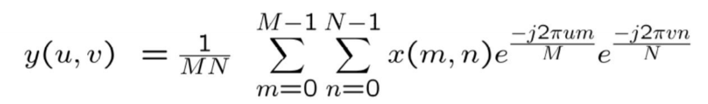

where f(x,y) is a digital image of size MxN. As in the 1-D case, the 2D DFT must be evaluated for values of the discrete variables u and v in the ranges u = 0, 1, 2, …, M - 1 and v = 0, 1, 2, …, N – 1.

As shown in figure 1, when we do the DFT directly, two back to back period would meet in the center of M/2-1. In order to locate the F(0) in the center of interval [0, M-1], we need to multiply f(x) by (-1)x. In 2D DFT, similarly, we have to multiply f(x, y) with (-1)x+y before the transform. Due to the periodicity of DFT, in the real implementation of DFT shift, we could just divide the input image into four quadrants, with the center of the image as the origin. And then we swap the top-left with the bottom right and the top right with the bottom left. After shifting, we do the DFT directly. Now the image should be a complex image. Therefore, in fact we have to merge the image and an image full of zero values with the same image size as a complex input image. After that we have to do the shifting again. It should be noticed that we have done the scaling by dividing the number of image pixels, MxN, so we do not need to do scaling again. However, in some version of DFT, there is no 1/MN in the formula, so we need to do the log transformation, that is, log (1+f (x, y)) and then the normalization. Another critical point is that we need to pad the image to an optimal size to do DFT. And after DFT, we need to crop the image to its original size.

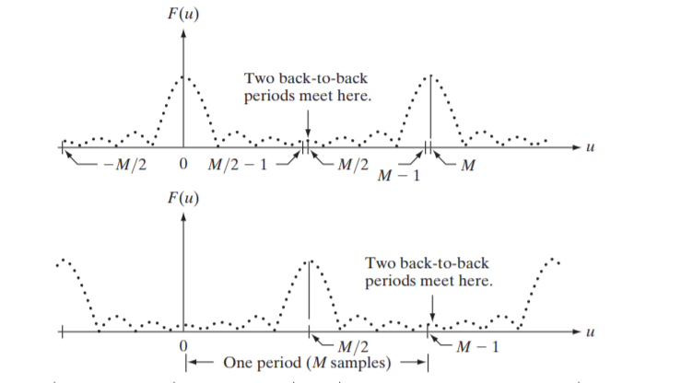

**Fig. 1**. Direct DFT(left) and DFT shift(right)

We could then split the DFT spectrum into magnitude spectrum and phase spectrum. Actually, we often refer “spectrum” to the magnitude spectrum. Three images and their spectrums are shown in figure 2.

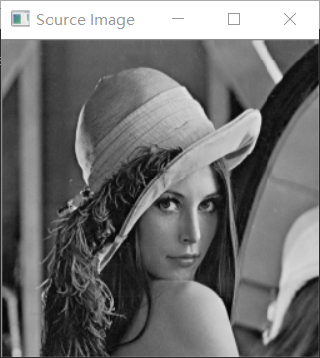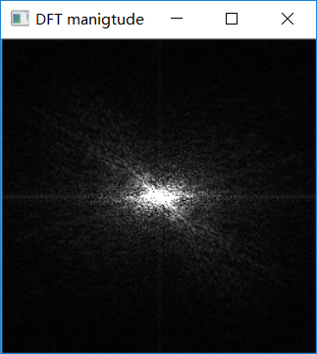

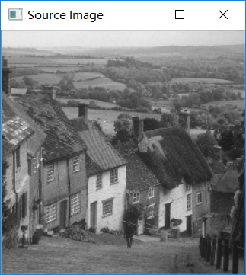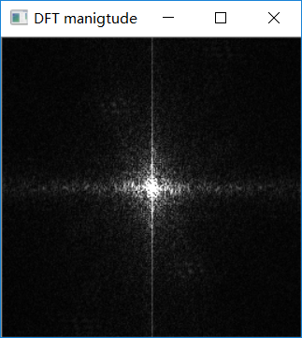

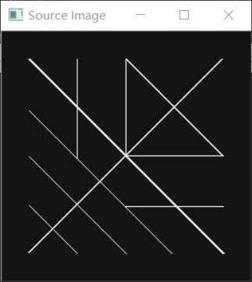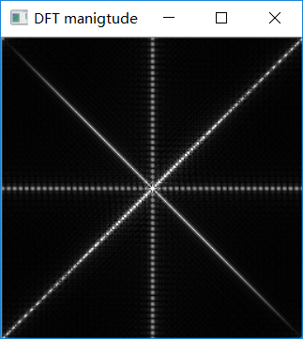

**Fig. 2.** Lena, Goldhill, crosses and their spectrum

As expected, the area around the image centre has the highest pixel value (the brightest). The bright places in the transformed image indicates the fast change of the pixel values, that is, large amplitude implies a greater prominence of a sinusoid of that frequency in the image. Actually, the DFT is insensitive to the image translation, but sensitive to the image rotation. As shown in figure 3, we can see that when the image was translated for about 10 pixels at each direction, the DFT almost did not change. However, when we rotate the image for 90, the DFT image rotated by the same angle.

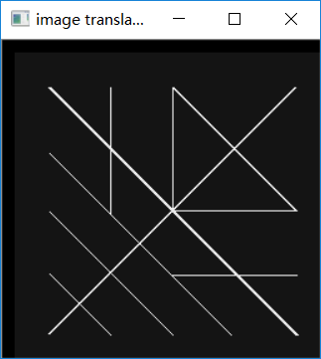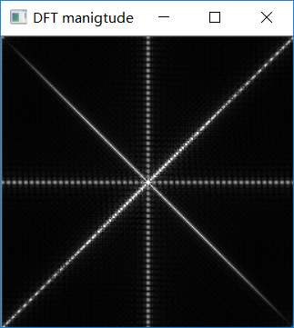

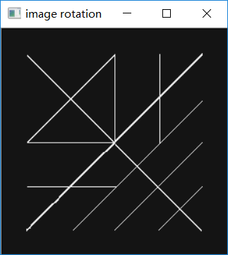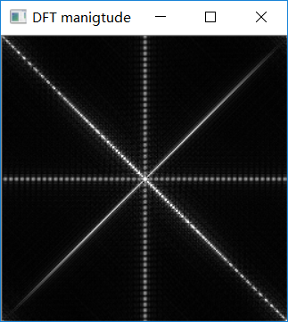

**Fig. 3.** Translated and Rotated image and their DFTs

# Image reconstruction

In this part, we are going to reconstruct the image from its magnitude spectrum and phase spectrum, respectively.

Firstly, we would like to look at the magnitude spectrum and the phase spectrum of lena.pgm. The magnitude spectrum is represented as:



and the phase spectrum is represented as:

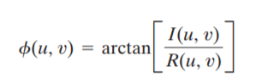

In OpenCV, it is easy to get the magnitude and spectrum using built-in function cartToPolar. And we could get these two images of lena.pgm in figure 4. In order to show the phase more clearly, we did the log transformation and normalize the value to between 0 and 255.

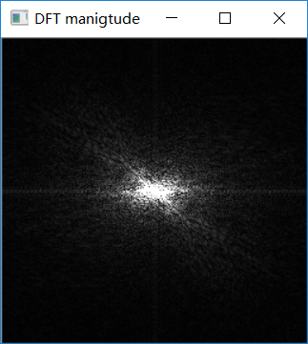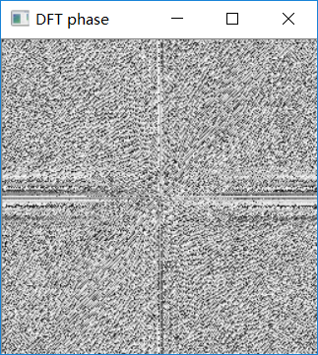

**Fig. 4.** DFT magnitude and phase of lena.pgm

We then obtain the DFT of the translated image and rotated image of lena.pgm, shown in figure 5. We can see that the although the magnitude of the DFT is the same as the translated image (the small difference in the vertical line is just due to we keep the rotated image the same size as the original one), the phase image is different. And the phase angle of the rotated image did not rotate by 90 degrees as in the magnitude image. As the phase image of the three image is different, it seems that the phase angle of the DFT could determine the feature content of an image. We would then reconstruct the image from the magnitude and phase angle respectively.

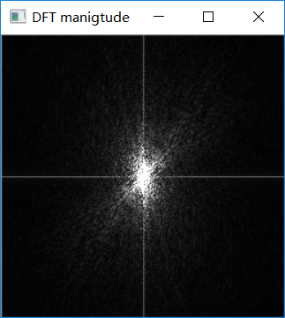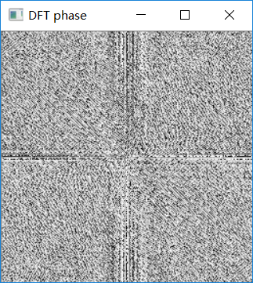

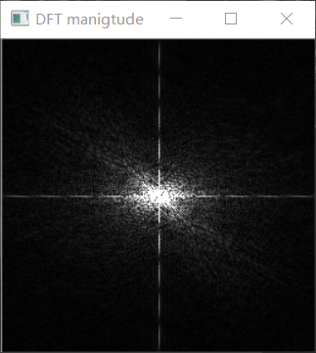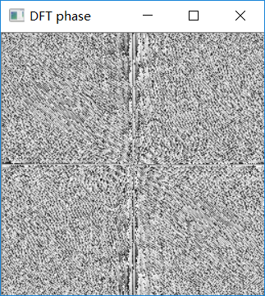

**Fig. 5.** DFT of translated(down) and rotated version(up) of lena.pgm

To reconstruct the image from its phase or magnitude, we need to do the inverse DFT, that is:

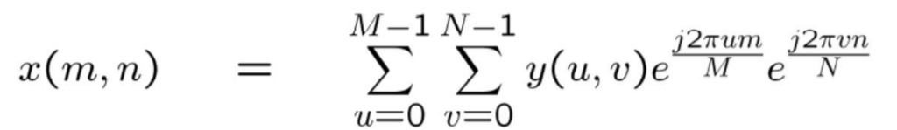

Firstly, we would like to use the phase angle to reconstruct the image. We set the magnitude as 1 and remained the phase part unchanged and then convert them to real and imaginary using polarToCart. Then we merge them to a complex image and did the DFT shift. Finally, we implemented the inverse DFT and normalized the image. The procedure of reconstructing the image using only the magnitude is similar, except that we retain the magnitude and set the phase part as 0. The result is shown in figure 6. We can see that using only phase, we could almost reconstruct the core feature of the original image while using magnitude could get nothing. This is not unexpected. The magnitude contains only intensity information, with the dc term being the most dominant. There is no shape information in the image because the phase was set to zero.

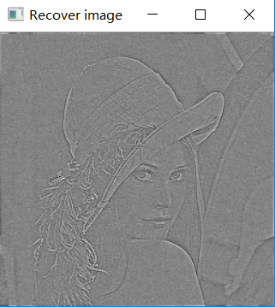 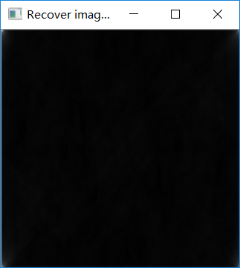

**Fig. 6.** Image reconstruction (L: phase, R: magnitude)

# Conclusion

In this lab, we implement the 2D DFT. We examined both the magnitude spectrums and the phase spectrums of the images. And then we reconstruct the image using the phase and magnitude respectively. We could see that the phase takes the dominance of determining the feature content of an image while the magnitude spectrum is sensitive to image rotation.

# Reference

[1] *Digital Image Processing* Gonzalez 4th edition

[2]<https://docs.opencv.org/2.4/doc/tutorials/core/discrete_fourier_transform/discrete_fourier_transform.html>.

1. Chengpin Luo is with Electrical and Electronic Engineering Department, Southern University of Science and Technology, 518055, CHINA (Student Number: 11510880, e-mail: 11510880@mail.sustc.edu.cn).