[1]

Lab 5

Chengpin Luo, 11510880, SUSTech

*Abstract*—In this lab, we are going to implement image filtering in the frequency domain. Both highpass filtering and lowpass filtering would be performed using ideal filter, Butterworth filter and Gaussian filter.

*Index Terms*— Frequency domain filtering, LPF, HPF

# INTRODUCTION

A

LHOUGH significant effort was devoted to spatial filtering, a thorough understanding of this area is impossible without having at least a working knowledge of how the Fourier transform and the frequency domain can be used for image filtering. In this lab, we would implement the image filtering in the frequency domain. Three kinds of filter would be used: ideal filter, Butterworth filter and Gaussian filter. We would do both the high-pass filtering and low-pass filtering, to blur the images and sharpen the images respectively.

The following sections would be constructed as: (II) Principle of frequency domain filtering(III) Lowpass filtering (IV)Highpass filtering. (V)Conclusion

# Fundamentals of frequency domain filtering

Filtering in the frequency domain consists of modifying the Fourier transform of an image and then computing the inverse transform to obtain the processed result, as shown in figure 1. In the time domain, we do the convolution using the filter mask. Correspondingly, we do the multiplication in the frequency domain. The critical operation is that we have to choose the appropriate filter function H(u , v) to perform the filtering.

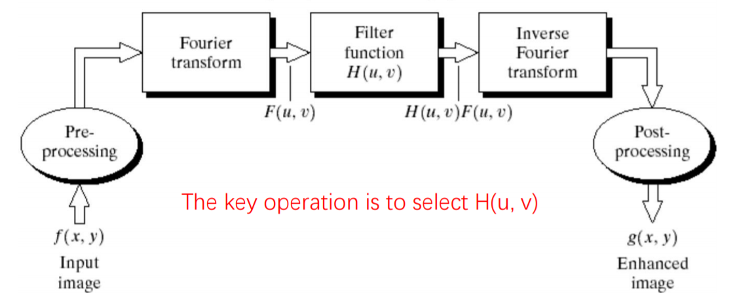**Fig. 1.** Frequency domain filtering

The basic steps for frequency domain filtering is shown in figure 2. We need to center the transform first by multiply the input image with (-1)x+y. And after filtering we have to shift the transform back.

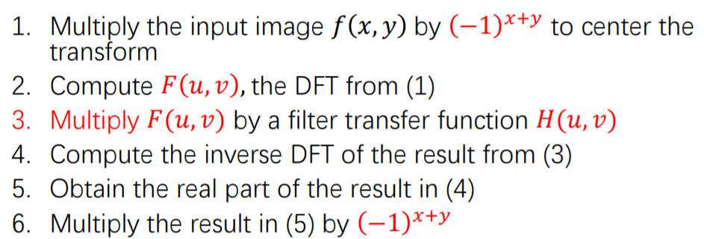

**Fig.2.** Basic steps for frequency domain filtering

The choice of the filter transfer function determines which frequency would be filtered and which would remain. Basically, a lowpass filter attenuates high frequencies without disturbing the low frequencies in frequency domain and a highpass filter attenuates low frequencies without disturbing the high frequencies in frequency domain. Three kinds of filters are shown in table 1, including the lowpass type and the highpass type. In table 1, D0 represents the

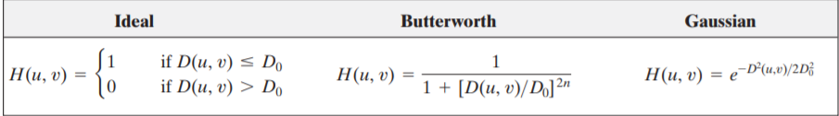

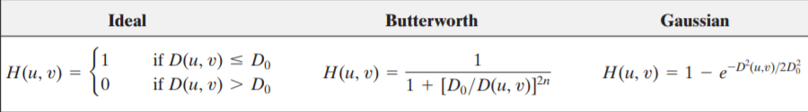

**Table. 1.** Filter transfer function (top: LPF, bottom: HPF)

# Lowpass filtering

In this part, we are going to implement lowpass filtering to lena.pgm and bridge.pgm with different kinds of filter and different cutoff frequencies. The two source images are shown in figure 3.

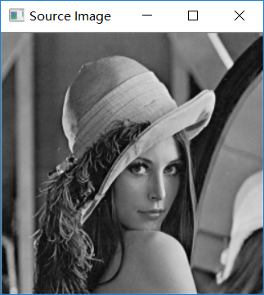 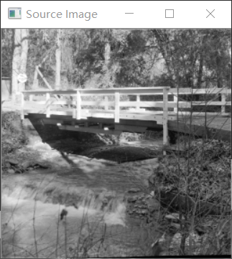’

**Fig. 3.** Lena.pgm(left) and bridge.pgm(right)

Following the steps in figure 2 and setting the cutoff frequency as 15, 30 and 80, we could get the results shown in figure 3, figure 4, and figure 5 using LDLPF, BLPF(order=2) and GLPF.

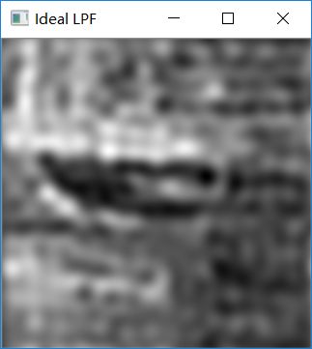 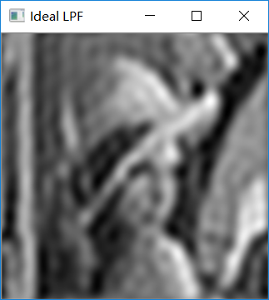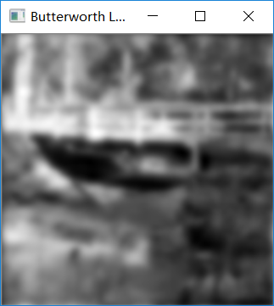 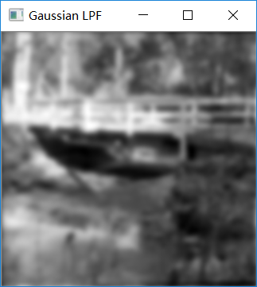 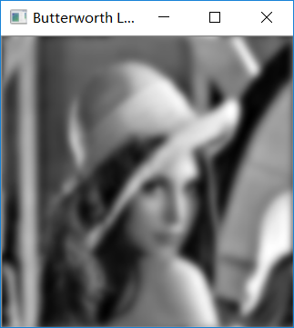 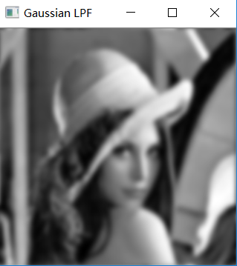

**Fig .3.** LPF, cutoff frequency=15 Hz

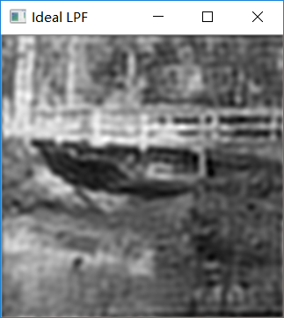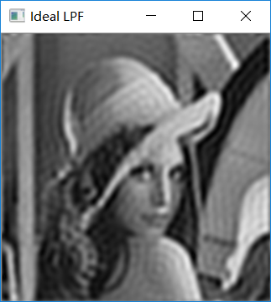

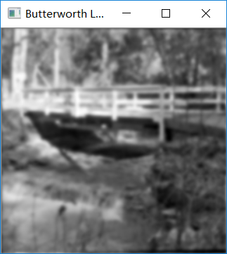 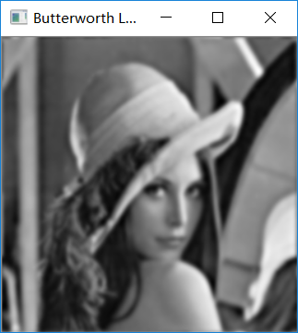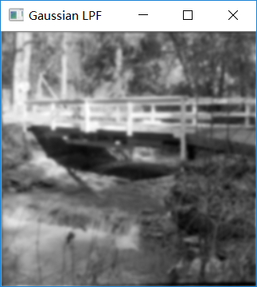 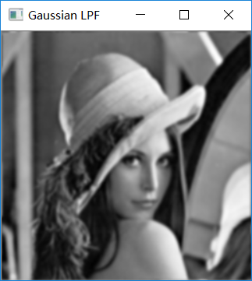

**Fig .4.** LPF, cutoff frequency=30 Hz

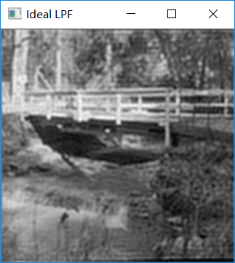 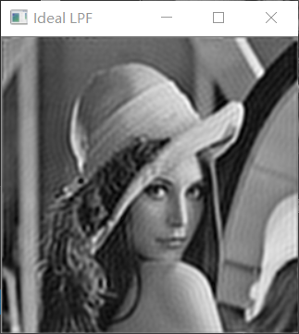

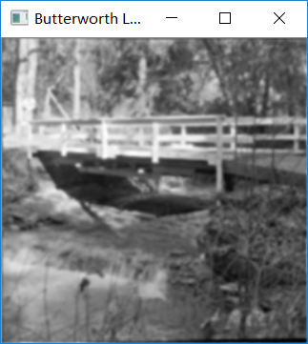 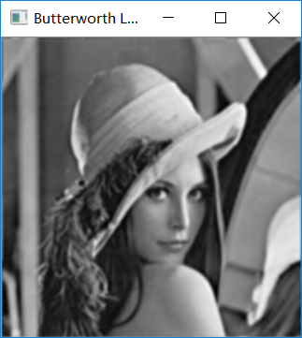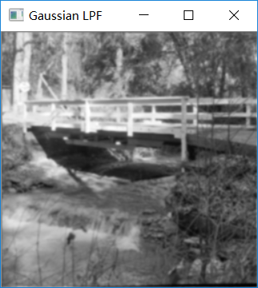 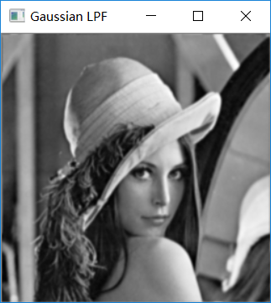

**Fig .5.** LPF, cutoff frequency=80 Hz

Comparing the results in figure 3, figure 4 and figure 5, we could see at the same cutoff frequency, the ideal lowpass filter blurred the image most while BLPF less blurred the image and GLPF is slightly sharpen than BLPF. At all the cutoff frequencies, ILPF showed ring effect while a BLPF showed no ring effect at order 2 and a GLPF also showed no ring effect. This is reasonable because an ILPF is a sinc function in the spatial domain, a BLPF would be closer to a sinc function in the spatial domain as the order increase and a GLPF is also Gaussian in the spatial domain. As the cutoff frequency increase, all the images become sharpener because more high frequency components preserved.

# Highpass filtering

In this part, we are going to sharpen two fingerprint images using high pass filter and thresholding. As discuss in part III, a Gaussian filter caused least ring effects so a GHPF would be used in this part. The two fingerprint images are shown in figure 6.

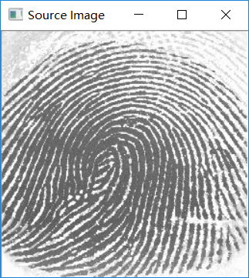 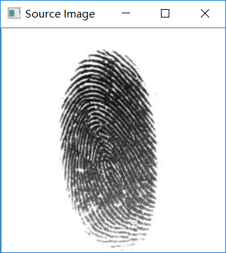

**Fig. 6.** Fingerprints

Firstly, we implemented GHPF to the two images. The steps are similar to LPF, except that the filter transfer function are different. Setting the cutoff frequencie as 80Hz, the result images are shown in figure 7. We could see that the images were sharpened because most of the low frequencies were filtered.

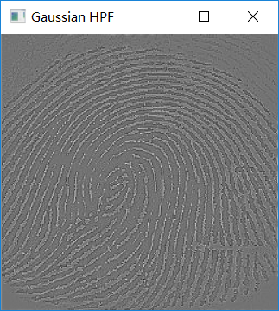 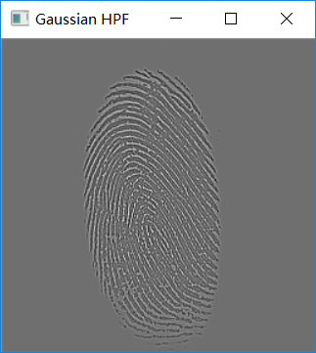

**Fig. 7.** GHPF Fingerprints

To see the image clearer, we need to threshold the images. As we have normalize the image value to the inteval [0,1], we set the threshold as 0.43 after trials. And then we got the final results in figure 8. Now we could see the images both sharpened and clearly.

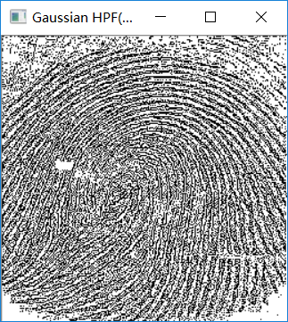 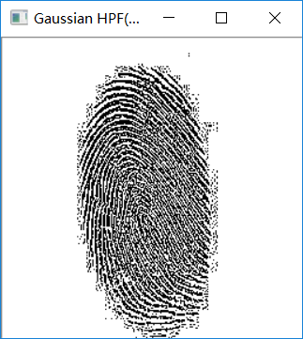

**Fig. 6.** Sharpened Fingerprints

# Conclusion

In this lab, we implement both the lowpass filter and the highpass filter using ideal filter, Butterworth filter and Gaussian filter. We can see that a LPF would smooth an image while a HPF would sharpen an image. With cutoff frequencies increase increasing, a LPF image would become less blurred while a HPF image would become sharpened. Different kinds filter has different effects. For example, a ILPF would have the severest ring effect while a GLPF have no ring effect. Last but not least, when we sharpen an image using HPF, we have to set a threshold also in order to make the image more sharpened.

# Reference

[1] *Digital Image Processing* Gonzalez 4th edition

[2]<https://docs.opencv.org/2.4/doc/tutorials/core/discrete_fourier_transform/discrete_fourier_transform.html>.

[3] https://github.com/alessandro-gentilini/opencv_exercises-butterworth

1. Chengpin Luo is with Electrical and Electronic Engineering Department, Southern University of Science and Technology, 518055, CHINA (Student Number: 11510880, e-mail: 11510880@mail.sustc.edu.cn).