[1]

Lab 7

Chengpin Luo, 11510880, SUSTech

*Abstract*—In this lab, we are going to design filters to remove noise patterns in noisy images. For some images, the filtering is performed in frequency domain, such as band-reject filtering. For others, several kinds of filters would be used, such as arithmetic mean filter, Alpha-trimmed mean filter and so on.

*Index Terms*— Noise removal, mean filter, median filter, band-reject filter

# INTRODUCTION

I

N order to remove noise in images, we would like to see the noise patterns in the frequency domain first. If the noise could be easily removed in the frequency domain, such as sinusoidal noise, then the filtering would be performed in the frequency domain directly. For some other kinds of noise, such as Gaussian noise, which would be everywhere in the frequency domain, band-reject filtering or band-pass filtering would not be feasible anymore. It would be more suitable to remove the Gaussian noise using a mean filter in the time-domain. In this lab, we will implement frequency domain filtering using band-reject filter and time-domain filtering using mean filter and median filter as appropriate.

# Fundamentals of noise removal

In this part, we will give some brief information about the fundamentals of noise removal. First comes the frequency domain filtering. Suppose an image was interrupted by sinusoidal noises, which would become a pair of bright point in the frequency domain, then we can filter this kind of noise out using a band-reject filter. Three kinds of band-reject filters are shown in figure 1 and the Butterworth one would be used in this lab.

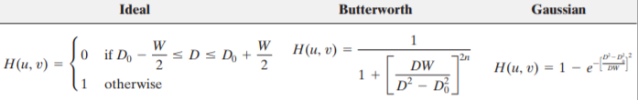

**Fig. 1.** Band-reject filters

For some cases, the noise in an image is uncorrelated with the image and the statistical behaviors of the noise components can be considered as the random variable, characterized by the probability density function. Six kinds of common noises’ PDFs are shown in figure 2. To remove those noises, a band-reject filter does not work. Instead, we will use mean filters and median filters, which are implemented in the spatial domain. Typically, there are different kinds of mean filters and median filters. For examples, there are four kinds of mean filters—arithmetic mean filter, geometric mean filter, harmonic mean filter and contraharmonic mean filter. More details would be given in part III.

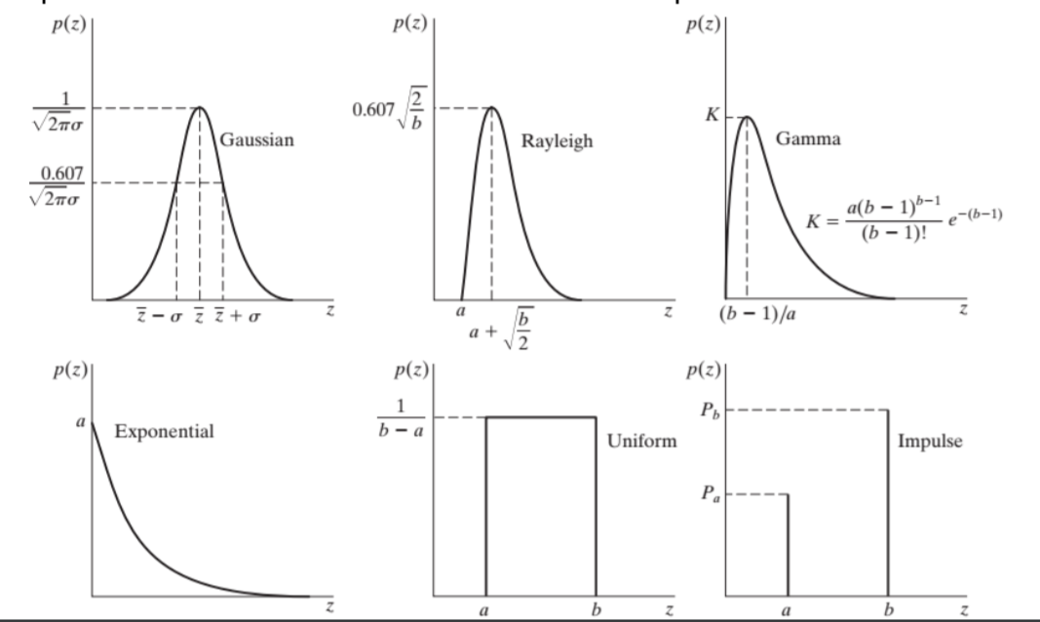

**Fig. 2.** Simple noise models

# Experiment and results

In this part, we are going to remove the noise pattern in images from spatial domain or frequency domain.

Firstly, we would like to restore two images, lenaWithNoise.pgm and cameraWithNoise.pgm. Those two images are shown in figure 3. In LenaWithNoise.pgm, those noise patterns—the strips are sinusoidal noises. To verify this, we did the Fourier transformation and the frequency-domain image is shown in figure 4. We can see that except the center, there are several pairs of bright points along the vertical axis, which represent the sinusoidal noise. To remove those noise patterns, Butterworth band-reject filters were used twice. The result image and its DFT are shown in figure 5.

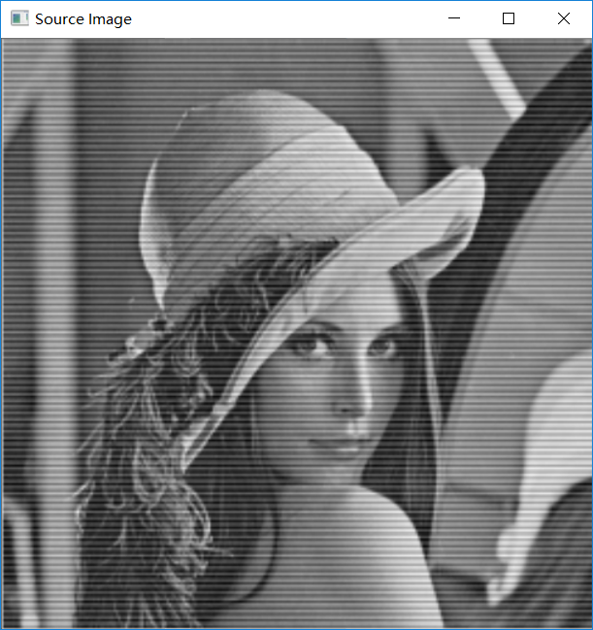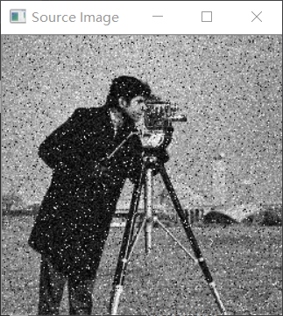

**Fig. 3.** LenaWithNoise(left)&cameraWithNoise(right)

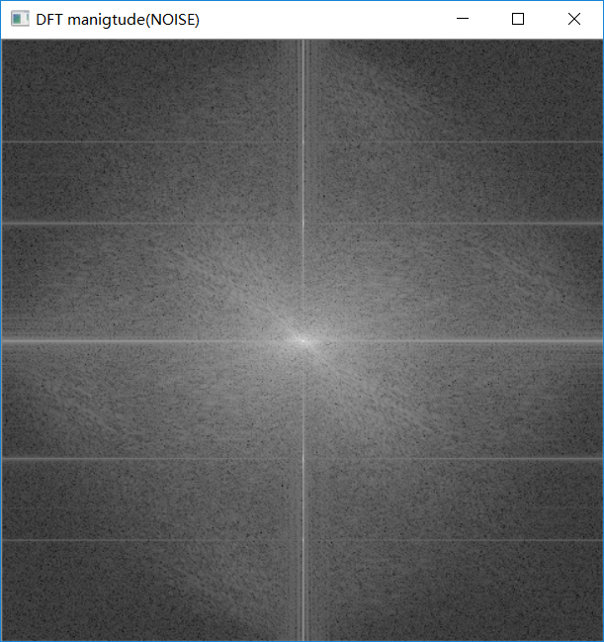

**Fig. 4.** DFT of lenaWithNoise.pgm

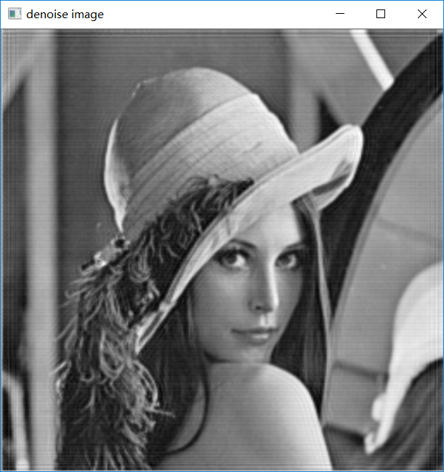 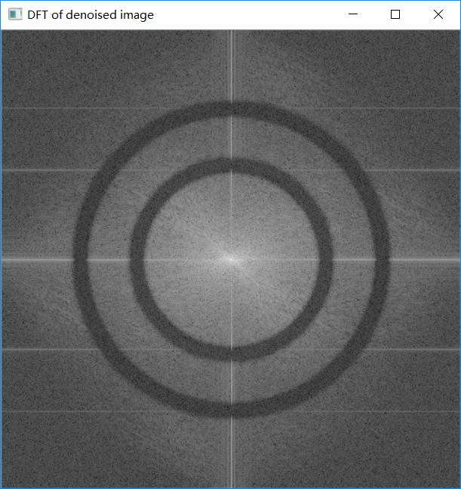

**Fig. 5.** Restored image and its DFT(lena)

From figure 5, we can see that the sinusoidal noises were removed, with ring effect exists because of the spatial-domain characteristics of Butterworth filter. From the DFT image, we can see that band-reject filter is actually dark ring in the frequency domain, where the unwanted frequencies filtered.

Next comes the restoration of cameraWithNoise.pgm. The DFT of the image is shown in figure 6. From the spectrum we cannot find the locations of noises—it seems to exist everywhere in the frequency domain. Therefore, band-reject filtering would not have good performance. We need to consider the noise’s statistical characteristics and then perform spatial domain filtering. We took a small part of the noisy image (from (0,0) to (49,49)) and calculated its histogram. The results are shown in figure 7. From the histogram, we can see that the image was interrupted by impulse noise and Gaussian noise.

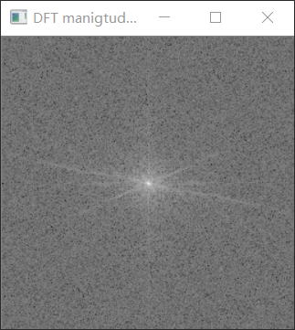

**Fig. 6.** DFT of cameraWithNoise.pgm

 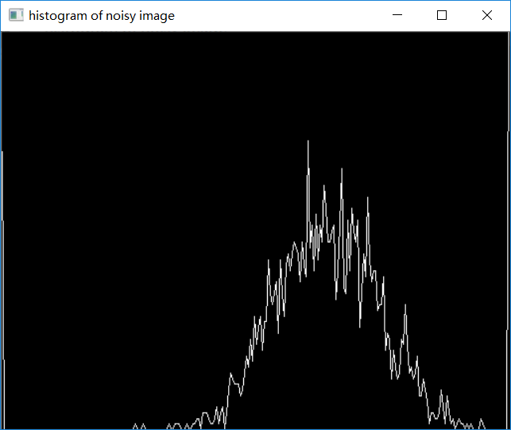

**Fig. 7.** image strip and its histogram

To remove impulse noise (more precisely, Salt&Pepper noise), a median filter can be used. A 3x3 median filter would assign the median value of the values under the kernel to the center. To remove Gaussian noise, using an arithmetic mean filter is effective. The arithmetic mean filter is given by

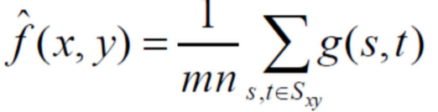

where the kernel is of size mxn and Sxy represents the subarea that the kernel covers. The results are shown in figure 8. The images after median filtering only are shown at the left when the images after median filtering and arithmetic mean filtering are shown at the right. In the top two images 3x3 kernels were used when in the bottom two images 5x5 kernels were used. We can see that the median filtering removed the dark and white noises in the original image and the mean filter removed the Gaussian noises as well as blurred the images more. When the kernel size is increased, the images looks more blurred and more noises were removed.

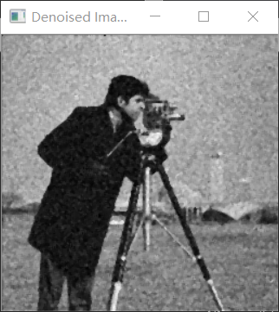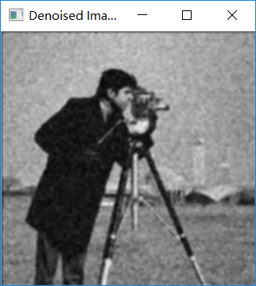 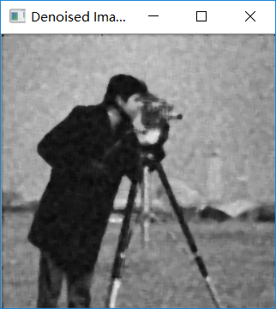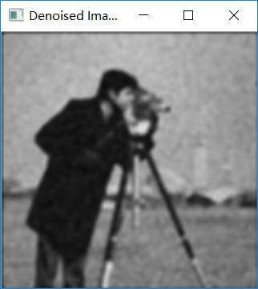

**Fig. 8.** Median filtering and Arithmetic-mean Filtering

Now, we are going to use arithmetic mean filter, geometric mean filter, median filter, Alpha-trimmed mean filter, and adaptive median filter respectively to reduce the lenaD1.pgm, lenaD2.pgm, lenaD3.pgm.

A geometric mean filter is given by:

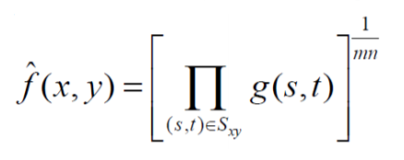

An alpha-trimmed mean filter is given by:

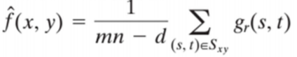

where d represents the number of pixels to be deleted. That is, to delete the lowest d/2 pixels and the highest d/2 pixels and then average the remaining intensity values.

The algorithm of implementing an adaptive median filter is given by:

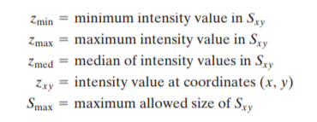

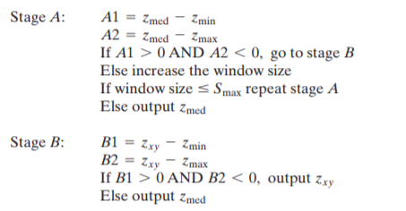

where Sxy represents the subarea that the kernel covers.

The results are given in figure 9, figure 10 and figure 11 for lenaD1.pgm, lenaD2.pgm and lenaD3.pgm respectively, where 3x3 kernels were used in all cases and d=4 for alpha-trimmed filter.

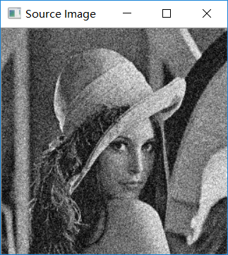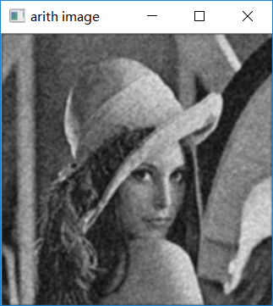 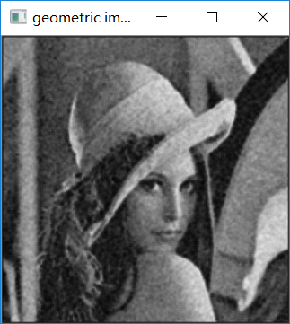

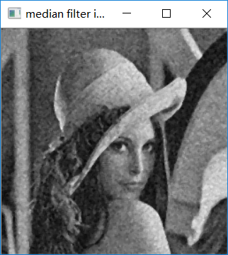 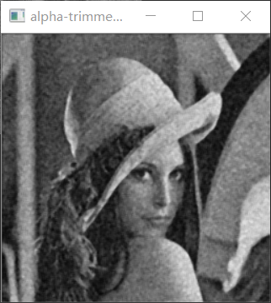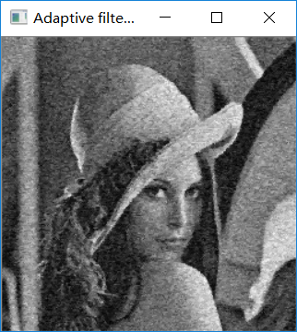

**Fig. 9.** Median and mean filtering for lenaD1.pgm

In figure 9, the image were conrrupted by Gaussian noise. We can see that mean filters blurred the images and reduced the noise when median filters performed poorer. Among the mean filters, the arithmetic blurred the image most while alpha-trimmed blurred the image least because arithmetic filter took 9 values into account when alpha-trimmed filter only considered 4 intensiy values.

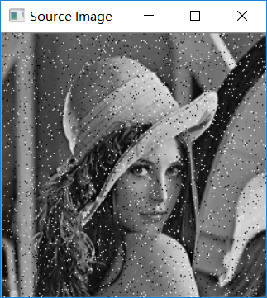 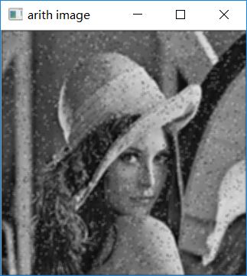 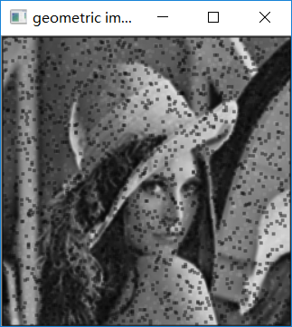

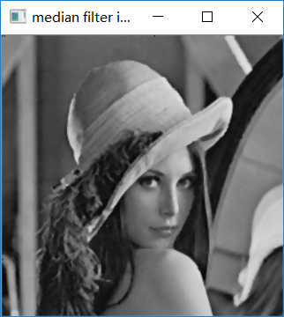 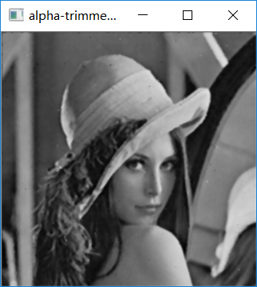 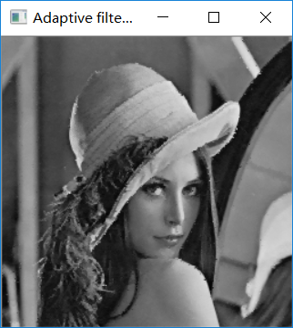

**Fig. 10.** Median and mean filtering for lenaD2.pgm

In figure 10, we can see the impulse noise clearly in lenaD2.pgm. In this case, the mean filter performs poor except alpha-trimmed mean filter. In contrast, all the median filters perform very well. The adpative mean filter removed the noise perfectly and made the image looks sharper than using a median filter. The alpha-trimmed mean filter also performs well because both the largest and lowest intensity values are thrown, with only modest values considered.

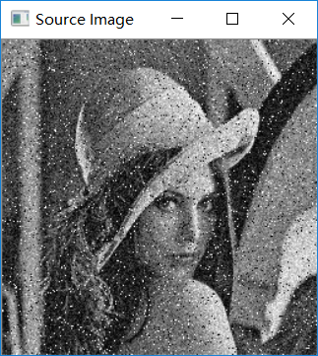 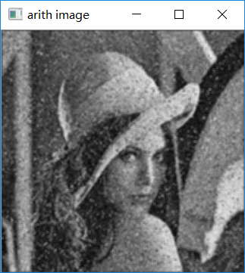 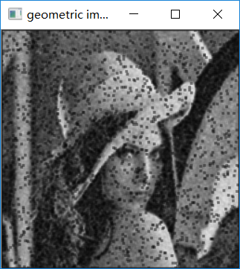

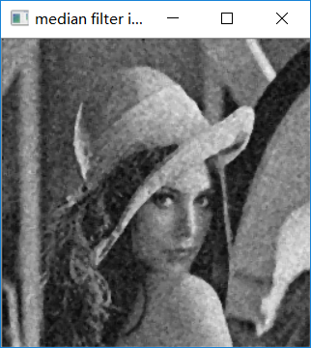 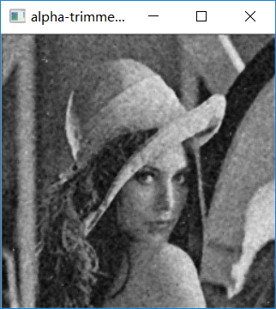 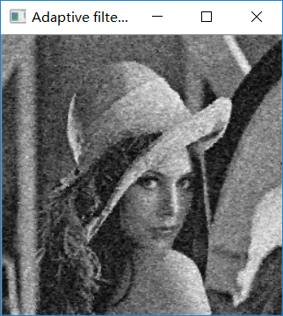

**Fig. 11.** Median and mean filtering for lenaD3.pgm

In figure 11, the image are corrupted by salt&pepper noise severely. The airthmetic mean filter and geometric filter have very bad performance, especially geometric image, where a great number of black squares appear because the pepper noise is multiplied to get zero values. The median filters and alpha-trimmed filter performed better. The adaptive filter has the best performance—removing the noise with least distortion.

# Conclusion

In this lab, we try different methods to remove noises in images from both spatial domain and frequency domain. For sinusoidal noise, we often restored the image using band-reject filter, such as results in figure 5. For some other kinds of noise, such as Gaussian noise and salt&pepper noise, it is more suitable to filter the image in spatial domain. For Gaussian noise, mean filters performs better than median filters. For impulse noise, median filters give better results. To restore the image with less distortion, it is a great idea to use adaptive filters, which would change its size when the noise pattern in the subarea changes.

1. Chengpin Luo is with Electrical and Electronic Engineering Department, Southern University of Science and Technology, 518055, CHINA (Student Number: 11510880, e-mail: 11510880@mail.sustc.edu.cn).