Real-Time Sport Posture Correction

HUI Wang Chi, YUEN Ho

1. **Project Goal**

Our project goal is to develop a model that offers real-time posture correction for yoga and gym exercises. This project is research-based, meaning that we will concentrate on developing the core functionality without a user interface. First, we will compile our own dataset of posture images specifically tailored for this project. Then, we will examine and compare the performance of various model architectures in terms of latency and accuracy. Finally, we will employ the most effective model for posture detection and further enhance it with a detailed alert mechanism for identifying improper postures.

1. **Significance of Project**

Yoga and gym workouts both heavily rely on proper posture. Some yogis may assume that yoga is less likely to cause injuries because its poses often appear static and soothing compared to faster, more dynamic sports like football or basketball. However, research[1] shows that even yoga can lead to pain when performed with improper postures. The risk of injury and pain from yoga is comparable to that of other exercises. Similarly, gym exercises, which frequently involve external equipment and heavier loads, may pose an even higher risk of injury or pain due to incorrect postures.

For individuals training on their own, without the guidance of a coach, identifying and correcting improper postures can be difficult. To address this, we aim to develop a posture correction model to assist these solo trainers in facilitating safe and convenient training sessions.

1. **Problem Statement**

Currently, there is a shortage of mature posture correction applications on the market. While MoveNet, PoseNet, and OpenPose are the three mainstream human pose estimation models, there is no comprehensive research comparing their suitability for our specific case. Additionally, no existing dataset fully meets the requirements of our project. Key challenges include the lack of negative samples (incorrect postures) and the high variance in activity poses, leading to insufficient data for certain postures.

1. **Proposed Solutions**

To deal with the stated problem, we will begin by creating our own dataset of yoga posture images. This will be achieved by combining existing datasets and sourcing additional videos from YouTube, thereby enriching the quantity and variety of training data.

**Figure 1.** The overall two-stage approach model pipeline of this project.

Regarding the model, the general expected architecture will follow a two-stage approach as shown in Figure 1. In the first stage, we will employ a pre-trained human pose estimation model that demonstrates the best performance in our comparative evaluation to capture body key-points. The retrieved key-points will then be passed to the second stage, where the model will classify the posture types and provide corrective feedback. Throughout both stages, our objective is to evaluate and identify the best model for each stage.

Regarding the training approach, we expect to use transfer learning, where only the classification model will be trained, while the first-stage model will remain frozen. During model training, we will apply various techniques such as normalization, augmentation, and regularization to enhance the model’s functionality.

1. **Proposed Timelines**

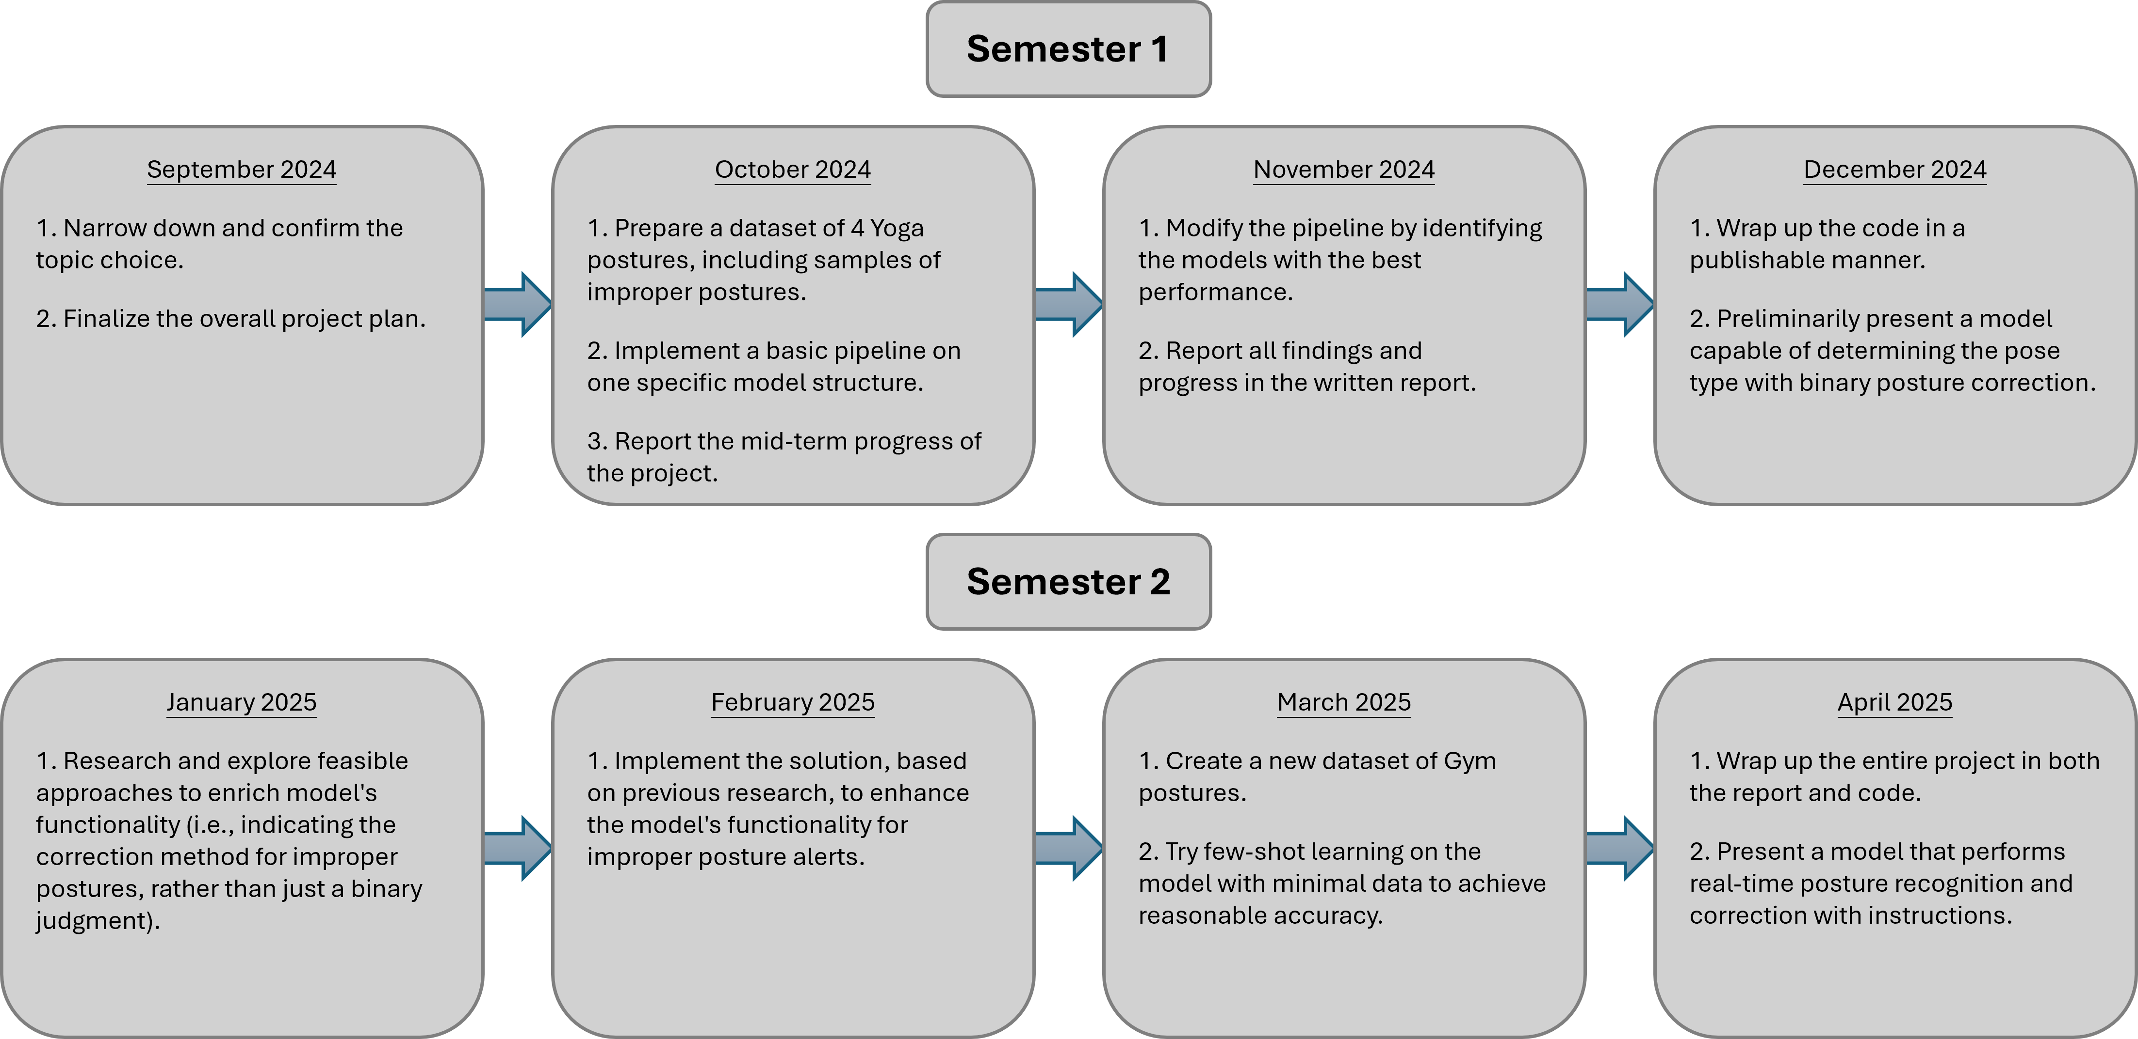

1. M. Campo, M. P. Shiyko, M. B. Kean, L. Roberts, and E. Pappas, “Musculoskeletal pain associated with recreational yoga participation: A prospective cohort study with 1-year follow-up,” Journal of Bodywork and Movement Therapies, vol. 22, no. 2, pp. 418–423, Apr. 2018, doi: 10.1016/j.jbmt.2017.05.022.