COMP3322 Modern Technologies on World Wide Web

Lab1: Fundamentals of Web Pages – HTML and

CSS

# Introduction

In this lab, we are going to develop a simple HKU Custom Search Page. We will practice how to use basic HTML elements and format the webpage using basic CSS styling rules. A screenshot of the finished page is as follows:

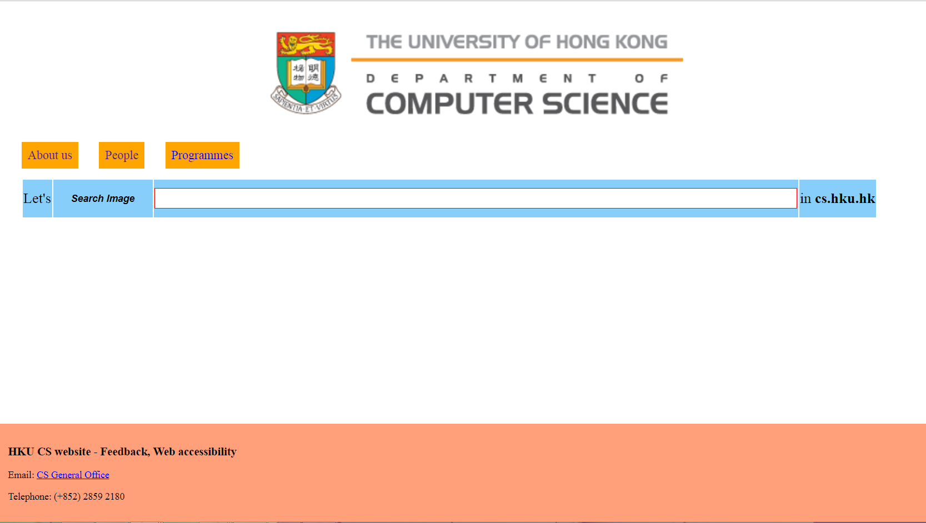

Note: The same CSS code may lead to quite different page display on different browsers. We will check your page in the Chrome browser. So you are recommended to use Chrome to develop/test your page as well.

# Lab Exercise

[Step1]: Download "**lab1_2018xxxx.zip**" from HKU Moodle, and extract it to a folder named "lab1". In this folder, there are two files **index_template.html** and **style_template.css**, which are the template files in which you will add more HTML code and CSS code, respectively.

# Section 1: Build the HTML page

[Step2 (Page Title)]: In **index_template.html**, set the title of the page to "**HKU CS Custom Search**".

[Step3 (Logo)]: At the top of the page, there is a division **<div>** with the id of "logo". Make the division clickable, and link to **HKU CS Home page (**[**https://www.cs.hku.hk/index.jsp**](https://www.cs.hku.hk/index.jsp)**)** when clicked (using the **<a>** element).

[Step4 (Navigation List)]: Underneath the HKU logo, there is a division **<div>** with id "navi". In this division, use **<ul>**, **<li>**, and **<a>** elements to implement a navigation list, including three list items as follows. All three list items should be hyperlinks. The mapping between list items and links is as follows:

|  |  |
| --- | --- |
| List Item | **Hyperlink** |
| About us | <https://www.cs.hku.hk/aboutus/general.jsp> |
| People | <https://www.cs.hku.hk/people/academic.jsp> |
| Programmes | <https://www.cs.hku.hk/programme/beng-cs/programme-learning-outcomes.jsp> |

[Step 5 (Search (Table)): In the division **<div>** with id "searchArea" underneath the navigation list, use the **<form>** element to create a form. Inside the **<form>** element, use **<table>, <tr>, <td>** to create a 1x4 table (one row and four columns), as shown in the above screenshot. The first cell in the table shows “Let's”. The second cell contains a search button implemented using an **<input>** element with type=”submit” and value=” Search Image” (the text displayed on the button). The third cell includes an input textbox, where the search string is to be entered; set the "name" attribute of the input textbox to "q". The fourth cell contains “in <b> cs.hku.hk </b>” (cs.hku.hk will be in bold font) and an **<input>** element with the input type of "hidden" (refer to <http://www.w3schools.com/tags/att_input_type.asp>); set the "name" attribute of the hidden input field to "as_sitesearch" and the "value" attribute to " cs.hku.hk ", which provides the search domain parameter to Google server. (You can learn more about Google search parameters at <https://moz.com/ugc/the-ultimate-guide-to-the-google-search-parameters>).

Set the "**method**" attribute of the form (the HTTP request method) to "**get**", and "**action**" attribuite of the form to " http://images.google.com/images " (where the form data will be sent when the search button is clicked). Then after you type the search string and click the search button, an HTTP request carrying the URL [https://www.google.com/search?q=yoursearchstring&as_sitesearch=cs.hku.hk](https://www.google.com/search?q=yoursearchstring&as_sitesearch=hku.hk)&… (additional parameters might be appended by your browser) will be sent to the Google server, and a Google result page corresponding to your input and search domain parameter will appear.

[Step 6 (Contact Information)]: At the bottom of the page, there is a division **<div>** with id "footer". In this division, add a **<h3>** element containing "HKU CS website - Feedback, Web accessibility", and two **<p>** elements to show the following two lines of contact information.

|  |
| --- |
| Email: CS General Office |
| Telephone: (+852) 2859 2180 |

In addition, make the CS General Office a hyperlink (mailto:enquiry@cs.hku.hk) (using the **<a>** element) and when you click the email address, a mail client should be invoked (Hint: use "mailto:" in the href attribute of the **<a>** element; see <https://www.w3schools.com/tags/att_a_href.asp>).

Your page will look as follows after you have done the above steps:

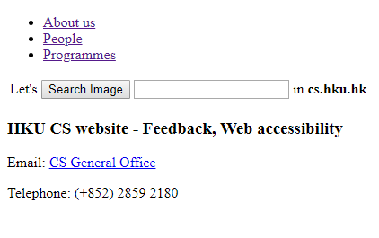

# Section 2: Improve the page appearance using CSS styling

[Step 7 (linking to css file)]: Add the following in the **<head>** element in **index_template.html**, such that the html page will be styled by the styling rules in **style_template.css**.

|  |
| --- |
| <link rel="stylesheet" href="style_template.css" type="text/css"> |

[Step 8 (logo)]: In "**lab1_2018xxxx.zip**", you can also find a HKU CS logo image (**hku-cs-logo.png**). Set the image as the background of the "logo" division (Hint: use "background-image" <http://www.w3schools.com/cssref/pr_background-image.asp> and other relevant background properties to achieve the look as in the screenshot). Set the width of the "logo" division to 50%, height to 180 px. Position the image to the left with a 435px margin and to the top of the page with a 35px margin (Hint: set "margin-left" and "margin-top" of the division).

[Step 9 (Navigation List)]: Arrange all list items horizontally (by setting the “display” property of each list item to the appropriate value), without bullets and underline of each clickable list item (Hint: use "text-decoration: none" on the **<a>** element in the list). Set the font size to 20px. Set the right margin of each list item (**<li>** element) to 30px, background color to " orange ", with a padding of 10px.

Set the left padding and the left margin of the list (**<ul>** element) to 0px and 30px, respectively.

[Step 10 (Search textbox and button)]: Set the width of the search input textbox to 1050px, height to 30px, border width to 1px, border style of solid with color "red". The font size of the input text should be 20px.

Set the width and height of the search button to 160px and 30px, respectively, the background color of the search button to "lightskyblue", the font of the text on the search button to bold, italic, 16px with a black color. There is no border for the search button.

[Step11 (Table)]: Set the background color of each cell to " lightskyblue " and height to 60px. Set the font size of "Let's" and "in hku.hk" to "x-large" (<http://www.w3schools.com/cssref/pr_font_font-size.asp)>. Change the background color of a cell to " orange " when the cursor moves over it.

Set a left margin of 30px for the table.

[Step 12 (Footer)]: Set the background color of the footer division to "lightsalmon". Set its position property to "absolute", and right/bottom/left to 0px (https://www.w3schools.com/cssref/pr_pos_right.asp), and padding to 1rem.

# Upload and Test

Uploading Method:

Use any FTP Client to upload your files (including index_template.html, style_template.css, as well as the HKU logo image) to the server i.cs.hku.hk. Suggested FTP Client is WinSCP which you can download here:

<https://winscp.net/eng/download.php>

Step1: When you first enter into WinSCP, you would need to first login into the server. Choose SFTP for the file protocol, host name as “i.cs.hku.hk”, port number as 22. Enter your username and password as the one in the CS Intranet. Then click “Login”.

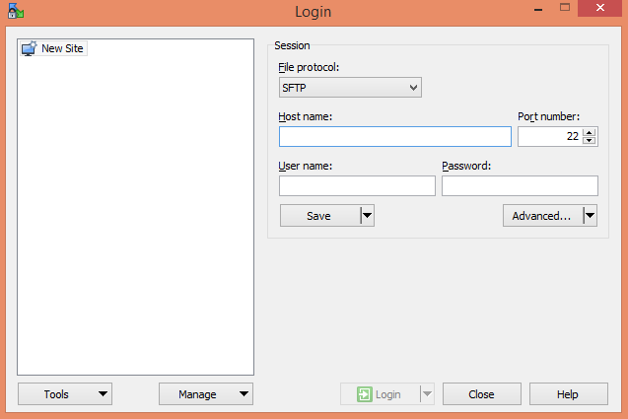

Step2: You can see a common FTP interface which on the left hand side is your Windows file system, while on the right hand side is the server file system. Create a folder “Lab1” under “public_html” folder and put all the necessary files in this lab into the folder. Please follow the folder naming rule “LabX” and please put all the lab folders under “public_html” folder in all the labs remaining in this course which X represents the number of lab session (i.e. 1 here).

Step 3: Browse and test your webpage at (make sure you test your page after uploading it to i.cs.hku.hk):

http://i.cs.hku.hk/~[your_CSID]/Lab1/index_template.html

**Submission:**

Please finish this lab exercise before 23:59 27 September 2018 (Thursday). We will go to your individual webpage at http://i.cs.hku.hk/~[your_CSID]/Lab1/index_template.html to check your page. If the page is correctly implemented, you will get the "1" mark for this lab exercise.