**GATE TYPE SELECTION BASED ON FUZZY MAPPING**\***(22p, Arial Narrow, Bold)**

**Yang Yu1, \***(*号用以表示尾注)**, Xing Yuan2** **(14p, Arial Narrow, Bold)**

(1. School of Mechatronics Engineering, Harbin Institute of Technology, Harbin Heilongjiang, 150001

2. School of Mechanical Engineering, Shanghai Jiaotong University, Shanghai 200030) (10. 5p, Arial Narrow)

**Abstract(9p, Bold)**: A novel method for selecting gate type based on fuzzy logic is proposed. The proposed methodology follows three steps: Design requirements for gate is extracted and generalized; Possible gate types (design schemes) are presented; The fuzzy mapping relationship between gate design requirements and gate design scheme is established based on fuzzy composition and fuzzy relation transition matrices that are assigned by domain experts(9p). …

**Key words(9p, Bold)**: Gate type selection, Fuzzy logic, … (9p)

**基于模糊映射的类型选择（小四，宋体，加粗）**

杨玉1，邢原2（五号，宋体）

（1．哈尔滨工业大学机电工程学院 黑龙江 哈尔滨 150001；

2．上海交通大学机械工程与动力学院 上海 200030）（小五，宋体）

摘要(小五，黑体)：介绍了一种新型的基于模糊逻辑的类型选择方法。…（小五，宋体）

关键词(小五，黑体)：类型选择，模糊逻辑，… （小五，宋体）

## 0 INTRODUCTION(10.5p, Bold)[1]*(此处尾注符号*号改白色)

Mould conceptual design is the most important phase of mould design. … (9p)

## 1 BASIC THEORY OF FUZZY SETS

### 1.1 Fuzzy set(9p, Bold)

Let *U* be a universe, whose generic elements are denoted by *x*. If the membership in subset *A* of *U* is allowed to be the real interval [0, 1], then *A* is called a fuzzy set, and it can be characterized by the set of pairs

*A* (1)

where —— Grade of membership of *x* in *A* with grades 1 and 0 representing full membership and non-membership in a fuzzy set res pectively

When *U* is a finite set ｛*x*1, *x* 2, *A*, *x**n*｝, a fuzzy set *A* on *U* is expressed as

##### A=μA( x1 )/x1+Λ+μA( xn )/ xn=ΣμA( xi )/ xi (2)

### 1.2 …

The inputs of the system are gate design requirements, and outputs are the selected possibilities of candidate gate design schemes (see Fig.1). (7.5p in Fig.)

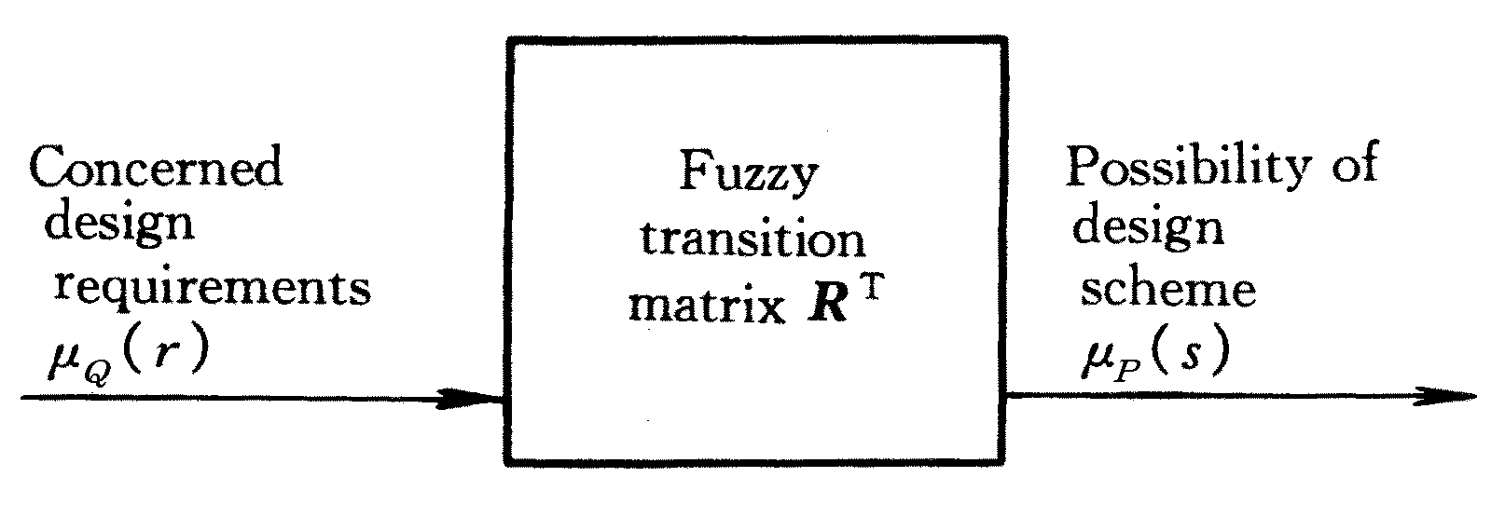

Fig.1 Mapping from design requirements to design scheme(8p)

## 2 PROPOSED METHODOLOGY

### 2.1 Establishment of fuzzy transition relation

Since the transition relation ***R***T should reflect the two scenarios, it is proposed that ***R***T be the weighted average of ***R***1and ***R***2, i.e.

 (3)

*i*=1, 2, … , *m j*=1, 2, … , *n*

where —— Entries of matrix ***R***T

*w*1, *w*2—— Weight values

## 3 IMPLEMENTATION

By interviewing with domain experts and referring to many design handbooks, 12 design requirements for gate design were identified and 12 kinds of gate were choose to meet the design requirements (see Table 2).

Table 2 Gate design requirements and design scheme(8p, Bold)

|  |  |  |  |
| --- | --- | --- | --- |
| No. | Design requirement | No. | Design scheme |
| 1 | Apply to single impression | 1 | Edge gate |
| 2 | Strong material adaptability | 2 | Overlap gate |
| 3 | … | 3 | … |

(7.5p in Table)

4 CONCLUSIONS

(1) The stepping accuracy comes to …

(2) …

(3) …

References(10p, Bold)

1. Von H, Detlef W. Advanced joining technologies. Schweissen and Schneiden. Welding and Cutting, 2000, 52(9): 195~200 (8p)
2. Gao X D, Huang S S. Artifical neural technique for arc-welding seam detection. Transaction of the China Welding Institution, 1998, 19(5): 118~124 (In Chinese)
3. …

1. 作者简介：姓名（出生年-），性别，民族，籍贯，？？大学博士研究生（用中文写）

   联系方式：电话，Email