FEFU ARRIVAL FORM

**For exchange students**

Spring Semester 2019

1. First Name
2. Last Name
3. Sending University
4. I arrive on □ March, 19[1]

other date of arrival to Vladivostok[2] (local time in Vladivostok)

1. Time of arrival [3](local time in Vladivostok)
2. Flight number (Ship, bus, train)
3. Place of arrival
4. Do you need pick up service?
5. Address of your dormitory in Vladivostok
6. Signature

TRANSPORT INFORMATION

Plan of Airport Knevichi (Vladivostok)

ф International terminal Local terminal ф Common area

Exit

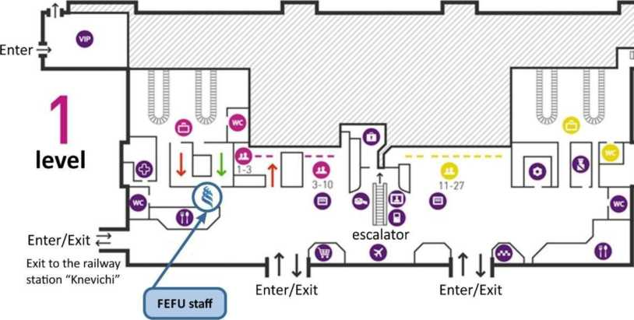

From Airport Vladivostok (Knevichi) to ^FEFU Campus (Dormitory No.6-7-8-9- 10-11), Russky Island

1. Taxi - approx. 1000-2000 rubles
2. Aeroexpress Knevichi-Vladivostok railway station 1st class- 350 rubles

Economy class- 200 rubles

1. Bus Nr. 107, Knevichi-Vladivostok bus station

Cost - 150 rubles

From bus stop "Vladivostok railway station" (ZD voksal) to FEFU Campus (Dormitory No.6-

1. , Russky island
2. Taxi -approx.600 rubles
3. Bus Nr. 59, 60, 7т, 81 (Cost- 25 rubles) to the bus stop "Izumrud".

On the bus stop "Izumrud", please take bus Nr. 15 to the bus stop "Campus DVFU", Russky Island

From bus stop "Bus station" (Avtovokzal) to FEFU Campus (Dormitory No.6-11), Russky island

1. Taxi- approx. 700 rubles
2. Bus Nr.81 to the bus stop "Izumrud", on the bus stop „Izumrud" please take bus Nr. 15 to the bus stop "Campus DVFU", Russky island

From the bus stop "Campus DVFU" to FEFU Campus (Dormitory No. 6-11)

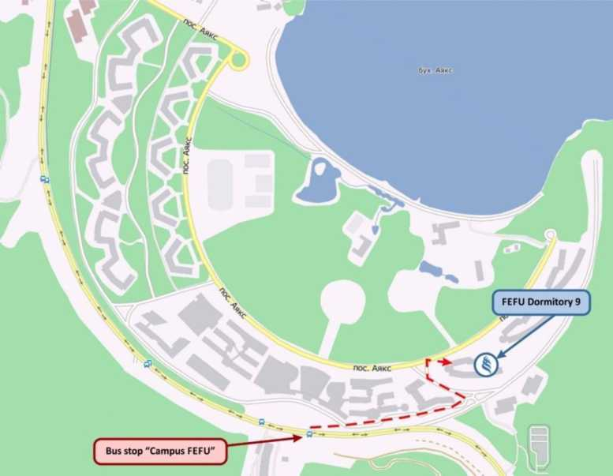

1. Exact dates will be informed later.
2. Please regard that pick up service is available just during recommended arrival dates.
3. Recommended time of arrival is between 9:00 AM and 5:00 PM, no pick up service after 5:00 PM is available, and no pick up service during weekends is available