**Ubuntu Server Script**

Linux Ubuntu geïnstalleerd

#!/bin/bash

Sudo apt-get install **apache2**

wget https://download.nextcloud.com/server/releases/nextcloud-21.0.1.zip

sudo unzip nextcloud-21.0.1.zip

Sudo apt install **php7.4**

Sudo apt install **mysql-server**

Sudo install **fail2ban**

sudo openssl req -x509 -nodes -days 365 -newkey rsa:2048 -keyout /etc/ssl/private/apache-selfsigned.key -out /etc/ssl/certs/apache-selfsigned.key -out /etc/ssl/certs/apache-selfsigned.crt sudo openssl dhparam -out /etc/ssl/certs/dhparam.pem 2048

sudo iptables -I input -P tcp --dport 80 -J ACCEPT

sudo iptables -I input -P tcp --dport 443 -J ACCEPT

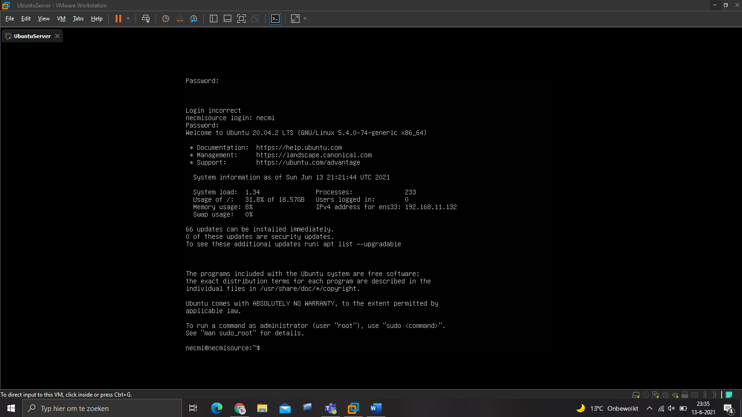

**Verbeterpunten:**

Read a

If [ ‘’ $a’’ = ‘’apache’’ ]

Then

Echo ‘’apache will now be installed’’

Fi

Read a

If [ ‘’ $a’’ = ‘’nextcloud’’ ]

Then

Echo ‘’nextcloud will now be installed’’

Fi

Read a

If [ ‘’ $a’’ = ‘’php7.4’’ ]

Then

Echo ‘’php7.4 will now be installed’’

Fi

Read a

If [ ‘’ $a’’ = ‘’ mysql-server’’ ]

Then

Echo ‘’ mysql-server’’ will now be installed’’

Fi

Read a

If [ ‘’ $a’’ = ‘’ fail2ban’’ ]

Then

Echo ‘’ fail2ban’’ will now be installed’’

Fi

#!/bin/bash

Read opnieuwladen

While [ $opnieuwladen = ‘’Y’’ || $opnieuwladen = ‘’J ‘’ ]

Do

Echo ‘’Het script begint opnieuw’’

Read opnieuwladen

done

**Made by Necmi & Mo !!!!!!!!!!!!!!!!!!!!!!!!!!!!!!**