## Android扫码功能的实现

1. 导入model包

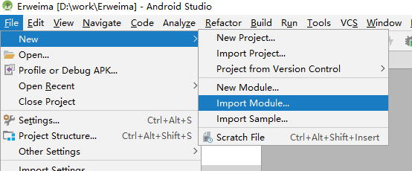

1. 建立联系

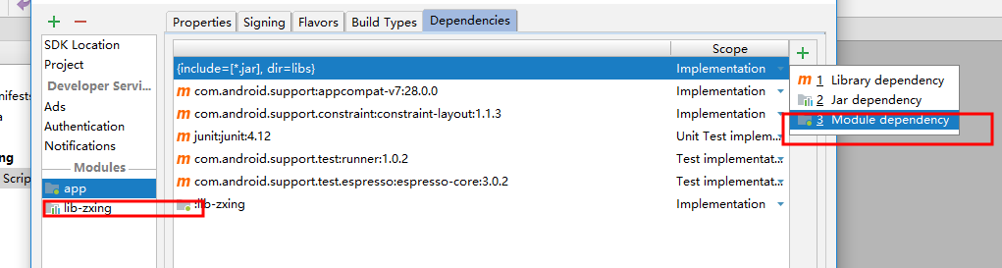

将这添加进去

1. 在APplication.xml添加相机权限

<**uses-permission android:name="android.permission.CAMERA"** /> *<!-- 拍照的权限 -->*

*//手机震动*<**uses-permission android:name="android.permission.VIBRATE"** />

1. 测试

|  |
| --- |
| **package** com.example.a11699.erweima;  **import** android.Manifest; **import** android.content.Intent; **import** android.content.pm.PackageManager; **import** android.os.Build; **import** android.os.StrictMode; **import** android.support.annotation.Nullable; **import** android.support.v7.app.AppCompatActivity; **import** android.os.Bundle; **import** android.view.View; **import** android.widget.Button; **import** android.widget.Toast;  **import** com.uuzuche.lib_zxing.activity.CaptureActivity; **import** com.uuzuche.lib_zxing.activity.CodeUtils; **import** com.uuzuche.lib_zxing.activity.ZXingLibrary;  **public class** MainActivity **extends** AppCompatActivity {  **public static final int *RE_CODE***=111;  **public** Button **button1**;  @Override  **protected void** onCreate(Bundle savedInstanceState) {  **super**.onCreate(savedInstanceState);  setContentView(R.layout.***activity_main***);  ZXingLibrary.*initDisplayOpinion*(**this**);  **if** (Build.VERSION.***SDK_INT*** >= Build.VERSION_CODES.***M***) {  **if** (checkSelfPermission(Manifest.permission.***CAMERA***) != PackageManager.***PERMISSION_GRANTED***) {  requestPermissions(**new** String[] {Manifest.permission.***CAMERA***}, 1);  }  }  **button1**=(Button)findViewById(R.id.***button1***);  **button1**.setOnClickListener(**new** View.OnClickListener() {  @Override  **public void** onClick(View view) {  Intent intent=**new** Intent(getApplication(), CaptureActivity.**class**);  startActivityForResult(intent,***RE_CODE***);  }  });  }  *//处理二维码返回的结果* @Override  **protected void** onActivityResult(**int** requestCode, **int** resultCode, @Nullable Intent data) {  **super**.onActivityResult(requestCode, resultCode, data);  **if** (requestCode == ***RE_CODE***) {  *//处理扫描结果（在界面上显示）* **if** (**null** != data) {  Bundle bundle = data.getExtras();  **if** (bundle == **null**) {  **return**;  }  **if** (bundle.getInt(CodeUtils.***RESULT_TYPE***) == CodeUtils.***RESULT_SUCCESS***) {  String result = bundle.getString(CodeUtils.***RESULT_STRING***);  Toast.*makeText*(**this**, **"解析结果:"** + result, Toast.***LENGTH_LONG***).show();  } **else if** (bundle.getInt(CodeUtils.***RESULT_TYPE***) == CodeUtils.***RESULT_FAILED***) {  Toast.*makeText*(MainActivity.**this**, **"解析二维码失败"**, Toast.***LENGTH_LONG***).show();  }  }  }  } } |

