1. 在activity_main.xml添加fragmentLayout

|  |
| --- |
| *<?***xml version="1.0" encoding="utf-8"***?>* <**LinearLayout xmlns:android="http://schemas.android.com/apk/res/android"  xmlns:app="http://schemas.android.com/apk/res-auto"  xmlns:tools="http://schemas.android.com/tools"  android:layout_width="match_parent"  android:layout_height="match_parent"  android:orientation="vertical"  tools:context=".activities.MainActivity"**> <**FrameLayout  android:layout_width="match_parent"  android:layout_height="0dp"  android:layout_weight="1"  android:id="@+id/main_fl2"** > </**FrameLayout**> </**LinearLayout**> |

1. 给主页面添加导航栏



|  |
| --- |
| *<?***xml version="1.0" encoding="utf-8"***?>* <**LinearLayout xmlns:android="http://schemas.android.com/apk/res/android"  android:layout_width="match_parent"  android:layout_height="50dp"  android:background="#ffff"  android:orientation="horizontal"** >  <**LinearLayout  android:id="@+id/tab_home_ll"  android:layout_width="0dp"  android:layout_height="fill_parent"  android:layout_weight="1"  android:gravity="center"  android:orientation="vertical"** >   <**ImageButton  android:id="@+id/tab_home_ib"  android:layout_width="23dp"  android:layout_height="35dp"  android:background="#00000000"  android:scaleType="centerInside"  android:clickable="false"  android:src="@drawable/home_press"** />   <**TextView  android:id="@+id/tab_home_tv"  android:layout_width="wrap_content"  android:layout_height="wrap_content"  android:textSize="12sp"  android:text="首页"  android:textColor="#FF4081"**/>  </**LinearLayout**>   <**LinearLayout  android:id="@+id/tab_news_ll"  android:layout_width="0dp"  android:layout_height="fill_parent"  android:layout_weight="1"  android:gravity="center"  android:orientation="vertical"** >   <**ImageButton  android:id="@+id/tab_news_ib"  android:layout_width="25dp"  android:layout_height="35dp"  android:background="#00000000"  android:scaleType="centerInside"  android:clickable="false"  android:src="@drawable/news_normal"** />   <**TextView  android:id="@+id/tab_news_tv"  android:layout_width="wrap_content"  android:layout_height="wrap_content"  android:text="资讯"  android:textSize="12sp"  android:textColor="#272727"** />  </**LinearLayout**>  <**LinearLayout  android:id="@+id/tab_search_ll"  android:layout_width="0dp"  android:layout_height="fill_parent"  android:layout_weight="1"  android:gravity="center"  android:orientation="vertical"** >   <**ImageButton  android:id="@+id/tab_search_ib"  android:layout_width="25dp"  android:layout_height="35dp"  android:background="#00000000"  android:scaleType="centerInside"  android:clickable="false"  android:src="@drawable/search_normal"** />   <**TextView  android:id="@+id/tab_search_tv"  android:layout_width="wrap_content"  android:layout_height="wrap_content"  android:text="搜索"  android:textSize="12sp"  android:textColor="#272727"** />  </**LinearLayout**>   <**LinearLayout  android:id="@+id/tab_mine_ll"  android:layout_width="0dp"  android:layout_height="fill_parent"  android:layout_weight="1"  android:gravity="center"  android:orientation="vertical"**>   <**ImageButton  android:id="@+id/tab_mine_ib"  android:layout_width="25dp"  android:layout_height="35dp"  android:background="#00000000"  android:clickable="false"  android:scaleType="centerInside"  android:src="@drawable/mine_normal"** />  <**TextView  android:id="@+id/tab_mine_tv"  android:layout_width="wrap_content"  android:layout_height="wrap_content"  android:text="我的"  android:textColor="#272727"  android:textSize="12sp"** />  </**LinearLayout**> </**LinearLayout**> |

然后在activity_main.xml添加这个布局

<**include layout="@layout/layout_bottom"**></**include**>

1. 新建四个Fragment（HomeFragment MineFragment NewsFragment SearchFragment）

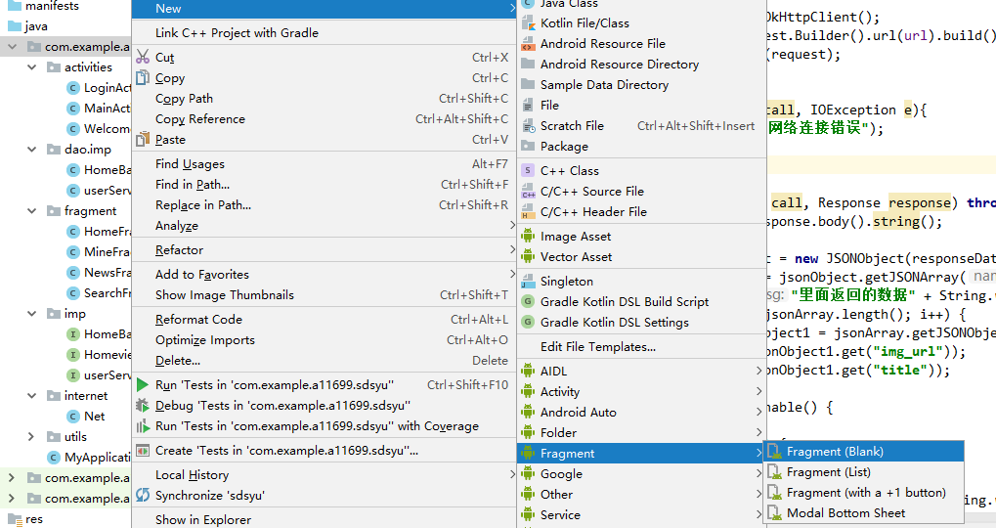

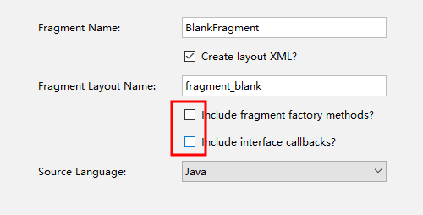

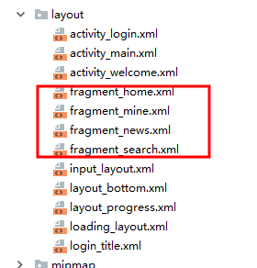

1. 先进行测试，让主页面能够显示不同每个Fragment

|  |
| --- |
| 1. 在(MainActivity.java)定义四个Fragment   **private** HomeFragment **homeFragment**; **private** MineFragment **mineFragment**; **private** NewsFragment **newsFragment**; **private** SearchFragment **searchFragment**;   1. 给按钮图片 文字添加链接   @BindView(R.id.tab_home_ll)LinearLayout tab_home_ll; @BindView(R.id.tab_news_ll)LinearLayout tab_news_ll; @BindView(R.id.tab_search_ll)LinearLayout tab_search_ll; @BindView(R.id.tab_mine_ll)LinearLayout tab_mine_ll; //4个底部栏按键图片 @BindView(R.id.tab_home_ib) ImageButton tab_home_ib; @BindView(R.id.tab_news_ib) ImageButton tab_news_ib; @BindView(R.id.tab_search_ib) ImageButton tab_search_ib; @BindView(R.id.tab_mine_ib) ImageButton tab_mine_ib;  //4个底部栏项目文字 @BindView(R.id.tab_home_tv) TextView tab_home_tv; @BindView(R.id.tab_news_tv) TextView tab_news_tv; @BindView(R.id.tab_search_tv) TextView tab_search_tv; @BindView(R.id.tab_mine_tv) TextView tab_mine_tv;  /*  这里用到了@BindView需要导入架包  *// @BindView框架 控件注入框架，* implementation **'com.jakewharton:butterknife:8.8.1'** implementation **'com.jakewharton:butterknife-compiler:8.8.1'**  */  然后在onCreate方法里写入ButterKnife.bind(this);   1. 给每个控件添加点击事件   **private void** initEvent(){  **tab_home_ll**.setOnClickListener(**this**);  **tab_mine_ll**.setOnClickListener(**this**);  **tab_news_ll**.setOnClickListener(**this**);  **tab_search_ll**.setOnClickListener(**this**); }   1. 重载onClick方法   @Override **public void** onClick(View view) {  }   1. 重置图标样式   *//重置图片效果* **private void** resetImgs() {  *//重置icon图标* **tab_home_ib**.setImageResource(R.drawable.***home_normal***);  **tab_news_ib**.setImageResource(R.drawable.***news_normal***);  **tab_search_ib**.setImageResource(R.drawable.***search_normal***);  **tab_mine_ib**.setImageResource(R.drawable.***mine_normal***);  *//重置文字颜色* **tab_home_tv**.setTextColor(Color.*parseColor*(**"#272727"**));  **tab_news_tv**.setTextColor(Color.*parseColor*(**"#272727"**));  **tab_search_tv**.setTextColor(Color.*parseColor*(**"#272727"**));  **tab_mine_tv**.setTextColor(Color.*parseColor*(**"#272727"**)); }  这个方法在onClick开始位置里面调用   1. 书写onClick方法   @Override **public void** onClick(View view) {  resetImgs();  **switch** (view.getId()){  **case** R.id.***tab_home_ll***:  **tab_home_ib**.setImageResource(R.drawable.***home_press***);  startShakeByPropertyAnim(**tab_home_ib**, 0.9f, 1.2f, 10f, 400);  **tab_home_tv**.setTextColor(Color.*parseColor*(**"#FF4081"**));  setSelect(0);  **break**;  **case** R.id.***tab_news_ll***:  **tab_news_ib**.setImageResource(R.drawable.***news_press***);  startShakeByPropertyAnim(**tab_news_ib**, 0.9f, 1.2f, 10f, 400);  **tab_news_tv**.setTextColor(Color.*parseColor*(**"#FF4081"**));  setSelect(1);**break**;  **case** R.id.***tab_search_ll***:  **tab_search_ib**.setImageResource(R.drawable.***search_press***);  startShakeByPropertyAnim(**tab_search_ib**, 0.9f, 1.2f, 10f, 400);  **tab_search_tv**.setTextColor(Color.*parseColor*(**"#FF4081"**));  setSelect(2);**break**;  **case** R.id.***tab_mine_ll***:  **tab_mine_ib**.setImageResource(R.drawable.***mine_press***);  startShakeByPropertyAnim( **tab_mine_ib**, 0.9f, 1.2f, 10f, 400);  **tab_mine_tv**.setTextColor(Color.*parseColor*(**"#FF4081"**));  setSelect(3);**break**;  **default**:**break**;  } }  给图标添加点击效果  **private void** startShakeByPropertyAnim(View view, **float** scaleSmall, **float** scaleLarge, **float** shakeDegrees, **long** duration) {  **if** (view == **null**) {  **return**;  }  *//****TODO 验证参数的有效性*** *//先变小后变大* PropertyValuesHolder scaleXValuesHolder = PropertyValuesHolder.*ofKeyframe*(View.***SCALE_X***,  Keyframe.*ofFloat*(0f, 1.0f),  Keyframe.*ofFloat*(0.25f, scaleSmall),  Keyframe.*ofFloat*(0.5f, scaleLarge),  Keyframe.*ofFloat*(0.75f, scaleLarge),  Keyframe.*ofFloat*(1.0f, 1.0f)  );  PropertyValuesHolder scaleYValuesHolder = PropertyValuesHolder.*ofKeyframe*(View.***SCALE_Y***,  Keyframe.*ofFloat*(0f, 1.0f),  Keyframe.*ofFloat*(0.25f, scaleSmall),  Keyframe.*ofFloat*(0.5f, scaleLarge),  Keyframe.*ofFloat*(0.75f, scaleLarge),  Keyframe.*ofFloat*(1.0f, 1.0f)  );   *//先往左再往右* PropertyValuesHolder rotateValuesHolder = PropertyValuesHolder.*ofKeyframe*(View.***ROTATION***,  Keyframe.*ofFloat*(0f, 0f),  Keyframe.*ofFloat*(0.3f, -shakeDegrees),  Keyframe.*ofFloat*(0.6f, shakeDegrees),  Keyframe.*ofFloat*(0.9f, -shakeDegrees),  Keyframe.*ofFloat*(1.0f, 0f)  );   ObjectAnimator objectAnimator = ObjectAnimator.*ofPropertyValuesHolder*(view, scaleXValuesHolder, scaleYValuesHolder, rotateValuesHolder);  objectAnimator.setDuration(duration);  objectAnimator.start(); }   1. 将不同的fragment添加到页面上   private void setSelect(int i){  FragmentManager fm=getSupportFragmentManager();////获取到Fragmentmanager  FragmentTransaction tf=fm.beginTransaction();//调用beginTransaction方法开启h  //隐藏所有fragment 不然的话，所有的会叠加在一起  hidenFragment(tf);  switch (i){  case 0:  if (homeFragment == null) {  homeFragment = new HomeFragment();  tf.add(R.id.main_fl2, homeFragment);  } else {  tf.show(homeFragment);  }  //mImmersionBar.statusBarColor("#00A7FF").fitsSystemWindows(true).init();  break;  case 1:  if (newsFragment == null) {  newsFragment = new NewsFragment();  tf.add(R.id.main_fl2, newsFragment);  } else {  tf.show(newsFragment);  }  // mImmersionBar.statusBarColor("#00A7FF").fitsSystemWindows(true).init();  break;  case 2:  if (searchFragment == null) {  searchFragment = new SearchFragment();  tf.add(R.id.main_fl2, searchFragment);  } else {  tf.show(searchFragment);  }  // mImmersionBar.statusBarColor("#00A7FF").fitsSystemWindows(true).init();  break;  case 3:  if (mineFragment == null) {  mineFragment = new MineFragment();  tf.add(R.id.main_fl2, mineFragment);  } else {  tf.show(mineFragment);  // mineFragment.mineModel.getUser();//重新加载用户数据  }  // mImmersionBar.statusBarColor("#4AC0F4").fitsSystemWindows(true).init();  break; } tf.commit();  }  */*/隐藏所有Fragment private void hidenFragment(FragmentTransaction tf) {  if (homeFragment != null)  {  tf.hide(homeFragment);  }  if (newsFragment != null)  {  tf.hide(newsFragment);  }  if (searchFragment != null)  {  tf.hide(searchFragment);  }  if (mineFragment != null)  {  tf.hide(mineFragment);  } }   1. finish |