### Screenshot_2018-10-30-15-51-39-94Recycleview实时监听item的Edittext内容的改变

例如这个界面，获取所有Edittext的内容

适配器

|  |
| --- |
| **public static class** itdabianAdapter **extends** RecyclerView.Adapter{  **private** Context **context**;  **private** List<String> **list**;  **private** View **view**;  **public** itdabianAdapter(Context context, List<String> list) {  **this**.**context** = context;  **this**.**list** = list;  }  @NonNull  @Override  **public** RecyclerView.ViewHolder onCreateViewHolder(@NonNull ViewGroup viewGroup, **int** i) {  **view**= LayoutInflater.*from*(**context**).inflate(R.layout.***item\_recy\_lie***,viewGroup,**false**);  MyviewHolderr myViewHolder=**new** MyviewHolderr(**view**);  **return** myViewHolder;  }  @Override  **public void** onBindViewHolder(@NonNull RecyclerView.ViewHolder viewHolder, **int** i) {  ((MyviewHolderr)viewHolder).**item\_timu**.setText(**list**.get(i));  }  @Override  **public int** getItemCount() {  **return list**.size();  }  **public class** MyviewHolderr **extends** RecyclerView.ViewHolder{  TextView **item\_timu**;  EditText **item\_question**;  **public** MyviewHolderr(@NonNull View itemView) {  **super**(itemView);  **item\_timu**=itemView.findViewById(R.id.***item\_timu***);  **item\_question**=itemView.findViewById(R.id.***item\_question***);  }  } } |

适配器写完了，效果图就是那样

1. 新建一个接口



|  |
| --- |
| **public interface** SavaEdittevtListener {  **void** SaveEdit(**int** position, String string); } |

然后我们需要给EditText添加监听事件

|  |
| --- |
| 在适配里面 自定义EditText的监听类  //自定义EditText的监听类  class TextSwitcher implements TextWatcher {    private MyViewHolder mHolder;    public TextSwitcher(MyViewHolder mHolder) {  this.mHolder = mHolder;  }    @Override  public void beforeTextChanged(CharSequence s, int start, int count, int after) {    }    @Override  public void onTextChanged(CharSequence s, int start, int before, int count) {    }    @Override  public void afterTextChanged(Editable s) {  //用户输入完毕后，处理输入数据，回调给主界面处理  SaveEditListener listener= (SaveEditListener) mContext;  if(s!=null){  listener.SaveEdit(Integer.parseInt(mHolder.c\_name\_et.getTag().toString()),s.toString());  }    }  } |

1. 在onBindViewHolder添加编辑框的监听事件

|  |
| --- |
| *//添加editText的监听事件* ((MyviewHolderr)viewHolder).**item\_question**.addTextChangedListener(**new** TextSwitcher(((MyviewHolderr)viewHolder))); *//通过设置tag，防止position紊乱* ((MyviewHolderr)viewHolder).**item\_question**.setTag(i); |

1. 然后在使用这个适配器的实现接口

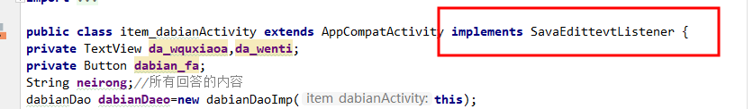

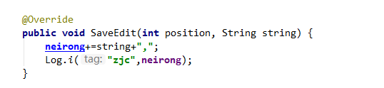

然后就能做你想做的事了

1. 适配器全部代码

|  |
| --- |
| **public static class** itdabianAdapter **extends** RecyclerView.Adapter{  **private** Context **context**;  **private** List<String> **list**;  **private** View **view**;  **public** itdabianAdapter(Context context, List<String> list) {  **this**.**context** = context;  **this**.**list** = list;  }  **class** TextSwitcher **implements** TextWatcher{  **private** MyviewHolderr **mHolder**;   **public** TextSwitcher (MyviewHolderr mHolder) {  **this**.**mHolder** = mHolder;  }   @Override  **public void** beforeTextChanged(CharSequence s, **int** start, **int** count, **int** after) {   }   @Override  **public void** onTextChanged(CharSequence s, **int** start, **int** before, **int** count) {   }   @Override  **public void** afterTextChanged(Editable s) {  *//用户输入完毕后，处理输入数据，回调给主界面处理* SavaEdittevtListener listener= (SavaEdittevtListener) **context**;  **if**(s!=**null**){  listener.SaveEdit(Integer.*parseInt*(**mHolder**.**item\_question**.getTag().toString()),s.toString());  }   }  }  @NonNull  @Override  **public** RecyclerView.ViewHolder onCreateViewHolder(@NonNull ViewGroup viewGroup, **int** i) {  **view**= LayoutInflater.*from*(**context**).inflate(R.layout.***item\_recy\_lie***,viewGroup,**false**);  MyviewHolderr myViewHolder=**new** MyviewHolderr(**view**);  **return** myViewHolder;  }   @Override  **public void** onBindViewHolder(@NonNull RecyclerView.ViewHolder viewHolder, **int** i) {  ((MyviewHolderr)viewHolder).**item\_timu**.setText(**list**.get(i));  *//添加editText的监听事件* ((MyviewHolderr)viewHolder).**item\_question**.addTextChangedListener(**new** TextSwitcher(((MyviewHolderr)viewHolder)));  *//通过设置tag，防止position紊乱* ((MyviewHolderr)viewHolder).**item\_question**.setTag(i);  }  @Override  **public int** getItemCount() {  **return list**.size();  }  **public class** MyviewHolderr **extends** RecyclerView.ViewHolder{  TextView **item\_timu**;  EditText **item\_question**;  **public** MyviewHolderr(@NonNull View itemView) {  **super**(itemView);  **item\_timu**=itemView.findViewById(R.id.***item\_timu***);  **item\_question**=itemView.findViewById(R.id.***item\_question***);  }  } } |