## 实现悬浮菜单效果：

效果：

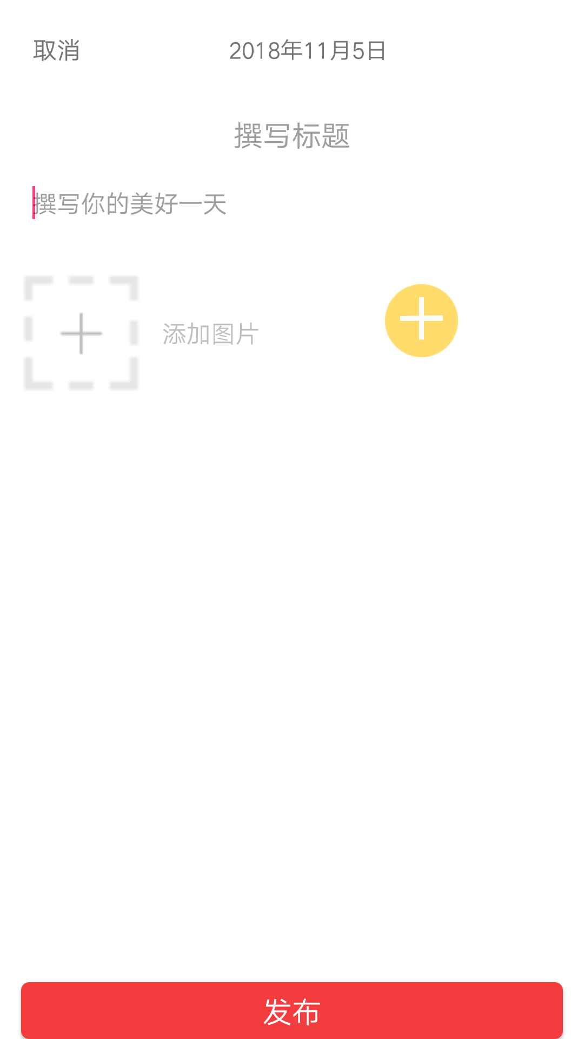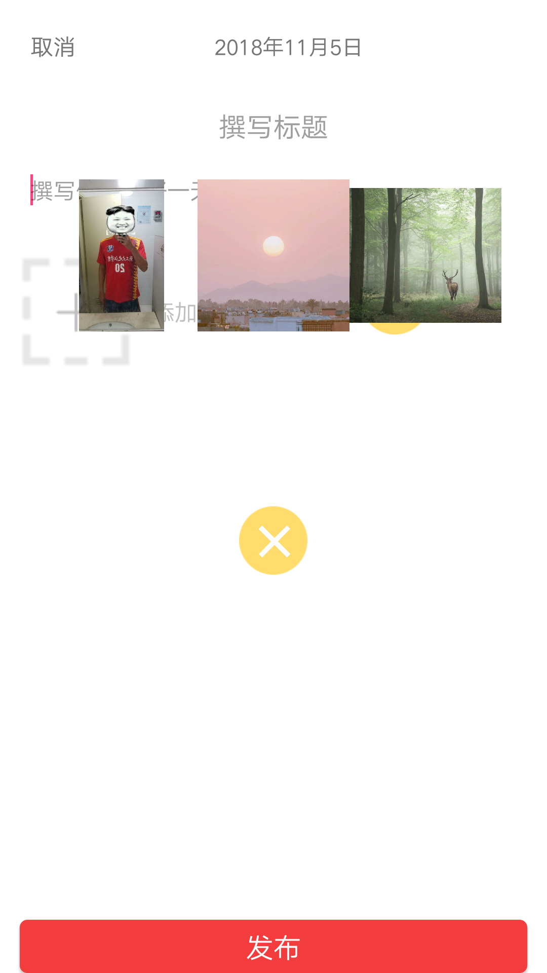

1. 给那个加号添加事件：

|  |
| --- |
| PopupMenuUtil.*getInstance*()._show(**this**, **iv_img**,**dizhi**); |

1. 新建类PopupMenuUtil类

|  |
| --- |
| *//执行伸缩菜单的工具类* **public class** PopupMenuUtil {  **private** FinalBitmap **fb**;*//显示图片* **private static final** String ***TAG*** = **"PopupMenuUtil"**;  **private** View **rootview**;  **private** PopupWindow **popupWindow**;  **private** ImageView **ivBtn**;*//那个十字架* **private** RelativeLayout **rlClick**;  DraweeView **pic1**,**pic2**,**pic3**,**pic4**,**pic5**,**pic6** ;  DraweeView **s**[]={**pic1**,**pic2**,**pic3**,**pic4**,**pic5**,**pic6**};  */**  * 动画执行的 属性值数组  */* **float animatorProperty**[] = **null**;  List<String> **dizhi**=**new** ArrayList<>();  */**  * 第一排图 距离屏幕底部的距离  */* **int top** = 0;  */**  * 第二排图 距离屏幕底部的距离  */* **int bottom** = 0;   **public static** PopupMenuUtil getInstance() {  **return** MenuUtilHolder.*INSTANCE*;  }  **private static class** MenuUtilHolder {  **public static** PopupMenuUtil *INSTANCE* = **new** PopupMenuUtil();  }  **public void** _show(Context context, View parent,List<String> dizhi){  **fb**=FinalBitmap.*create*(context);   **this**.**dizhi**=dizhi;  _createView(context);  **if** (**popupWindow** != **null** && !**popupWindow**.isShowing()) {  **popupWindow**.showAtLocation(parent, Gravity.***NO_GRAVITY***, 0, 0);  _openPopupWindowAction();  }  }  */**  * 刚打开popupWindow 执行的动画  */* **private void** _openPopupWindowAction() {   *//属性动画中旋转动画中rotation,rotationX和rotationY的区别  //第一个参数是执行动画的参数 第二个是指定控件属性 第三个是被拉升的长度* ObjectAnimator objectAnimator = ObjectAnimator.*ofFloat*(**ivBtn**, **"rotation"**, 0f, 135f);  objectAnimator.setDuration(200);  objectAnimator.start();   _startAnimation(**pic1**, 500, **animatorProperty**);  _startAnimation(**pic2**, 430, **animatorProperty**);  _startAnimation(**pic3**, 500, **animatorProperty**);  _startAnimation(**pic4**, 500, **animatorProperty**);  _startAnimation(**pic5**, 430, **animatorProperty**);  _startAnimation(**pic6**, 500, **animatorProperty**);  }  */**  * 启动动画  *  \** ***@param view*** *view  \** ***@param duration*** *执行时长  \** ***@param distance*** *执行的轨迹数组  */* **private void** _startAnimation(View view, **int** duration, **float**[] distance) {  ObjectAnimator anim = ObjectAnimator.*ofFloat*(view, **"translationY"**, distance);  anim.setDuration(duration);  anim.start();  }    **private void** _createView(Context context){  **rootview**= LayoutInflater.*from*(context).inflate(R.layout.***tupianzhanshi***,**null**);  **popupWindow**=**new** PopupWindow(**rootview**, LinearLayout.LayoutParams.***MATCH_PARENT***,LinearLayout.LayoutParams.***MATCH_PARENT***);  **popupWindow**.setFocusable(**false**);*//设置失去焦点，方便监听返回按键  // 如果想要popupWindow 遮挡住状态栏可以加上这句代码  //popupWindow.setClippingEnabled(false);* **popupWindow**.setBackgroundDrawable(**new** BitmapDrawable());  **popupWindow**.setOutsideTouchable(**false**);  **if** (**animatorProperty** == **null**) {  **top** = *dip2px*(context, 310);  **bottom** = *dip2px*(context, 210);  **animatorProperty** = **new float**[]{**bottom**, 60, -30, -20 - 10, 0};  }   initLayout(context);  } *//初始化view* **private void** initLayout(Context context){  **ivBtn** = (ImageView) **rootview**.findViewById(R.id.***pop_iv_img***);*//那个十字架* **rlClick** = (RelativeLayout) **rootview**.findViewById(R.id.***pop_rl_click***);  **s**[0]=**rootview**.findViewById(R.id.***pic1***);  **s**[1]=**rootview**.findViewById(R.id.***pic2***);  **s**[2]=**rootview**.findViewById(R.id.***pic3***);  **s**[3]=**rootview**.findViewById(R.id.***pic4***);  **s**[4]=**rootview**.findViewById(R.id.***pic5***);  **s**[5]=**rootview**.findViewById(R.id.***pic6***);   **rlClick**.setOnClickListener(**new** MViewClick(0, context));  **s**[0].setOnClickListener(**new** MViewClick(1, context));  **s**[1].setOnClickListener(**new** MViewClick(2, context));  **s**[2].setOnClickListener(**new** MViewClick(2, context));  **s**[3].setOnClickListener(**new** MViewClick(3, context));  **s**[4].setOnClickListener(**new** MViewClick(4, context));  **s**[5].setOnClickListener(**new** MViewClick(5, context));  **if**(**dizhi**.size()!=0){  **for**(**int** i=0;i<**dizhi**.size();i++){  **if**(i>=6){  **fb**.display(**s**[5],**dizhi**.get(i));  }**else**{  **fb**.display(**s**[i],**dizhi**.get(i));  }  }  }  }  */**  * 点击事件  */* **private class** MViewClick **implements** View.OnClickListener {   **public int index**;  **public** Context **context**;   **public** MViewClick(**int** index, Context context) {  **this**.**index** = index;  **this**.**context** = context;  }   @Override  **public void** onClick(View v) {  **if** (**index** == 0) {  *//加号按钮点击之后的执行* _rlClickAction();  } **else** {  *// new PopWindow_image(fb,context,dizhi.get(index-1)).showAtLocation(v,0,0,0);* }  }  }  */**  * 关闭 popupWindow执行的动画  */* **public void** _rlClickAction() {  **if** (**ivBtn** != **null** && **rlClick** != **null**) {   ObjectAnimator objectAnimator = ObjectAnimator.*ofFloat*(**ivBtn**, **"rotation"**, 135f, 0f);  objectAnimator.setDuration(300);  objectAnimator.start();   _closeAnimation(**pic1**, 300, **top**);  _closeAnimation(**pic2**, 200, **top**);  _closeAnimation(**pic3**, 300, **top**);  _closeAnimation(**pic4**, 300, **bottom**);  _closeAnimation(**pic5**, 200, **bottom**);  _closeAnimation(**pic6**, 300, **bottom**);    **rlClick**.postDelayed(**new** Runnable() {  @Override  **public void** run() {  _close();  }  }, 300);   }  }  */**  * 关闭popupWindow  */* **public void** _close() {  **if** (**popupWindow** != **null** && **popupWindow**.isShowing()) {  **popupWindow**.dismiss();  **popupWindow** = **null**;  }  }  */**  * 关闭 popupWindow 时的动画  *  \** ***@param view*** *mView  \** ***@param duration*** *动画执行时长  \** ***@param next*** *平移量  */* **private void** _closeAnimation(View view, **int** duration, **int** next) {  ObjectAnimator anim = ObjectAnimator.*ofFloat*(view, **"translationY"**, 0f, next);  anim.setDuration(duration);  anim.start();  }  */**  * dp转化为px  *  \** ***@param context*** *context  \** ***@param dipValue*** *dp value  \** ***@return*** *转换之后的px值  */* **public static int** dip2px(Context context, **float** dipValue) {  **final float** scale = context.getResources().getDisplayMetrics().**density**;  **return** (**int**) (dipValue * scale + 0.5f);  } } |

1. 这个菜单的布局

|  |
| --- |
| *<?***xml version="1.0" encoding="utf-8"***?>* <**LinearLayout xmlns:android="http://schemas.android.com/apk/res/android"  android:layout_width="match_parent"  android:orientation="vertical"  android:layout_height="match_parent"** >  <**LinearLayout  android:layout_marginTop="100dp"  android:id="@+id/ds"  android:gravity="center"  android:layout_gravity="center"  android:layout_width="match_parent"  android:layout_height="wrap_content"  android:orientation="horizontal"** >  <**com.facebook.drawee.view.DraweeView  android:layout_width="100dp"  android:layout_height="100dp"  android:id="@+id/pic1"** />  <**com.facebook.drawee.view.DraweeView  android:layout_width="100dp"  android:layout_height="100dp"  android:id="@+id/pic2"** />  <**com.facebook.drawee.view.DraweeView  android:layout_width="100dp"  android:layout_height="100dp"  android:id="@+id/pic3"** />  </**LinearLayout**>  <**LinearLayout  android:layout_marginTop="10dp"  android:layout_gravity="center"  android:gravity="center"  android:layout_width="match_parent"  android:layout_height="wrap_content"  android:orientation="horizontal"** >  <**com.facebook.drawee.view.DraweeView  android:layout_width="100dp"  android:layout_height="100dp"  android:id="@+id/pic4"** />  <**com.facebook.drawee.view.DraweeView  android:layout_width="100dp"  android:layout_height="100dp"    android:id="@+id/pic5"** />  <**com.facebook.drawee.view.DraweeView  android:layout_width="100dp"  android:layout_height="100dp"  android:id="@+id/pic6"** />  </**LinearLayout**>  <**RelativeLayout  android:id="@+id/pop_rl_click"  android:layout_width="wrap_content"  android:layout_height="55dip"   android:layout_centerHorizontal="true"  android:layout_gravity="center_horizontal"**>  <**ImageView  android:layout_width="45dip"  android:layout_height="45dip"  android:layout_centerInParent="true"  android:src="@drawable/bg"** />   <**ImageView  android:id="@+id/pop_iv_img"  android:layout_width="40dp"  android:layout_height="40dp"  android:layout_centerInParent="true"  android:src="@drawable/plus"** />  </**RelativeLayout**> </**LinearLayout**> |