

数字媒体技术
实验报告

题 目 实验一 根据文字生成电子签章
学 院 计算机科学与技术
专 业 计算机科学与技术
学 号 1170300404
学 生 金富源
任 课 教 师 刘绍辉

哈尔滨工业大学计算机科学与技术学院
2020.3

实验一:根据文字生成电子签章
- 实验内容或者文献情况介绍
根据老师对于实验一的要求以及我个人对于实验一的理解，设计了一款根据输入的文字来生成相应电子签章的程序。
- 算法简介及其实现细节
java实现代码如下：
import java.awt.AlphaComposite;
import java.awt.BasicStroke;
import java.awt.Color;
import java.awt.Font;
import java.awt.Graphics2D;
import java.awt.Shape;
import java.awt.font.FontRenderContext;
import java.awt.geom.AffineTransform;
import java.awt.geom.Arc2D;
import java.awt.geom.Rectangle2D;
import java.awt.image.BufferedImage;
import java.io.BufferedOutputStream;
import java.io.ByteArrayOutputStream;
import java.io.File;
import java.io.FileOutputStream;
import java.io.IOException;
import javax.imageio.ImageIO;
public class SealUtils {
private static final int CANVAS_SIZE = 300; // 画布宽
private static final String FONT_FAMILY = "宋体"; // 字体
//private static final String FOOT_TXT = "电子签约专用章";// 底部文字
private static final String FOOT_TXT = "金富源";// 底部文字
private static final String STAR = "★";
private static int STAR_SIZE = (int) (CANVAS_SIZE / 3.2); // 五角星大小
private static int FOOT_FONT_SIZE = CANVAS_SIZE / 12; // 底部文字大小
/**
* 根据companyName获得合同专用章
* @param companyName
* @return
*/
public static BufferedImage genSealImage(String companyName) {
BufferedImage bi = new BufferedImage(CANVAS_SIZE, CANVAS_SIZE, BufferedImage.TYPE_4BYTE_ABGR);
Graphics2D g2d = bi.createGraphics();
g2d.setComposite(AlphaComposite.getInstance(AlphaComposite.SRC, 0));
g2d.fillRect(0, 0, CANVAS_SIZE, CANVAS_SIZE);
g2d.setComposite(AlphaComposite.getInstance(AlphaComposite.SRC, 1));
int circleRadius = CANVAS_SIZE / 2 - 10;
drawCicle(g2d, circleRadius);
drawStar(g2d, circleRadius);
drawFootText(g2d, circleRadius);
drwaHeadText(companyName, g2d, circleRadius);
g2d.dispose();
return bi;
}
public static void main(String[] args) {
try {
String name="我的印章";
byte[] img= SealUtils.genSealData(name);
byte2File(img,"D:\\金富源文件\\学习文件\\数字媒体与技术",name+".png");
} catch (IOException e) {
// TODO Auto-generated catch block
e.printStackTrace();
}
}
/**
* 辅助方法，byte数组保存为本地文件
* @param buf
* @param filePath
* @param fileName
*/
private static void byte2File(byte[] buf, String filePath, String fileName)
{
BufferedOutputStream bos = null;
FileOutputStream fos = null;
File file = null;
try
{
File dir = new File(filePath);
if (!dir.exists())
{
dir.mkdirs();
}
file = new File(filePath + File.separator + fileName);
fos = new FileOutputStream(file);
bos = new BufferedOutputStream(fos);
bos.write(buf);
}
catch (Exception e)
{
e.printStackTrace();
}
finally
{
if (bos != null)
{
try
{
bos.close();
}
catch (IOException e)
{
e.printStackTrace();
}
}
if (fos != null)
{
try
{
fos.close();
}
catch (IOException e)
{
e.printStackTrace();
}
}
}
}
/**
* 根据companyName获得合同专用章
*
* @param companyName
* @return
* @throws IOException
*/
public static byte[] genSealData(String companyName) throws IOException {
BufferedImage image = genSealImage(companyName);
ByteArrayOutputStream outStream = new ByteArrayOutputStream();
try {
ImageIO.write(image, "png", outStream);
}
catch (IOException e) {
throw e;
}
finally {
try {
outStream.close();
}
catch (IOException e) {
}
}
byte[] imageData = outStream.toByteArray();
return imageData;
}
/**
* 弧形绘制顶部名称
*
* @param companyName
* @param g2d
* @param circleRadius
*/
private static void drwaHeadText(String companyName, Graphics2D g2d, int circleRadius) {
int companyNameLen = companyName.length();
int headFontSize;
if (companyNameLen < 8) { // 字体根据画布大小微调出来的
headFontSize = 47;
}
else {
headFontSize = 43 - (companyNameLen - 8) * 2;
}
Font f;
FontRenderContext context;
Rectangle2D rectangle;
f = new Font(FONT_FAMILY, Font.PLAIN, headFontSize);
context = g2d.getFontRenderContext();
rectangle = f.getStringBounds(companyName, context);
double interval; // 文字之间间距
if (companyNameLen == 1) {
interval = 0;
}
else {
interval = rectangle.getWidth() / (companyNameLen - 1) * 0.9;
}
double newRadius = circleRadius + rectangle.getY() - 10; // bounds.getY()是负数，这样可以将弧形文字固定在圆内了。-10目的是离圆环稍远一点
double radianPerInterval = 2 * Math.asin(interval / (2 * newRadius)); // 每个间距对应的角度
// 第一个元素的角度
double firstAngle;
if (companyNameLen % 2 == 1) {
firstAngle = (companyNameLen - 1) * radianPerInterval / 2.0 + Math.PI / 2 + 0.18; // 0.18是浮点计算误差，如果文字不对称，可以微调
}
else {
firstAngle = (companyNameLen / 2.0 - 1) * radianPerInterval + radianPerInterval / 2.0 + Math.PI / 2 + 0.18;
}
for (int i = 0; i < companyNameLen; i++) {
double theta = firstAngle - i * radianPerInterval;
double thetaX = newRadius * Math.sin(Math.PI / 2 - theta); // 小小的trick，将【0，pi】区间变换到[pi/2,-pi/2]区间
double thetaY = newRadius * Math.cos(theta - Math.PI / 2); // 同上类似，这样处理就不必再考虑正负的问题了
AffineTransform transform = AffineTransform.getRotateInstance(Math.PI / 2 - theta);
Font f2 = f.deriveFont(transform);
g2d.setFont(f2);
g2d.drawString(companyName.substring(i, i + 1), (float) (circleRadius + thetaX + 10), (float) (circleRadius - thetaY + 10));
}
}
/**
* 画底部文字
*
* @param g2d
* @param circleRadius
*/
private static void drawFootText(Graphics2D g2d, int circleRadius) {
Font f;
FontRenderContext context;
Rectangle2D rectangle;
f = new Font(FONT_FAMILY, Font.BOLD, FOOT_FONT_SIZE);
context = g2d.getFontRenderContext();
rectangle = f.getStringBounds(FOOT_TXT, context);
int a = 10 * CANVAS_SIZE / 350; // 底部文字距中心的距离，这是调出来的
g2d.setFont(f);
g2d.drawString(FOOT_TXT, (float) (circleRadius + a - rectangle.getCenterX()), (float) (circleRadius * 1.5 + a - rectangle.getCenterY()));
}
/**
* 画中心的 ★
*
* @param g2d
* @param circleRadius
*/
private static void drawStar(Graphics2D g2d, int circleRadius) {
Font f = new Font(FONT_FAMILY, Font.PLAIN, STAR_SIZE);
FontRenderContext context = g2d.getFontRenderContext();
Rectangle2D rectangle = f.getStringBounds(STAR, context);
g2d.setFont(f);
g2d.drawString(STAR, (float) (circleRadius + 10 - rectangle.getCenterX()), (float) (circleRadius + 10 - rectangle.getCenterY()));
}
/**
* 画外圈圆
*
* @param g2d
* @param circleRadius
*/
private static void drawCicle(Graphics2D g2d, int circleRadius) {
g2d.setPaint(Color.red);
int lineSize = circleRadius * 2 / (35); // 圆线条粗细是圆直径的1/35
g2d.setStroke(new BasicStroke(lineSize));
Shape circle = new Arc2D.Double(10, 10, circleRadius * 2, circleRadius * 2, 0, 360, Arc2D.OPEN);
g2d.draw(circle);
}
}

- 实验设置及结果分析（包括实验数据集）
实验界面：
使用idea编辑器
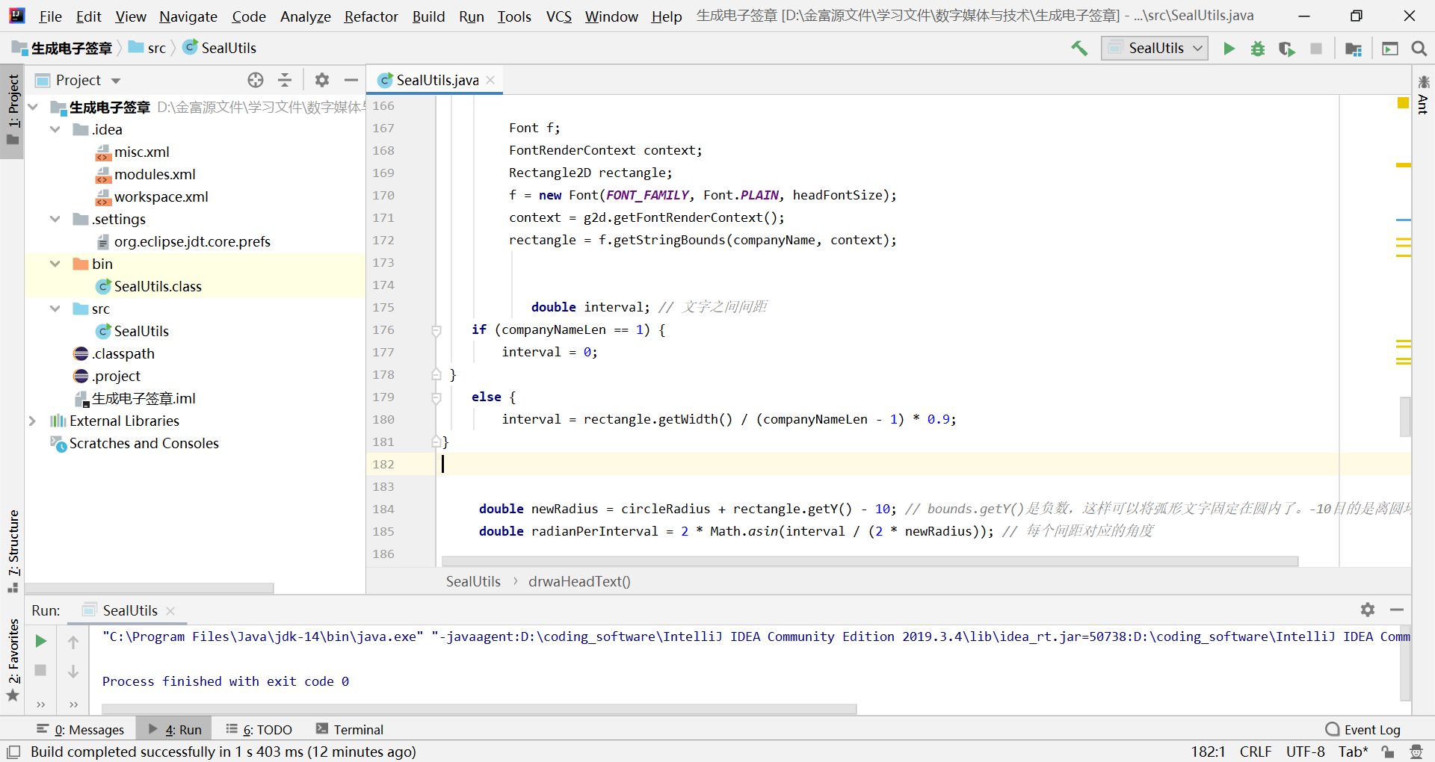

文件目录：
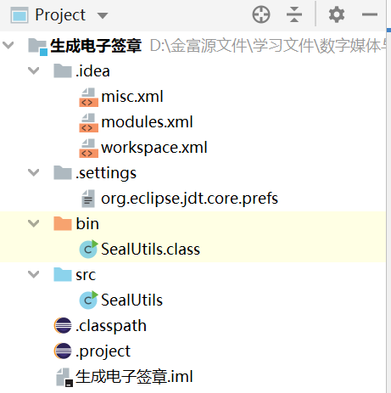

生成图片：

