姓名：熊健羽 班级：1703002 学号：1170500913

选择的题目：**最短路径算法的实现**

文件说明：

minWay.c：源程序

graph.png：有向图图的图形化表示（自行绘制的）

input.txt：有向图的输入

minWay.exe：可执行程序

output.png：运行minWay.exe的结果截图

满足的要求：

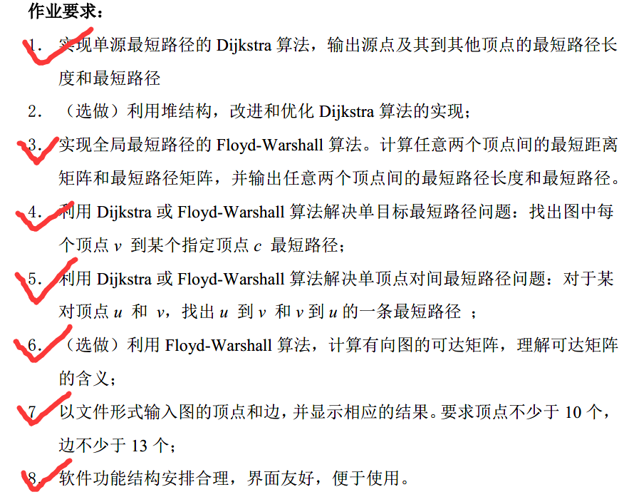

用于测试的带权值的有向图：

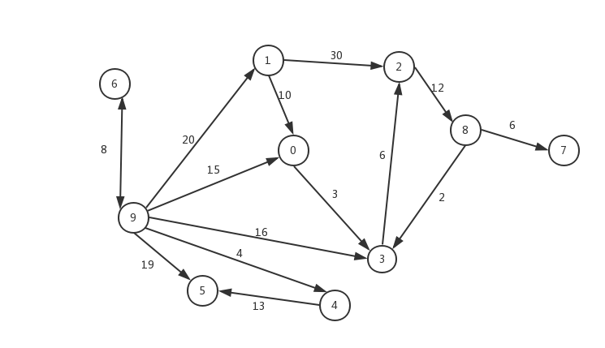

测试结果（截图）：

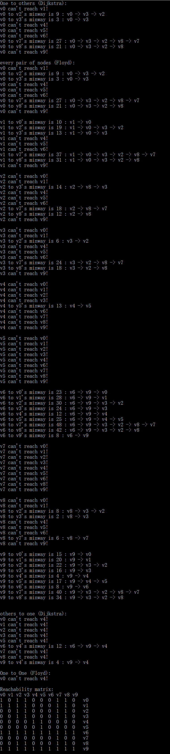 

测试结果：（文本）

One to others (Dijkstra):

v0 can't reach v1!

v0 to v2's minway is 9 : v0 -> v3 -> v2

v0 to v3's minway is 3 : v0 -> v3

v0 can't reach v4!

v0 can't reach v5!

v0 can't reach v6!

v0 to v7's minway is 27 : v0 -> v3 -> v2 -> v8 -> v7

v0 to v8's minway is 21 : v0 -> v3 -> v2 -> v8

v0 can't reach v9!

every pair of nodes (Floyd):

v0 can't reach v1!

v0 to v2's minway is 9 : v0 -> v3 -> v2

v0 to v3's minway is 3 : v0 -> v3

v0 can't reach v4!

v0 can't reach v5!

v0 can't reach v6!

v0 to v7's minway is 27 : v0 -> v3 -> v2 -> v8 -> v7

v0 to v8's minway is 21 : v0 -> v3 -> v2 -> v8

v0 can't reach v9!

v1 to v0's minway is 10 : v1 -> v0

v1 to v2's minway is 19 : v1 -> v0 -> v3 -> v2

v1 to v3's minway is 13 : v1 -> v0 -> v3

v1 can't reach v4!

v1 can't reach v5!

v1 can't reach v6!

v1 to v7's minway is 37 : v1 -> v0 -> v3 -> v2 -> v8 -> v7

v1 to v8's minway is 31 : v1 -> v0 -> v3 -> v2 -> v8

v1 can't reach v9!

v2 can't reach v0!

v2 can't reach v1!

v2 to v3's minway is 14 : v2 -> v8 -> v3

v2 can't reach v4!

v2 can't reach v5!

v2 can't reach v6!

v2 to v7's minway is 18 : v2 -> v8 -> v7

v2 to v8's minway is 12 : v2 -> v8

v2 can't reach v9!

v3 can't reach v0!

v3 can't reach v1!

v3 to v2's minway is 6 : v3 -> v2

v3 can't reach v4!

v3 can't reach v5!

v3 can't reach v6!

v3 to v7's minway is 24 : v3 -> v2 -> v8 -> v7

v3 to v8's minway is 18 : v3 -> v2 -> v8

v3 can't reach v9!

v4 can't reach v0!

v4 can't reach v1!

v4 can't reach v2!

v4 can't reach v3!

v4 to v5's minway is 13 : v4 -> v5

v4 can't reach v6!

v4 can't reach v7!

v4 can't reach v8!

v4 can't reach v9!

v5 can't reach v0!

v5 can't reach v1!

v5 can't reach v2!

v5 can't reach v3!

v5 can't reach v4!

v5 can't reach v6!

v5 can't reach v7!

v5 can't reach v8!

v5 can't reach v9!

v6 to v0's minway is 23 : v6 -> v9 -> v0

v6 to v1's minway is 28 : v6 -> v9 -> v1

v6 to v2's minway is 30 : v6 -> v9 -> v3 -> v2

v6 to v3's minway is 24 : v6 -> v9 -> v3

v6 to v4's minway is 12 : v6 -> v9 -> v4

v6 to v5's minway is 25 : v6 -> v9 -> v4 -> v5

v6 to v7's minway is 48 : v6 -> v9 -> v3 -> v2 -> v8 -> v7

v6 to v8's minway is 42 : v6 -> v9 -> v3 -> v2 -> v8

v6 to v9's minway is 8 : v6 -> v9

v7 can't reach v0!

v7 can't reach v1!

v7 can't reach v2!

v7 can't reach v3!

v7 can't reach v4!

v7 can't reach v5!

v7 can't reach v6!

v7 can't reach v8!

v7 can't reach v9!

v8 can't reach v0!

v8 can't reach v1!

v8 to v2's minway is 8 : v8 -> v3 -> v2

v8 to v3's minway is 2 : v8 -> v3

v8 can't reach v4!

v8 can't reach v5!

v8 can't reach v6!

v8 to v7's minway is 6 : v8 -> v7

v8 can't reach v9!

v9 to v0's minway is 15 : v9 -> v0

v9 to v1's minway is 20 : v9 -> v1

v9 to v2's minway is 22 : v9 -> v3 -> v2

v9 to v3's minway is 16 : v9 -> v3

v9 to v4's minway is 4 : v9 -> v4

v9 to v5's minway is 17 : v9 -> v4 -> v5

v9 to v6's minway is 8 : v9 -> v6

v9 to v7's minway is 40 : v9 -> v3 -> v2 -> v8 -> v7

v9 to v8's minway is 34 : v9 -> v3 -> v2 -> v8

others to one (Dijkstra):

v0 can't reach v4!

v1 can't reach v4!

v2 can't reach v4!

v3 can't reach v4!

v5 can't reach v4!

v6 to v4's minway is 12 : v6 -> v9 -> v4

v7 can't reach v4!

v8 can't reach v4!

v9 to v4's minway is 4 : v9 -> v4

One to One (Floyd):

v0 can't reach v4!

Reachability matrix:

v0 v1 v2 v3 v4 v5 v6 v7 v8 v9

1 0 1 1 0 0 0 1 1 0 v0

1 1 1 1 0 0 0 1 1 0 v1

0 0 1 1 0 0 0 1 1 0 v2

0 0 1 1 0 0 0 1 1 0 v3

0 0 0 0 1 1 0 0 0 0 v4

0 0 0 0 0 1 0 0 0 0 v5

1 1 1 1 1 1 1 1 1 1 v6

0 0 0 0 0 0 0 1 0 0 v7

0 0 1 1 0 0 0 1 1 0 v8

1 1 1 1 1 1 1 1 1 1 v9