**CIFAR-10数据集训练及预测实例**

**1.简介**

Cifar-10是由Hinton的两个大弟子Alex Krizhevsky、Ilya Sutskever收集的一个用于普适物体识别的数据集。Cifar是加拿大政府牵头投资的一个先进科学项目研究所。Cifar-10由60000张32*32的RGB彩色图片构成，共10个分类。50000张训练，10000张测试（交叉验证）。这个数据集最大的特点在于将识别迁移到了普适物体，而且应用于多分类，姊妹数据集Cifar-100达到100类，ILSVRC比赛则是1000类。

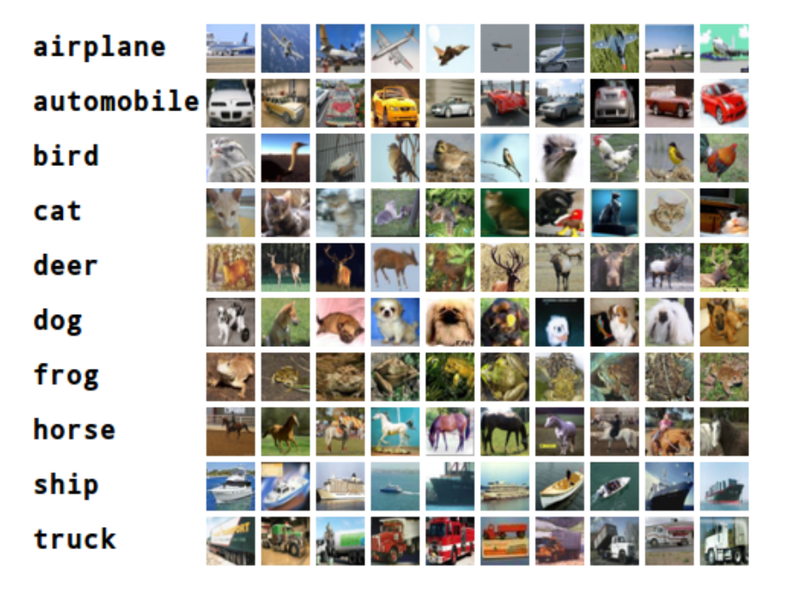

**2.数据集**

[**https://www.cs.toronto.edu/~kriz/cifar.html**](https://www.cs.toronto.edu/~kriz/cifar.html)

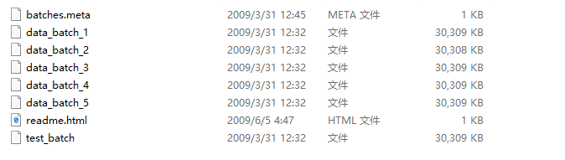

**3.代码**

[**https://github.com/1172939260/CIFAR-10/blob/master/cifar.py**](https://github.com/1172939260/CIFAR-10/blob/master/cifar.py)

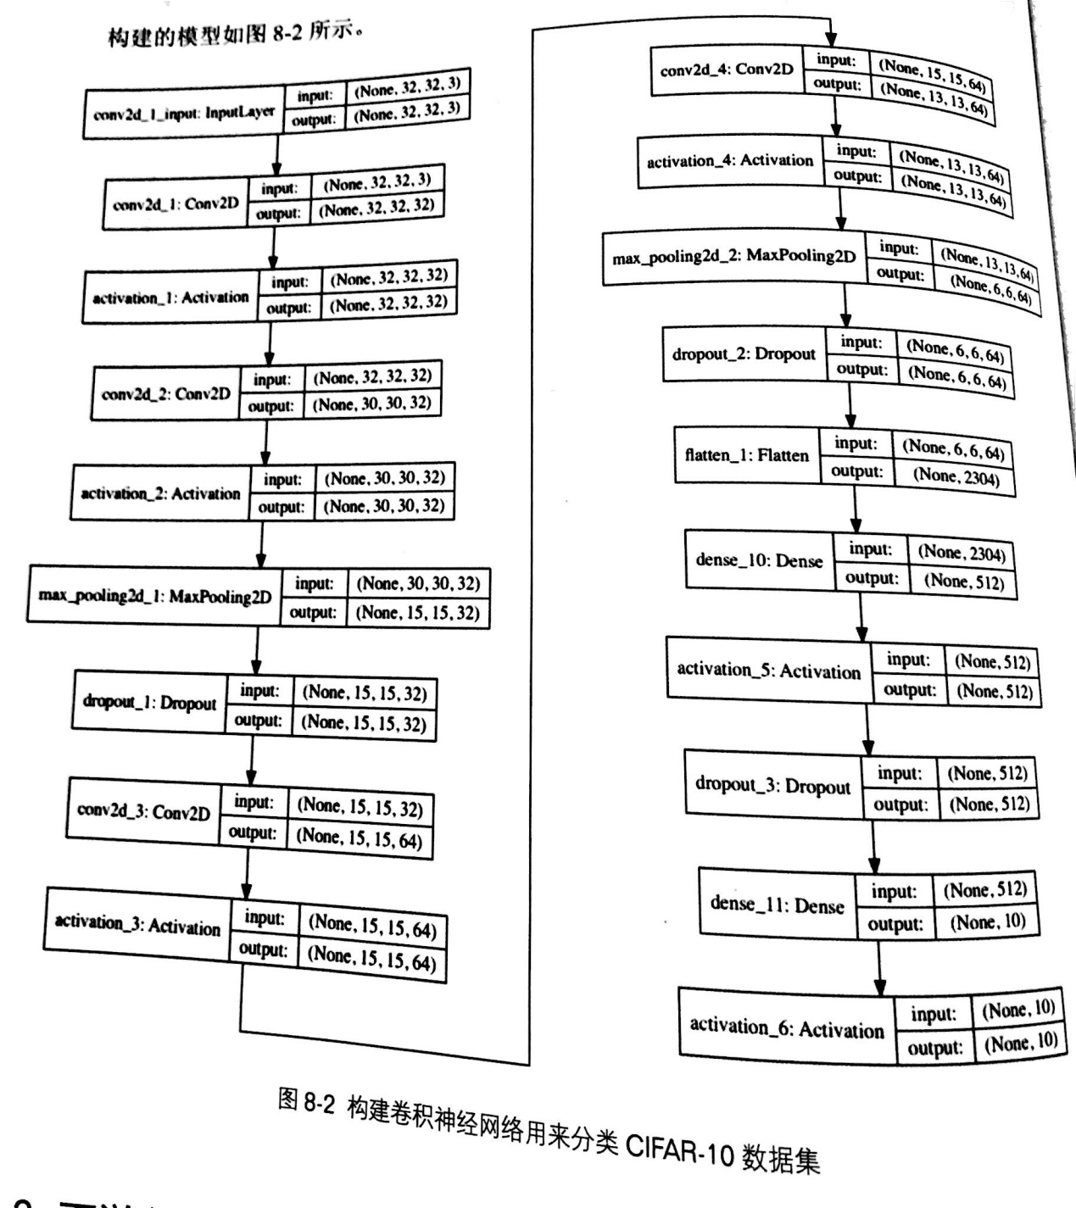

Epoch 1/50

1562/1562 [==============================] - 142s 91ms/step - loss: 1.8533 - acc: 0.3142 - val_loss: 1.5809 - val_acc: 0.4327

Epoch 2/50

1562/1562 [==============================] - 144s 92ms/step - loss: 1.5635 - acc: 0.4283 - val_loss: 1.3629 - val_acc: 0.5083

Epoch 3/50

1562/1562 [==============================] - 152s 97ms/step - loss: 1.4534 - acc: 0.4753 - val_loss: 1.2800 - val_acc: 0.5385

Epoch 4/50

1562/1562 [==============================] - 142s 91ms/step - loss: 1.3766 - acc: 0.5046 - val_loss: 1.2098 - val_acc: 0.5701

Epoch 5/50

1562/1562 [==============================] - 160s 102ms/step - loss: 1.3044 - acc: 0.5346 - val_loss: 1.1702 - val_acc: 0.5812

Epoch 6/50

1562/1562 [==============================] - 156s 100ms/step - loss: 1.2487 - acc: 0.5535 - val_loss: 1.1065 - val_acc: 0.6043

Epoch 7/50

1562/1562 [==============================] - 157s 101ms/step - loss: 1.1978 - acc: 0.5740 - val_loss: 1.0460 - val_acc: 0.6268

Epoch 8/50

1562/1562 [==============================] - 143s 92ms/step - loss: 1.1621 - acc: 0.5883 - val_loss: 1.0506 - val_acc: 0.6293

Epoch 9/50

1562/1562 [==============================] - 164s 105ms/step - loss: 1.1220 - acc: 0.6034 - val_loss: 1.0056 - val_acc: 0.6396

Epoch 10/50

1562/1562 [==============================] - 151s 97ms/step - loss: 1.0892 - acc: 0.6123 - val_loss: 0.9831 - val_acc: 0.6508

Epoch 11/50

1562/1562 [==============================] - 149s 96ms/step - loss: 1.0522 - acc: 0.6275 - val_loss: 0.9138 - val_acc: 0.6801

Epoch 12/50

1562/1562 [==============================] - 159s 102ms/step - loss: 1.0300 - acc: 0.6358 - val_loss: 0.8799 - val_acc: 0.6971

Epoch 13/50

1562/1562 [==============================] - 132s 85ms/step - loss: 1.0005 - acc: 0.6471 - val_loss: 0.8689 - val_acc: 0.6987

Epoch 14/50

1562/1562 [==============================] - 147s 94ms/step - loss: 0.9828 - acc: 0.6540 - val_loss: 0.8401 - val_acc: 0.7083 - ETA: 59s - loss: 0.9803 - acc: 0.6573

Epoch 15/50

1562/1562 [==============================] - 133s 85ms/step - loss: 0.9591 - acc: 0.6629 - val_loss: 0.8558 - val_acc: 0.7034

Epoch 16/50

1562/1562 [==============================] - 133s 85ms/step - loss: 0.9306 - acc: 0.6720 - val_loss: 0.8083 - val_acc: 0.7211

Epoch 17/50

1562/1562 [==============================] - 146s 93ms/step - loss: 0.9177 - acc: 0.6795 - val_loss: 0.7922 - val_acc: 0.7250

Epoch 18/50

1562/1562 [==============================] - 132s 85ms/step - loss: 0.9049 - acc: 0.6840 - val_loss: 0.7409 - val_acc: 0.7431

Epoch 19/50

1562/1562 [==============================] - 146s 94ms/step - loss: 0.8834 - acc: 0.6878 - val_loss: 0.7257 - val_acc: 0.7518

Epoch 20/50

1562/1562 [==============================] - 133s 85ms/step - loss: 0.8670 - acc: 0.6955 - val_loss: 0.7714 - val_acc: 0.7316

Epoch 21/50

1562/1562 [==============================] - 147s 94ms/step - loss: 0.8496 - acc: 0.7047 - val_loss: 0.7698 - val_acc: 0.7312

Epoch 22/50

1562/1562 [==============================] - 133s 85ms/step - loss: 0.8371 - acc: 0.7067 - val_loss: 0.6911 - val_acc: 0.7606

Epoch 23/50

1562/1562 [==============================] - 133s 85ms/step - loss: 0.8279 - acc: 0.7121 - val_loss: 0.7112 - val_acc: 0.7552

Epoch 24/50

1562/1562 [==============================] - 145s 93ms/step - loss: 0.8140 - acc: 0.7160 - val_loss: 0.7236 - val_acc: 0.7474

Epoch 25/50

1562/1562 [==============================] - 132s 85ms/step - loss: 0.8046 - acc: 0.7186 - val_loss: 0.6716 - val_acc: 0.7699

Epoch 26/50

1562/1562 [==============================] - 145s 93ms/step - loss: 0.7953 - acc: 0.7229 - val_loss: 0.6772 - val_acc: 0.7661

Epoch 27/50

1562/1562 [==============================] - 132s 85ms/step - loss: 0.7856 - acc: 0.7239 - val_loss: 0.6830 - val_acc: 0.7680

Epoch 28/50

1562/1562 [==============================] - 145s 93ms/step - loss: 0.7755 - acc: 0.7285 - val_loss: 0.6776 - val_acc: 0.7674

Epoch 29/50

1562/1562 [==============================] - 132s 85ms/step - loss: 0.7653 - acc: 0.7343 - val_loss: 0.6961 - val_acc: 0.7601

Epoch 30/50

1562/1562 [==============================] - 133s 85ms/step - loss: 0.7583 - acc: 0.7356 - val_loss: 0.6484 - val_acc: 0.7761

Epoch 31/50

1562/1562 [==============================] - 145s 93ms/step - loss: 0.7479 - acc: 0.7401 - val_loss: 0.6719 - val_acc: 0.7692 - ETA: 44s - loss: 0.7401 - acc: 0.7426

Epoch 32/50

1562/1562 [==============================] - 132s 84ms/step - loss: 0.7400 - acc: 0.7417 - val_loss: 0.6546 - val_acc: 0.7726

Epoch 33/50

1562/1562 [==============================] - 145s 93ms/step - loss: 0.7304 - acc: 0.7444 - val_loss: 0.6340 - val_acc: 0.7816

Epoch 34/50

1562/1562 [==============================] - 133s 85ms/step - loss: 0.7226 - acc: 0.7481 - val_loss: 0.6759 - val_acc: 0.7677

Epoch 35/50

1562/1562 [==============================] - 145s 93ms/step - loss: 0.7163 - acc: 0.7506 - val_loss: 0.6718 - val_acc: 0.7674

Epoch 36/50

1562/1562 [==============================] - 133s 85ms/step - loss: 0.7072 - acc: 0.7529 - val_loss: 0.6495 - val_acc: 0.7755

Epoch 37/50

1562/1562 [==============================] - 146s 94ms/step - loss: 0.7065 - acc: 0.7555 - val_loss: 0.6308 - val_acc: 0.7839

Epoch 38/50

1562/1562 [==============================] - 133s 85ms/step - loss: 0.7027 - acc: 0.7538 - val_loss: 0.6162 - val_acc: 0.7861

Epoch 39/50

1562/1562 [==============================] - 146s 93ms/step - loss: 0.6944 - acc: 0.7575 - val_loss: 0.6081 - val_acc: 0.7880

Epoch 40/50

1562/1562 [==============================] - 133s 85ms/step - loss: 0.6847 - acc: 0.7605 - val_loss: 0.6053 - val_acc: 0.7903

Epoch 41/50

1562/1562 [==============================] - 145s 93ms/step - loss: 0.6825 - acc: 0.7608 - val_loss: 0.6208 - val_acc: 0.7861 - ETA: 36s - loss: 0.6882 - acc: 0.7582

Epoch 42/50

1562/1562 [==============================] - 133s 85ms/step - loss: 0.6753 - acc: 0.7635 - val_loss: 0.6029 - val_acc: 0.7922

Epoch 43/50

1562/1562 [==============================] - 145s 93ms/step - loss: 0.6761 - acc: 0.7627 - val_loss: 0.6104 - val_acc: 0.7900

Epoch 44/50

1562/1562 [==============================] - 133s 85ms/step - loss: 0.6662 - acc: 0.7670 - val_loss: 0.5880 - val_acc: 0.7968

Epoch 45/50

1562/1562 [==============================] - 146s 94ms/step - loss: 0.6586 - acc: 0.7695 - val_loss: 0.6219 - val_acc: 0.7858

Epoch 46/50

1562/1562 [==============================] - 133s 85ms/step - loss: 0.6515 - acc: 0.7740 - val_loss: 0.5704 - val_acc: 0.8046

Epoch 47/50

1562/1562 [==============================] - 145s 93ms/step - loss: 0.6478 - acc: 0.7742 - val_loss: 0.5677 - val_acc: 0.8023

Epoch 48/50

1562/1562 [==============================] - 133s 85ms/step - loss: 0.6437 - acc: 0.7743 - val_loss: 0.5791 - val_acc: 0.7997

Epoch 49/50

1562/1562 [==============================] - 145s 93ms/step - loss: 0.6475 - acc: 0.7747 - val_loss: 0.5877 - val_acc: 0.7968

Epoch 50/50

1562/1562 [==============================] - 133s 85ms/step - loss: 0.6372 - acc: 0.7791 - val_loss: 0.5624 - val_acc: 0.8040

Test score: 0.5623835807800293

Accuracy: 80.40%

Compiled!