Paper Draft (auto-assembled)

Methods

Methods

Data and scope
We compile a small event corpus related to the “85 New Wave” narrative and its later archival re-inscriptions. Each row is an event-like record (exhibition / publication / platform item), enriched with 4D iconology features.

Feature construction (4D)
We operationalize four iconological directions:
• Time: rupture-related scores and component means.
• Space: city concentration and spatial scope / evidence.
• Social: institution-level categories (market / media / museum / platform / unknown).
• Tech/Channel: dissemination channels and their shares.

O/R/S stage projection
We project the 4D features into a 3-state stage space:
• O (Openness): strength of objectification / archivalization.
• R (Reorganization): rupture / polemic intensity (plus semantic noise).
• S (SteadyState / opacity): structural opacity driven by missingness / unknown evidence.

We aggregate yearly means and normalized shares, and visualize trajectories across observed years.

Results

Results

Rupture components
We report yearly means for O/R/S and semantic noise, as well as yearly shares normalized within (O+R+S).

Key figures
• fig_rupture_components_means.png
• fig_rupture_components_shares.png

Tables
• table_rupture_components_yearly.csv

Figures and Tables
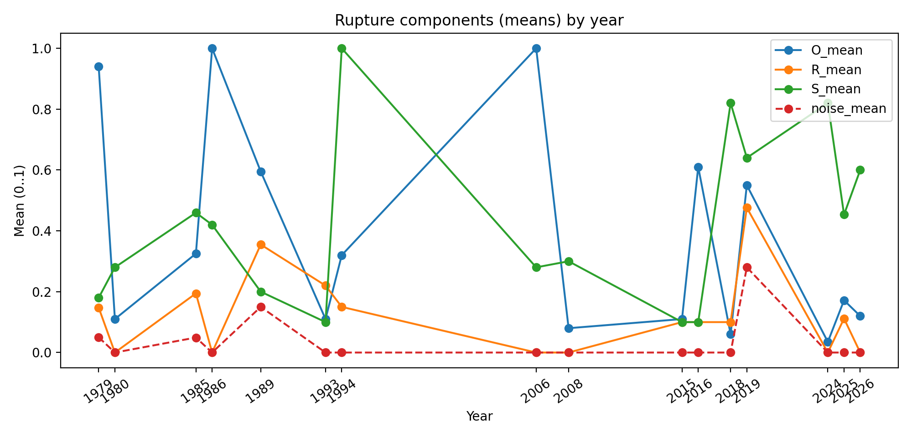
Figure 1. Rupture components (means) by year.
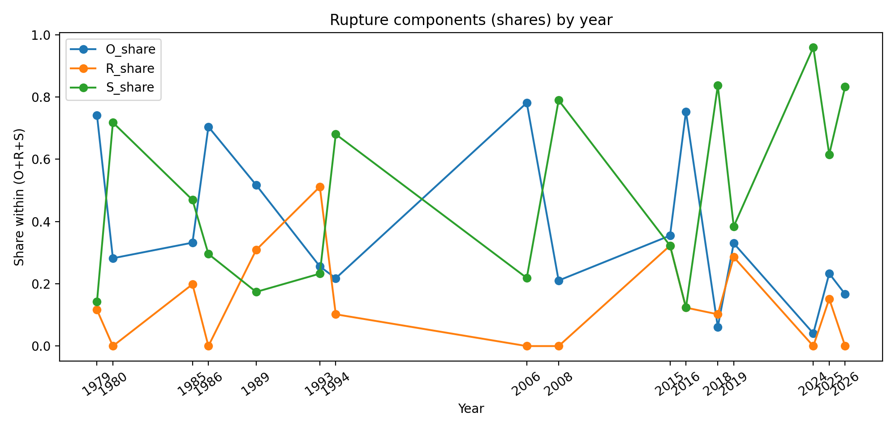
Figure 2. Rupture components (shares) by year.

Table 1. Rupture components yearly (preview)
year | n | O_mean | R_mean | S_mean | noise_mean | O_share | R_share | S_share
1979.0 | 4.0 | 0.94 | 0.1475 | 0.18 | 0.05 | 0.7416173570019724 | 0.116370808678501 | 0.1420118343195266
1980.0 | 1.0 | 0.11 | 0.0 | 0.28 | 0.0 | 0.282051282051282 | 0.0 | 0.717948717948718
1985.0 | 41.0 | 0.3251219512195122 | 0.1943658536585366 | 0.4595121951219512 | 0.0492682926829268 | 0.3320959665163556 | 0.1985350905603029 | 0.4693689429233413
1986.0 | 1.0 | 1.0 | 0.0 | 0.42 | 0.0 | 0.7042253521126761 | 0.0 | 0.295774647887324
1989.0 | 4.0 | 0.595 | 0.355 | 0.2 | 0.15 | 0.5173913043478261 | 0.308695652173913 | 0.1739130434782609
1993.0 | 1.0 | 0.11 | 0.22 | 0.1 | 0.0 | 0.255813953488372 | 0.5116279069767442 | 0.2325581395348837
1994.0 | 1.0 | 0.32 | 0.15 | 1.0 | 0.0 | 0.217687074829932 | 0.1020408163265306 | 0.6802721088435374
2006.0 | 1.0 | 1.0 | 0.0 | 0.28 | 0.0 | 0.78125 | 0.0 | 0.21875
2008.0 | 2.0 | 0.08 | 0.0 | 0.3 | 0.0 | 0.2105263157894736 | 0.0 | 0.7894736842105263
2015.0 | 1.0 | 0.11 | 0.1 | 0.1 | 0.0 | 0.3548387096774193 | 0.3225806451612902 | 0.3225806451612902
2016.0 | 1.0 | 0.6100000000000001 | 0.1 | 0.1 | 0.0 | 0.7530864197530865 | 0.1234567901234567 | 0.1234567901234567
2018.0 | 1.0 | 0.06 | 0.1 | 0.8199999999999998 | 0.0 | 0.0612244897959183 | 0.1020408163265306 | 0.836734693877551
(Preview first 12 rows; full CSV saved alongside.)

