**Date Submitted: 09/24/2019**

**Task 00: Execute provided code**

**Youtube Link: Said no submission required as its shown through task 1 and 2.**

**------------------------------------------------------------------------------------**

**Task 01: Determine Current period and on-time of the LED blinking. Change the delay of LED blink (0.5sec) by changing the delay and clock source and configuration. Determine CLK Frequency – verify the dealy to be approx. 0.5sec.**

Youtube Link: <https://youtu.be/CGCKEaaa3ms>

**Modified Code:** 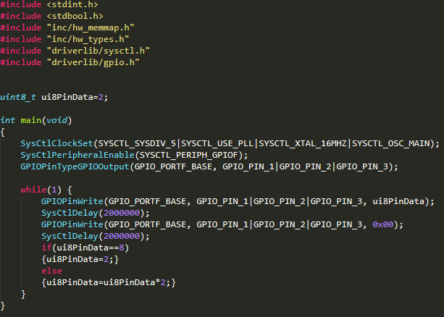

**------------------------------------------------------------------------------------**

**Task 02.A: Change sequence of LED blinking (RGB => BGR)**

Youtube Link: <https://youtu.be/M8G8_z-x8mM>

**Modified Code:**

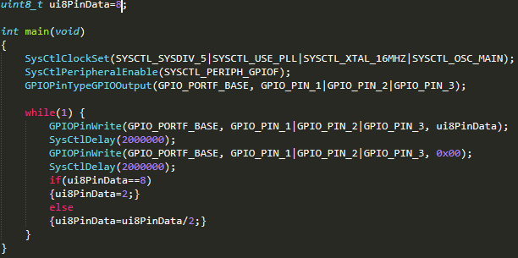

**------------------------------------------------------------------------------------**

**Task 02.B: Blink 1 LED, 2 LED, 3 LED at an instance and with a sequence (sequence with delay – R,G,B,RG,RB,GB, RGB, R, G, …).**

Youtube Link: <https://youtu.be/GJPCjmLg-Qk>

**Modified Code:**



