**Date Submitted: 09/28/2019**

**Task 00: Execute provided code**

**Youtube Link:**://www.youtube.com/watch?v=X2JonuHu03w

**------------------------------------------------------------------------------------**

**Task 01: Change the toggle of the GPIO @ 10 Hz using Timer0 with a 43% duty cycle and verify wavefo**



Youtube Link: http://www.youtube.com/watch?v=1TJP7hi7_mI

**Modified Code:** 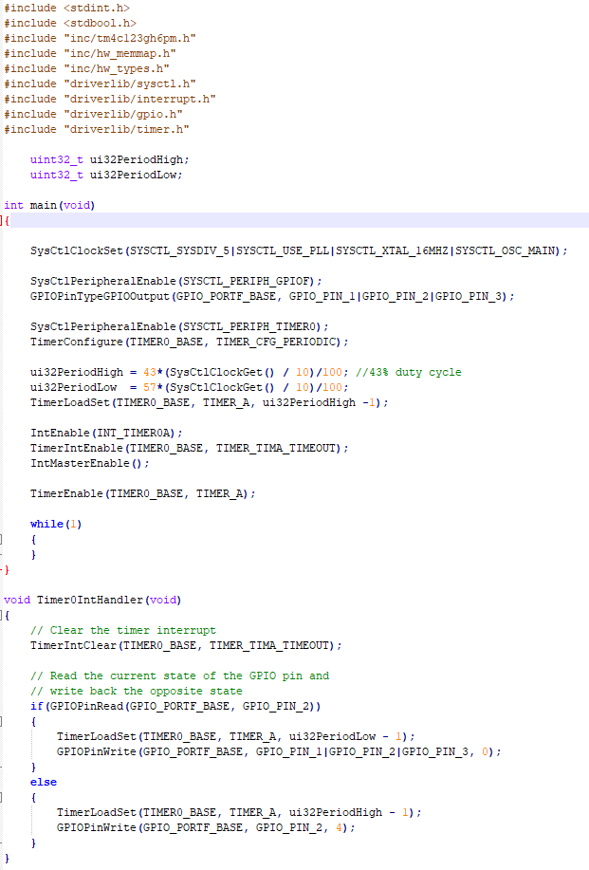

**------------------------------------------------------------------------------------**

**Task 02: Include a GPIO Interrupt to Task 01 from switch SW2 to turn ON and the LED for 1 sec. Use a Timer1 to calculate the 1 sec delay. The toggle of the GPIO is suspended when executing the interrupt.**

Youtube Link: http://www.youtube.com/watch?v=1wjSk-SMx2A

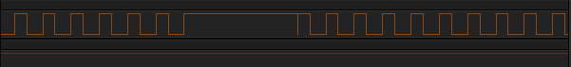

**Modified Code:**



