CPE301 – SPRING 2019

Design Assignment 1A

Student Name: Theodore Pele

Student #: 2000862662

Student Email: pele@unlv.nevada.edu

Primary Github address: pele@unlv.nevada.edu

Directory: DA1A

1. **COMPONENTS LIST AND CONNECTION BLOCK DIAGRAM w/ PINS**

N/A

1. **INITIAL/MODIFIED/DEVELOPED CODE OF TASK 1/A**

N/A

1. **DEVELOPED MODIFIED CODE OF TASK 2/A from TASK 1/A**

N/A

1. **SCHEMATICS**

N/A

1. **SCREENSHOTS OF EACH TASK OUTPUT (ATMEL STUDIO OUTPUT)**

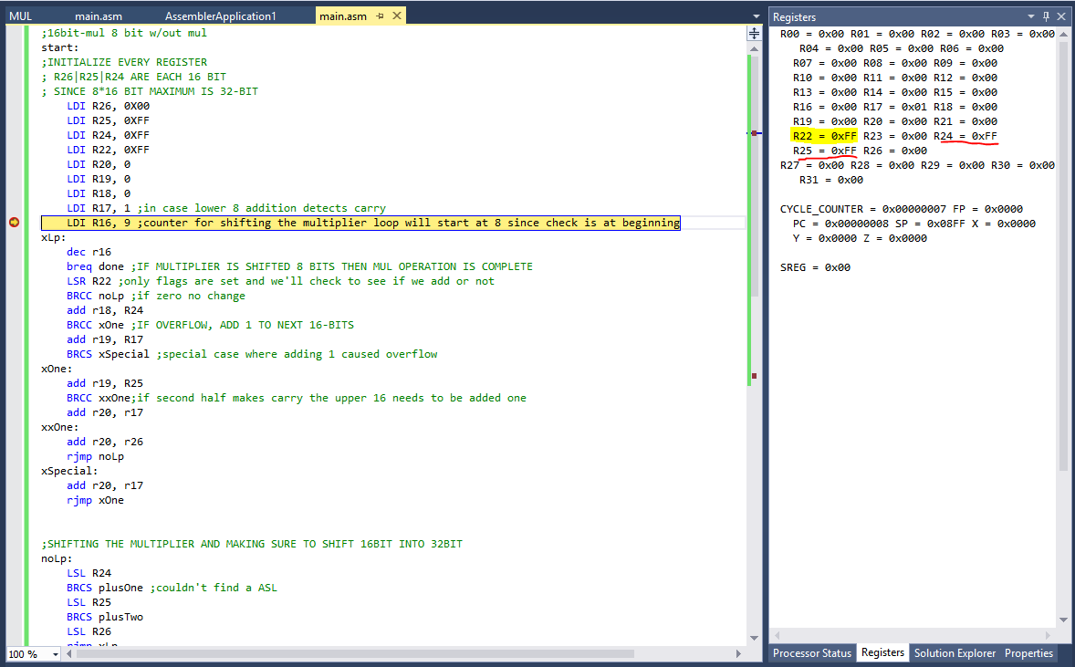

Figure : Initialize Registers for 0xFFFF mul 0xFF

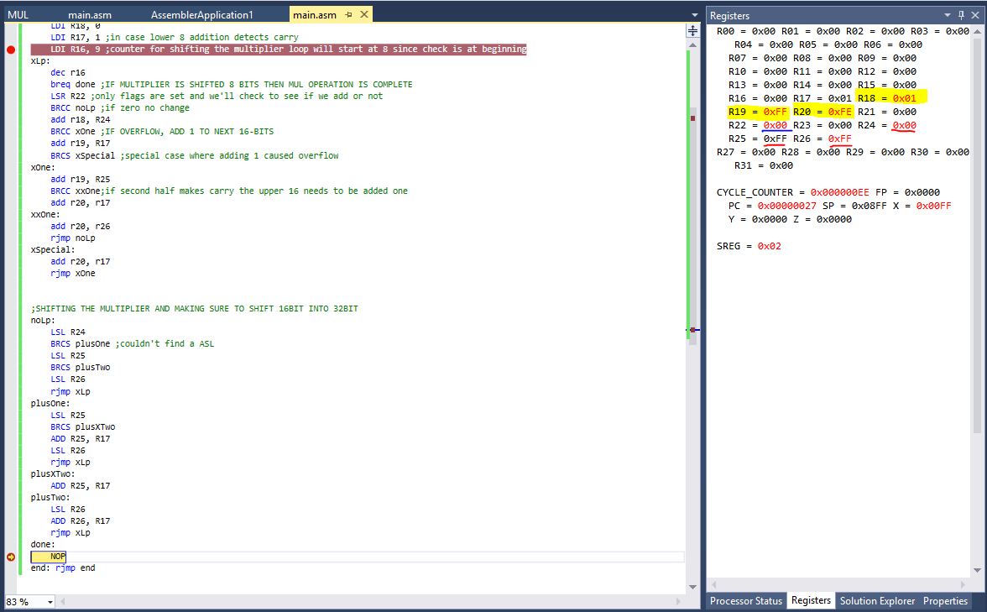

Figure : AFTER RUN, HL SHOWS RESULT AS R20|R19|R18 AND SUCCESSFUL LEFT SHIFT OF R26\R25|R24 AND RIGHT SHIFT R22

1. **SCREENSHOT OF EACH DEMO (BOARD SETUP)**

N/A

1. **VIDEO LINKS OF EACH DEMO**

https://youtu.be/ANv3eKX0BpA

1. **GITHUB LINK OF THIS DA**

https://github.com/1177307/submission_DA/tree/master/DesignAssignments/DA1/DA1A

**Student Academic Misconduct Policy**

<http://studentconduct.unlv.edu/misconduct/policy.html>

“This assignment submission is my own, original work”.

-THEODORE PELE