CPE301 – SPRING 2019

Design Assignment 1B

Student Name: Theodore Pele

Student #: 2000862662

Student Email: pele@unlv.nevada.edu

Primary Github address: pele@unlv.nevada.edu

Directory: DA1B

1. **COMPONENTS LIST AND CONNECTION BLOCK DIAGRAM w/ PINS**

Not using any external components of the Atmega328p processor. Only using the AVR studio to demonstrate writing data into memory locations.

1. **INITIAL/MODIFIED/DEVELOPED CODE OF TASK 1/A**

Base code was taken from lecture 4a for copying value $55 into memory locations $140 to $144.

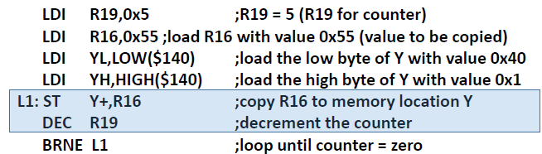

Figure : Code is not mine but provided a simple guide to writing data into memory addresses. From lecture 4a of CpE301.

1. **DEVELOPED MODIFIED CODE OF TASK 2/A from TASK 1/A**

Everything of the code is brand new or an expansion of the example code.

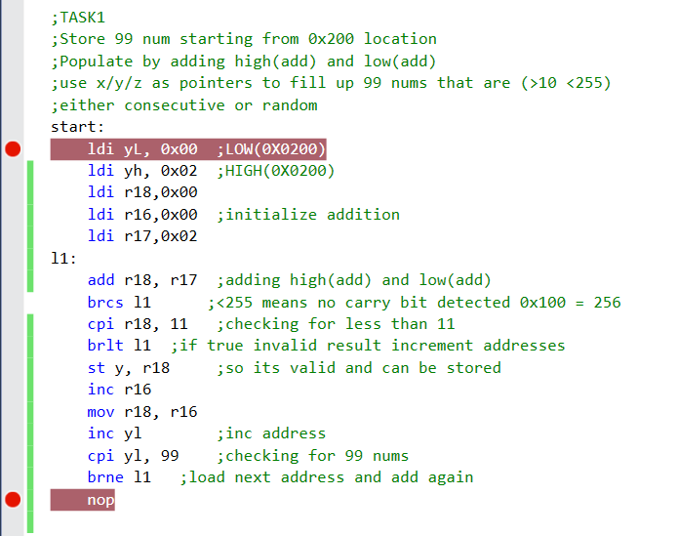

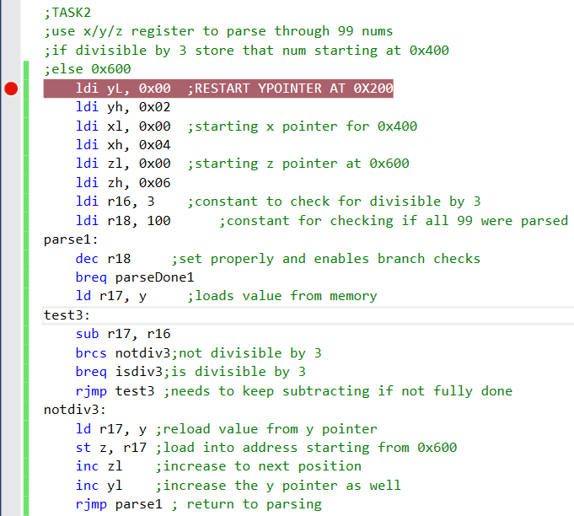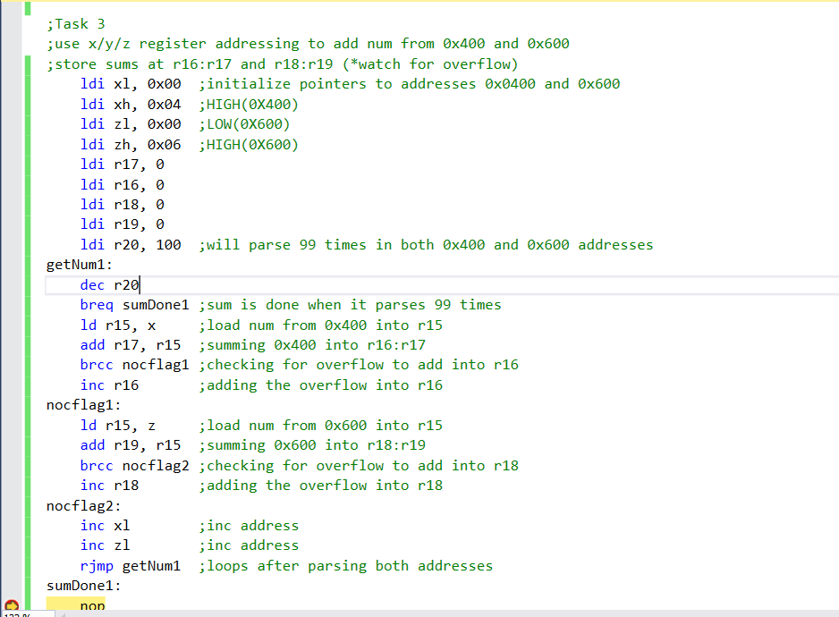

1. **SCHEMATICS**

Not designing a circuit out of this since its already predefined inside the atmega328p datasheet as well as no external components were used since its all done through simulator.

1. **SCREENSHOTS OF EACH TASK OUTPUT (ATMEL STUDIO OUTPUT)**

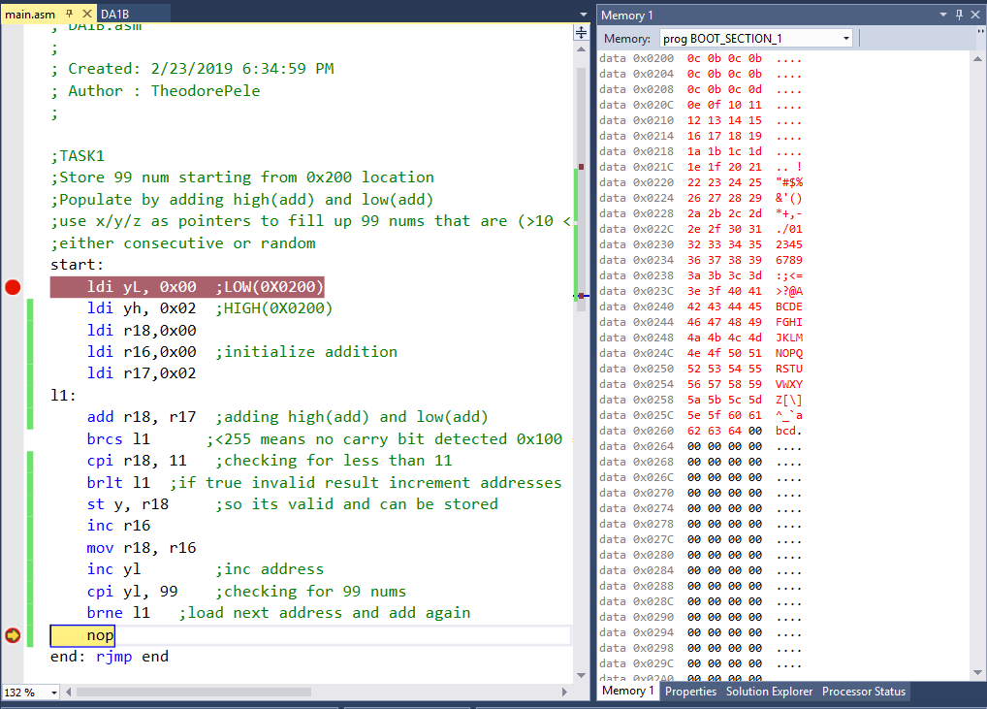Task 1: Create the starting address at 0x0200 and then begin to fill up the addresses with values between [11,255] by adding the high(startadds) and low(startadds). I had made it so that r16 the lower 16 bits was incremented by 1 while the upper starting address remained the same everytime an entry was made.

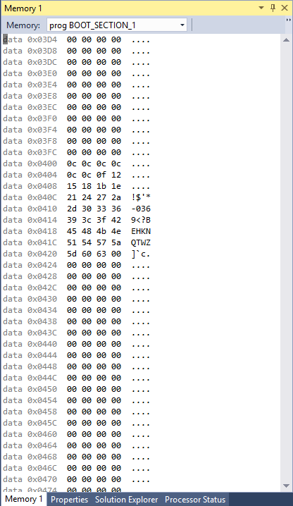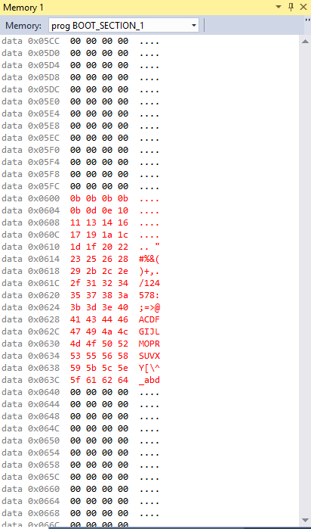

Task 2: Required us to separate the 99 numbers inside of addresses 0x20XX to divisible by 3 in addresses starting at 0x0400 and if not, 0x0600.

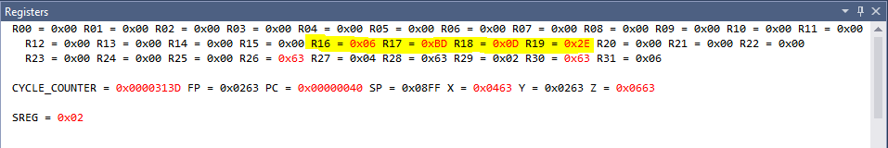

Task 3: Required summing 0x0400 into R16:R17 and numbers starting at 0x0600 into R18:R19.

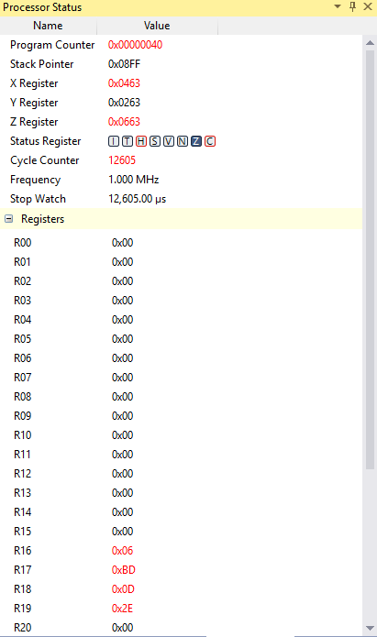

Task 5: Determine execution time @ 16Mhz/#cycles

16*(10^6) / 12605 = 1269 seconds.

1. **SCREENSHOT OF EACH DEMO (BOARD SETUP)**

No board needed since its only manipulating data inside the memory.

1. **VIDEO LINKS OF EACH DEMO**

https://youtu.be/-bw881jOQNQ

1. **GITHUB LINK OF THIS DA**

**Student Academic Misconduct Policy**

<http://studentconduct.unlv.edu/misconduct/policy.html>

“This assignment submission is my own, original work”.

Theodore Pele