CPE301 – SPRING 2019

Design Assignment 2A

Student Name: THEODORE PELE

Student #: 2000862662

Student Email: pele@unlv.nevada.edu

Primary Github address: https://github.com/1177307/submission_DA

Directory: DA2

1. **COMPONENTS LIST AND CONNECTION BLOCK DIAGRAM w/ PINS**

USED LEDs and PUSH BUTTONS TO EMULATE THE ASSIGNMENT

1. **INITIAL/MODIFIED/DEVELOPED CODE OF TASK 1/A**

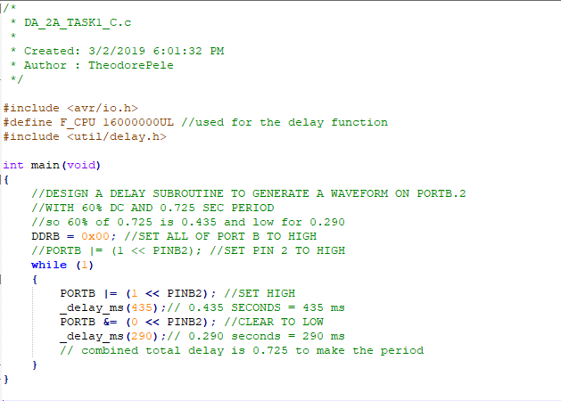

Here is the c code to generate a waveform with 60% DC and 0.725 second period. Basically, from the 60% duty cycle, the first delay was calculated by 0.725 * 60% = 0.435 seconds.

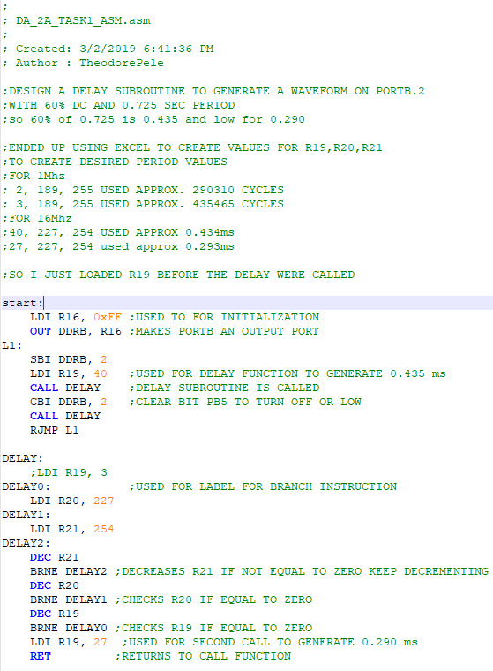

Similar to the C code it initializes the ports and sets them active. Then, it checks sets the bit to high to turn on and low to turn off with a delay function. In L1, it loads 40 into r19 which creates the delay required to create around 0.435 seconds. At the end of the delay function, it loads 27 into r19 which is needed to create the 0.290 seconds for the remaining period.

1. **DEVELOPED MODIFIED CODE OF TASK 2/A from TASK 1/A**

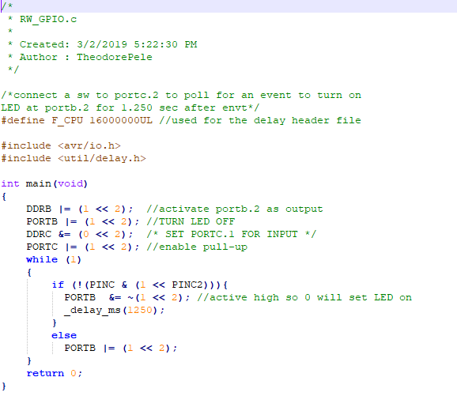

Pretty much a replica of the example from a slide that was given to control a led with a switch. Now, task 2 required that we use PORTC pin 2 to activate PORTB pin 2 (the LED) to turn off and remain on for 1.25 seconds. The c function _delay_ms(1250) easily does this.

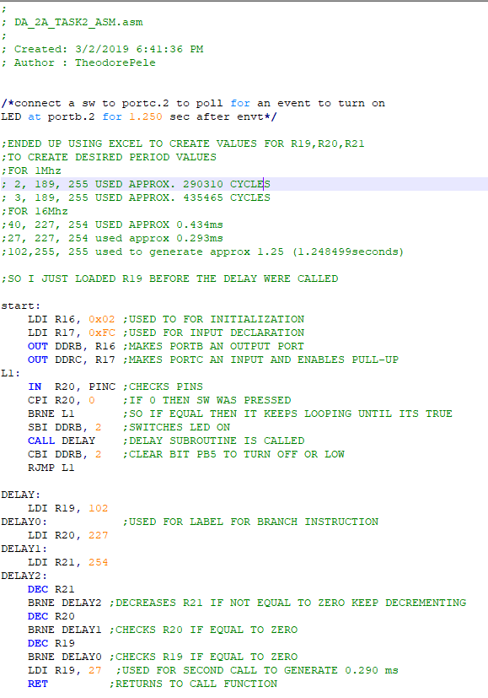

Similar to task 1, I calculated the required loop cycles in 16Mhz to generate the immediate values. Additional codes were setting up the input and output that would read constantly from the pins.

1. 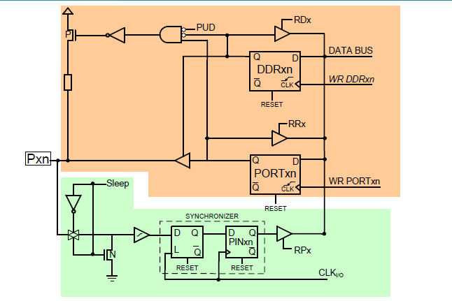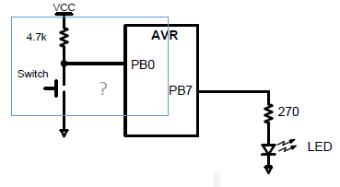**SCHEMATICS**

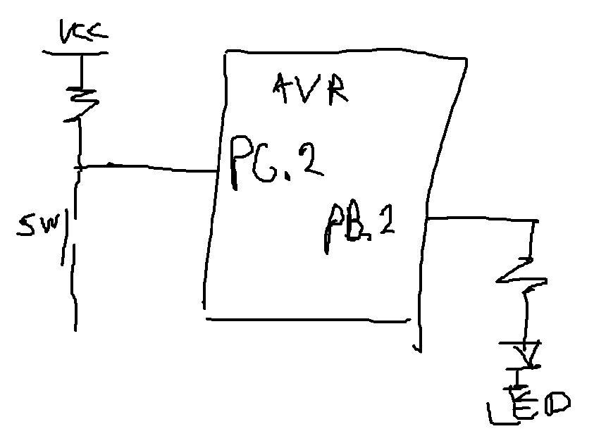

So, I was having trouble downloading the fritzing and decided to just give a simple drawing of task 2. For task 1, it was only accessing the LED through ports B.

1. **SCREENSHOTS OF EACH TASK OUTPUT (ATMEL STUDIO OUTPUT)**

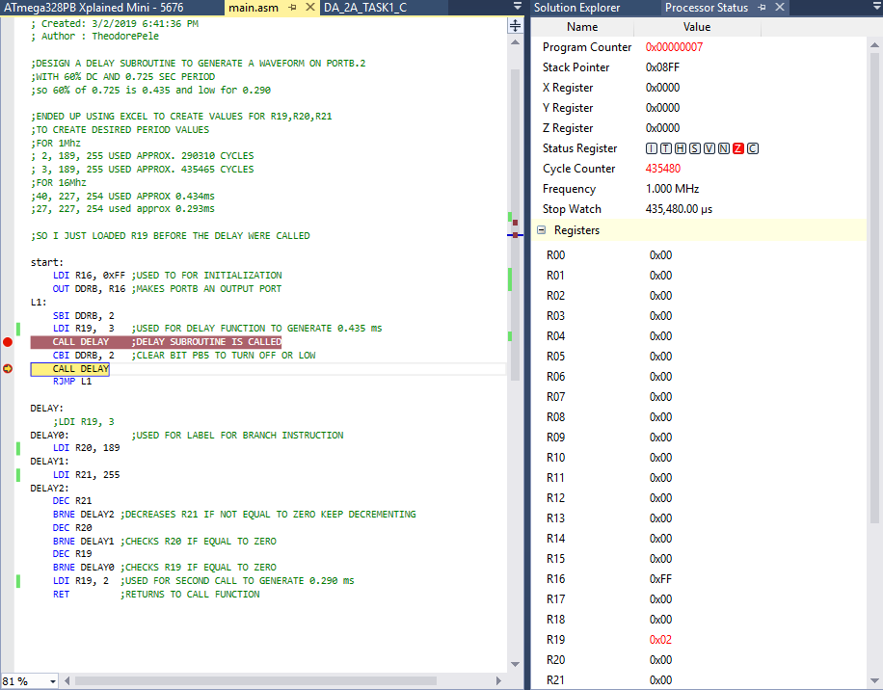

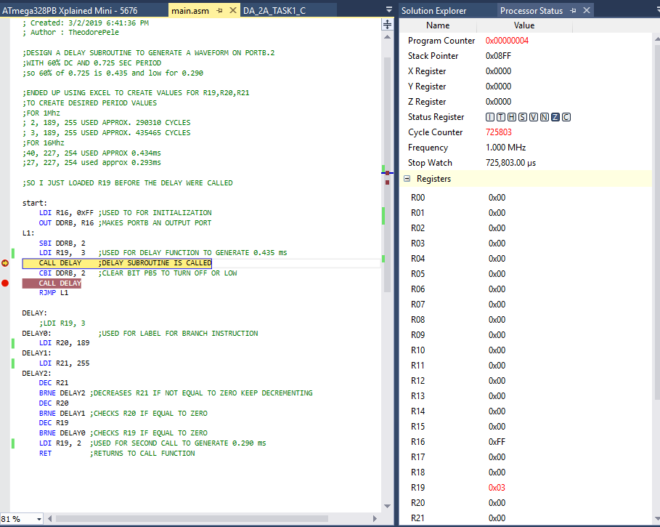

Using 1Mhz in this simulation, if I change the immediate values to the ones described in the comments it will also show a similar result. First run shows the first delay and second run shows the total period when it loops, which is approximately the period that was needed.

**TASK 2:**

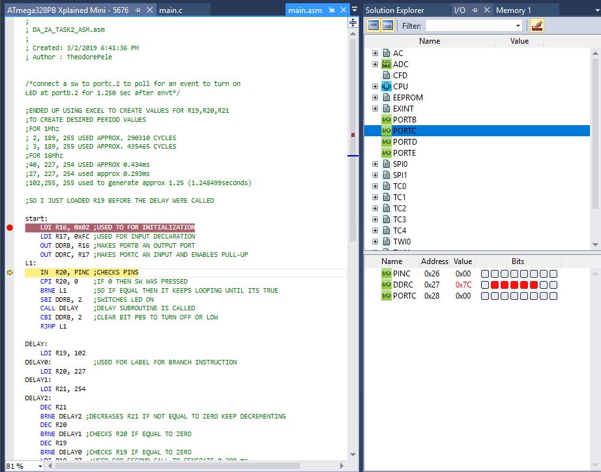

Detecting Input, if not press keeps looping, if press will run and then switch the LED on and also delay for 1.250 seconds then turn off. Below shows the different stages as its pressed, remained on, and then cleared.

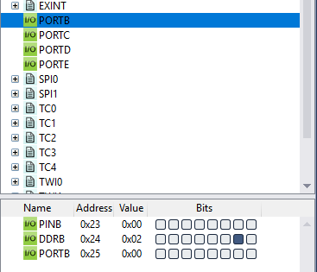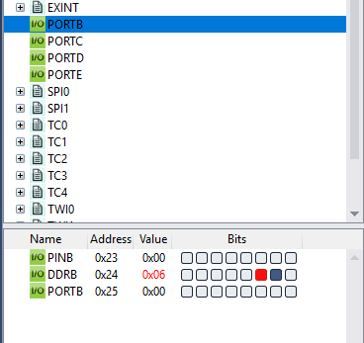

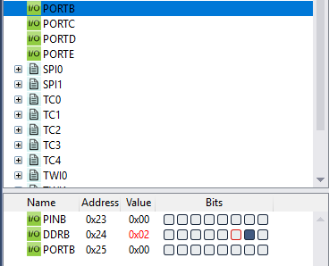

1. **SCREENSHOT OF EACH DEMO (BOARD SETUP)**

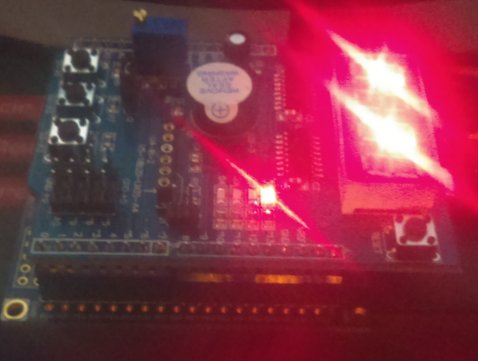

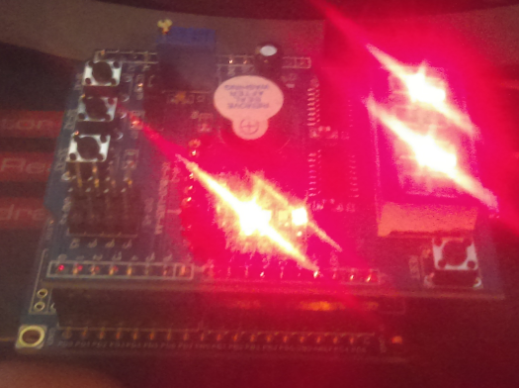

(TOP) OFF (BOTTOM) ON, I pressed the button.

1. **VIDEO LINKS OF EACH DEMO**

<https://youtu.be/t3mWfa2Pexk> - EMULATONS

<https://youtu.be/8rgCEhfuSwk> - SIMULATIONS

Unfortunately, couldn’t combine the videos.

1. **GITHUB LINK OF THIS DA**

https://github.com/1177307/submission_DA/tree/master/DesignAssignments/DA2/DA2A

**Student Academic Misconduct Policy**

<http://studentconduct.unlv.edu/misconduct/policy.html>

“This assignment submission is my own, original work”.

THEODORE PELE