CPE301 – SPRING 2019

Design Assignment 2C

Student Name: THEODORE PELE

Student #: 2000862662

Student Email: pele@unlv.nevada.edu

Primary Github address: https://github.com/1177307/submission_DA

Directory: DA2C

1. **COMPONENTS LIST AND CONNECTION BLOCK DIAGRAM w/ PINS**

USED LEDs and WIRE TO CREATE EXTERNAL INTERRUPT OF A SHORT

LED (D4) – PORT B, PIN 2

INTERRUPT – PORT D, PIN 2

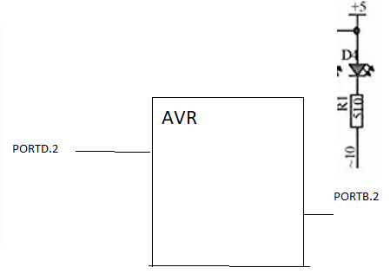

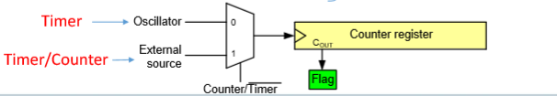

1. **INITIAL/MODIFIED/DEVELOPED CODE OF TASK 1/A**

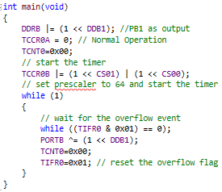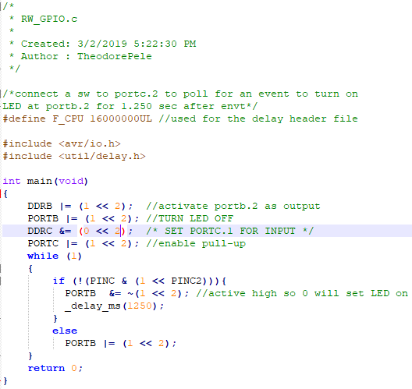

The code given in module 7 for timer 0 normal mode. It was combined with the code from 2A where it used the _delay_ms (1250) function and used the input pin for the switch. (Right) codes from lectures and videos. (Left) codes from 2A polling for an event.

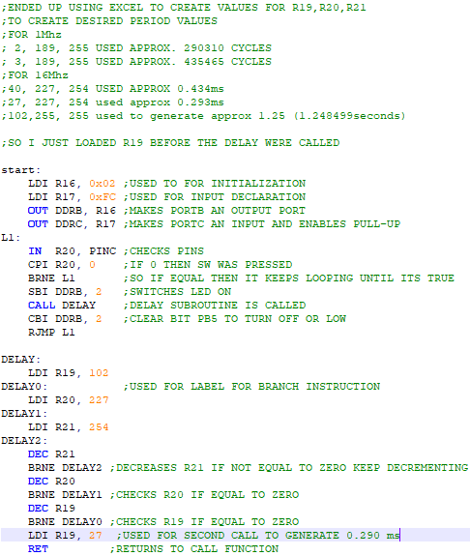

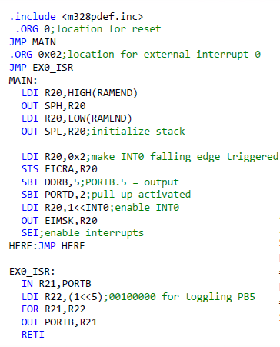

1. **DEVELOPED MODIFIED CODE OF TASK 2/A from TASK 1/A**

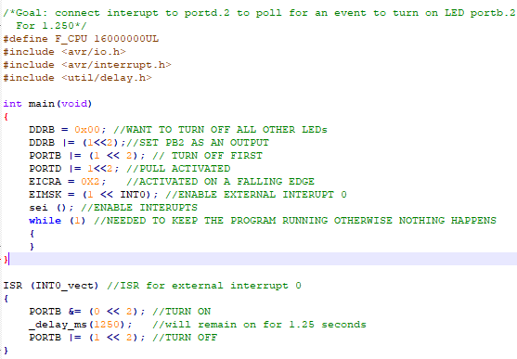

Similar to the code of from the video, where it has the specific registers set so that the external interrupt 0 can be accessed. I included the infinite loop, so the code would keep running while allowing the interrupt to be included. Inside the interrupt loop is the polling simulation of turning on for 1.25 seconds and turning off afterwards.

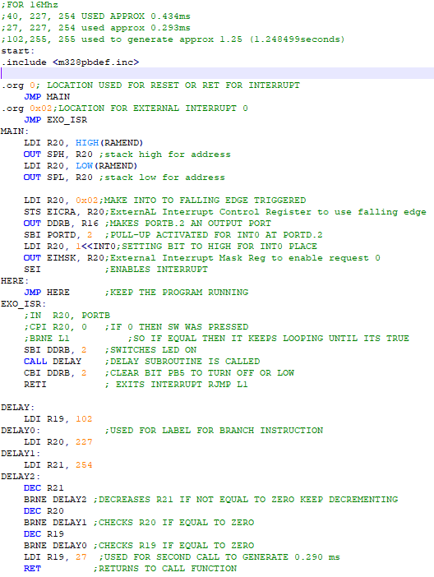

Again, from DA 2A we used the frequency of 16Mhz to create the delay subroutine. Using the lecture notes, I followed the same step to have the addresses defined for the code to begin as well as activating the external interrupt. It also includes the external interrupt subroutine (EX0_ISR) to turn LED on for 1.25 seconds then off.

1. 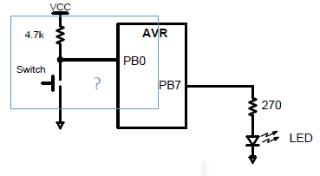**SCHEMATICS** 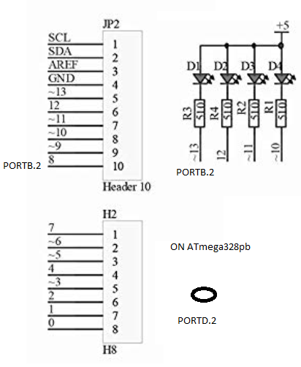

Found the multifunction shield schematic, we have the AVR microcontroller, ATmega328pb that has multiple pins. For this assignment, we used PORT D PIN 2 and PORT B PIN 2 where if PORTD.2/INT0 was activated the PORT B PIN 2 would be fed to turn ON and remain fed for 1.25 seconds then turned OFF.

1. **SCREENSHOTS OF EACH TASK OUTPUT (ATMEL STUDIO OUTPUT)**

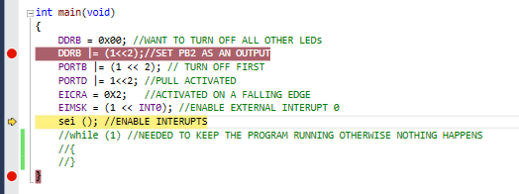

Couldn’t do simulations because of the infinite loop, and Atmel Studio crashed every time I tried using a stimulus file.

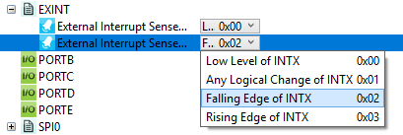

External Interrupt was set to trigger at falling edge.

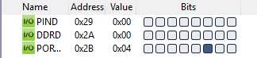

PORTB.2 is set as output and is off. PORTD.2 is input that is used for INTERRUPT.

1. **SCREENSHOT OF EACH DEMO (BOARD SETUP)**

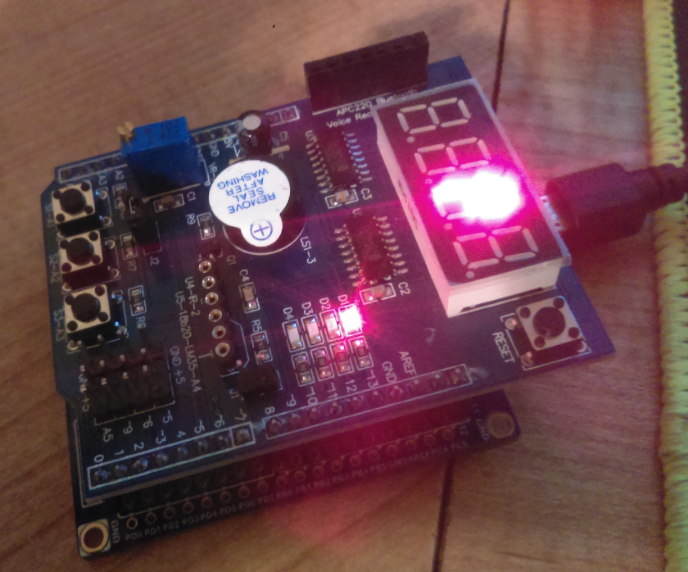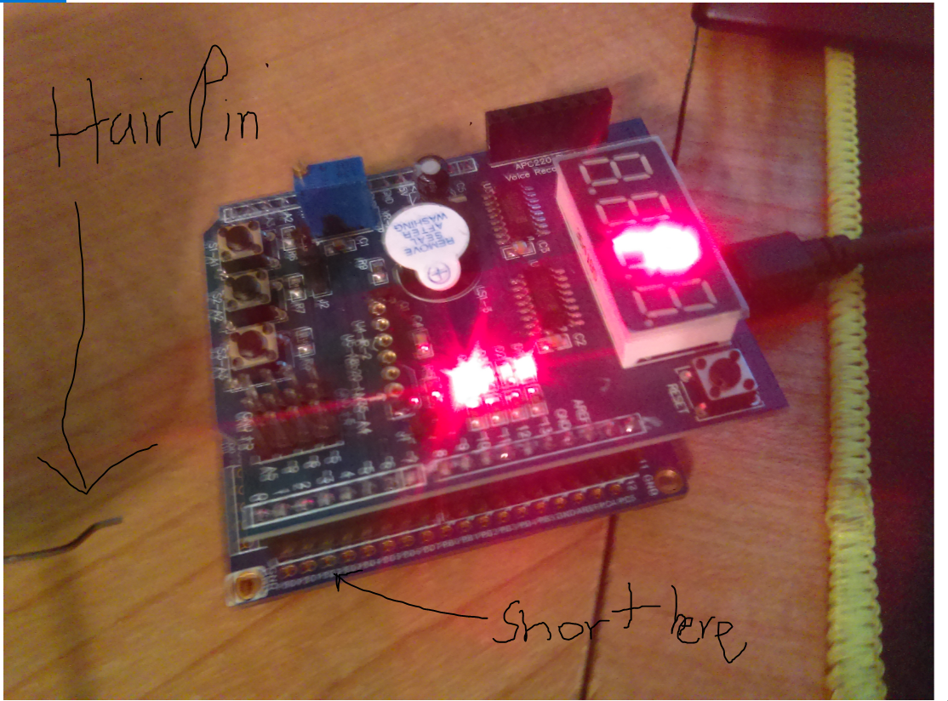

(TOP) OFF (BOTTOM) ON, I used a hair pin to short PD.2

1. **VIDEO LINKS OF EACH DEMO**

https://youtu.be/t_lvahBLRS4 - EMULATONS

No simulations didn’t know how to use stimulus file.

1. **GITHUB LINK OF THIS DA**

https://github.com/1177307/submission_DA/tree/master/DesignAssignments/DA2/DA2B

**Student Academic Misconduct Policy**

<http://studentconduct.unlv.edu/misconduct/policy.html>

“This assignment submission is my own, original work”.

THEODORE X PELE