CPE301 – SPRING 2019

Design Assignment 3A

Student Name: THEODORE PELE

Student #: 2000862662

Student Email: pele@unlv.nevada.edu

Primary Github address: https://github.com/1177307/submission_DA

Directory: DA3A

1. **COMPONENTS LIST AND CONNECTION BLOCK DIAGRAM w/ PINS**

USED MOSTLY INTERNAL COMPONENTS AS IT WOULD BE APPEARING ON THE MONITOR OF THE COMPUTER.

1. **INITIAL/MODIFIED/DEVELOPED CODE OF TASK 1/A**

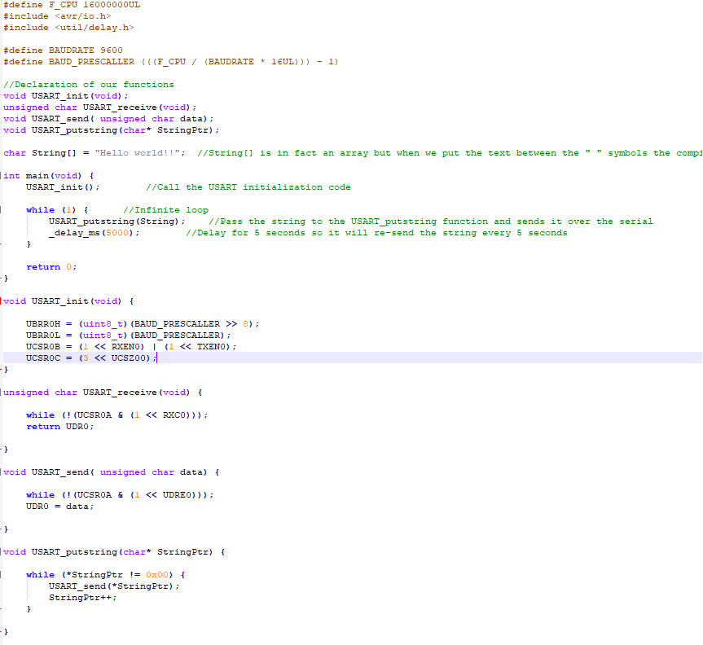

Base code is from lecture8a.1 c where we learned about UART and how to send signals from the ATmega328pb to terminal to print out “Hello World!!”.

1. **DEVELOPED MODIFIED CODE OF TASK 2/A from TASK 1/A**

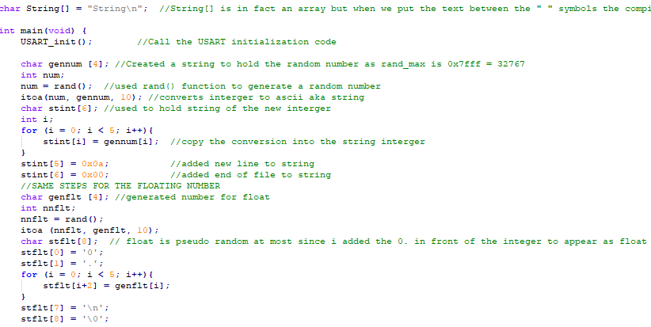

Before the printing loop this is how I generated the random integer and floating number. For the string, I left it as a constant.

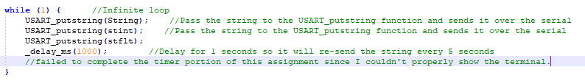

This is how I would then begin to print the order from the task as such that the string appear first, then random integer and floating number. However, there was an error when I tried adding the print string float where it would print out three times, so I couldn’t spend time on implementing the Timer delay of 1 second.

1. **SCHEMATICS** 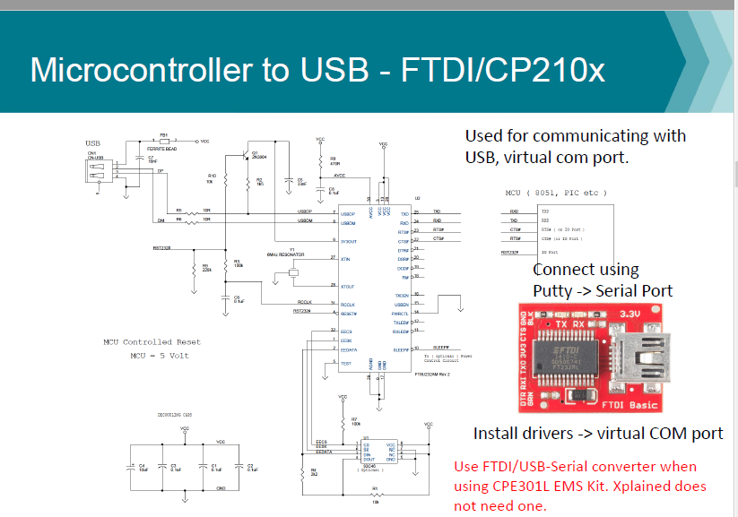

I don’t consider there to be a schematic for this since the AVR studio already had a data visualizer for the Xplained Mini and the FTDI wasn’t needed since I wasn’t using the Lab EMS kit.

1. **SCREENSHOTS OF EACH TASK OUTPUT (ATMEL STUDIO OUTPUT)**

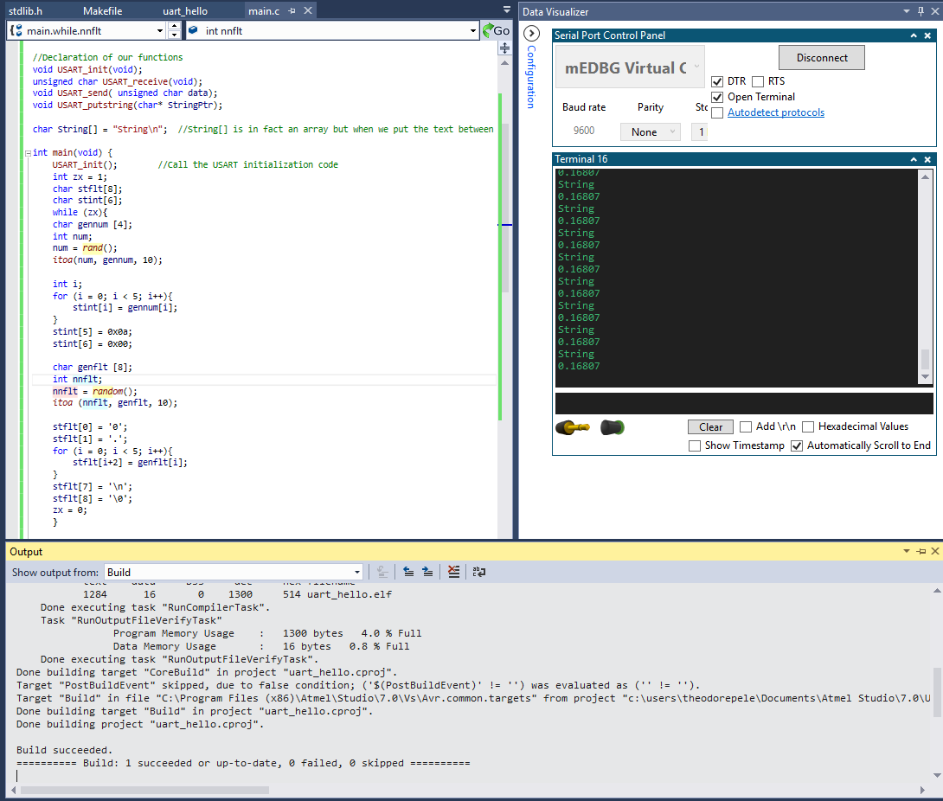

Our only task was to print a string, random integer and floating number, so for the output the terminal is all that was needed.

1. **SCREENSHOT OF EACH DEMO (BOARD SETUP)**

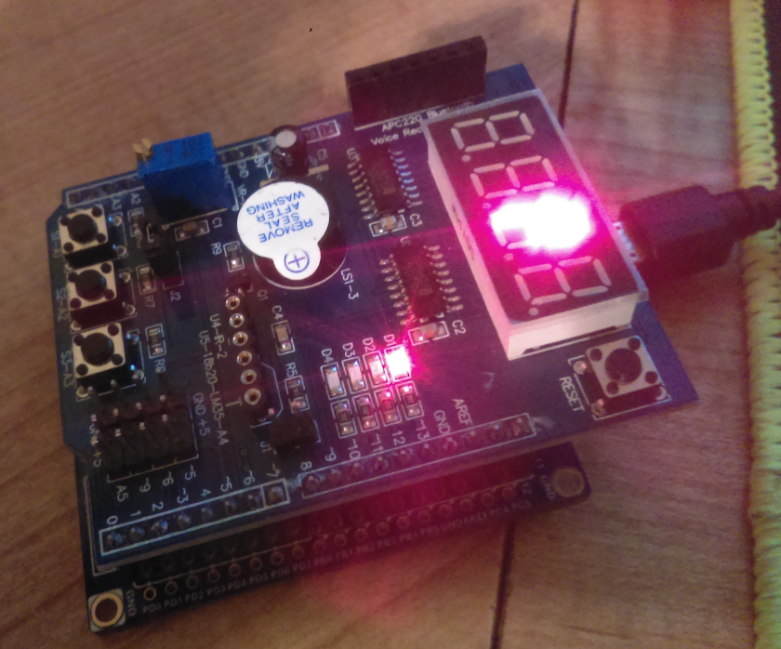

I used the same picture from assignment 2C since all that was needed for setup was a connection to the Xplained Mini.

1. **VIDEO LINKS OF EACH DEMO**

<https://youtu.be/b0lRBYjHss0>

1. **GITHUB LINK OF THIS DA**

https://github.com/1177307/submission_DA/tree/master/DesignAssignments/DA3/DA3A

**Student Academic Misconduct Policy**

<http://studentconduct.unlv.edu/misconduct/policy.html>

“This assignment submission is my own, original work”.

THEODORE X PELE