CPE301 – SPRING 2019

Design Assignment 4A

Student Name: THEODORE PELE

Student #: 2000862662

Student Email: pele@unlv.nevada.edu

Primary Github address: https://github.com/1177307/submission_DA

Directory: DA4

1. **COMPONENTS LIST AND CONNECTION BLOCK DIAGRAM w/ PINS**

USED POTENTIOMETER and PUSH BUTTONS TO EMULATE THE ASSIGNMENT

1. **INITIAL/MODIFIED/DEVELOPED CODE OF TASK 1/A**

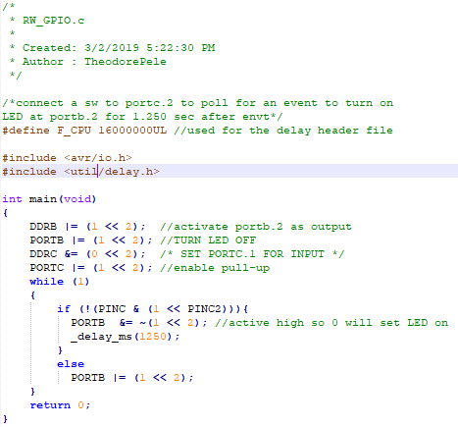

Base code used to simulate the pushbutton to turning OFF and ON the PIN. The translation would be made for using the PUSHBUTTON for turning ON and OFF the DC motor’s PIN.

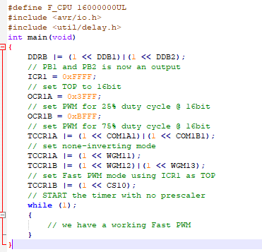

Base code from module 10_A2.c for setting up the PWM mode adjusting for % duty cycle, where the duty cycle would use the TOP value * desired duty cycle to set the comparison.

1. **DEVELOPED MODIFIED CODE OF TASK 2/A from TASK 1/A**

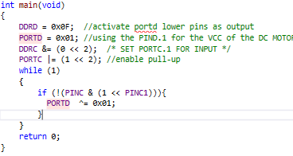

Base modification for the code to using the D port as the VCC pin of the DC motor and had it connected and had it toggle PIND.1 every time the switch was pressed.

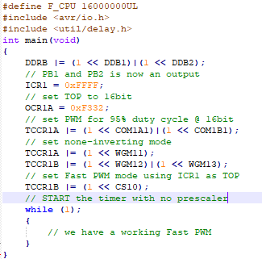

Since we’re only checking at 95% duty cycle of the PWM value, its calculated by 0Xffff => 65535*0.95 => 62,258.25 ≈ 0xf332.

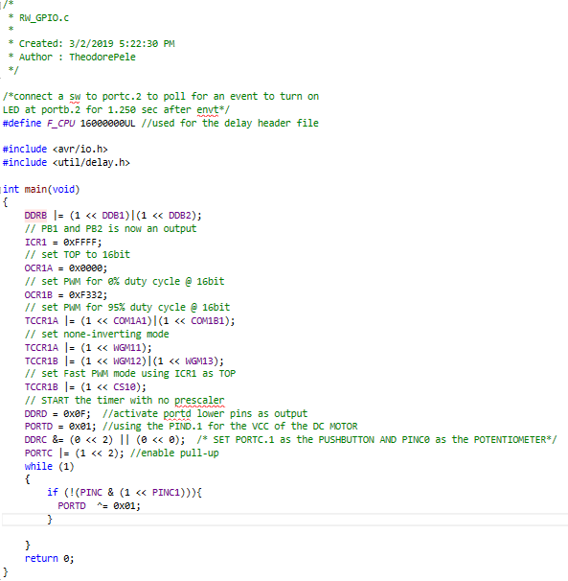

The potentiometer is connected to PINC0 on the multishield.

The final code would look something like this, however, I couldn’t setup the DC motor properly and somehow it shorted my ATMEGA328pb Xplained plenty of times and had occasional disconnection or errors during simulations. So, I couldn’t show a complete setup.

1. 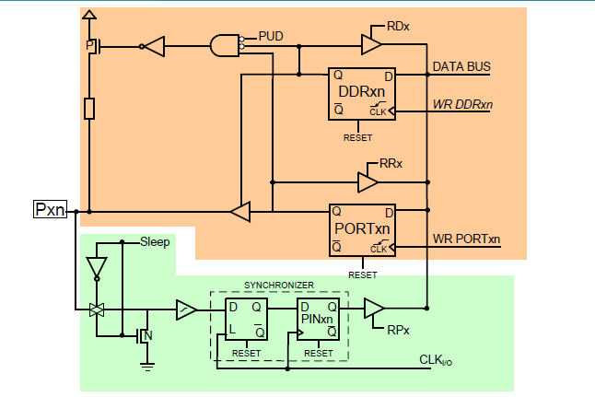**SCHEMATICS**

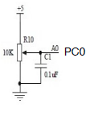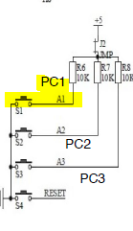

1. **SCREENSHOTS OF EACH TASK OUTPUT (ATMEL STUDIO OUTPUT)**

COULDN’T COMPILE

1. **SCREENSHOT OF EACH DEMO (BOARD SETUP)**

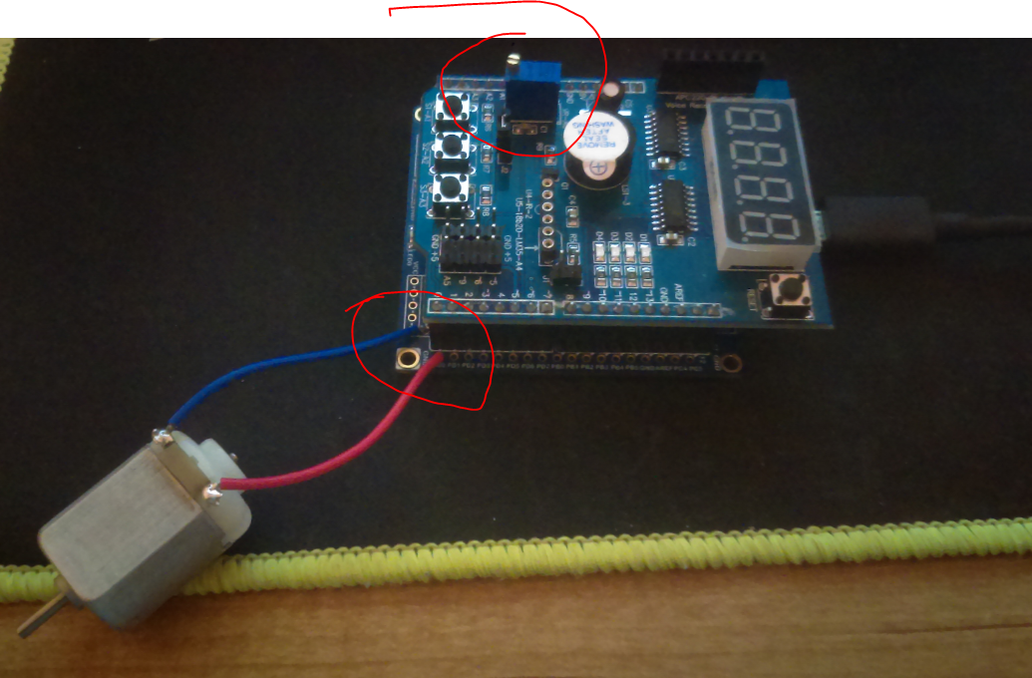

1. **VIDEO LINKS OF EACH DEMO**

FAILED TO COMPILE

1. **GITHUB LINK OF THIS DA**

https://github.com/1177307/submission_DA/tree/master/DesignAssignments/DA4/DA_4A

**Student Academic Misconduct Policy**

<http://studentconduct.unlv.edu/misconduct/policy.html>

“This assignment submission is my own, original work”.

THEODORE PELE