CPE301 – SPRING 2019

MIDTERM 1

Student Name: Theodore Pele

Student #: 2000862662

Student Email: pele@unlv.nevada.edu

Primary Github address: https://github.com/1177307/submission_DA

Directory: Midterms

1. **COMPONENTS LIST AND CONNECTION BLOCK DIAGRAM w/ PINS**

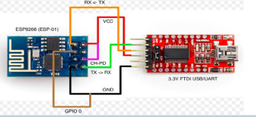

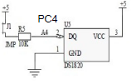

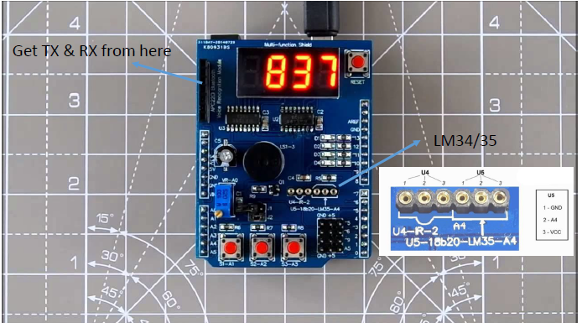

1. **INITIAL/MODIFIED/DEVELOPED CODE OF TASK 1/A**

Given code from module 8 when accessing the UART functions of the ATMEGA328.   
  
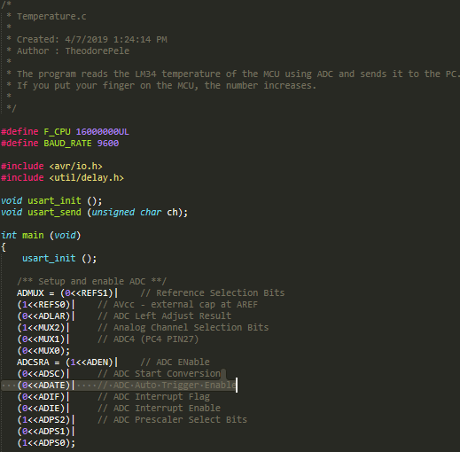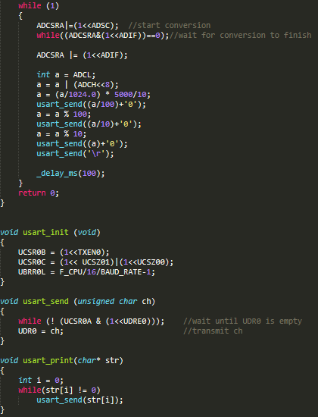

1. **DEVELOPED MODIFIED CODE OF TASK 2/A from TASK 1/A**

Didn’t make any changes to the code as the functionality of the ESP-01 could be accessed. However, if it had work It would require changing the baud rate to match each other from the sensor to the ESP-01.

1. **SCHEMATICS**

N/A

1. **SCREENSHOTS OF EACH TASK OUTPUT (ATMEL STUDIO OUTPUT)**

TASK 1 / 2: TEMPERATURE READING FROM LM35 TO UART

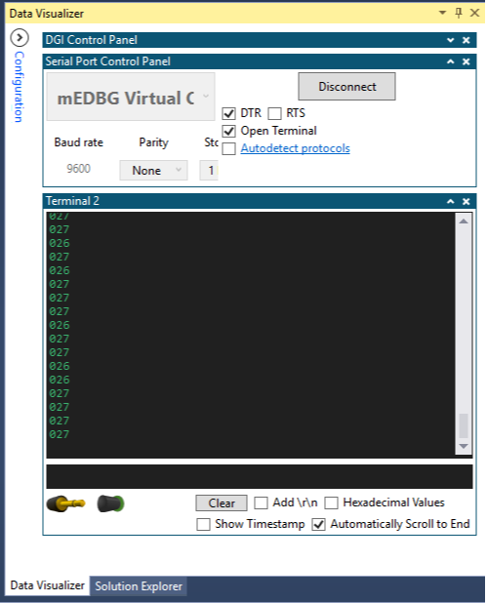

TASK 3: SETTING UP FIRMWARE FOR THE ESP-01 module (multiple attempts)

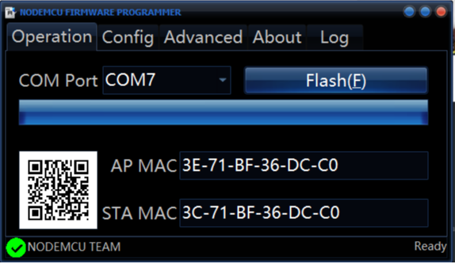

1. Tried the NODEMCU to burn the firmware into the ESP module. It loaded successfully but using ESPlorer didn’t show the AT code.

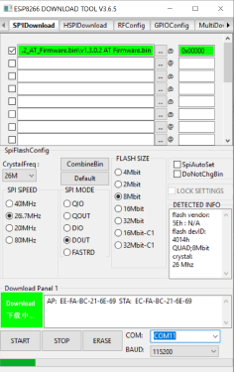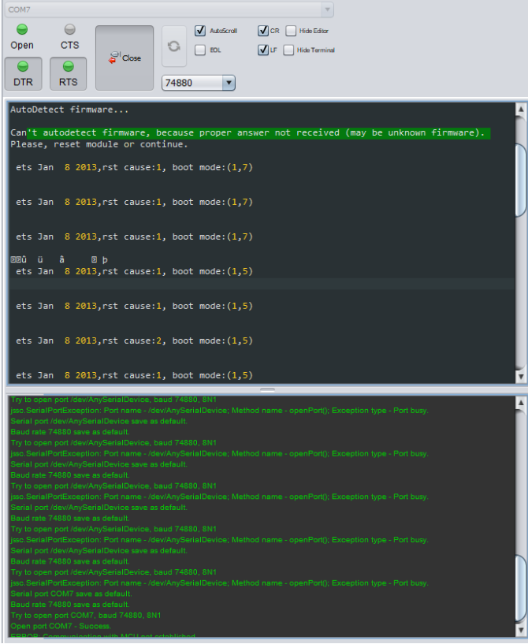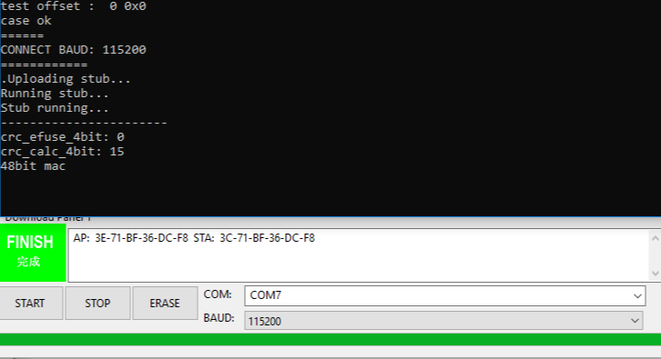2. Second attempt by following the tutorial video of using the flasher-master with settings from the 1.5 version of AT and still didn’t work.  
  
  
  
  
(Left)Issue resolved settings failed as well. (Right)Never connected, but was able to create error...

1. **SCREENSHOT OF EACH DEMO (BOARD SETUP)**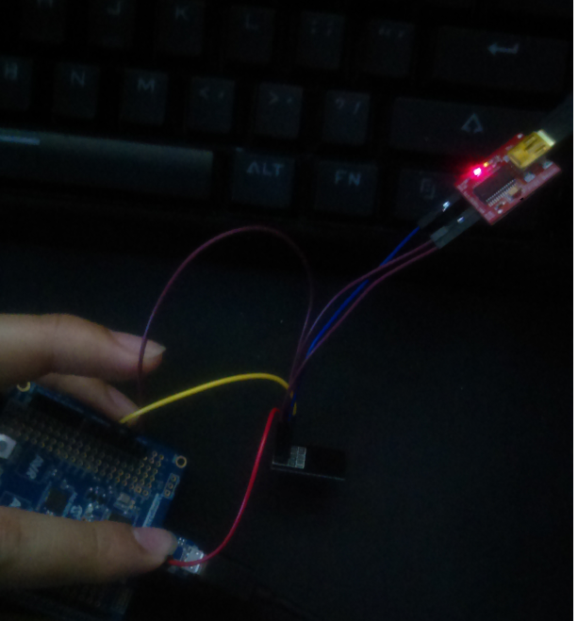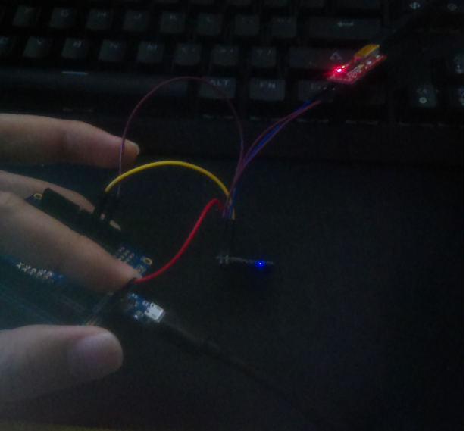

The setup of the programming the ESP01 module by connecting the proper pins into XplainedMini for its 3 V. Didn’t solder the back of the FTDI basic, so had to use an alternative.

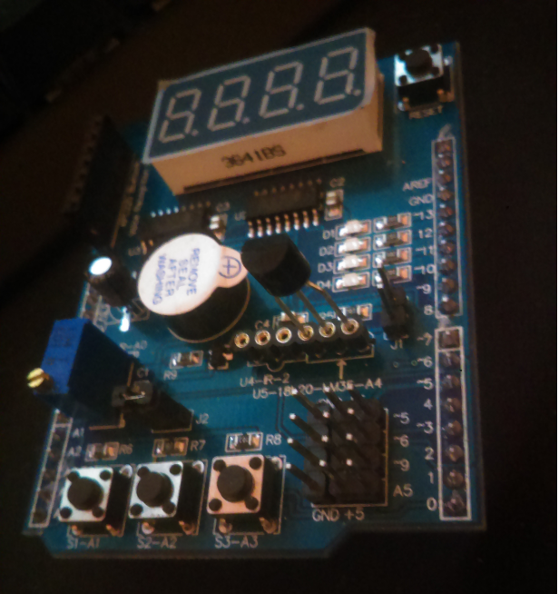

Setup for task 1, so it was easy assembly for the LM35.

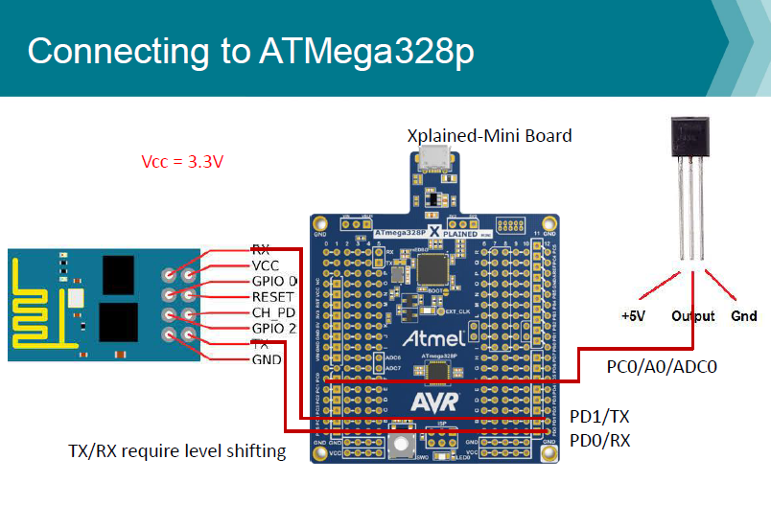

Final setup would’ve looked like this if it had worked… Needed to set up the ESP to connect to the proper channels before moving onto the next task.

1. **VIDEO LINKS OF EACH DEMO**

<https://youtu.be/3PQaR7lIjMM>

1. **GITHUB LINK OF THIS DA**

https://github.com/1177307/Midterms/M1/

**Student Academic Misconduct Policy**

<http://studentconduct.unlv.edu/misconduct/policy.html>

“This assignment submission is my own, original work”.

Theodore Pele