1180300829 余涛

1.待压缩文本文件内容：

I say to you today, my friends, so even though we face the difficulties of today and tomorrow, I still have a dream. It is a dream deeply rooted in the American dream. I have a dream that one day this nation will rise up and live out the true meaning of its creed, we hold these truths to be selfevident, that all men are created equal. I have a dream that one day on the red hills of Georgia, sons of former slaves and the sons of former slave owners will be able to sit down together at the table of brotherhood. I have a dream that one day even the state of Mississippi, a state sweltering with the heat of injustice, sweltering with the heat of oppression, will be transformed into an oasis of freedom and justice. I have a dream that my four little children will one day live in a nation where they will not be judged by the color of their skin but by the content of their character.

I HAVE A DREAM TODAY! I have a dream that one day down in Alabama with its vicious racists, with its Governor having his lips dripping with the words of interposition and nullification. one day right there in Alabama, little black boys and black girls will be able to join hands with little white boys and white girls as sisters and brothers.

I HAVE A DREAM TODAY! I have a dream that one day every valley shall be exalted, and every hill and mountain shall be made low. The rough places will be plain and the crooked places will be made straight, and the glory of the Lord shall be revealed, and all flesh shall see it together.

This is our hope. This is the faith that I go back to the South with. With this faith we will be able to hew out of the mountain of despair a stone of hope. With this faith we will be able to transform the jangling discords of our nation into a beautiful symphony of brother-hood. With this faith we will be able to work together, to pray together, to struggle together, to go to jail together, to stand up for freedom together, knowing that we will be free one day. And this will be the day. This will be the day when all of God's children will be able to sing with new meaning, my country tis of thee, sweet land of liberty, of thee I sing. Land where my father died, land of the pilgrim's pride, from every mountainside, let freedom ring. And if America is to be a great nation, this must become true.

2功能展示：

（1）.读入英文文件并统计各字符使用频率：

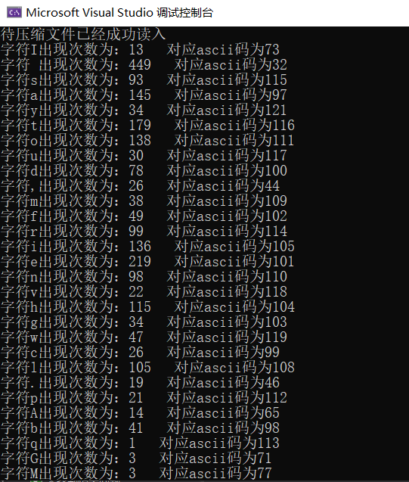

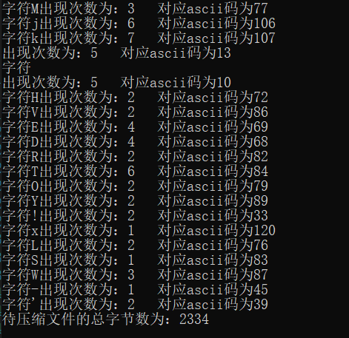

（2）构造哈夫曼编码树，给出每个字符的哈夫曼编码：

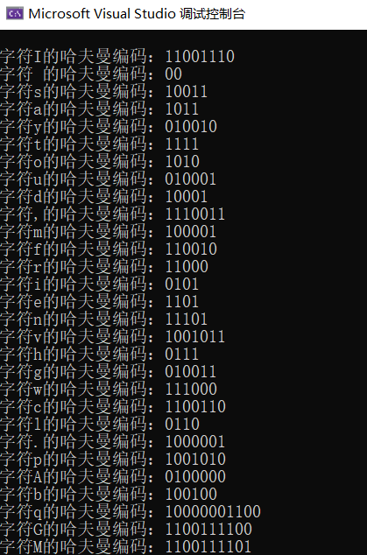

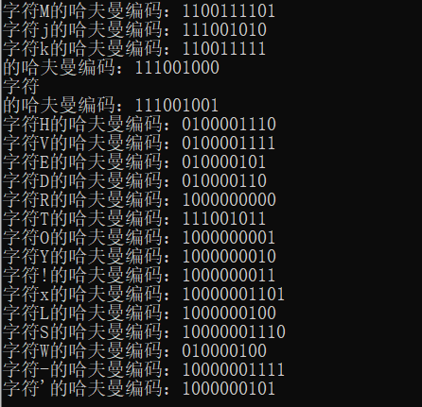

（3）.将文本文件用哈夫曼编码，存储成文本文件：

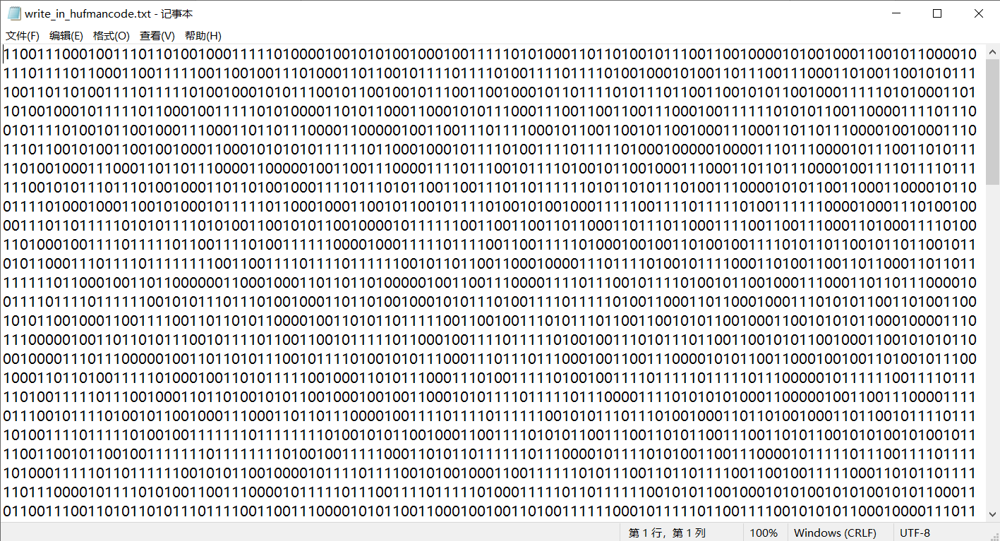

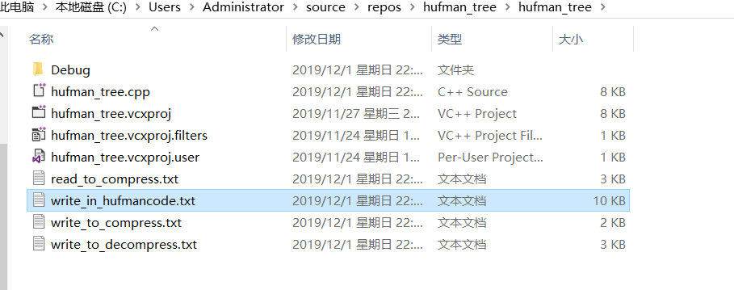

（4）.用八个字符0和1转换成一个字符压缩文件：

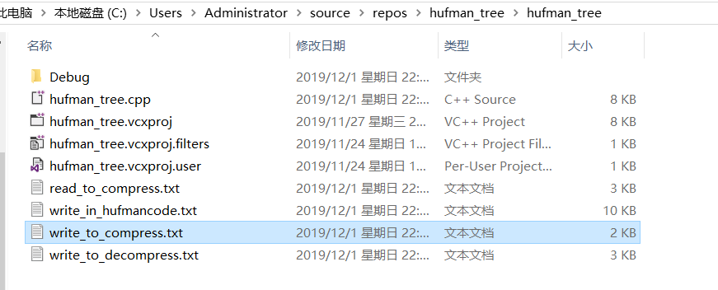

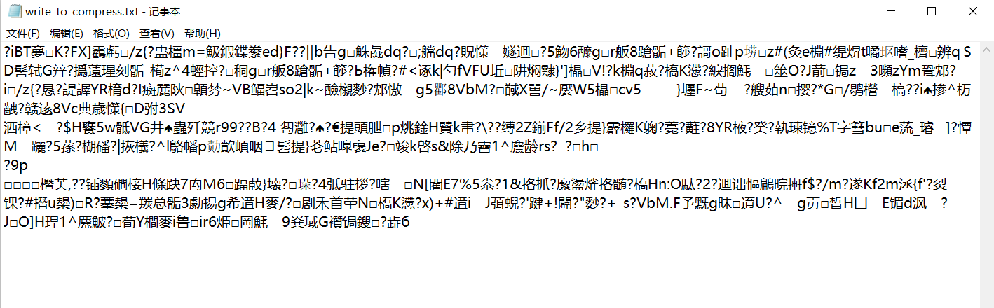

（5）.计算压缩率：

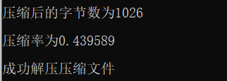

（6）. 将哈夫曼编码文件译码为文本文件，并与原文件进行比较:与原文件相同

