**Dot Net Phase 4 – Custom Support Logger**

**Bank Practice Project**

Github: <https://github.com/11812142/PHASE4.NET/tree/master/azure-web-forms-master>

**SSMS**

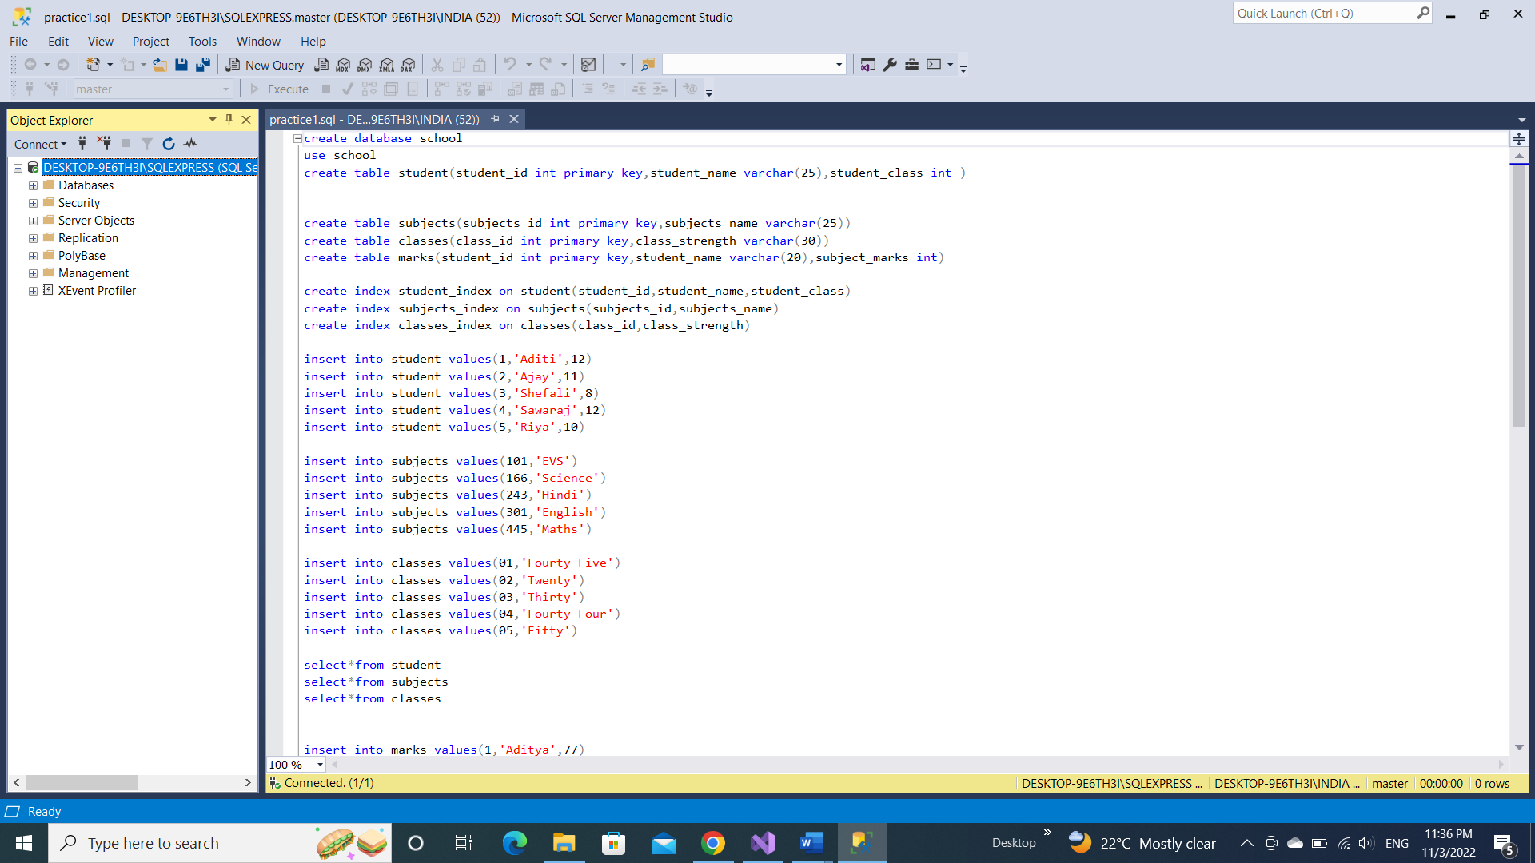

**Azure Virtual Machine**

1. **School Management**

1. **Class Details**

1. **Student Details**

1. **Subject Details**

