**ScreenShorts of Final Project:**

1. All Details of Existing Employees

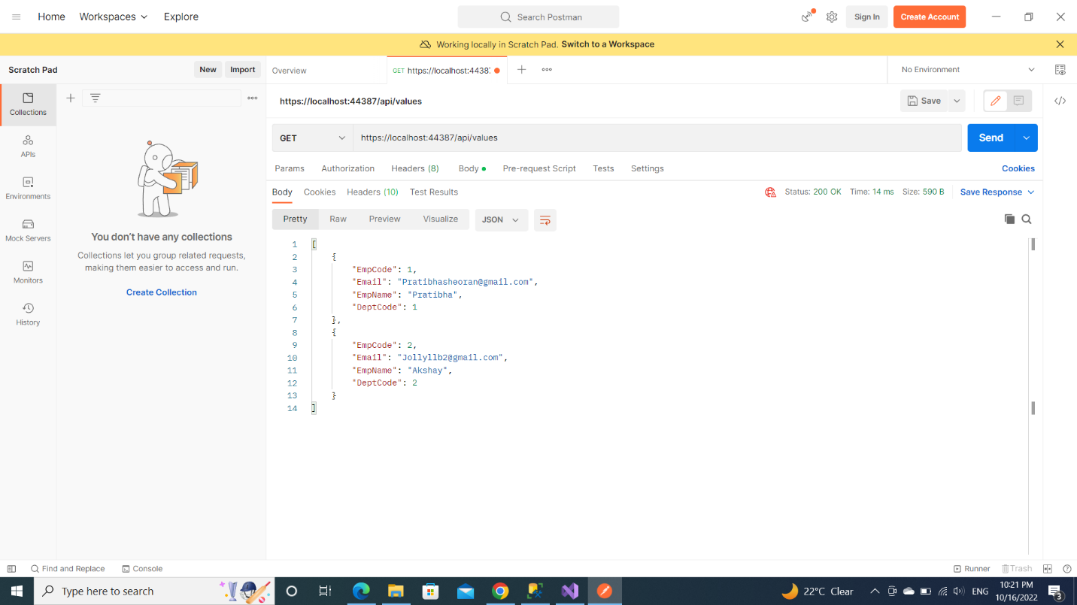

1. Update 🡪Put means update

1. Delete

